**Subject Name: Computer Programming with C**

**Subject Code: MCA102**

**Assignment-3**

**Topic: Arrays and Structures**

**Name: Shashwat Khaitan**

**Section: B**

**Enrollment No: 12024006015093**

**Class Roll No: 36**

1. Write a program to store marks for n numbers of students in an array and print their marks.

#include <stdio.h>

int main()

{

int n,i;

printf("enter the number of students:");

scanf("%d", &n);

int marks[n];

printf("enter the marks of %d student^:\n", n);

for(i=0;i<n;i++)

{

scanf("%d", &marks[i]);

}

printf("marks of students are:\n");

for(i=0;i<n;i++)

{

printf("%d", marks[i]);

}

return 0;

}

**OUTPUT**

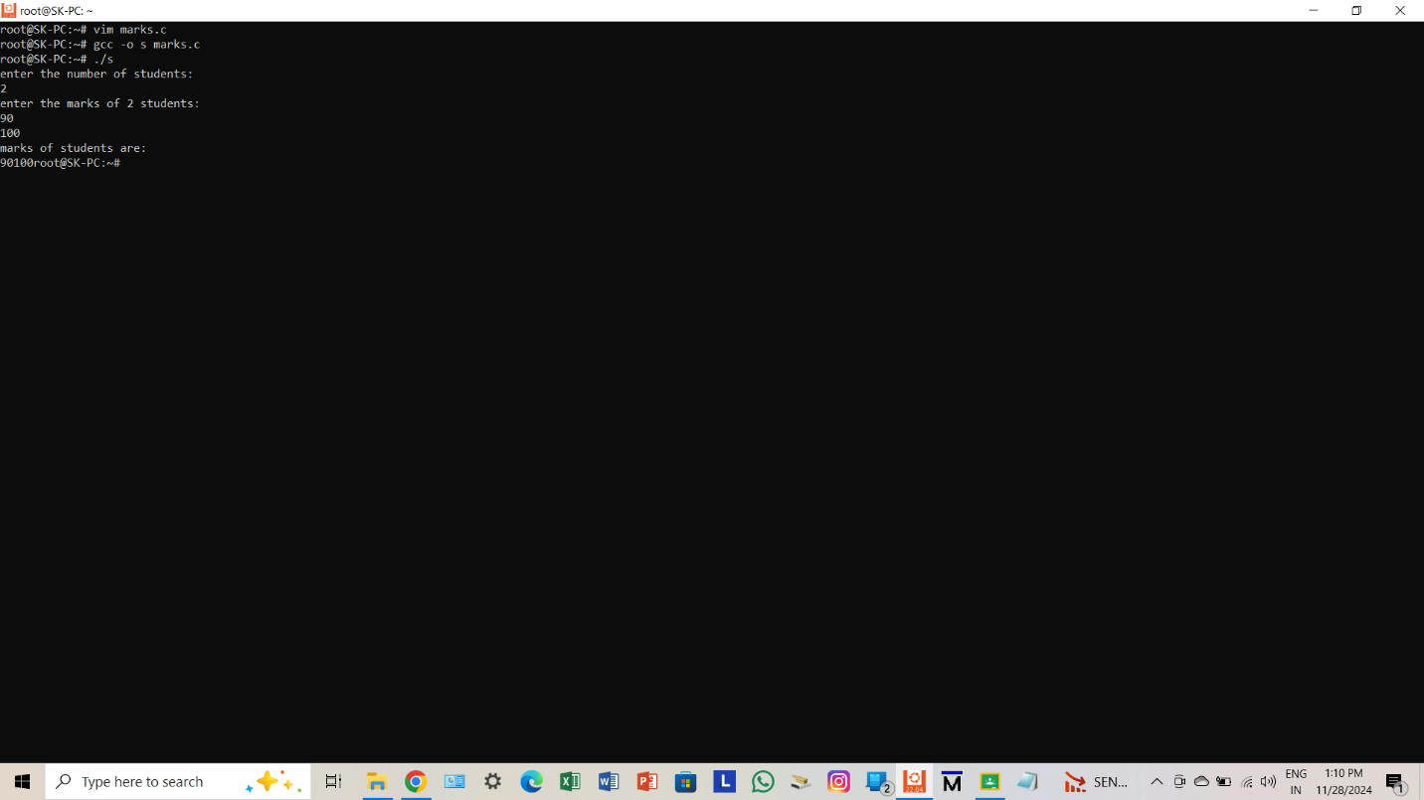

1. Write a program that stores the marks of the subjects Mathematics and English of n number of students in an array and then prints their total marks.

#include <stdio.h>

int main()

{

int n,i;

printf("enter the number of students: ");

scanf("%d", &n);

int m[n], e[n], total[n];

printf("enter the marks for mathematics:\n");

for(i=0;i<n;i++)

{

scanf("%d", &m[i]);

}

printf("enter the marks for english:\n");

for(i=0;i<n;i++)

{

scanf("%d", &e[i]);

}

printf("Total marks of students:\n");

for(i=0;i<n;i++)

{

total[i]= m[i]+e[i];

printf("%d", total[i]);

}

return 0;

}

**OUTPUT**

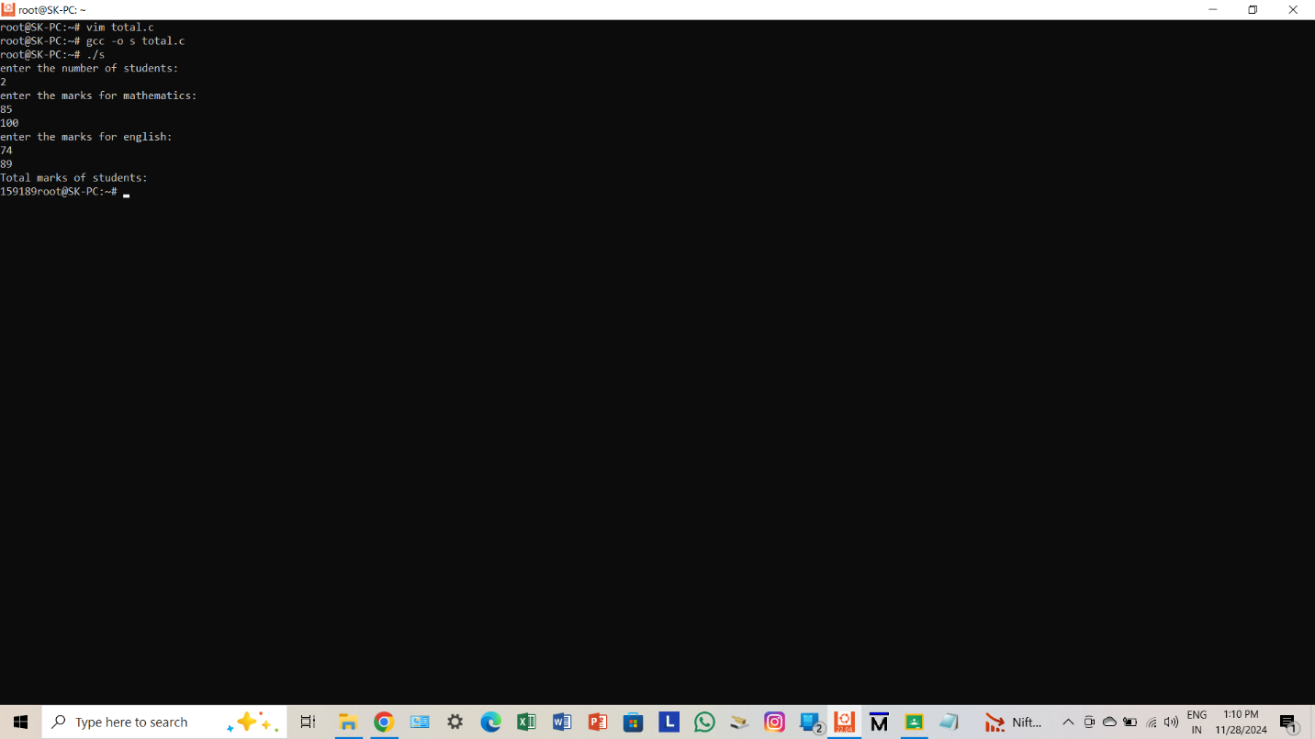

1. Write a program to insert an element in an array in a particular position.

#include <stdio.h>

int main()

{

int n,i,pos,v;

printf("enter the size of array: ");

scanf("%d", &n);

int arr[n+1];

printf("enter %d elements:\n", n);

for(i=0;i<n;i++)

{

scanf("%d", &arr[i]);

}

printf("enter the position and value to insert: ");

scanf("%d %d", &pos, &v);

for(i=n;i>=pos;i--)

{

arr[i]=arr[i-1];

}

arr[pos-1]=v;

printf("array after insertion:\n");

for(i=0;i<=n;i++)

{

printf("%d", arr[i]);

}

return 0;

}

**OUTPUT**

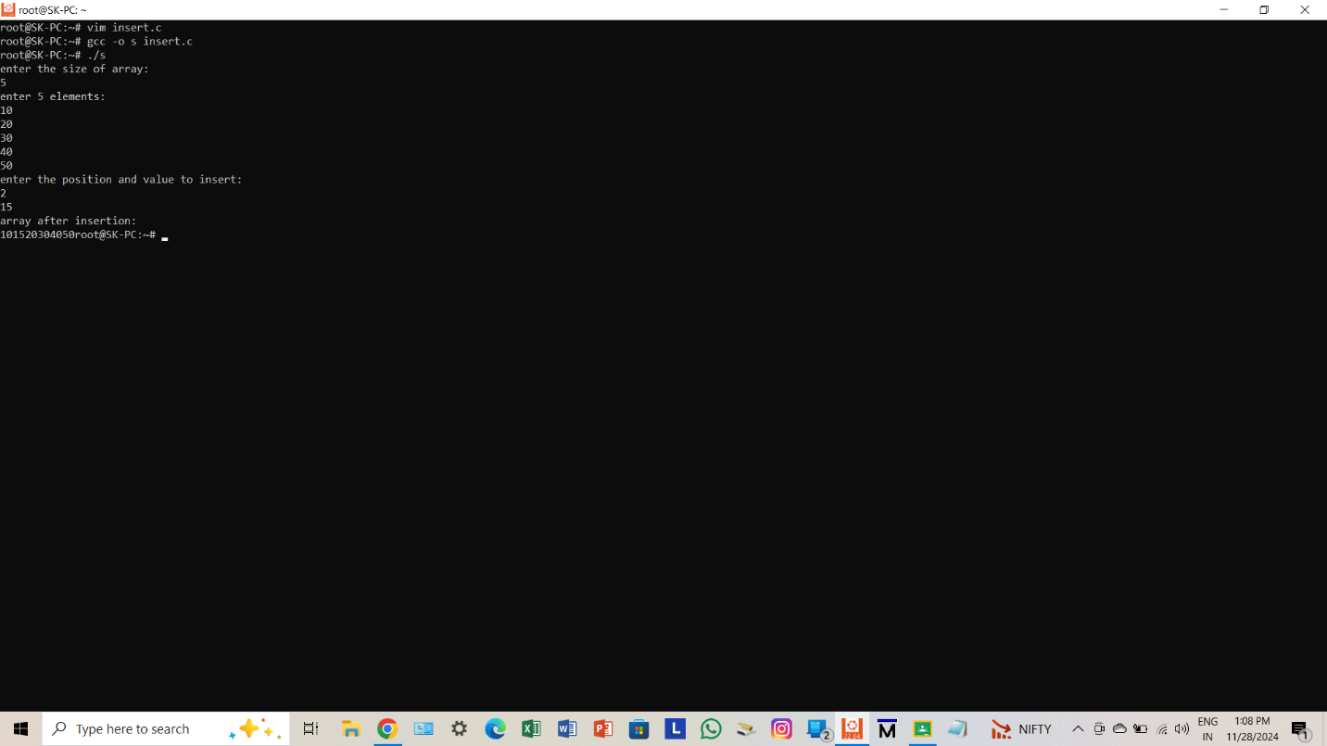

1. Write a program to delete an element from a particular position of an array.

#include <stdio.h>

int main()

{

int n,i,pos;

printf("enter the size of array: ");

scanf("%d", &n);

int a[n];

printf("enter %d elements:\n", n);

for(i=0;i<n;i++)

{

scanf("%d", &a[i]);

}

printf("enter the position to delete: ");

scanf("%d", &pos);

for(i=pos-1;i<n-1;i++)

{

a[i]=a[i+1];

}

printf("Array after deletion:\n");

for(i=0;i<n-1;i++)

{

printf("%d ", a[i]);

}

return 0;

}

**OUTPUT**

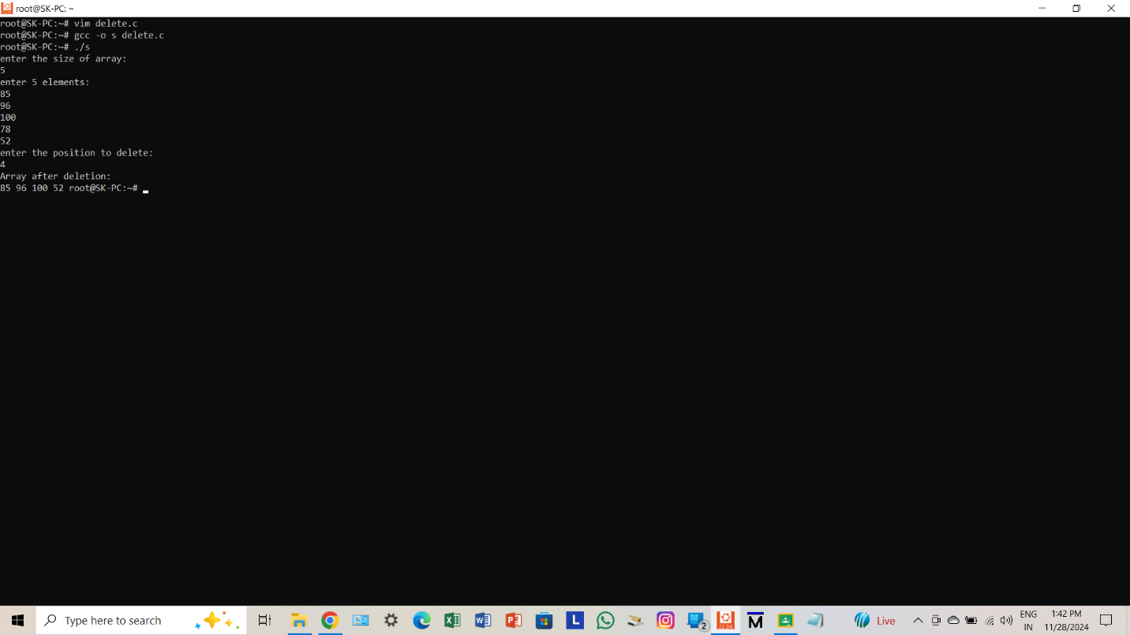

1. Write a program to convert a decimal number taken as input from a user to the corresponding binary number and store the result in an array.

#include <stdio.h>

int main()

{

int n, b[32], i=0;

printf("enter a decimal number: ");

scanf("%d", &n);

while(n>0)

{

b[i]=n%2;

n=n/2;

i++;

}

printf("Binary equivalent: ");

for(i=i-1;i>=0;i--)

{

printf("%d", b[i]);

}

return 0;

}

**OUTPUT**

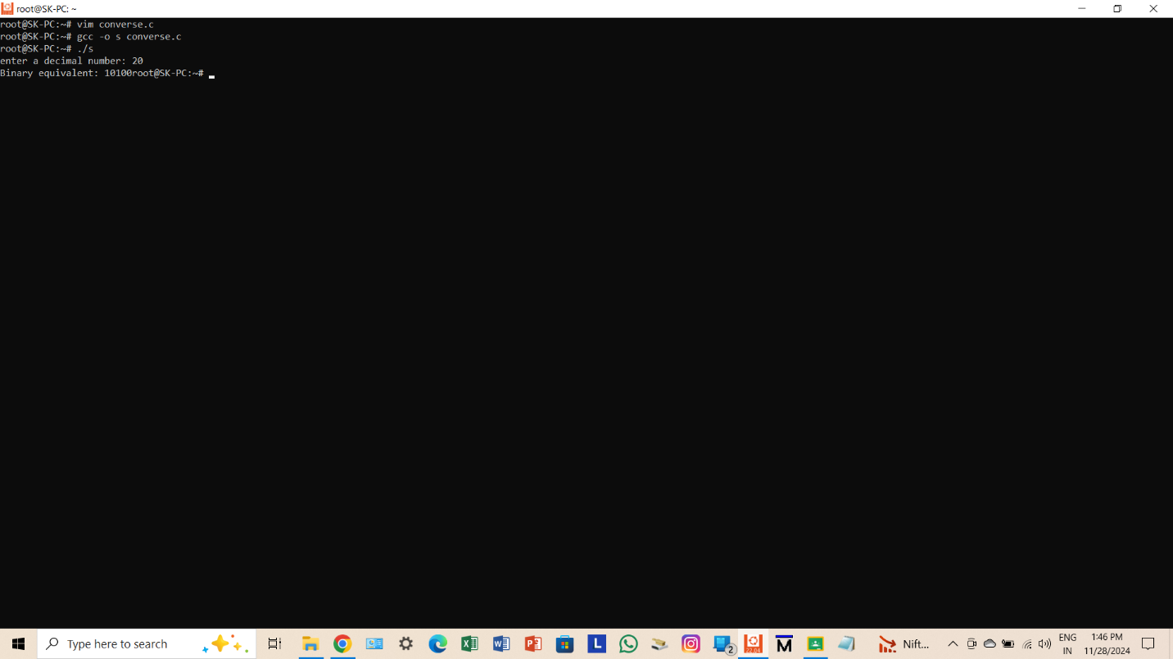

1. Write a program to input a binary number in an array and convert it into a corresponding decimal number.

#include <stdio.h>

int main()

{

int n,d=0,b=1,digit,i;

printf("enter the number of binary digits: ");

scanf("%d", &n);

int binary[n];

printf("enter the binary number:\n");

for(i=0;i<n;i++)

{

scanf("%d", &binary[i]);

}

for(i=n-1;i>=0;i--)

{

digit=binary[i];

d=d+digit*b;

b=b*2;

}

printf("Decimal equivalent: %d\n", d);

return 0;

}

**OUTPUT**

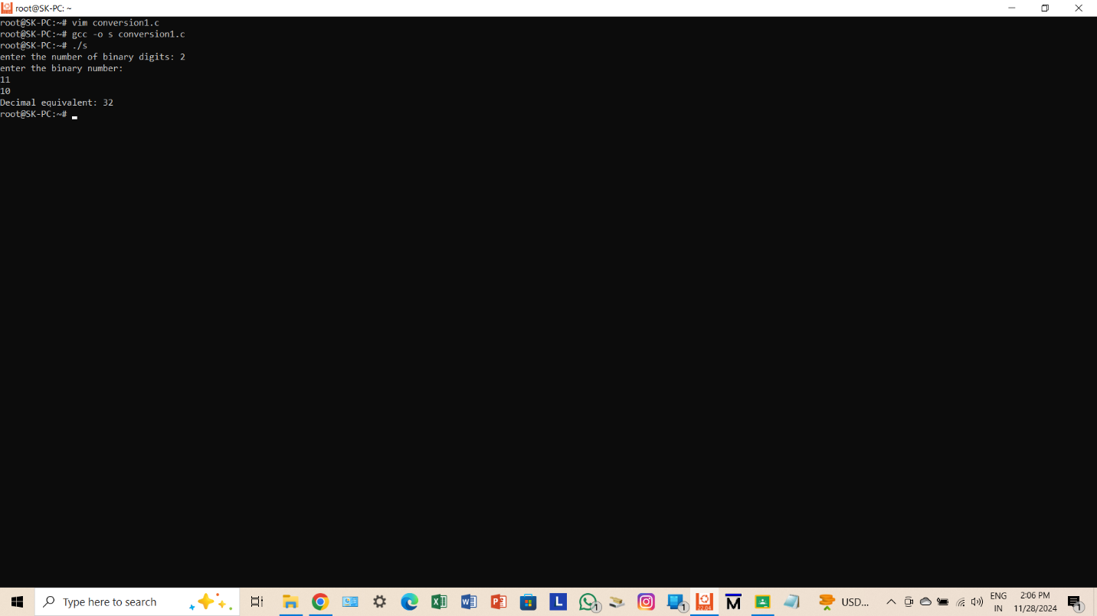

1. Write a program to find the smallest and the largest elements in an array.

#include <stdio.h>

int main()

{

int n,i,large,small;

printf("enter the size of array: ");

scanf("%d", &n);

int arr[n];

printf("enter %d elements:\n", n);

for(i=0;i<n;i++)

{

scanf("%d", &arr[i]);

}

small=large=arr[0];

for(i=1;i<n;i++)

{

if(arr[i]<small)

{

small=arr[i];

}

if(arr[i]>large)

{

large=arr[i];

}

}

printf("Smallest element is: %d\n", small);

printf("Largest element is: %d\n", large);

return 0;

}

**OUTPUT**

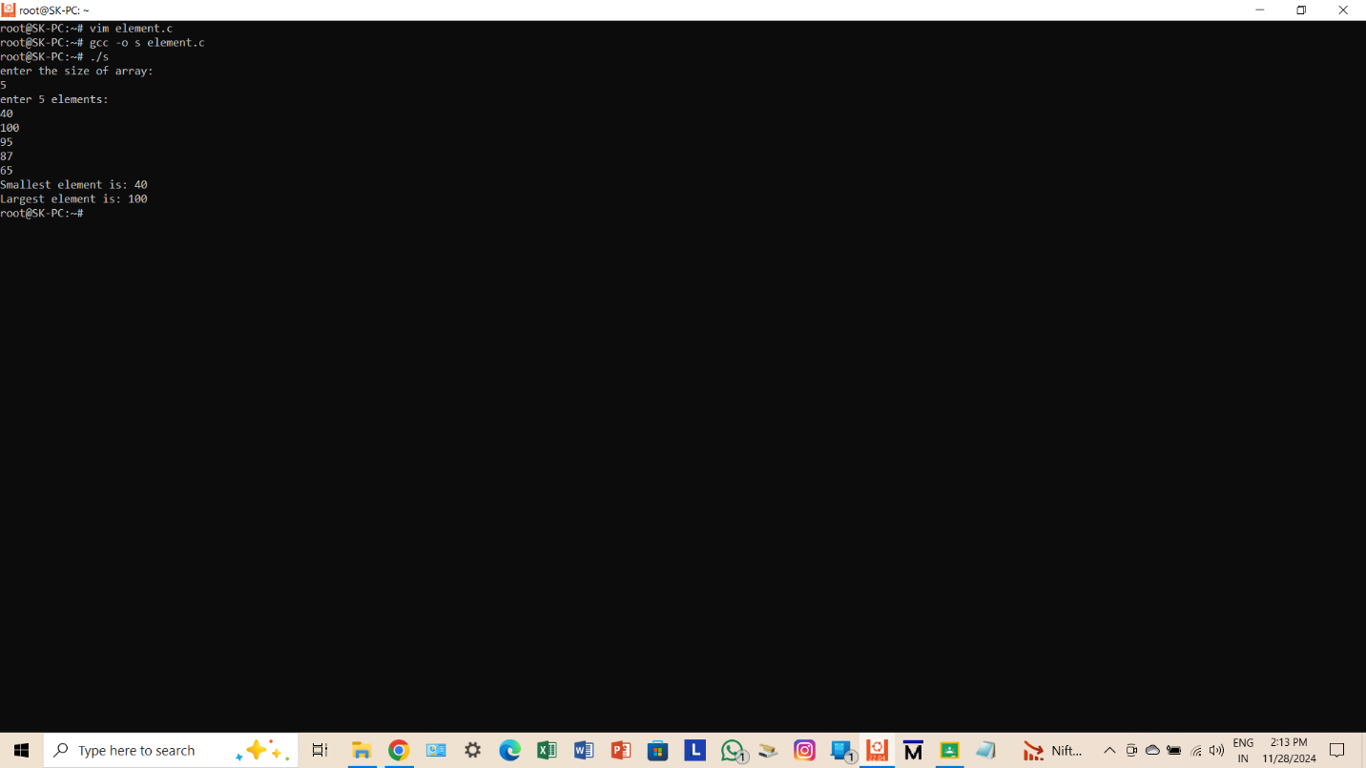

1. Write a program for deleting duplicate elements in an array.

#include <stdio.h>

int main()

{

int n,i,j,k;

printf("enter the size of array: ");

scanf("%d", &n);

int arr[n];

printf("enter %d elements:\n", n);

for(i=0;i<n;i++)

{

scanf("%d", &arr[i]);

}

for(i=0;i<n;i++)

{

for(j=i+1;j<n;)

{

if(arr[i]==arr[j])

{

for(k=j;k<n-i;k++)

{

arr[k]=arr[k+1];

}

n--;

}

else

{

j++;

}

}

}

printf("Array after removing duplicates is: \n");

for(i=0;i<n;i++)

{

printf("%d ", arr[i]);

}

return 0;

}

**OUTPUT**

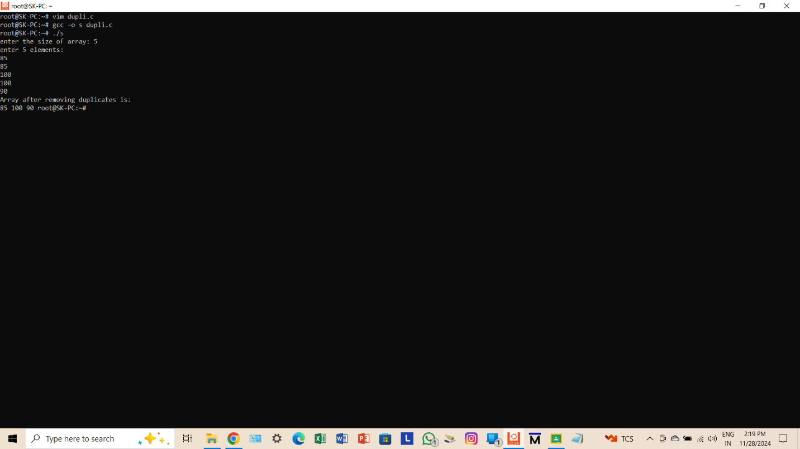

1. Write a program to search for a particular element in an array.

#include <stdio.h>

int main()

{

int n,i,s,f=0;

printf("enter the size of array: ");

scanf("%d", &n);

int arr[n];

printf("enter %d element:\n", n);

for(i=0;i<n;i++)

{

scanf("%d", &arr[i]);

}

printf("enter the element to search: ");

scanf("%d", &s);

for(i=0;i<n;i++)

{

if(arr[i]==s)

{

printf("Element found at position: %d\n", i+1);

f=1;

break;

}

}

if(!f)

{

printf("Element not found.\n");

}

return 0;

}

**OUTPUT**

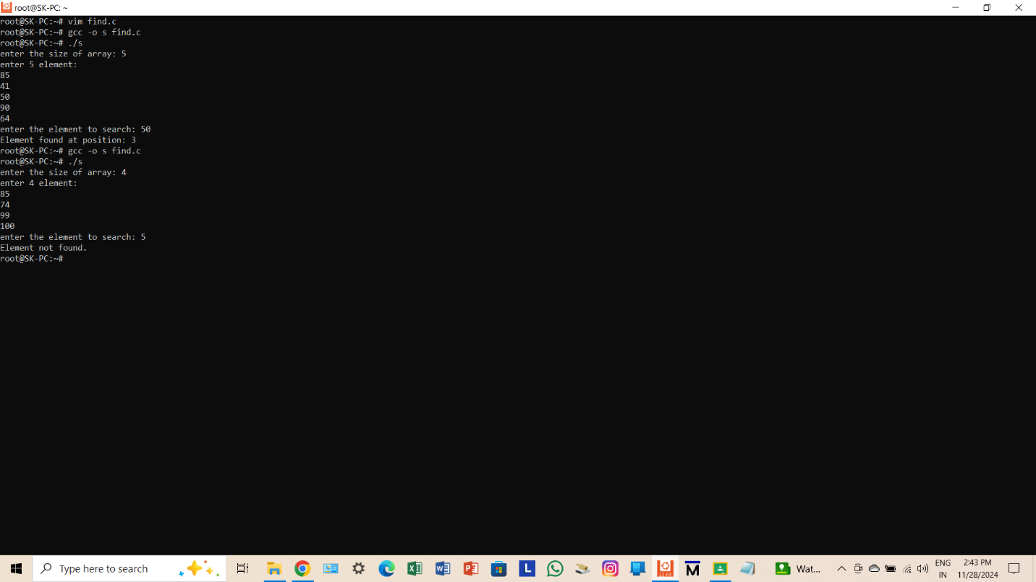

1. Write a program to sort n elements (in ascending order).

#include <stdio.h>

int main()

{

int n,i,j,t;

printf("enter the size of array: ");

scanf("%d", &n);

int arr[n];

printf("enter %d elements:\n", n);

for(i=0;i<n;i++)

{

scanf("%d", &arr[i]);

}

for(i=0;i<n-1;i++)

{

for(j=0;j<n-i-1;j++)

{

if(arr[j]>arr[j+1])

{

t=arr[j];

arr[j]=arr[j+1];

arr[j+1]=t;

}

}

}

printf("Array after sorting:\n");

for(i=0;i<n;i++)

{

printf("%d " , arr[i]);

}

return 0;

}

**OUTPUT**

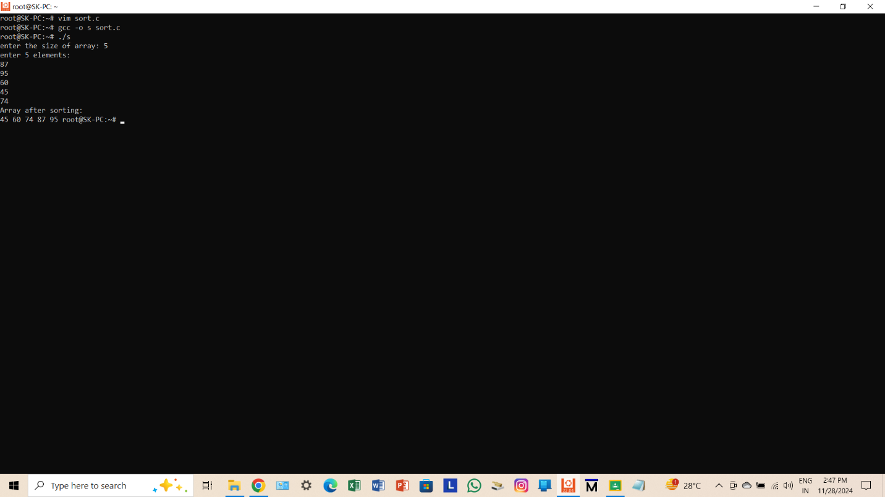

1. Write a program to find the second-highest number from the array without using sorting.

#include <stdio.h>

int main()

{

int n,i,large,second;

printf("enter the size of array: ");

scanf("%d", &n);

int arr[n];

printf("enter %d elements:\n", n);

for(i=0;i<n;i++)

{

scanf("%d", &arr[i]);

}

large=second= -2147483648;

for(i=0;i<n;i++)

{

if(arr[i]>large)

{

second=large;

large=arr[i];

}

else if(arr[i]>second && arr[i]!=large)

{

second=arr[i];

}

}

if(second==-2147483648)

{

printf("No second highest element.\n");

}

else

{

printf("Second highest element is: %d\n", second);

}

return 0;

}

**OUTPUT**

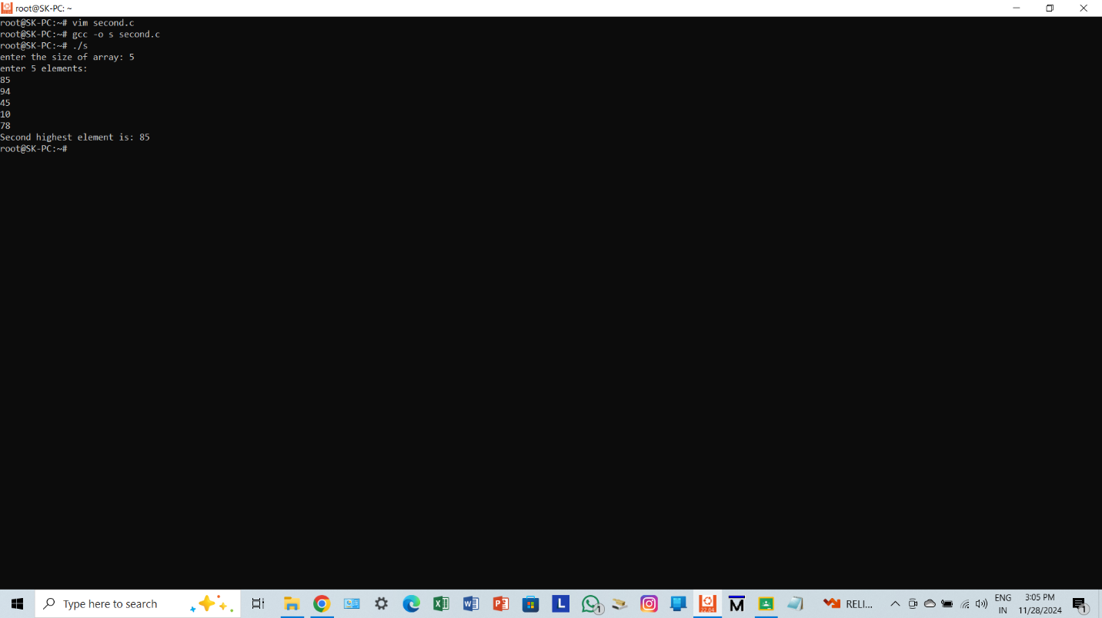

1. Write a program to perform addition and subtraction between two matrices.

#include <stdio.h>

int main()

{

int r,c,i,j;

printf("enter the number of rows and columns: ");

scanf("%d %d", &r, &c);

int m1[r][c], m2[r][c], sum[r][c], diff[r][c];

printf("enter the elements of first matrix:\n");

for(i=0;i<r;i++)

{

for(j=0;j<c;j++)

{

scanf("%d", &m1[i][j]);

}

}

printf("enter the elements of second matrix:\n");

for(i=0;i<r;i++)

{

for(j=0;j<c;j++)

{

scanf("%d", &m2[i][j]);

}

}

printf("Sum of matrices is:\n");

for(i=0;i<r;i++)

{

for(j=0;j<c;j++)

{

sum[i][j]= m1[i][j]+m2[i][j];

printf("%d ", sum[i][j]);

}

printf("\n");

}

printf("Difference of matrices is:\n");

for(i=0;i<r;i++)

{

for(j=0;j<c;j++)

{

diff[i][j]= m1[i][j]-m2[i][j];

printf("%d ", diff[i][j]);

}

printf("\n");

}

return 0;

}

**OUTPUT**

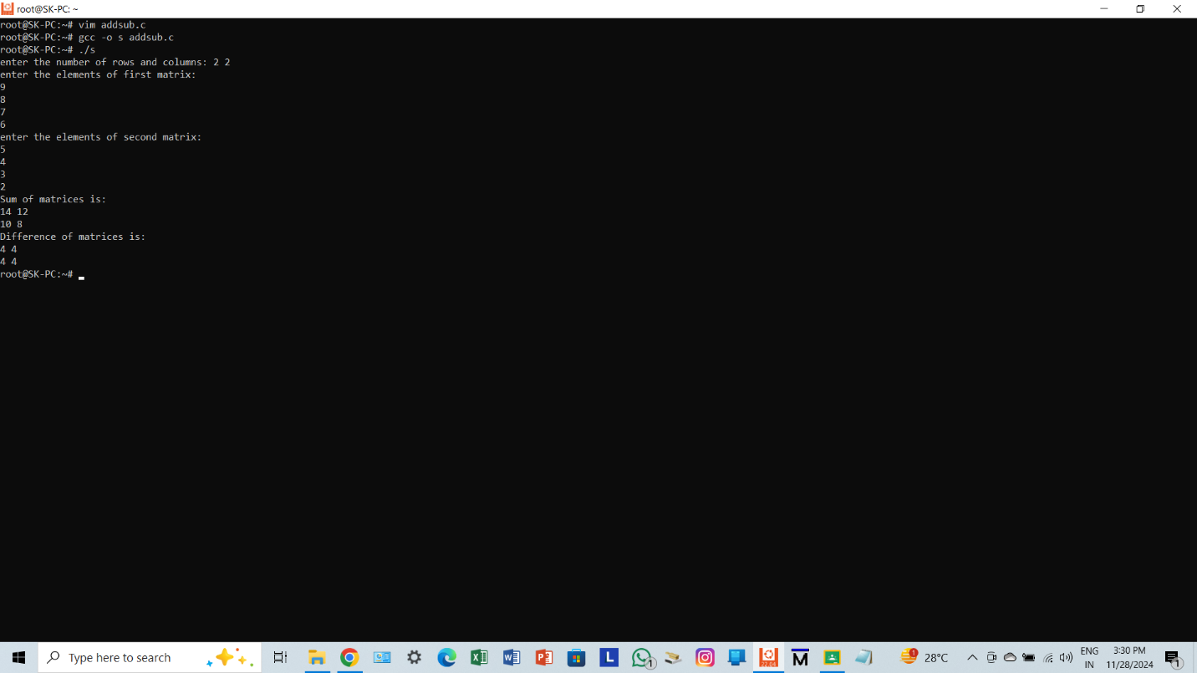

1. Write a program to transpose a matrix.

#include <stdio.h>

int main()

{

int r,c,i,j;

printf("enter the number of rows and columns: ");

scanf("%d %d", &r, &c);

int m[r][c], t[c][r];

printf("enter the elements of the matrix:\n");

for(i=0;i<r;i++)

{

for(j=0;j<c;j++)

{

scanf("%d", &m[i][j]);

}

}

for(i=0;i<r;i++)

{

for(j=0;j<c;j++)

{

t[j][i]=m[i][j];

}

}

printf("Transpose of the matrix is: \n");

for(i=0;i<c;i++)

{

for(j=0;j<r;j++)

{

printf("%d", t[i][j]);

}

printf("\n");

}

return 0;

}

**OUTPUT**

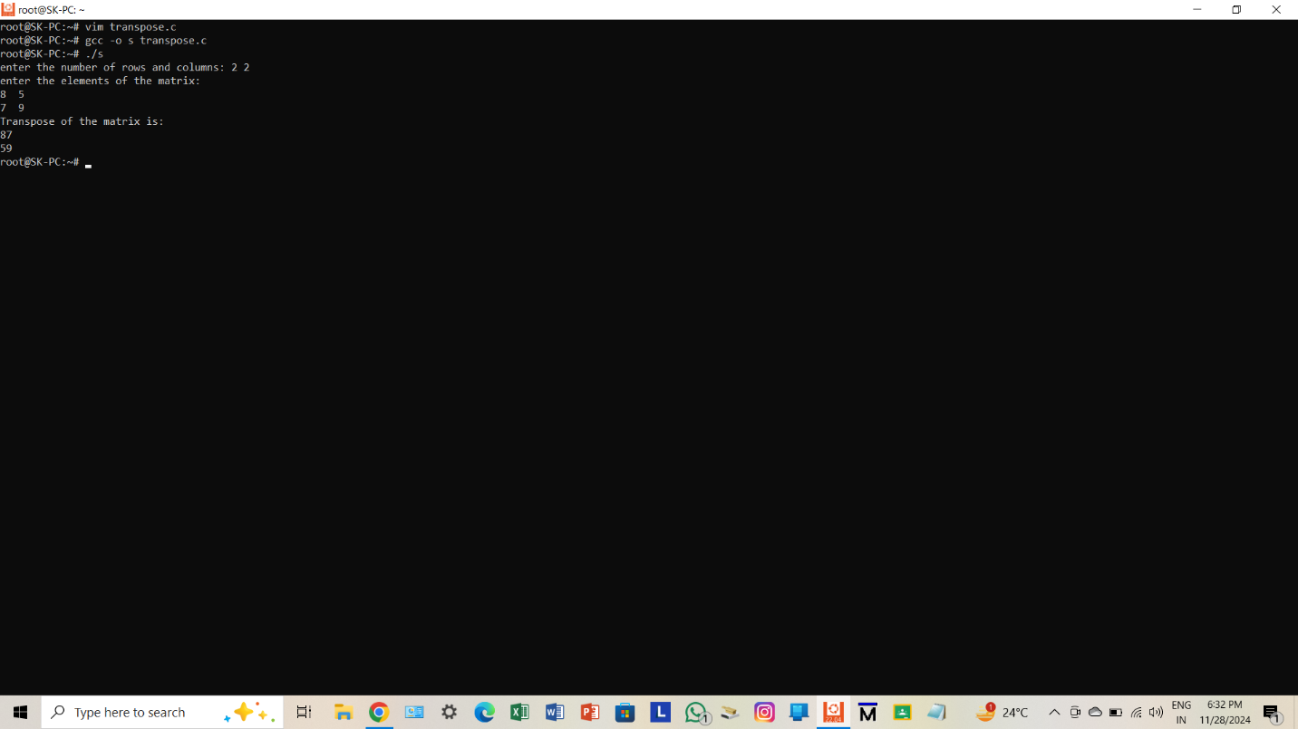

1. Write a program to add the elements of each row and each column of a matrix.

#include <stdio.h>

int main()

{

int r,c,i,j;

printf("enter the number of rows and columns: ");

scanf("%d %d", &r, &c);

int mat[r][c];

printf("enter the elements of the matrix:\n");

for(i=0;i<r;i++)

{

for(j=0;j<c;j++)

{

scanf("%d", &mat[i][j]);

}

}

printf("Sum of each row:\n");

for(i=0;i<r;i++)

{

int rowsum=0;

for(j=0;j<c;j++)

{

rowsum=rowsum+mat[i][j];

}

printf("Row %d: %d\n",i+1,rowsum);

}

printf("Sum of each column:\n");

for(i=0;i<r;i++)

{

int colsum=0;

for(j=0;j<c;j++)

{

colsum=colsum+mat[i][j];

}

printf("Column %d: %d\n",j+1,colsum);

}

return 0;

}

**OUTPUT**

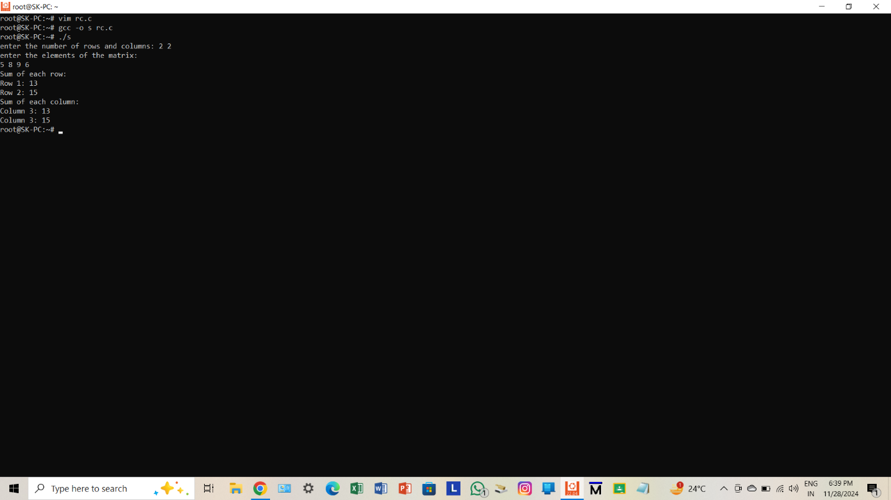

1. Write a program to perform the multiplication of two matrices.

#include <stdio.h>

int main()

{

int r,c,r1,c1,i,j,k;

printf("enter the number of rows and columns of the first matrix:");

scanf("%d %d", &r, &c);

printf("enter the number of rows and columns of the second matrix:");

scanf("%d %d", &r1, &c1);

if(c!=r1)

{

printf("matrix multiplication is not possible.\n");

return 1;

}

int m1[r][c], m2[r1][c1], result[r][c1];

printf("enter the elements of the first matrix:\n");

for(i=0;i<r;i++)

{

for(j=0;j<c;j++)

{

scanf("%d", &m1[i][j]);

}

}

printf("enter the elements of the second matrix:\n");

for(i=0;i<r1;i++)

{

for(j=0;j<c1;j++)

{

scanf("%d", &m2[i][j]);

}

}

for(i=0;i<r;i++)

{

for(j=0;j<c1;j++)

{

result[i][j]=0;

}

}

for(i=0;i<r;i++)

{

for(j=0;j<c1;j++)

{

for(k=0;k<c;k++)

{

result[i][j] += m1[i][k] * m2[k][j];

}

}

}

printf("matrix after multiplication:\n");

for(i=0;i<r;i++)

{

for(j=0;j<c1;j++)

{

printf("%d", result[i][j]);

}

printf("\n");

}

return 0;

}

**OUTPUT**

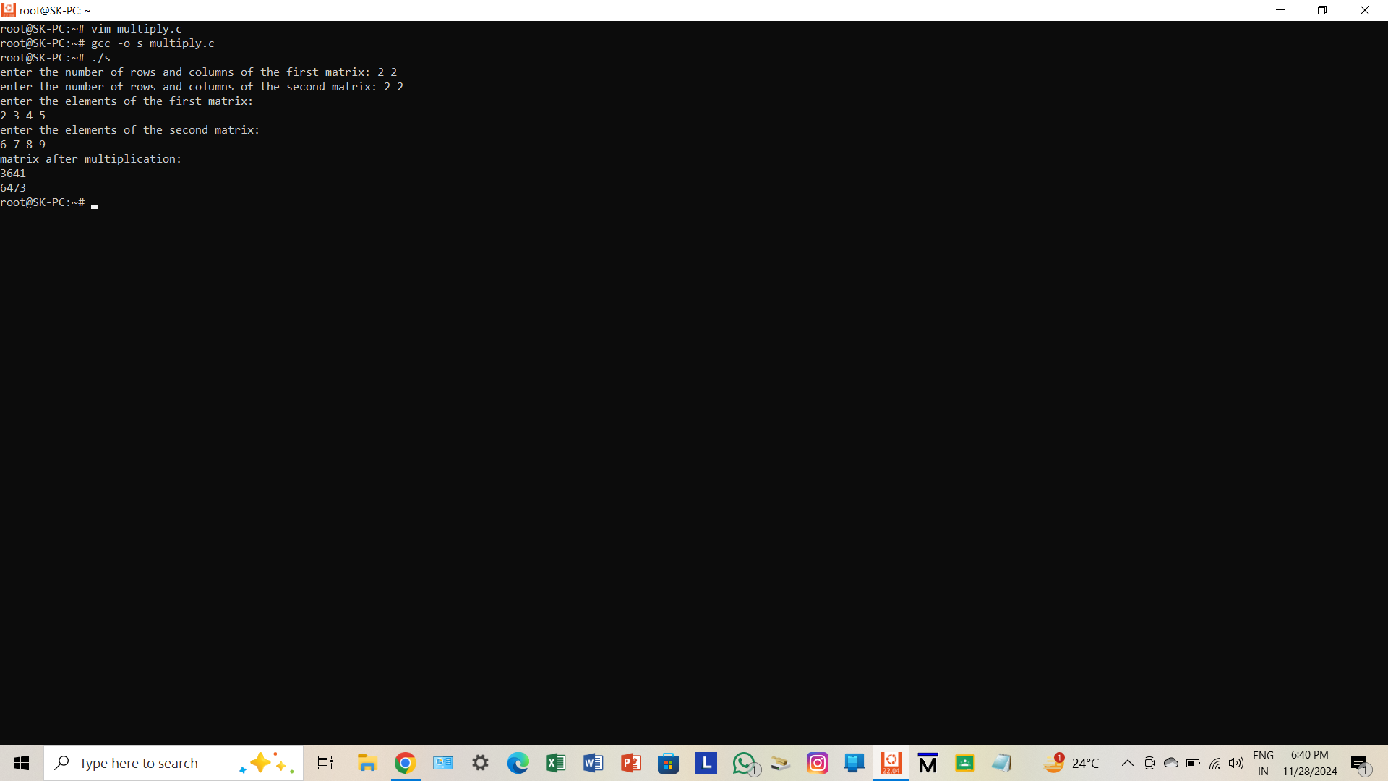

1. Write a program to check whether a matrix is an identity matrix or not.

#include <stdio.h>

int main()

{

int n,i,j,isIdentity=1;

printf("enter the size of the square matrix (n x n): ");

scanf("%d", &n);

int m[n][n];

printf("enter the elements of the matrix:\n");

for(i=0;i<n;i++)

{

for(j=0;j<n;j++)

{

scanf("%d", &m[i][j]);

}

}

for(i=0;i<n;i++)

{

for(j=0;j<n;j++)

{

if((i==j && m[i][j]!=1) || (i!=j && m[i][j]!=0))

{

isIdentity=0;

break;

}

}

}

if(isIdentity)

{

printf("The matrix is an identity matrix.\n");

}

else

{

printf("The matrix is not an identity matrix.\n");

}

return 0;

}

**OUTPUT**

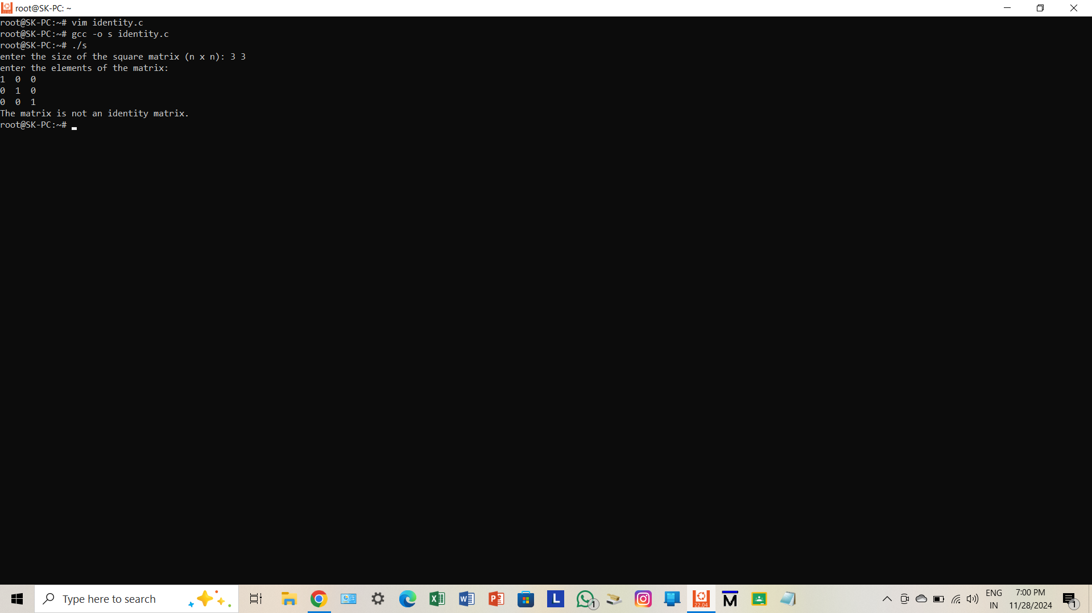

1. Write a program to check whether a matrix is a sparse matrix or not.

int main()

{

int r,c,i,j,zeroCount=0;

printf("enter the number of rows and columns:");

scanf("%d %d", &r, &c);

int arr[r][c];

printf("enter the elements:\n");

for(i=0;i<r;i++)

{

for(j=0;j<c;j++)

{

scanf("%d", &arr[i][j]);

if(arr[i][j]==0)

{

zeroCount++;

}

}

}

if(zeroCount > (r*c)/2)

{

printf("The matrix is a sparse matrix.\n");

}

else

{

printf("The matrix is not a sparse matrix.\n");

}

return 0;

}

**OUTPUT**

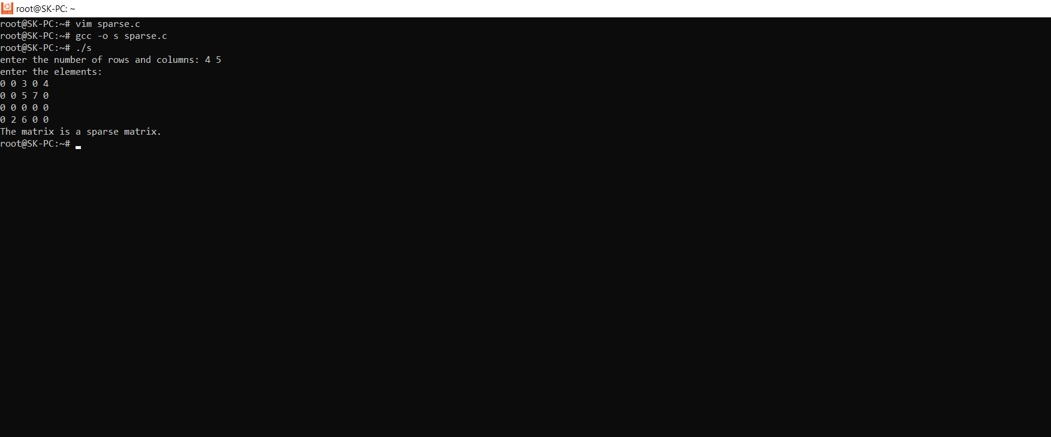

1. Write a C program to create a structure named company which has name, address, phone and no Of Employee as member variables. Read the name of the company, its address, phone and no Of Employee. Finally display these members‟ values.

#include <stdio.h>

struct company

{

char name[50];

char address[100];

char phone[15];

int employee;

};

int main()

{

struct company c;

printf("enter the company name: ");

fgets(c.name, sizeof(c.name), stdin);

printf("enter the address: ");

fgets(c.address, sizeof(c.address), stdin);

printf("enter the phone: ");

fgets(c.phone, sizeof(c.phone), stdin);

printf("enter the number of employees: ");

scanf("%d", &c.employee);

printf("\nComapny Details:\n");

printf("Name: %s", c.name);

printf("Address: %s", c.address);

printf("Phone: %s", c.phone);

printf("Number of employees: %d\n", c.employee);

return 0;

}

**OUTPUT**

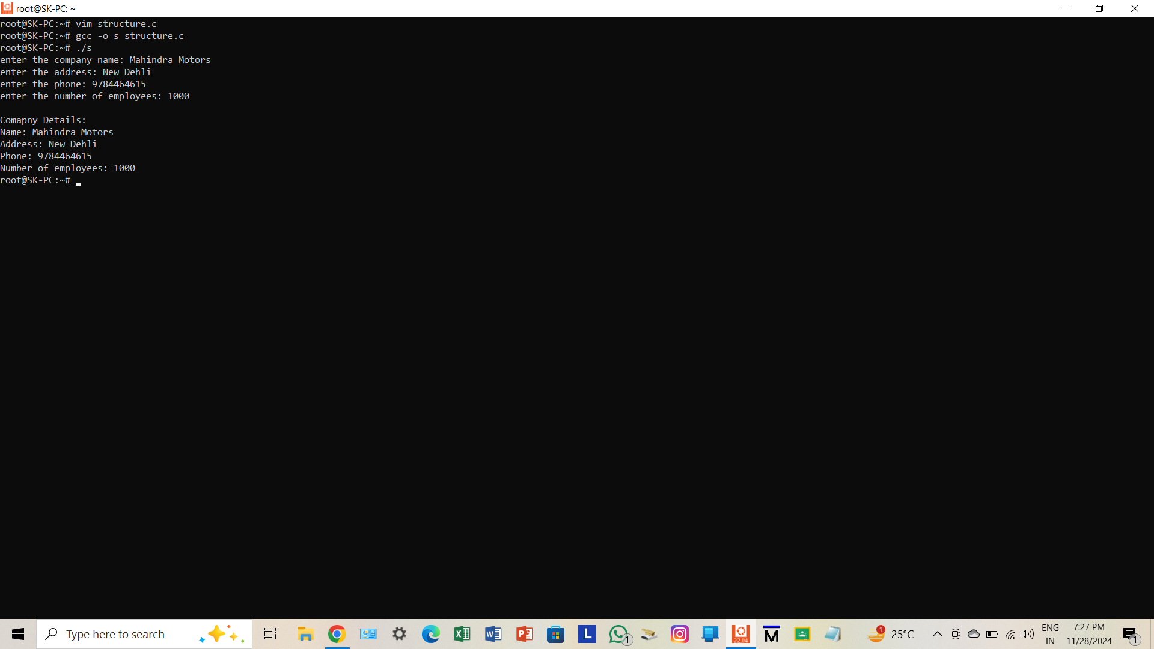

1. Define a structure “complex” (typedef) to read two complex numbers and perform addition and subtraction of these two complex numbers and display the result.

#include <stdio.h>

typedef struct complex

{

float real;

float imag;

} Complex;

Complex add(Complex c1, Complex c2)

{

Complex result;

result.real=c1.real+c2.real;

result.imag=c1.imag+c2.imag;

return result;

}

Complex sub(Complex c1, Complex c2)

{

Complex result;

result.real=c1.real-c2.real;

result.imag=c1.imag-c2.imag;

return result;

}

int main()

{

Complex c1,c2,sum,diff;

printf("enter the real and imaginary part of first complex number: ");

scanf("%f %f", &c1.real, &c1.imag);

printf("enter the real and imaginary part of second complex number: ");

scanf("%f %f", &c2.real, &c2.imag);

sum= add(c1, c2);

diff= sub(c1, c2);

printf("\nSum= %.2f + %.2fi\n", sum.real, sum.imag);

printf("\nDifference= %.2f + %.2fi\n", diff.real, diff.imag);

return 0;

}

**OUTPUT**

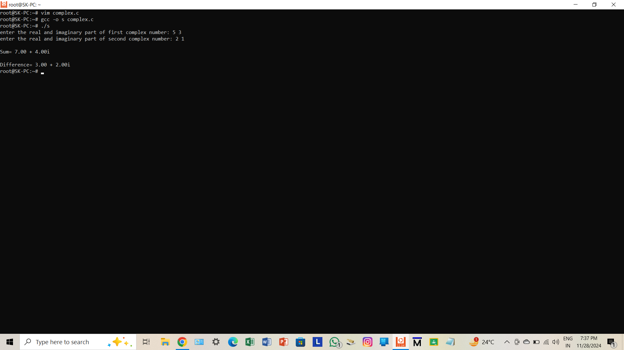

1. Write a C program to read the RollNo, Name, Address, and Age Marks of 12 students in the BCT class and display the details from the function.

#include <stdio.h>

struct student

{

int rollNo;

char name[50];

char address[100];

int age;

float marks;

};

void display(struct student students[], int n)

{

printf("\nStudent Details:\n");

for(int i=0;i<n;i++)

{

printf("Student %d:\n", i+1);

printf("Roll no: %d\n", students[i].rollNo);

printf("Name: %s", students[i].name);

printf("Address: %s", students[i].address);

printf("Age: %d\n", students[i].age);

printf("Marks: %.2f\n", students[i].marks);

}

}

int main()

{

struct student students[12];

int n=12;

for(int i=0;i<n;i++)

{

printf("enter the details of student %d:\n", i+1);

printf("Roll No: ");

scanf("%d", &students[i].rollNo);

getchar();

printf("Name: ");

fgets(students[i].name, sizeof(students[i].name), stdin);

printf("Address: ");

fgets(students[i].address, sizeof(students[i].address), stdin);

printf("Age: ");

scanf("%d", &students[i].age);

printf("Marks: ");

scanf("%f", &students[i].marks);

}

display(students, n);

return 0;

}