Program 4.2:

Code:

package com.shashwat;  
  
import java.lang.Thread;  
class myThread1 extends Thread{  
 public void run(){  
 for(int i=0; i<=10; i+=2){  
 System.*out*.println("From Even: "+i);  
 try {  
 Thread.*sleep*(10);  
 }  
  
 catch(Exception e)  
 {  
 System.*out*.println(e);  
 }  
 }  
 }  
  
}  
class myThread2 extends Thread {  
 public void run(){  
 for(int i=1; i<=10; i+=2){  
 System.*out*.println("From Odd : "+i);  
 try {  
 Thread.*sleep*(20);  
 }  
 catch(Exception e)  
 {  
 System.*out*.println(e);  
 }  
 }  
 }  
  
}  
class exp8 {  
 public static void main(String[] args) {  
 System.*out*.println("D10A_60_Shashwat Tripathi\n”);  
 myThread1 t1 = new myThread1();  
 myThread2 t2 = new myThread2();  
 t1.start();  
 t2.start();  
 }  
}

Output:

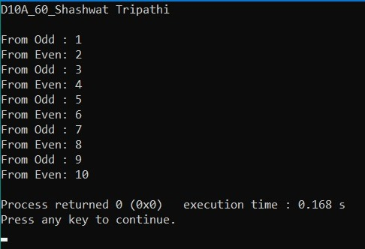

Program 4.3:

Code:

package com.shashwat;  
import java.util.*;  
  
class Bank {  
 int total = 10000;  
 void withdrawn(String name, int withdrawal)  
 {  
 if (total >= withdrawal) {  
 System.*out*.println(name + " withdrawn "  
 + withdrawal);  
 total = total - withdrawal;  
 System.*out*.println("Balance after withdrawal: "  
 + total);  
 try {  
 Thread.*sleep*(1000);  
 }  
 catch (InterruptedException e) {  
 e.printStackTrace();  
 }  
 }  
 else {  
 System.*out*.println(name  
 + " you can not withdraw "  
 + withdrawal);  
 System.*out*.println("your balance is: " + total);  
 try {  
 Thread.*sleep*(1000);  
 }  
 catch (InterruptedException e) {  
 e.printStackTrace();  
 }  
 }  
 }  
 void deposit(String name, int deposit)  
 {  
 System.*out*.println(name + " deposited " + deposit);  
 total = total + deposit;  
 System.*out*.println("Balance after deposit: "  
 + total);  
 try {  
 Thread.*sleep*(2000);  
 }  
 catch (InterruptedException e) {  
 e.printStackTrace();  
 }  
 }  
}  
class bankInfo {  
 public static void main(String[] args)  
 {  
 System.*out*.println("D10A_60_Shashwat Tripathi\n");  
 Bank obj = new Bank();  
 obj.withdrawn("John", 200);  
 obj.withdrawn("Joe", 360);  
 }  
}

Output:

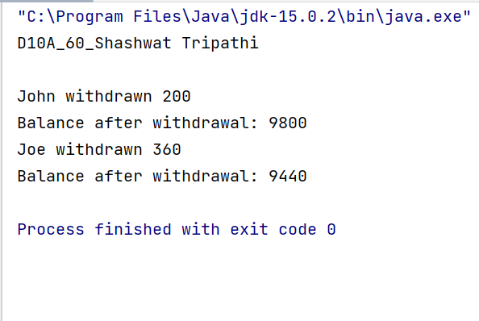

Program 5.1:

Code:

package com.shashwat;  
  
import javax.swing.*;  
import java.awt.*;  
import java.awt.event.*;  
public class calculator implements ActionListener  
{  
 int c,n;  
 String s1,s2,s3,s4,s5;  
 Frame f;  
 Button b1,b2,b3,b4,b5,b6,b7,b8,b9,b10,b11,b12,b13,b14,b15,b16,b17;  
 Panel p;  
 TextField tf;  
 GridLayout g;  
 calculator()  
 {  
 f = new Frame("My calculator");  
 f.setLayout(new FlowLayout());  
 p = new Panel();  
  
 *//Assigning buttons* b1 = new Button("0");  
 b1.addActionListener(this);  
 b2 = new Button("1");  
 b2.addActionListener(this);  
 b3 = new Button("2");  
 b3.addActionListener(this);  
 b4 = new Button("3");  
 b4.addActionListener(this);  
 b5 = new Button("4");  
 b5.addActionListener(this);  
 b6 = new Button("5");  
 b6.addActionListener(this);  
 b7 = new Button("6");  
 b7.addActionListener(this);  
 b8 = new Button("7");  
 b8.addActionListener(this);  
 b9 = new Button("8");  
 b9.addActionListener(this);  
 b10 = new Button("9");  
 b10.addActionListener(this);  
 b11 = new Button("+");  
 b11.addActionListener(this);  
 b12 = new Button("-");  
 b12.addActionListener(this);  
 b13 = new Button("*");  
 b13.addActionListener(this);  
 b14 = new Button("/");  
 b14.addActionListener(this);  
 b15 = new Button("=");  
 b15.addActionListener(this);  
 b16 = new Button("C");  
 b16.addActionListener(this);  
 *//Text field to display* tf = new TextField(20);  
 f.add(tf);  
 *//Setting the layout* g = new GridLayout(4,4,10,20);  
 p.setLayout(g);  
 *//Adding buttons to it* p.add(b1);p.add(b2);p.add(b3);p.add(b4);p.add(b5);p.add(b6);p.add(b7);p.add(b8);p.add(b9);  
 p.add(b10);p.add(b11);p.add(b12);p.add(b13);p.add(b14);p.add(b15);p.add(b16);  
 f.add(p); f.setSize(300,300); f.setVisible(true);  
 }  
 public void actionPerformed(ActionEvent e)  
 {  
 *//Performing calculations* if(e.getSource()==b1)  
 {  
 s3 = tf.getText();  
 s4 = "0";  
 s5 = s3+s4;  
 tf.setText(s5);  
 }  
 if(e.getSource()==b2)  
 {  
 s3 = tf.getText();  
 s4 = "1";  
 s5 = s3+s4;  
 tf.setText(s5);  
 }  
 if(e.getSource()==b3)  
 {  
 s3 = tf.getText();  
 s4 = "2";  
 s5 = s3+s4;  
 tf.setText(s5);  
 }  
 if(e.getSource()==b4)  
 {  
 s3 = tf.getText();  
 s4 = "3";  
 s5 = s3+s4;  
 tf.setText(s5);  
 }  
 if(e.getSource()==b5)  
 {  
 s3 = tf.getText();  
 s4 = "4";  
 s5 = s3+s4;  
 tf.setText(s5);  
 }  
 if(e.getSource()==b6)  
 {  
 s3 = tf.getText();  
 s4 = "5";  
 s5 = s3+s4;  
 tf.setText(s5);  
 }  
 if(e.getSource()==b7)  
 {  
 s3 = tf.getText();  
 s4 = "6";  
 s5 = s3+s4;  
 tf.setText(s5);  
 }  
 if(e.getSource()==b8)  
 {  
 s3 = tf.getText();  
 s4 = "7";  
 s5 = s3+s4;  
 tf.setText(s5);  
 }  
 if(e.getSource()==b9)  
 {  
 s3 = tf.getText();  
 s4 = "8";  
 s5 = s3+s4;  
 tf.setText(s5);  
 }  
 if(e.getSource()==b10)  
 {  
 s3 = tf.getText();  
 s4 = "9";  
 s5 = s3+s4;  
 tf.setText(s5);  
 }  
 if(e.getSource()==b11)  
 {  
 s1 = tf.getText();  
 tf.setText("");  
 c=1;  
 }  
 if(e.getSource()==b12)  
 {  
 s1 = tf.getText();  
 tf.setText("");  
 c=2;  
 }  
 if(e.getSource()==b13)  
 {  
 s1 = tf.getText();  
 tf.setText("");  
 c=3;  
 }  
 if(e.getSource()==b14)  
 {  
 s1 = tf.getText();  
 tf.setText("");  
 c=4;  
 }  
 if(e.getSource()==b15)  
 {  
 s2 = tf.getText();  
 if(c==1)  
 {  
 n = Integer.*parseInt*(s1)+Integer.*parseInt*(s2);  
 tf.setText(String.*valueOf*(n));  
 }  
 else  
 if(c==2)  
 {  
 n = Integer.*parseInt*(s1)-Integer.*parseInt*(s2);  
 tf.setText(String.*valueOf*(n));  
 }  
 else  
 if(c==3)  
 {  
 n = Integer.*parseInt*(s1)*Integer.*parseInt*(s2);  
 tf.setText(String.*valueOf*(n));  
 }  
 if(c==4)  
 {  
 try  
 {  
 int p=Integer.*parseInt*(s2);  
 if(p!=0)  
 {  
 n = Integer.*parseInt*(s1)/Integer.*parseInt*(s2);  
 tf.setText(String.*valueOf*(n));  
 }  
 else  
 tf.setText("infinite");  
 }  
 catch(Exception i){}  
 }  
 if(c==5)  
 {  
 n = Integer.*parseInt*(s1)%Integer.*parseInt*(s2);  
 tf.setText(String.*valueOf*(n));  
 }  
 }  
 if(e.getSource()==b16)  
 {  
 tf.setText("");  
 }  
 }  
 public static void main(String[] abc)  
 {  
 calculator v = new calculator();  
 }  
}

Output:

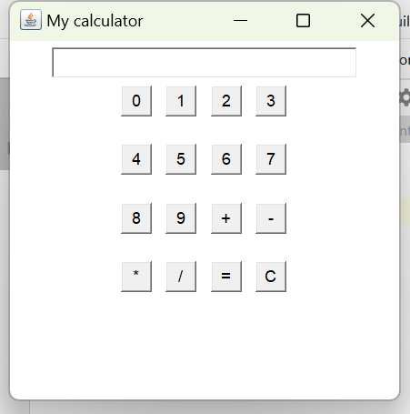 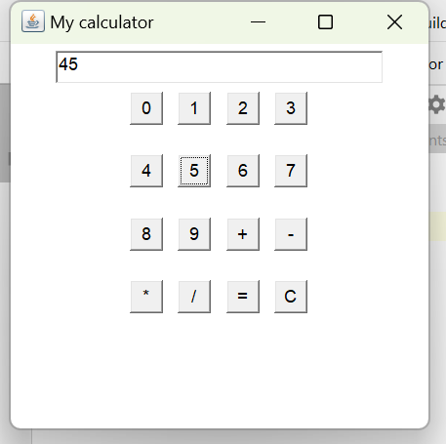

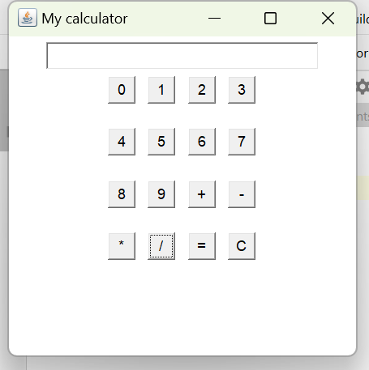 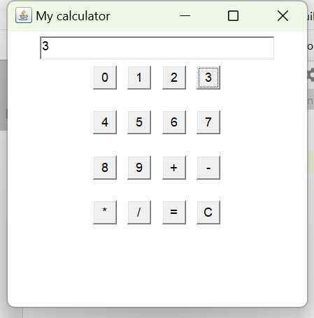

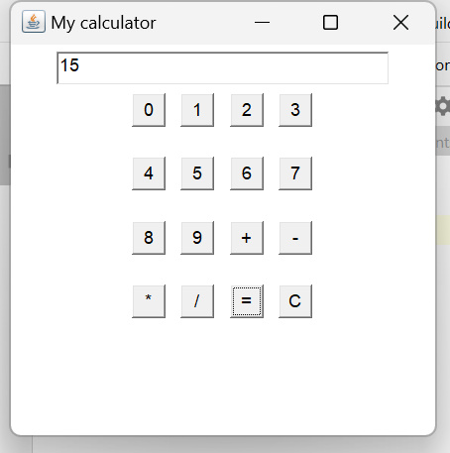 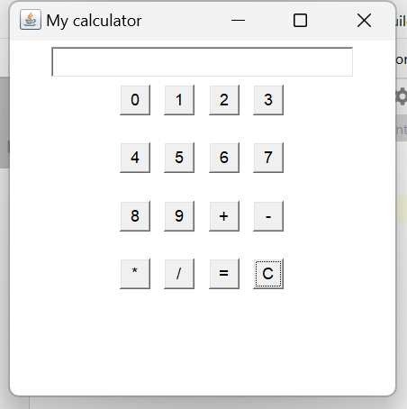

Program 5.2:

Code:

package com.shashwat;  
import javax.swing.*;  
import java.awt.event.*;  
import java.io.*;  
  
public class student {  
  
 public static void StudentInfo()  
 {  
 JFrame f  
 = new JFrame(  
 "Student Details Form");  
  
 JLabel l1, l2, l3, l4, l5;  
 JTextField t1, t2, t3;  
  
 JComboBox j1, j2;  
 JButton b1, b2;  
  
 l1 = new JLabel("Student Name:");  
 l1.setBounds(50, 50, 100, 30);  
 l2 = new JLabel("College Email ID:");  
 l2.setBounds(50, 120, 120, 30);  
 l3 = new JLabel("Branch:");  
 l3.setBounds(50, 190, 50, 30);  
 l4 = new JLabel("Section:");  
 l4.setBounds(420, 50, 70, 30);  
 l5 = new JLabel("Mobile No:");  
 l5.setBounds(420, 120, 70, 30);  
  
 t1 = new JTextField();  
 t1.setBounds(150, 50, 130, 30);  
 t2 = new JTextField();  
 t2.setBounds(160, 120, 130, 30);  
 t3 = new JTextField();  
 t3.setBounds(490, 120, 130, 30);  
  
 String s1[]  
 = { " ", "CMPN", "INFT", "EXTC",  
 "ETRX", "INST", "Others" };  
 String s2[]  
 = { " ", "D10A", "D10B",  
 "D7A", "D7C",  
 "D11" };  
  
 j1 = new JComboBox(s1);  
 j1.setBounds(120, 190, 100, 30);  
 j2 = new JComboBox(s2);  
 j2.setBounds(470, 50, 140, 30);  
  
 b1 = new JButton("Save");  
 b1.setBounds(150, 300, 70, 30);  
 b2 = new JButton("close");  
 b2.setBounds(420, 300, 70, 30);  
  
 b1.addActionListener(new ActionListener() {  
 public void actionPerformed(ActionEvent e)  
 {  
 String s1 = t1.getText();  
 String s2 = t2.getText();  
 String s3 = j1.getSelectedItem() + "";  
 String s4 = j2.getSelectedItem() + "";  
 String s5 = t3.getText();  
 if (e.getSource() == b1) {  
 try {  
 FileWriter w  
 = new FileWriter(  
 "GFG.txt", true);  
  
 w.write(s1 + "\n");  
 w.write(s2 + "\n");  
 w.write(s3 + "\n");  
 w.write(s4 + "\n");  
 w.write(s5 + "\n");  
 w.close();  
 }  
 catch (Exception ae) {  
 System.*out*.println(ae);  
 }  
 }  
  
 JOptionPane  
 .*showMessageDialog*(  
 f,  
 "Successfully Saved"  
 + " The Details");  
 }  
 });  
  
 b2.addActionListener(new ActionListener() {  
 public void actionPerformed(ActionEvent e)  
 {  
 f.dispose();  
 }  
 });  
  
 f.addWindowListener(new WindowAdapter() {  
 public void windowClosing(WindowEvent e)  
 {  
 System.*exit*(0);  
 }  
 });  
  
 f.add(l1);  
 f.add(t1);  
 f.add(l2);  
 f.add(t2);  
 f.add(l3);  
 f.add(j1);  
 f.add(l4);  
 f.add(j2);  
 f.add(l5);  
 f.add(t3);  
 f.add(b1);  
 f.add(b2);  
 f.setLayout(null);  
 f.setSize(700, 600);  
 f.setVisible(true);  
 }  
  
 public static void main(String args[])  
 {  
 *StudentInfo*();  
 }  
}

Output:

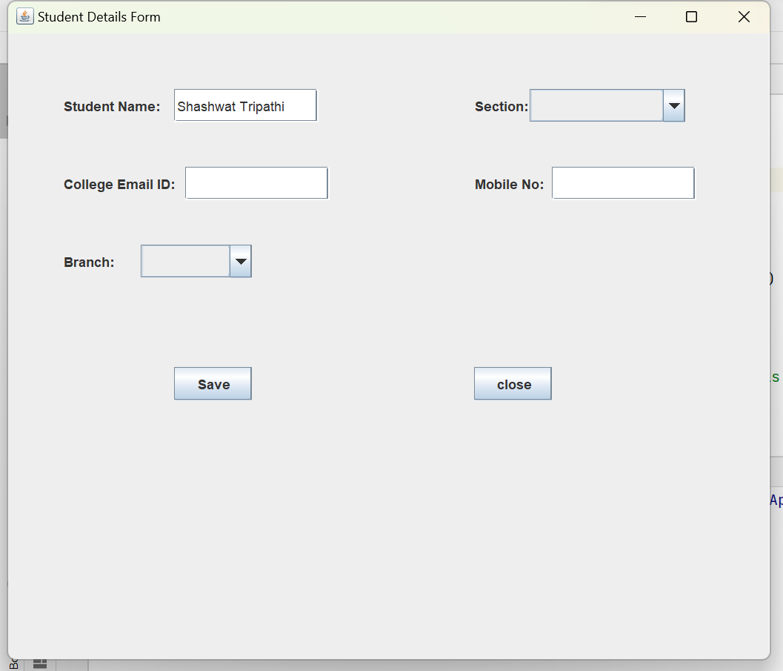

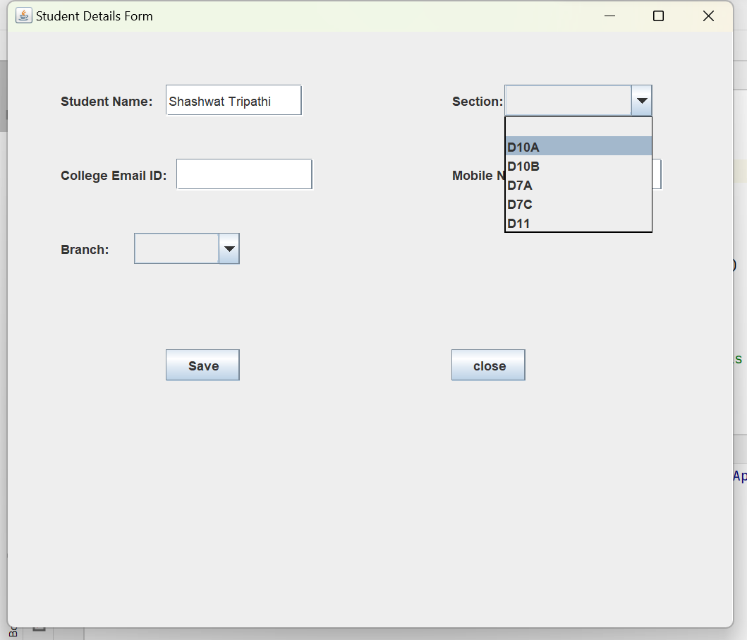

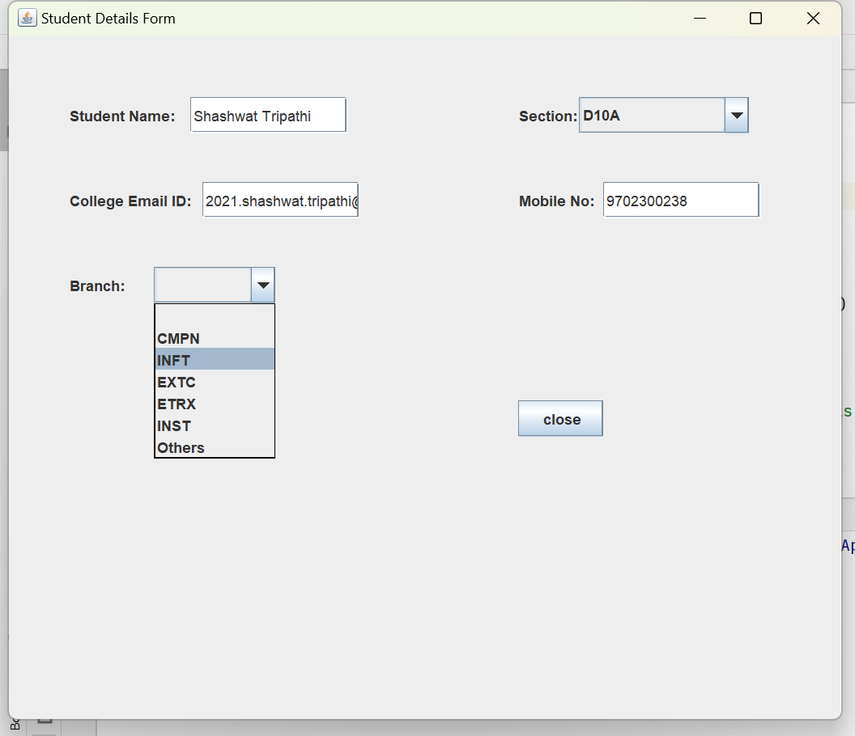

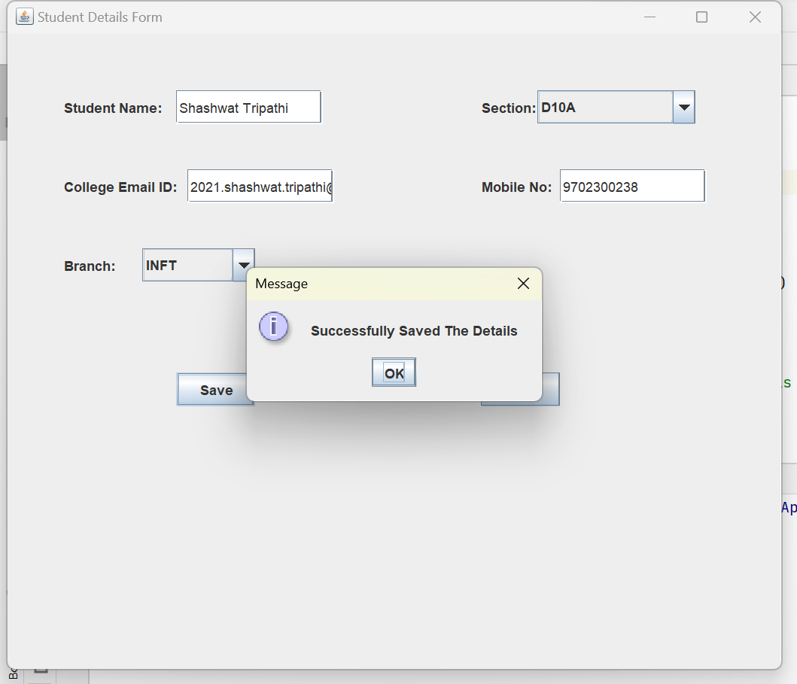

Program 5.3:

Code:

package com.shashwat;  
  
import javax.swing.*;  
import java.awt.*;  
import java.awt.event.*;  
class Frame_Color implements ActionListener  
{  
 static JFrame *frame*;  
 public static void main(String args[])  
 {  
 *frame* = new JFrame("Change Frame Background");  
 *frame*.setSize(400,400);  
 *frame*.setDefaultCloseOperation(JFrame.*EXIT_ON_CLOSE*);  
 *frame*.getContentPane().setBackground(Color.*white*);  
 *frame*.setLayout(new FlowLayout());  
 Frame_Color obj = new Frame_Color();  
 JButton button = new JButton("Change Color");  
 button.addActionListener(obj);  
 *frame*.add(button);  
 *frame*.setVisible(true);  
 }  
  
 public void actionPerformed(ActionEvent e)  
 {  
 JColorChooser color_box= new JColorChooser();  
 Color color=color_box.*showDialog*(*frame*,"Select a Color",Color.*white*);  
 *frame*.getContentPane().setBackground(color);  
 }  
}

Output:

