**DevOps Lab Experiment 12**

**Shashwat Tripathi  
D15A 64  
Batch C**

**Aim:** To learn Software Configuration Management and provisioning using Puppet

Blocks(Manifest, Modules, Classes, Function).

**Implementation:**

1. To test your cluster setup, run this command -

sudo /opt/puppetlabs/bin/puppet agent --test  
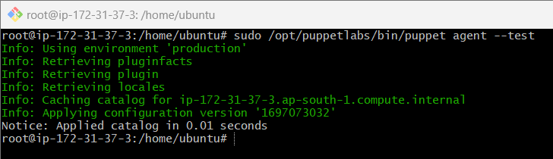

2. Create new directories

mkdir puppet_code

mkdir puppet_code/manifests

3. Create a new puppet manifest file and open it using nano.

nano /puppet_code/manifests/helloworld.pp

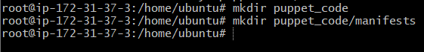

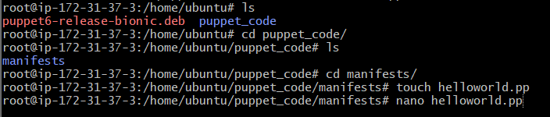

4. Enter the following contents inside the file.

notify { ‘greeting’:

message => & ’Hello! This is Shashwat’

}

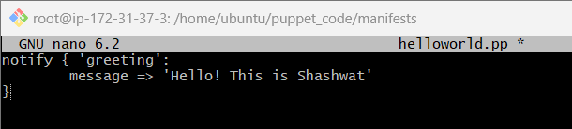

Change directory to /opt/puppetlabs/puppet/bin

cd /opt/puppetlabs/puppet/bin

6. Now, apply the file.

./puppet apply /home/ubuntu/puppet_code/manifests/helloworld.pp

**Final Output:**

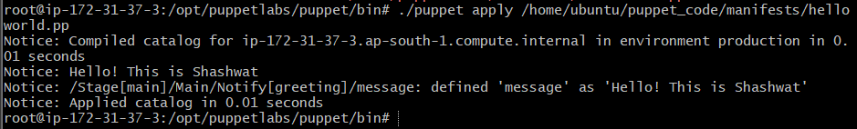

**CONCLUSION:**

Thus, we successfully learned about the syntax of manifest files and created our first puppet script to print a ‘Hello! This is Shashwat’ message.