**DevOps Lab Experiment 2**

Shashwat Tripathi  
D15A 64  
Batch C

**Aim:** To understand Version Control System / Source Code Management, install git and create a GitHub account.

**Implementation:**

Git Installations:

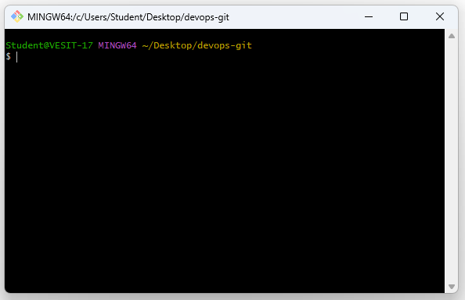

Github Account:

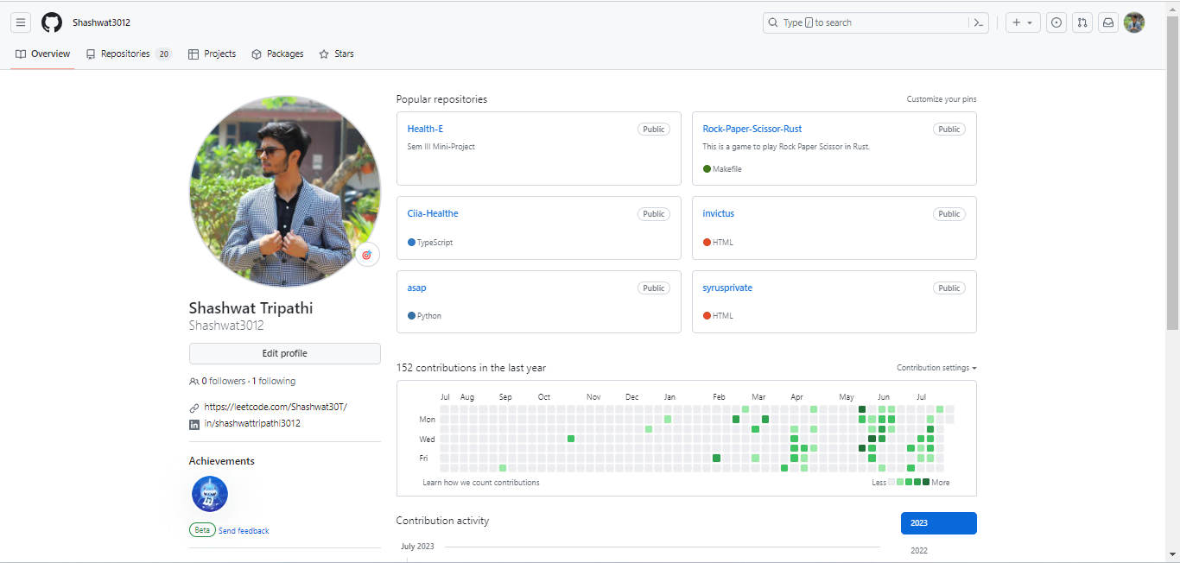

**Conclusion:**

I have previous experience of working with git and github version control systems.

Successfully installed git in Lab computer and had a github account already.

**Errors faced:**

Lab computers were blocking some features while installation(due to firewall).