**DevOps Lab Experiment 6**

Shashwat Tripathi  
D15A 64  
Batch C

**Aim-** To understand Jenkins Master-Slave Architecture and scale your Jenkins standalone implementation by implementing slave nodes.

Creating nodes:

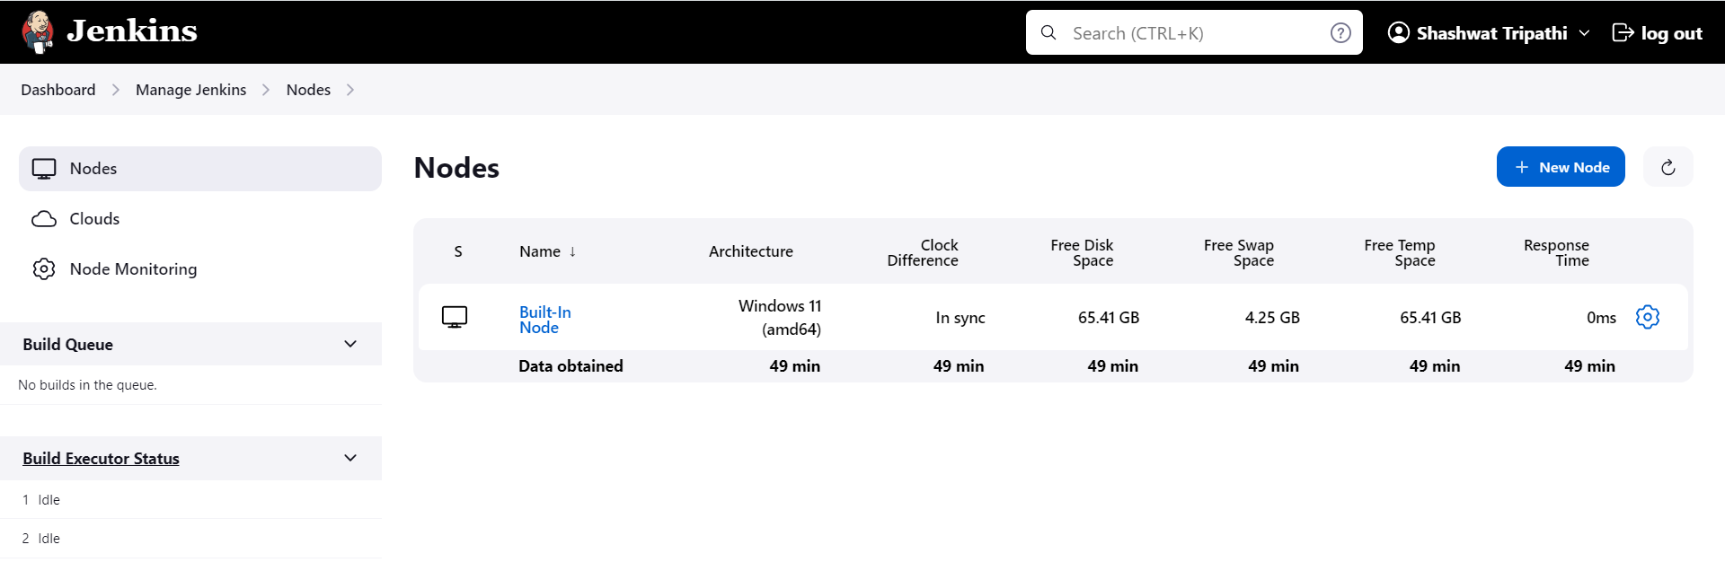

Creating Slave node:

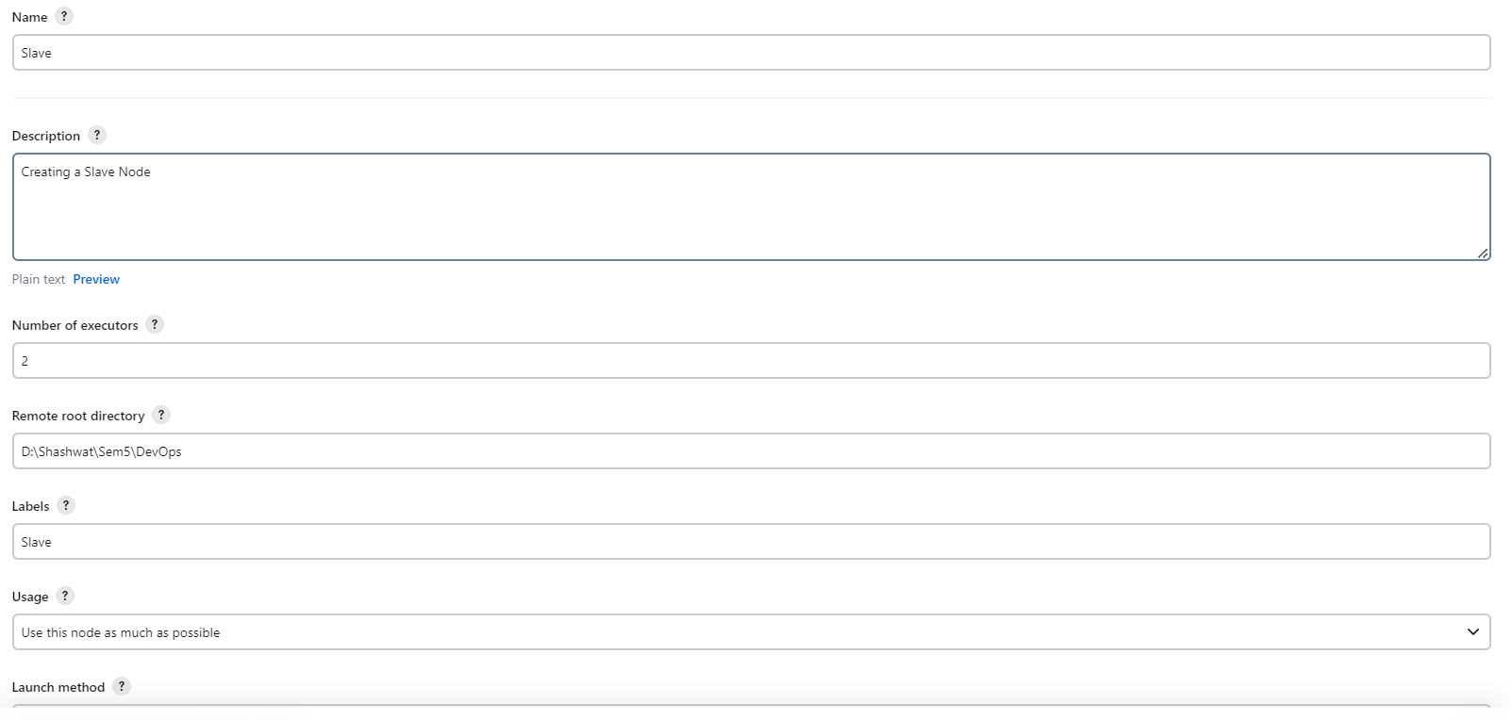

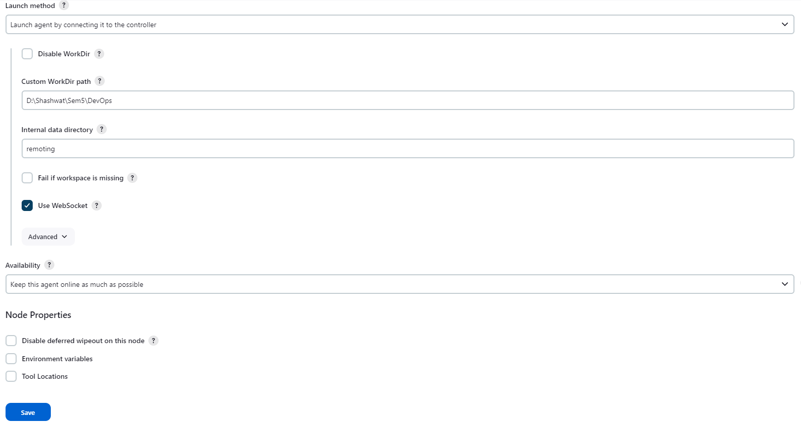

Node created but not connected to Master

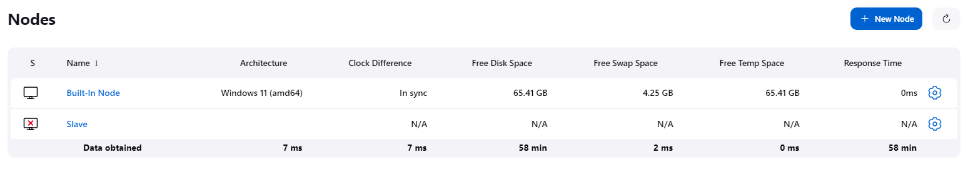

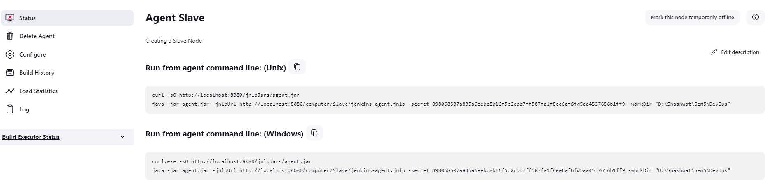

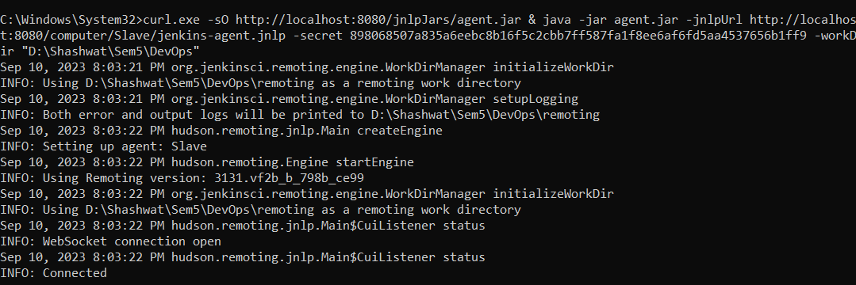

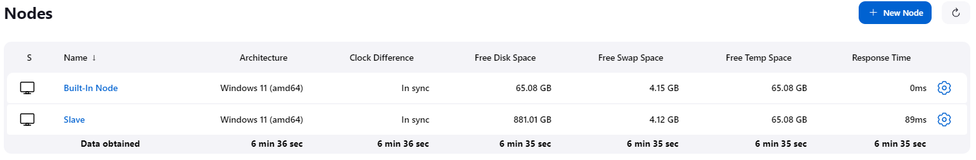

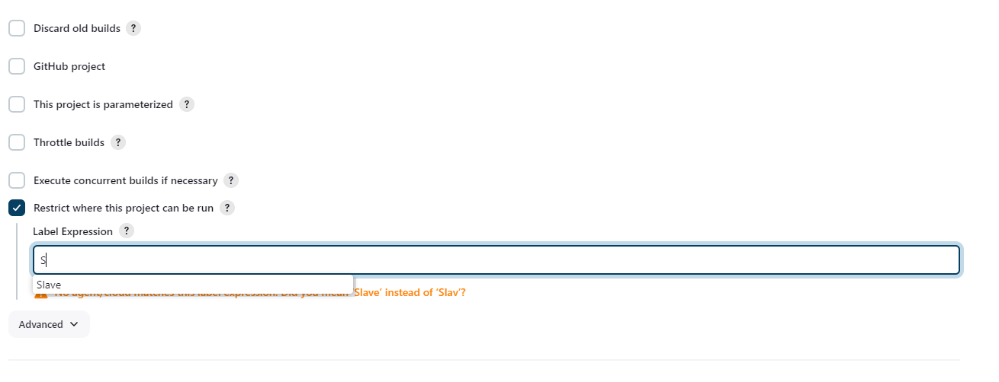

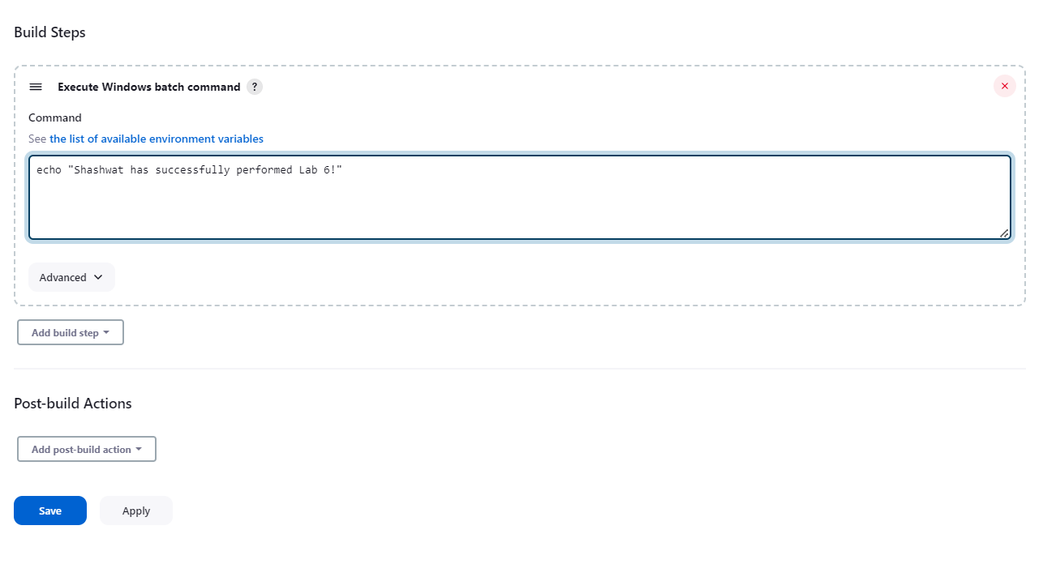

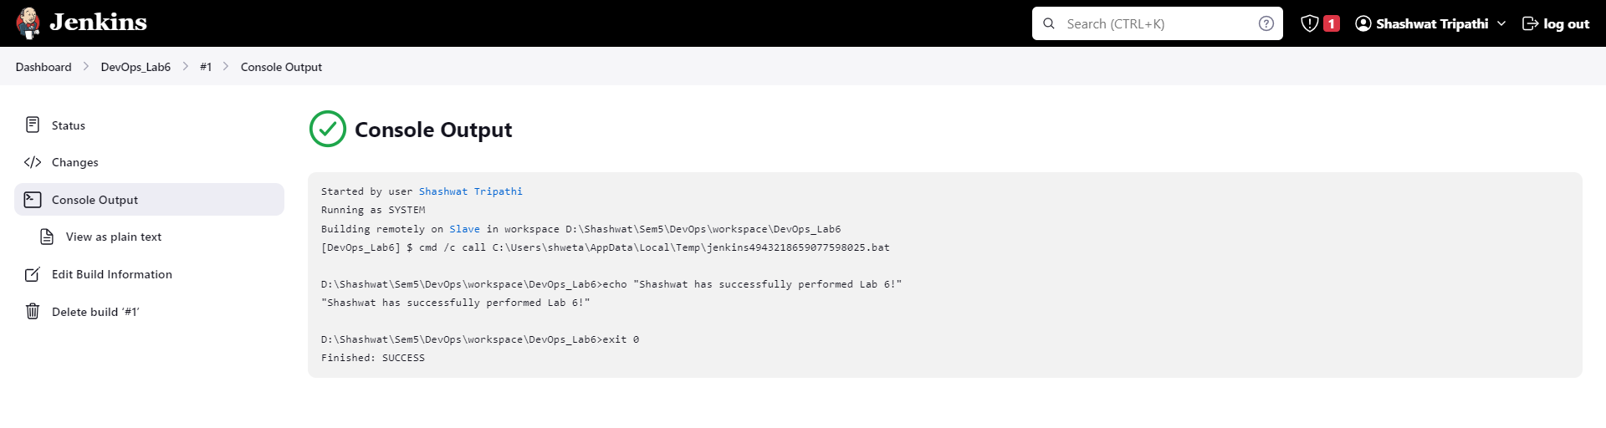

**Errors faced:** I faced some issues in implementing windows shell commands. It gave a build failure error.

**Conclusion:**  Thus we learnt about Jenkins Master-Slave Architecture and Jenkins standalone implementation by implementing slave nodes.