**DevOps Lab Experiment 8**

Shashwat Tripathi  
D15A 64  
Batch C

**Aim:** To Setup and Run Selenium Tests in Jenkins Using Maven.

**Steps:**

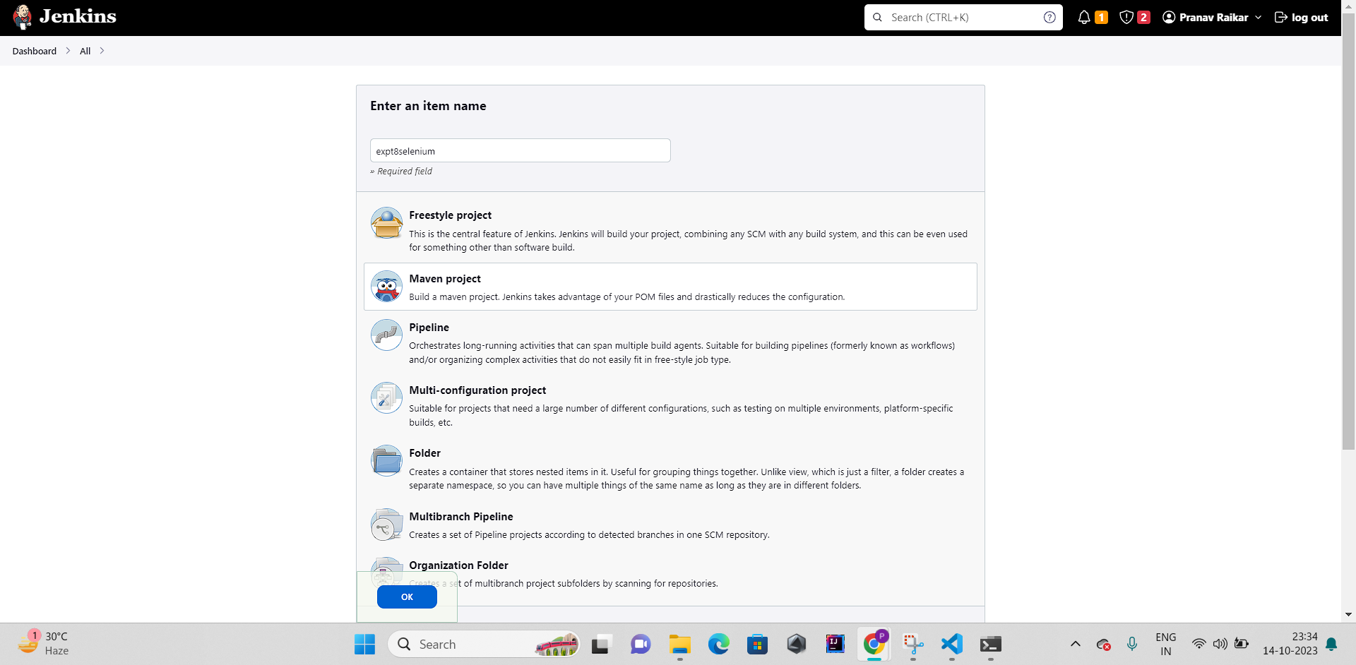

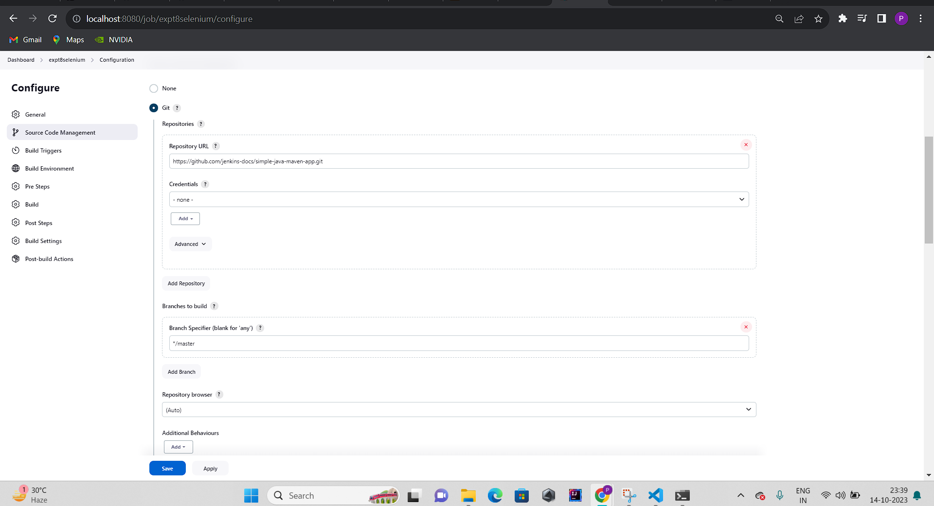

Add Pre-build-steps then click on **Invoke top-level Maven targets**

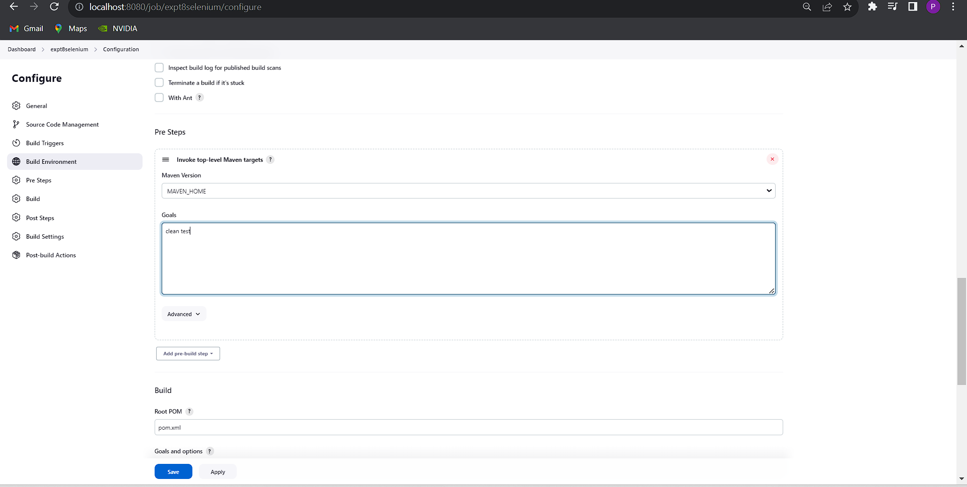

**Click on build now**

**Then** 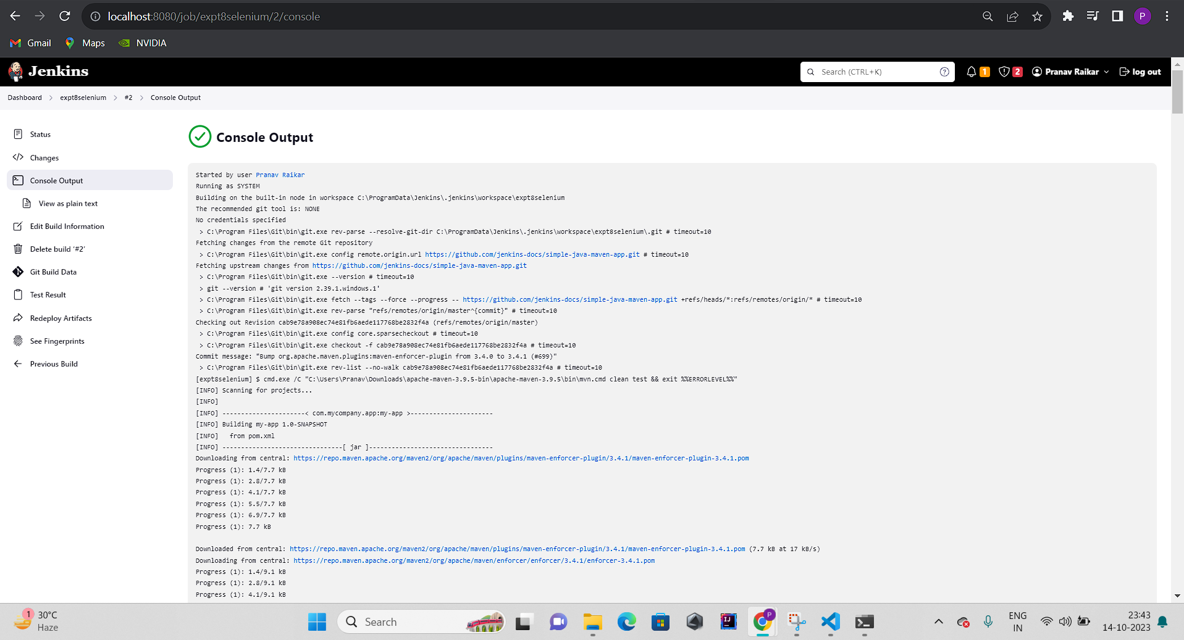

**This is the output i.e** 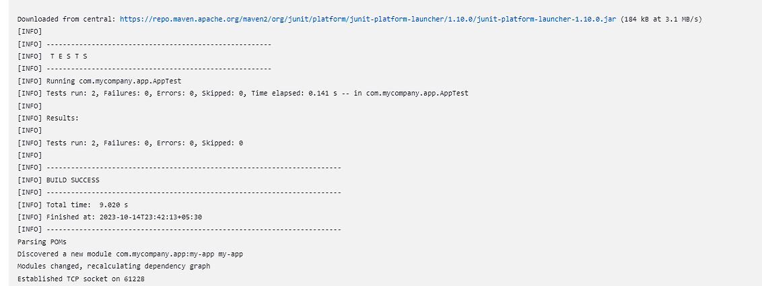

**Full page output:**

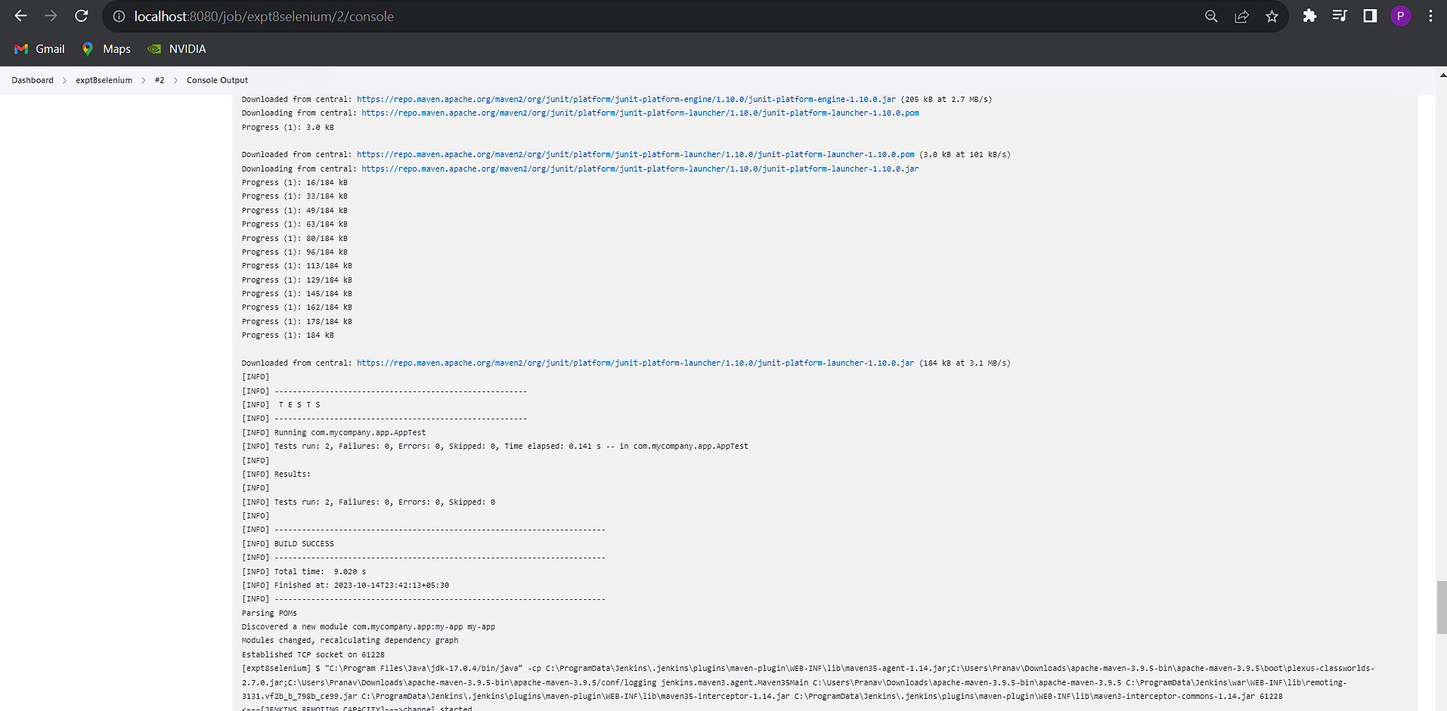

**Conclusion:** Thus we have set up and run Selenium Tests in Jenkins Using Maven.