**IP Exp 2**

**Shashwat Tripathi  
D15A 64**

**Batch C**

**Aim:** Experiment to study Advanced tags of HTML5 .

**Theory:**

HTML5 introduced a range of new tags that contribute to enhanced semantics and richer multimedia experiences. These include semantic tags, multimedia tags, and form elements and attributes.

* Semantic Tags: HTML5 introduced several semantic tags that provide meaningful structure to web content. Examples include <header>, <nav>, <article>, <section>, and <footer>. These tags facilitate better organization, navigation, and accessibility of web pages by conveying the purpose and relationships of different content sections.
* Multimedia Tags: HTML5 introduced multimedia tags that simplify the integration of multimedia content. <audio>, <video>, <embed>, and <svg> tags allow for seamless embedding of audio, video, and scalable vector graphics directly into web pages, enabling a more engaging and interactive user experience.
* Form Elements and Attributes: HTML5 extended the capabilities of form elements and introduced new attributes to enhance user interaction and data collection. The new input types, such as <email>, <tel>, and <date>, provide improved validation and user experience. Additionally, attributes like placeholder, required, and autocomplete enable developers to create more user-friendly and accessible forms.
* <frame>: The <frame> tag, while part of the HTML5 specification, is considered obsolete and not recommended for modern web development. It was historically used to create framesets for dividing a webpage into separate sections with individual content, but its usage has been largely replaced by CSS layouts and more advanced approaches.
* <form>: The <form> tag is crucial for creating interactive input forms on web pages. It allows users to input data that can be submitted to a server for processing. The <form> element contains various form elements such as text fields, checkboxes, radio buttons, and submit buttons, enabling the creation of user-friendly input interfaces.

(a) Design VESIT web site home page using advanced tags of HTML5 (frame,div,semantic tags,multimedia tags etc.)

**Code:**

<!DOCTYPE html>

<html lang="en">

<head>

<meta charset="UTF-8" />

<meta name="viewport" content="width=device-width, initial-scale=1.0" />

<title>VESIT Website</title>

<style>

body {

font-family: Arial, sans-serif;

margin: 0;

padding: 0;

}

header,

nav,

footer {

background-color: #3b8df3;

color: #fff;

padding: 10px 0;

text-align: center;

}

nav a {

color: #fff;

text-decoration: none;

margin: 0 20px;

}

.container {

margin: 20px auto;

padding: 20px;

border-radius: 10px;

box-shadow: 0 0 10px rgba(0, 0, 0, 0.2);

}

.courses {

display: grid;

grid-template-columns: repeat(3, 1fr);

gap: 20px;

margin-top: 20px;

}

.course {

padding: 10px;

background-color: #f9f9f9;

text-align: center;

border-radius: 5px;

}

</style>

</head>

<body>

<header style="background-color: beige; color: #000">

<img src="vesit.png" alt="vesit" width="100" height="100" />

<h1>V.E.S. Institute of Technology</h1>

<p>Your Path to Innovation</p>

</header>

<nav>

<a href="#admission">Admission</a>

<a href="#autonomy">Autonomy</a>

<a href="#knowyourcollege">Know Your College</a>

<a href="#naac">NAAC</a>

<a href="#nirf">NIRF</a>

<a href="#contact">Contact Us</a>

</nav>

<nav style="background-color: #05076c; color: #000">

<a href="#about">About</a>

<a href="#academics">Academics</a>

<a href="#studentcorner">Student's Corner</a>

<a href="#infrastructure">Infrastructure</a>

<a href="#examination">Examination</a>

<a href="#placement">Placement</a>

</nav>

<div class="container">

<h2>Welcome to VESIT</h2>

<p>

At VESIT, we provide top-notch education and opportunities for students

to excel in the field of technology.

</p>

<div class="courses">

<div class="course">

<h3>Computer Science</h3>

<p>

To create center of excellence in computing by imparting quality

education for developing competent professionals.

</p>

</div>

<div class="course">

<h3>Information Technology</h3>

<p>

To offer state-of-art information technology education, imparting

skills for building cutting-edge and innovative IT applications.

</p>

</div>

<div class="course">

<h3>AI & DS</h3>

<p>

To produce and nurture creative and technically strong engineers in

the field of Artificial Intelligence and Data Science.

</p>

</div>

</div>

</div>

<footer>

<p>&copy; 2023 VESIT. All rights reserved.</p>

</footer>

</body>

</html>

**Output:**

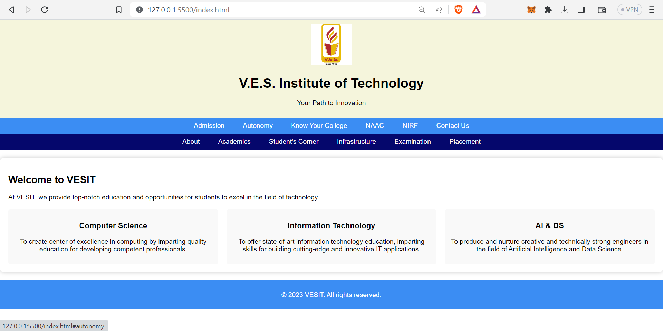

(b) Design FE admission form using HTML5 form tags.

**Code:**

<!DOCTYPE html>

<html lang="en">

<head>

<meta charset="UTF-8" />

<meta name="viewport" content="width=device-width, initial-scale=1.0" />

<title>FE Admission Form</title>

<style>

body {

font-family: Arial, sans-serif;

margin: 0;

padding: 0;

}

form {

max-width: 600px;

margin: 20px auto;

padding: 20px;

background-color: #f9f9f9;

border-radius: 10px;

box-shadow: 0 0 10px rgba(0, 0, 0, 0.2);

}

label {

display: block;

font-weight: bold;

margin-top: 10px;

}

input,

select,

textarea {

width: 100%;

padding: 8px;

margin-top: 4px;

margin-bottom: 10px;

border: 1px solid #ccc;

border-radius: 4px;

}

input[type="submit"] {

background-color: #333;

color: #fff;

border: none;

cursor: pointer;

}

</style>

</head>

<body>

<form action="#" method="post">

<h2>FE Admission Form</h2>

<label for="fullname">Full Name:</label>

<input type="text" id="fullname" name="fullname" required />

<label for="percentile">CET Percentile:</label>

<input type="tel" id="percentile" name="percentile" required />

<label for="email">Email:</label>

<input type="email" id="email" name="email" required />

<label for="phone">Phone:</label>

<input type="tel" id="phone" name="phone" required />

<label for="dob">Date of Birth:</label>

<input type="date" id="dob" name="dob" required />

<label for="gender">Gender:</label>

<select id="gender" name="gender" required>

<option value="male">Male</option>

<option value="female">Female</option>

<option value="other">Other</option>

</select>

<label for="address">Address:</label>

<textarea id="address" name="address" rows="4" required></textarea>

<label for="course">Select Course:</label>

<select id="course" name="course" required>

<option value="cmpn">Computer Science</option>

<option value="inft">Information Technology</option>

<option value="aids">AI & DS</option>

<option value="extc">Electronics & Telecomm</option>

<option value="ece">Electronics & Computers</option>

<option value="auro">Automation & Robotics</option>

</select>

<label for="terms">

<input type="checkbox" id="terms" name="terms" required />

I assure that the above information is true to the best of my knowledge.

</label>

<input type="submit" value="Submit" />

</form>

</body>

</html>

**Output:**

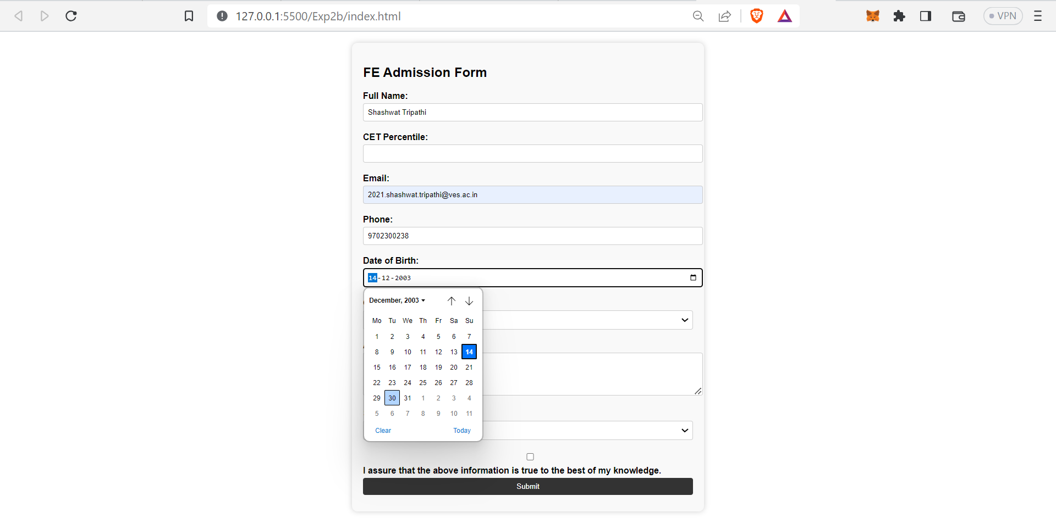

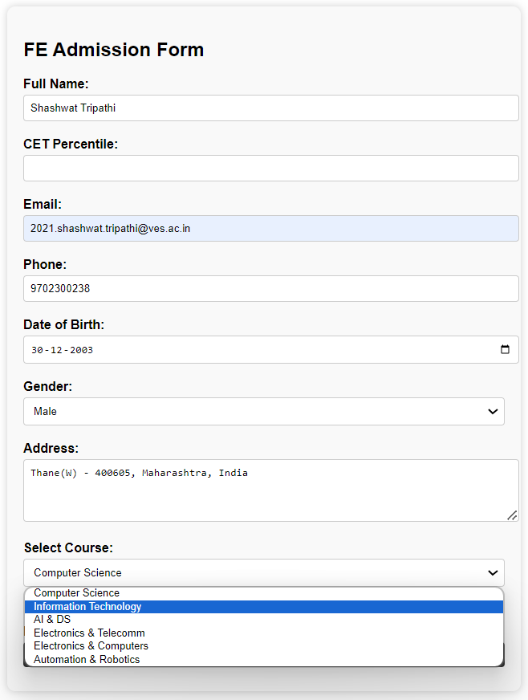

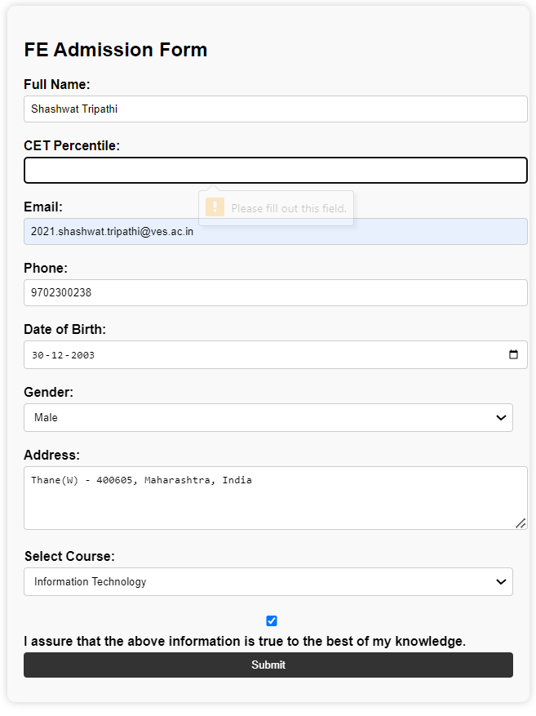

**Conclusion:**

In summary, the advanced HTML5 tags such as <div>, <span>, <frame>, and <form> play essential roles in web development, while the new tags introduced in HTML5, including semantic tags, multimedia tags, and enhanced form elements and attributes, contribute to improved structure, accessibility, and user experience on modern websites.