**IP Exp 3**

**Shashwat Tripathi  
D15A 64**

**Batch C**

**Aim: Experiment to study basics of CSS.**

**Theory:**

**Element Selector:**

The body element is selected, and CSS properties are applied, setting the font, background color, margin, and padding.

**Class Selector:**

The .header class is selected and styled to have a specific background color, text color, text alignment, and padding.

**Pseudo-class Selector:**

The .product-container class uses flex for a horizontal layout, justify-content for spacing between products, and flex-wrap to allow products to wrap to the next line.

**ID Selector:**

The #featured ID selector is used to style a specific element, setting background color, text alignment, padding, and margin.

**Inline Styles:**

Inline styles are directly applied to the header element, setting the font size.

**External Stylesheet:**

An external stylesheet is linked using the <link> element. In this case, the styles.css file is imported, which may contain additional CSS rules.

**Box Model:**

The code demonstrates the box model with properties like margin, padding, and border applied to elements. For example, the .product-card class sets the width, background color, margin, border, and box shadow.

**Transitions and Hover Effects:**

A transition is applied to the .product-card class to create a smooth hover effect. When hovered over, the card moves up slightly (transform: translateY(-5px);).

**Font and Text Styles:**

Various font and text styles are used. For example, the font-size, font-weight, and color properties are applied to style text content.

**Responsive Design:**

The viewport meta tag (<meta name="viewport") is used to ensure proper rendering on various screen sizes.

**Images and Media:**

Images are included with the <img> element, and attributes like alt, width, and height are used for proper image display.

**Layout and Flexbox:**

Flexbox properties (display: flex, justify-content, flex-wrap) are used for creating a responsive layout.

**Implementation:**

<!DOCTYPE html>

<html lang="en">

<head>

<meta charset="UTF-8" />

<meta name="viewport" content="width=device-width, initial-scale=1.0" />

<title>Shopping Website</title>

<!-- Internal Stylesheet -->

<style>

/* Element Selector */

body {

font-family: Arial, sans-serif;

background-color: #f4f4f4;

margin: 0;

padding: 0;

}

/* Class Selector */

.header {

background-color: #333;

color: #fff;

text-align: center;

padding: 20px;

}

/* Pseudo-class Selector */

.product-container {

display: flex; /* Use flexbox to create a horizontal layout */

justify-content: space-between; /* Space between products */

flex-wrap: wrap; /* Allow wrapping of products to the next line */

}

.product-card {

width: 300px;

background-color: #fff;

border: 1px solid #ccc;

margin: 10px;

box-shadow: 0 2px 4px rgba(0, 0, 0, 0.1);

transition: transform 0.2s ease-in-out;

}

.product-card:hover {

transform: translateY(-5px);

}

.product-title {

font-size: 18px;

font-weight: bold;

margin: 10px;

}

.product-description {

padding: 10px;

}

.product-price {

font-size: 16px;

font-weight: bold;

margin: 10px;

color: #e63926;

}

/* ID Selector */

#featured {

background-color: #2e89e4;

text-align: center;

padding: 20px;

margin: 10px;

}

</style>

<!-- External Stylesheet -->

<link rel="stylesheet" href="styles.css" />

</head>

<body>

<!-- Inline Styles -->

<div class="header" style="font-size: 24px">

Welcome to Shashwat's Shopping Website!

</div>

<!-- Internal Styles -->

<div class="product-container">

<div class="product-card">

<img

src="assets/product3.jpg"

alt="Product 1"

width="100%"

height="200"

/>

<div class="product-title">iPhone 7</div>

<div class="product-description">

This is a description of Product 1. Lorem ipsum dolor sit amet,

consectetur adipiscing elit.

</div>

<div class="product-price">Rs. 29,999</div>

</div>

<div class="product-card">

<img

src="assets/product2.jpeg"

alt="Product 2"

width="100%"

height="200"

/>

<div class="product-title">iPhone 11 Pro</div>

<div class="product-description">

This is a description of Product 2. Lorem ipsum dolor sit amet,

consectetur adipiscing elit.

</div>

<div class="product-price">Rs. 87,099</div>

</div>

<div class="product-card">

<img

src="assets/product1.jpeg"

alt="Product 1"

width="100%"

height="200"

/>

<div class="product-title">iPhone 13 Pro</div>

<div class="product-description">

This is a description of Product 1. Lorem ipsum dolor sit amet,

consectetur adipiscing elit.

</div>

<div class="product-price">Rs. 1,19,900</div>

</div>

<div class="product-card">

<img

src="assets/product4.jpg"

alt="Product 2"

width="100%"

height="200"

/>

<div class="product-title">iPhone 15 Pro Max</div>

<div class="product-description">

This is a description of Product 2. Lorem ipsum dolor sit amet,

consectetur adipiscing elit.

</div>

<div class="product-price">Rs. 1,59,900</div>

</div>

</div>

<!-- External Styles -->

<div id="featured">Featured Product</div>

</body>

</html>

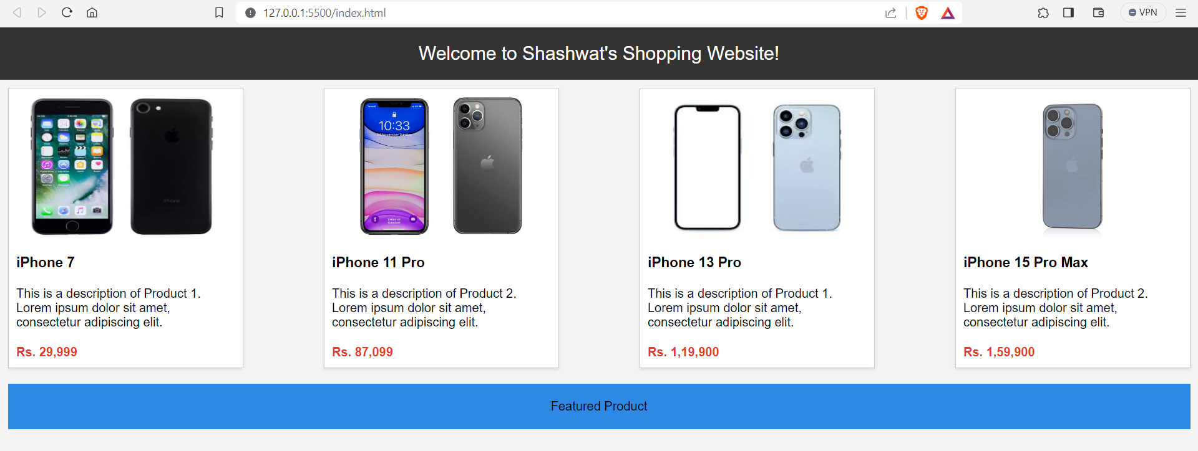

**Conclusion:**