**IP Exp 5**

**Shashwat Tripathi  
D15A 64**

**Batch C**

**Aim:** Experiment to study the basics of JavaScript.

JavaScript is a versatile and widely-used programming language for web development. Here are the basics of JavaScript, including various aspects of including JavaScript code in HTML, input-output, control structures, functions, arrow functions, and ES6 features:

Basics of JavaScript:

1. Variables: In JavaScript, you declare variables using the var, let, or const keyword. let and const are block-scoped, while var is function-scoped.

let name = "John"; const age = 30;

1. Data Types: JavaScript has several data types, including string, number, boolean, null, undefined, object, and symbol.
2. Operators: JavaScript supports various operators for arithmetic, comparison, logical operations, etc.

let x = 5; let y = 10; let result = x + y;

1. Conditional Statements: You can use if, else if, and else statements for conditional logic.

if (condition) { // code to execute if condition is true } else { // code to execute if condition is false }

1. Loops: JavaScript provides for, while, and do...while loops for iteration.

for (let i = 0; i < 5; i++) { // code to repeat }

Including JavaScript Code in HTML:

There are multiple ways to include JavaScript code in an HTML document:

1. Inline Script: You can include JavaScript directly within an HTML document using the <script> element.

<script> // JavaScript code here </script>

1. External Script: You can link to an external JavaScript file using the <script> element's src attribute.

<script src="script.js"></script>

1. Event Attributes: JavaScript can be executed in response to HTML events using attributes like onclick, onload, etc.

<button onclick="myFunction()">Click me</button>

Input-Output in JavaScript:

1. Output: You can display output using console.log() to the browser console.

console.log("Hello, world!");

1. Input: You can get user input using prompt() or interact with HTML elements through the DOM (Document Object Model).

let userInput = prompt("Enter your name:");

Functions:

Functions in JavaScript are blocks of reusable code. You can define them using the function keyword.

function greet(name) { return "Hello, " + name + "!"; }

Arrow Functions (ES6):

Arrow functions are a concise way to define functions in ES6.

const greet = (name) => { return `Hello, ${name}!`; };

ES6 Features:

ES6 (ECMAScript 2015) introduced several new features to JavaScript:

1. Spread Operator: Used for expanding arrays or objects.

const arr1 = [1, 2, 3]; const arr2 = [...arr1, 4, 5];

1. Rest Operator: Used for gathering function arguments into an array.

function sum(...numbers) { return numbers.reduce((total, num) => total + num, 0); }

1. Template Literals: A more flexible way to create strings using backticks.

const name = "Alice"; const message = `Hello, ${name}!`;

1. Destructuring: Allows you to extract values from arrays and objects easily.

const [x, y] = [10, 20]; const { firstName, lastName } = { firstName: "John", lastName: "Doe" };

These are some of the fundamental concepts and features of JavaScript, including different ways to include JavaScript code in HTML, input-output mechanisms, control structures, functions, arrow functions, and ES6 features. Learning and mastering these concepts is essential for web development using JavaScript.

Program 1:

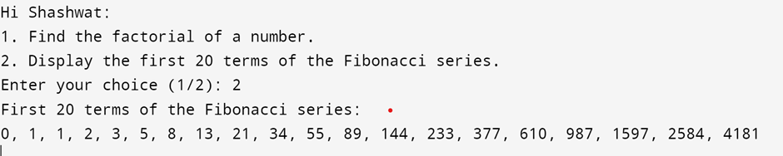

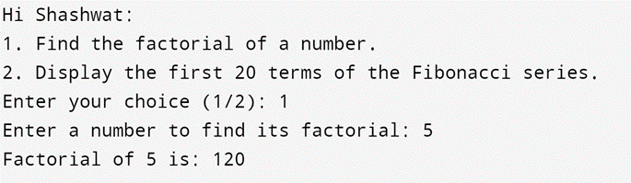

Program 2:

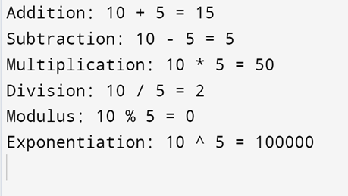

Program 3:

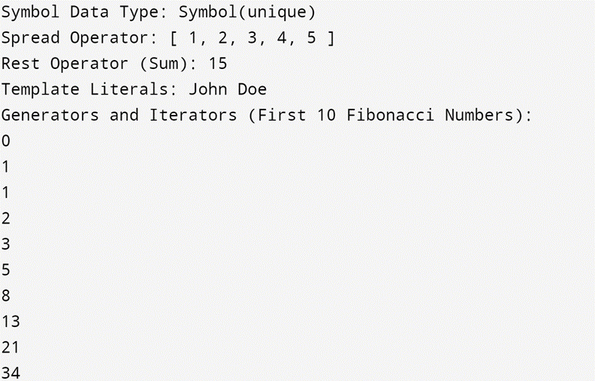

In this program:

1. We use the Symbol data type to create a unique symbol, uniqueKey.

2. The spread operator (...) is used to create a new array moreNumbers by spreading the elements of the numbers array.

3. The rest operator (...) is used in the sum function to collect a variable number of arguments and calculate their sum.

4. Template literals are used to create the fullName string by interpolating the firstName and lastName variables.

5. Generators and iterators are demonstrated with a generator function generateFibonacci that yields the first 10 numbers of the Fibonacci sequence. We then use a for...of loop to iterate through these numbers.

**Conclusion:**

Thus, we have understood the basics of JavaScript and implemented that in our programs.