**DevOps Lab Experiment 11**

**Shashwat Tripathi  
D15A 64  
Batch C**

**AIM :** To install and Configure Pull based Software Configuration Management and

provisioning tools using Puppet.

Creating two EC2 instances:

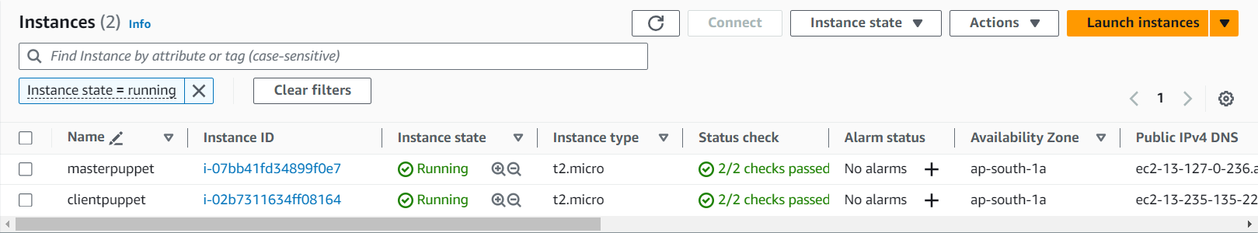

**ON MASTER :**

ssh -i “<key-pair.pem>” ubuntu@<master-node IPv4 address>

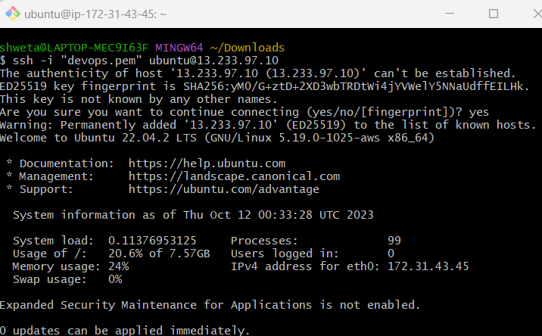

Similarly on AGENT/ SLAVE:  
ssh -i “<key-pair.pem>” ubuntu@<agent-node IPv4 address>

ON Both:  
Switch to root user

sudo su

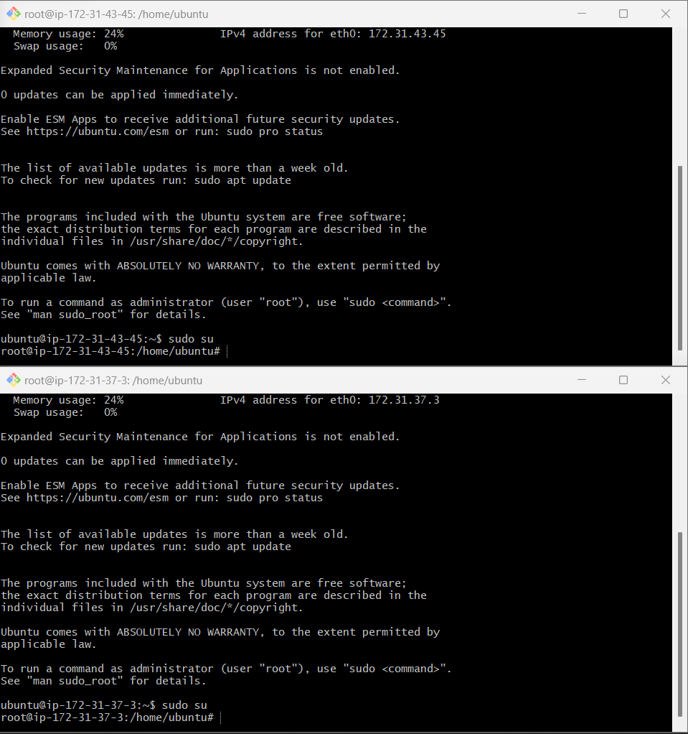

**ON MASTER:**

<Puppet_Master_Private_IP> puppet

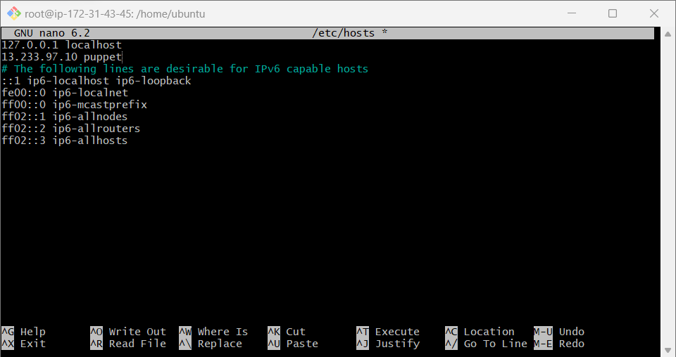

sudo apt-get install puppetserver -y

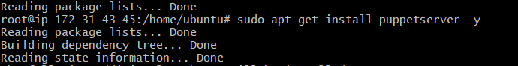

Now we will change the space requirements from 2GB to 512mb so that we do not overflow the nodes.

This will be done in Nano-editor

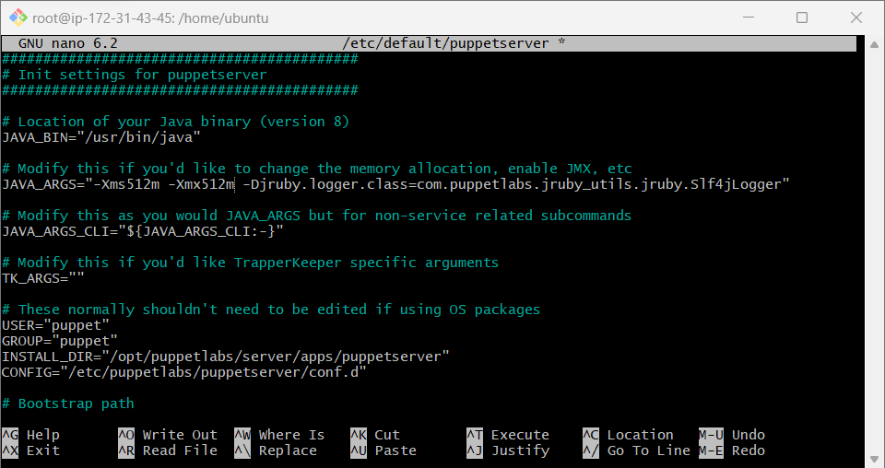

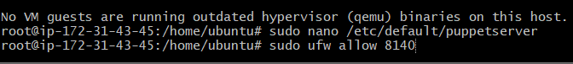

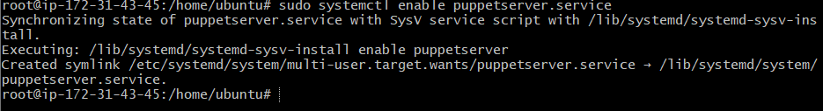

sudo systemctl status puppetserver.service

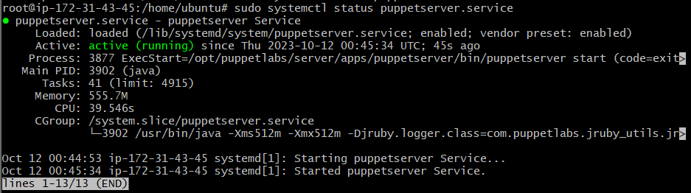

**ON AGENT :**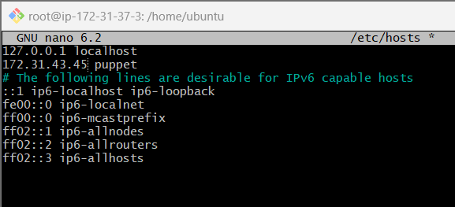

sudo systemctl enable puppet  
sudo systemctl restart puppet



sudo systemctl status puppet

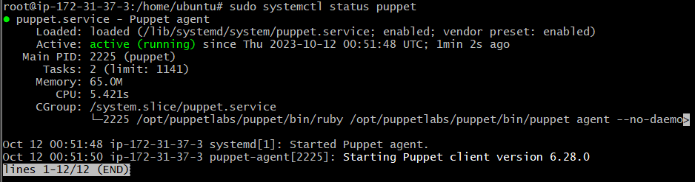

**ON MASTER :**

sudo /opt/puppet labs/bin/puppetserver ca list



sudo /opt/puppetlabs/bin/puppetserver ca sign --certname <Agent_CertName>



Now we will open the Nano editor and write some code which will be displayed in a file puppet_test.txt which is created only on successful execution.

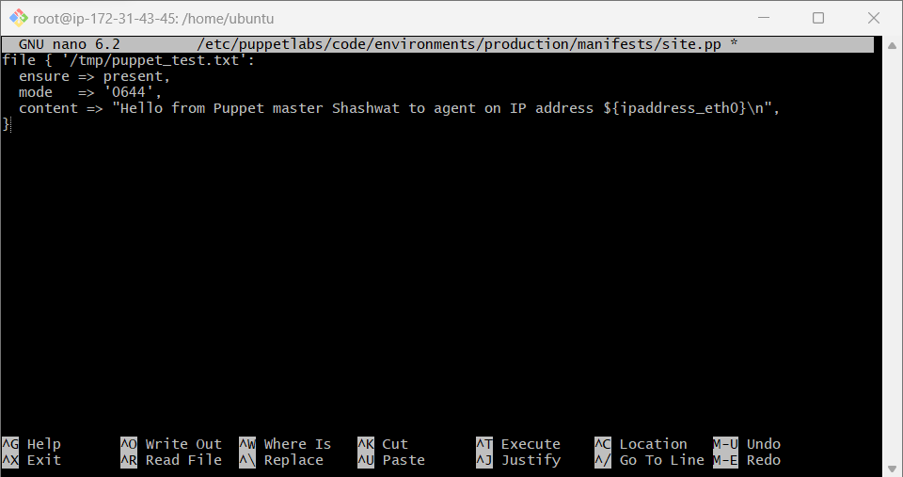

Agent:

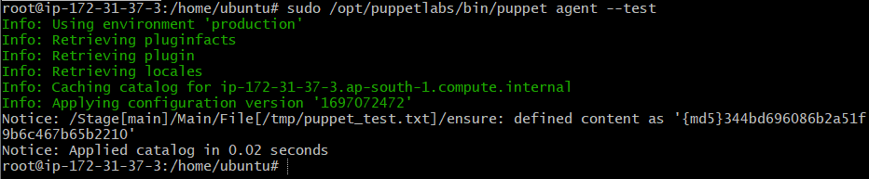

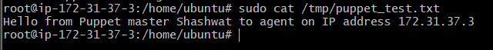

**CONCLUSION:**

Thus, we studied puppet, installed it on our machines and set up a master-worker cluster on it.