**DevOps Lab Experiment 13**

**Shashwat Tripathi  
D15A 64  
Batch C**

**Aim:** To provision a LAMP/MEAN Stack using Puppet Manifest.

**Implementation:**

1. To test your cluster setup, run this command -

sudo /opt/puppetlabs/bin/puppet agent --test

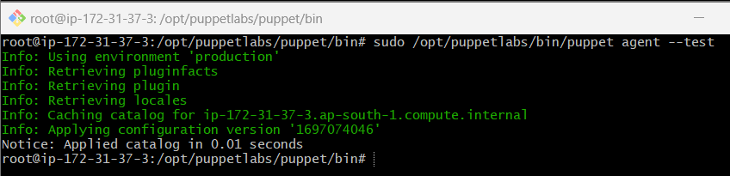

2. Change directories to the production folder

cd /etc/puppetlabs/code/environments/production/manifests

3. Use nano to create a new lamp.pp file.

sudo nano lamp.pp

4. Add this code to the file which will install all necessary dependencies and provision the

stack. You can obtain this code from here.

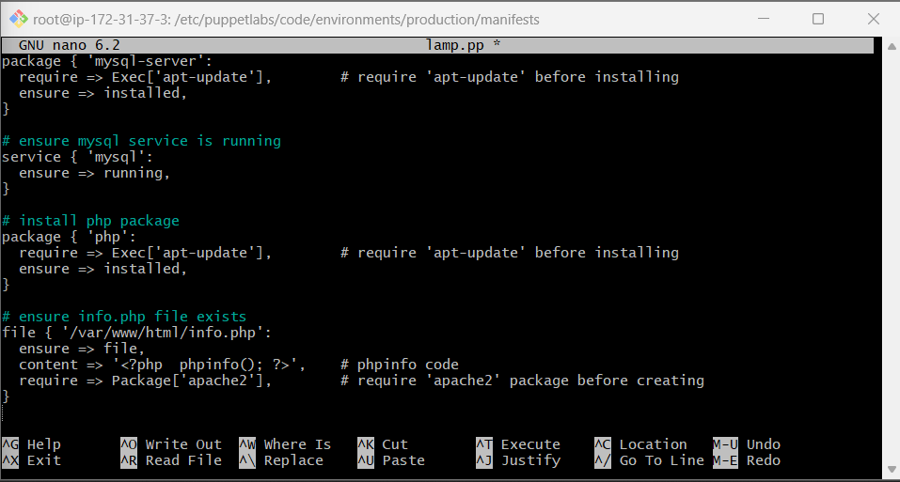

5. Change directory to the bin folder of puppetlabs where the puppet executable is present.

cd /opt/puppetlabs/bin

6. Use puppet apply to apply the scripts.

./puppet apply /etc/puppetlabs/code/environments/production/manifests/lamp.pp

7. Once done, go back to the EC2 Console, copy the public IP address of the client

machine and put it in the browser. The URL is -

In my case it is:

http://13.127.81.208/info.php

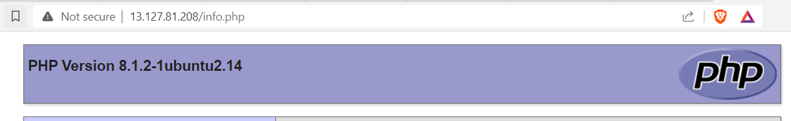

**Final Output:**

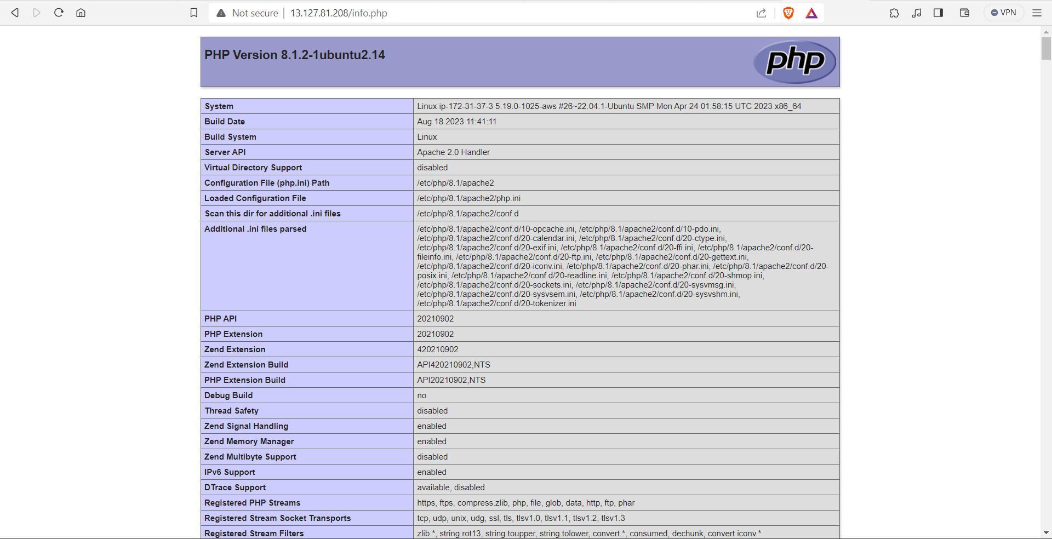

**Conclusion:**

Thus, we learned what a LAMP stack is and learned how to provision it using puppet scripts.