**DevOps Lab Experiment 3**

Shashwat Tripathi  
D15A 64  
Batch C

New Repository creation(Remote):

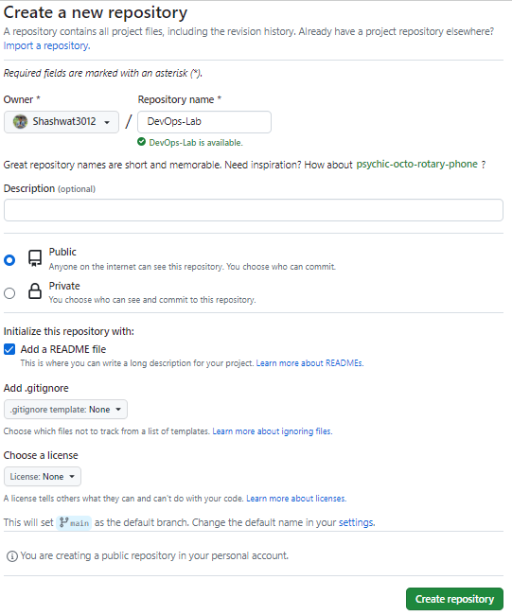

Cloning the repository into local machine:

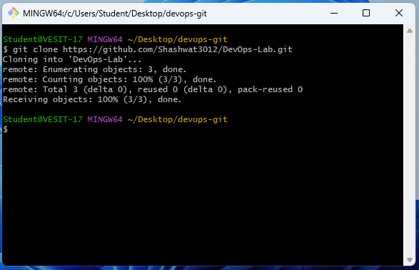

Making changes in our local repository:

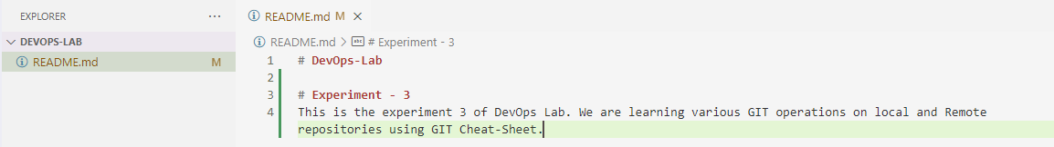

Pushing the local changes into remote repository:

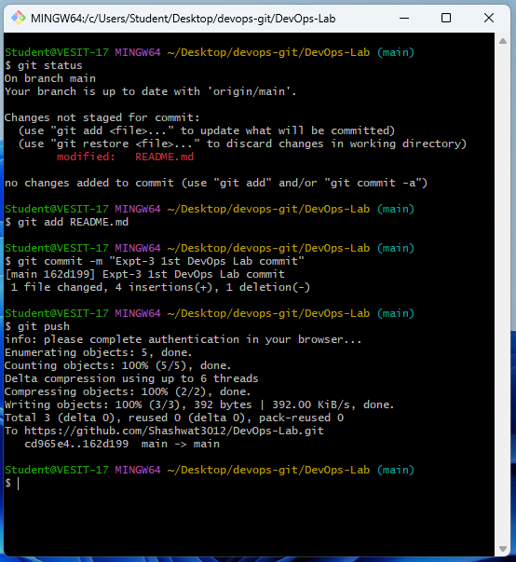

Conclusion:

Thus we have used various git commands in this experiment.

Errors faced:

Did not login to the git bash, so it displayed an error stating no username found.  
After logging in to my account, I was able to push the changes.