**DevOps Lab Experiment 4**

Shashwat Tripathi  
D15A 64  
Batch C

Creating a new branch “shashwat”



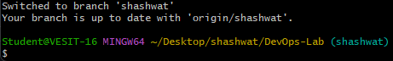

Committing changes into the main branch from the newly created branch

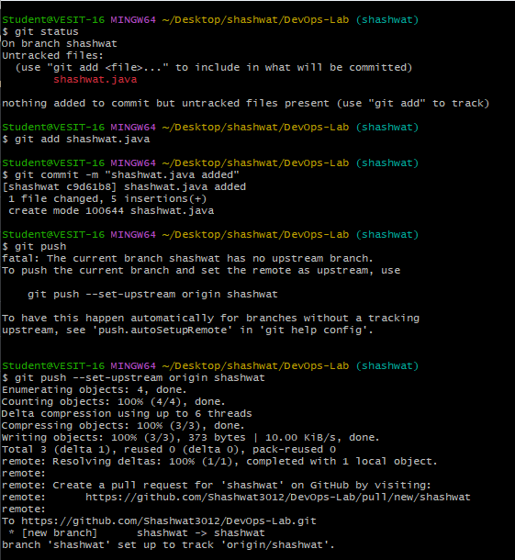

Git log

