**DevOps Lab Experiment 7**

Shashwat Tripathi  
D15A 64  
Batch C

**Aim:** To Build the pipeline of jobs using Maven / Gradle / Ant in Jenkins, create a pipeline script to build and deploy an application over the tomcat server.

**Steps:**

Create a pipeline

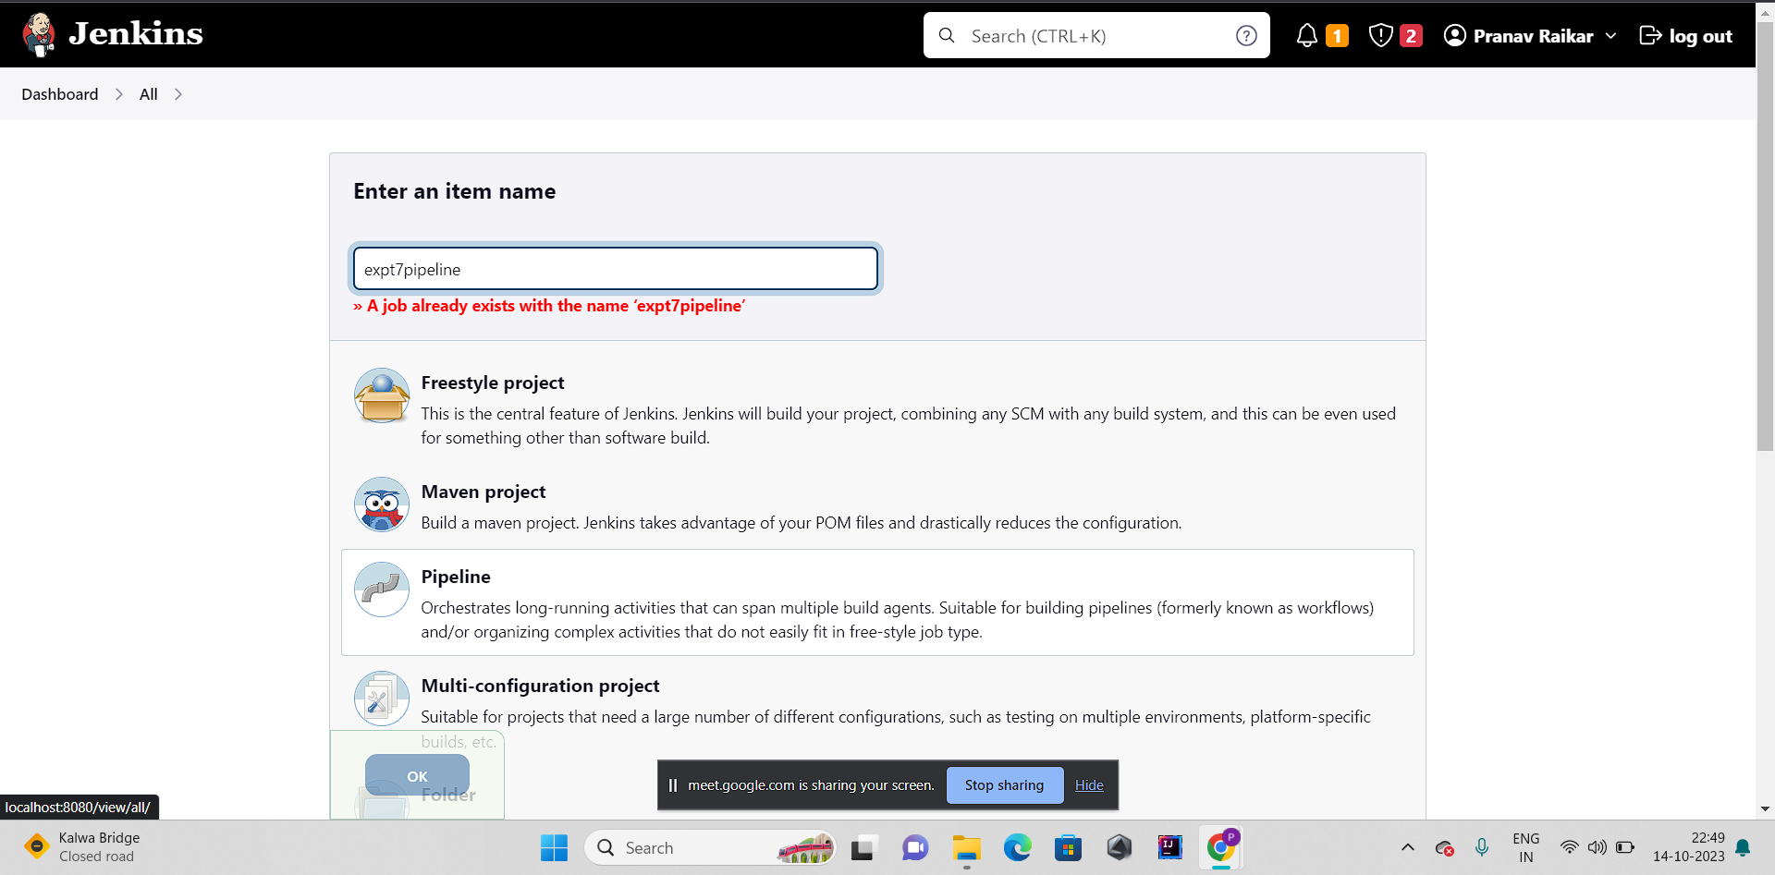

Add github project link

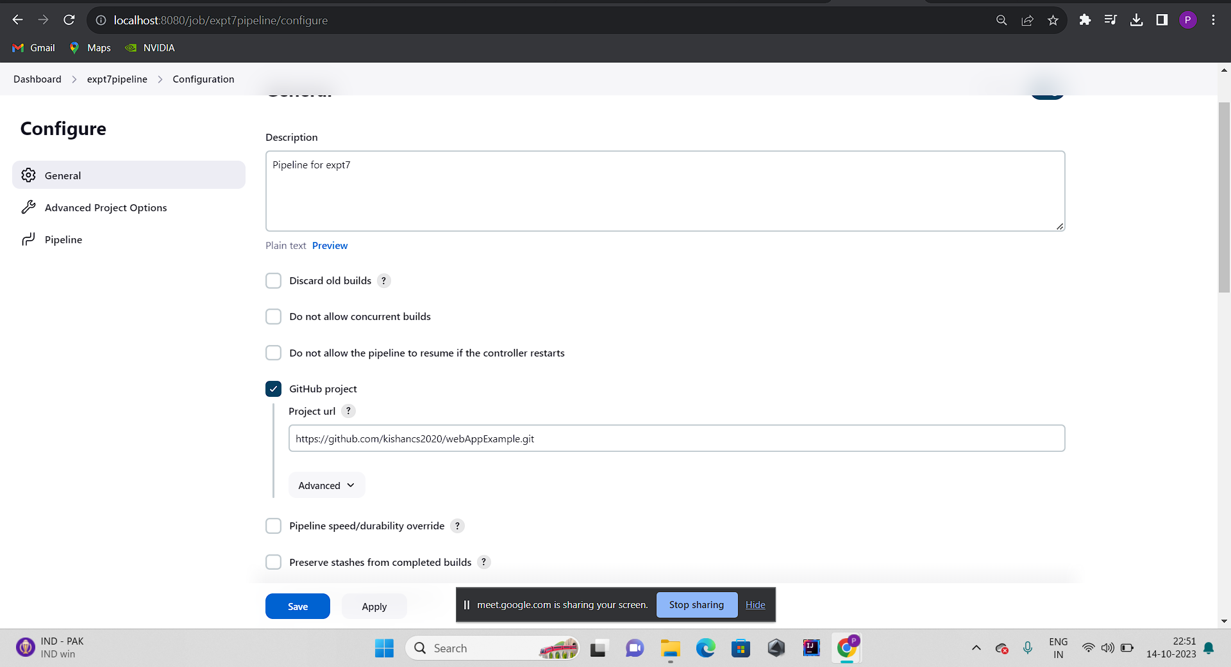

Now change from try sample pipeline to hello world at top right corner in scripts:

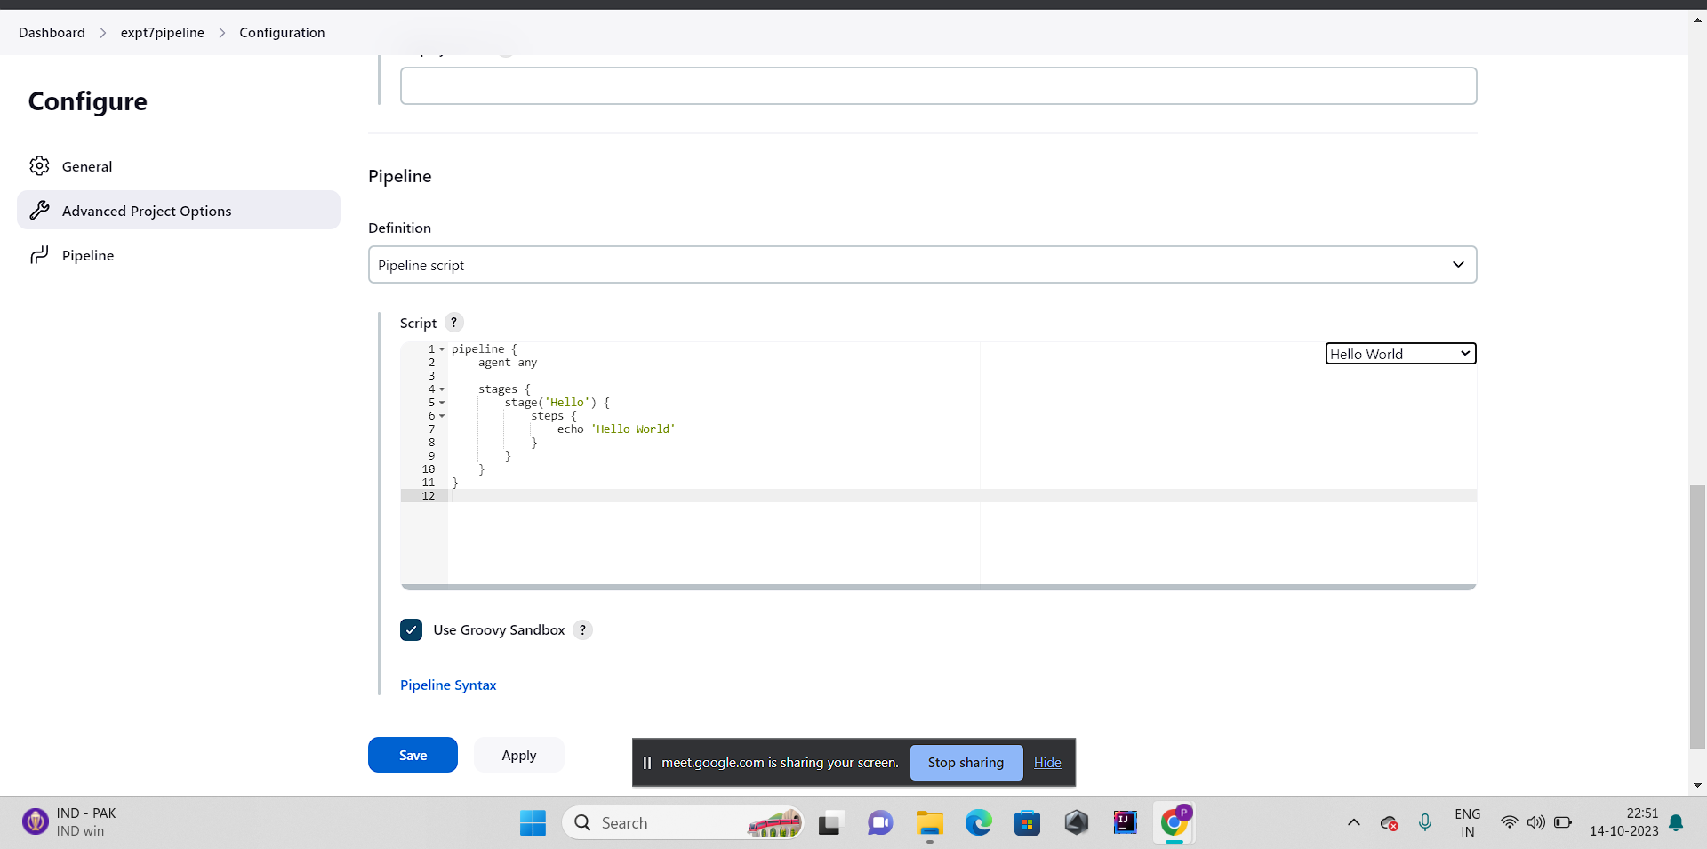

Then apply save and build

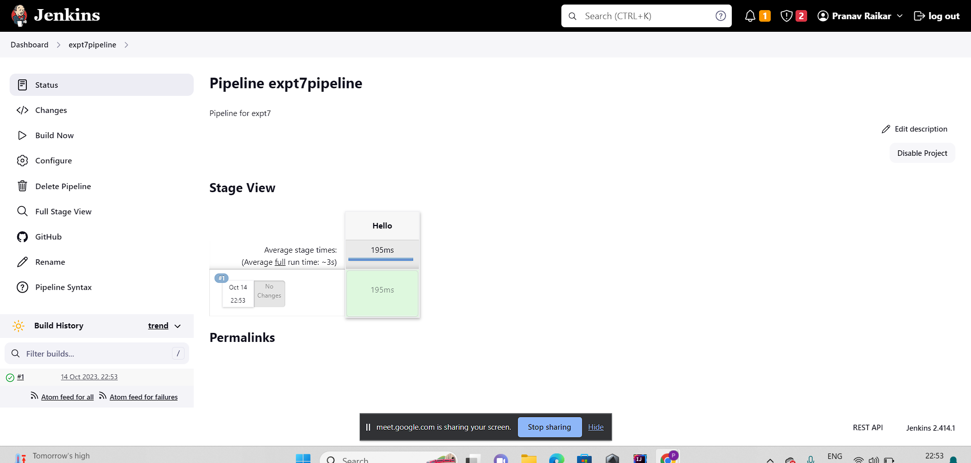

Then go to dashboard and create a new item

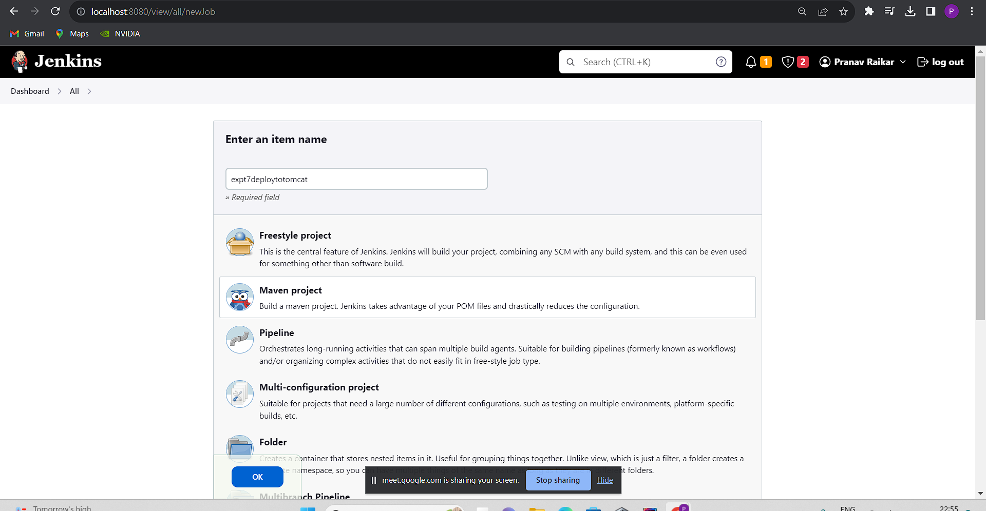

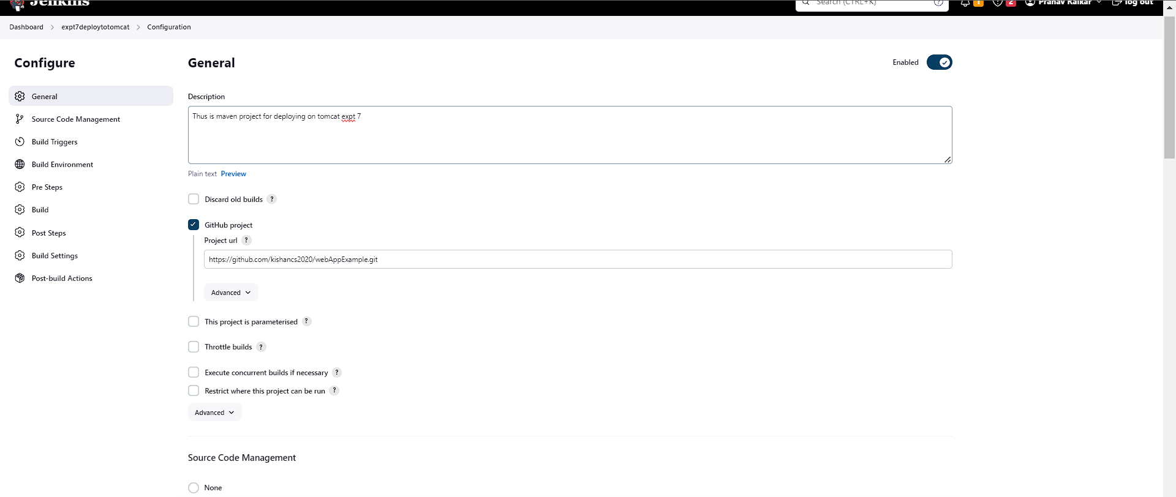

If repository not public then add credentials since we have used a public repo we havent added any credentials

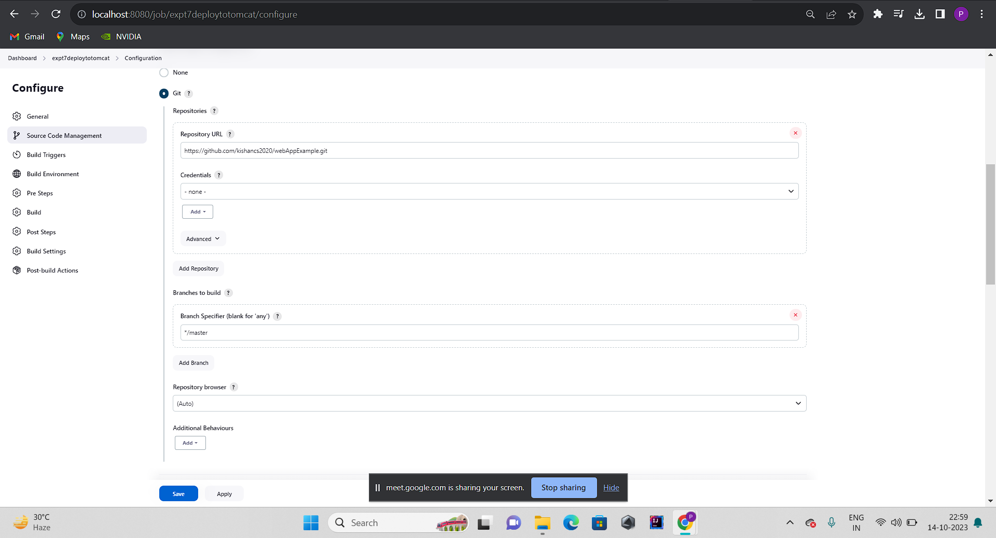

Then click on save and apply

Then go to dashboard and then manage jenkins

Then click on tools

Then click on add jdk and put the Name and path.Path must be from your local directory

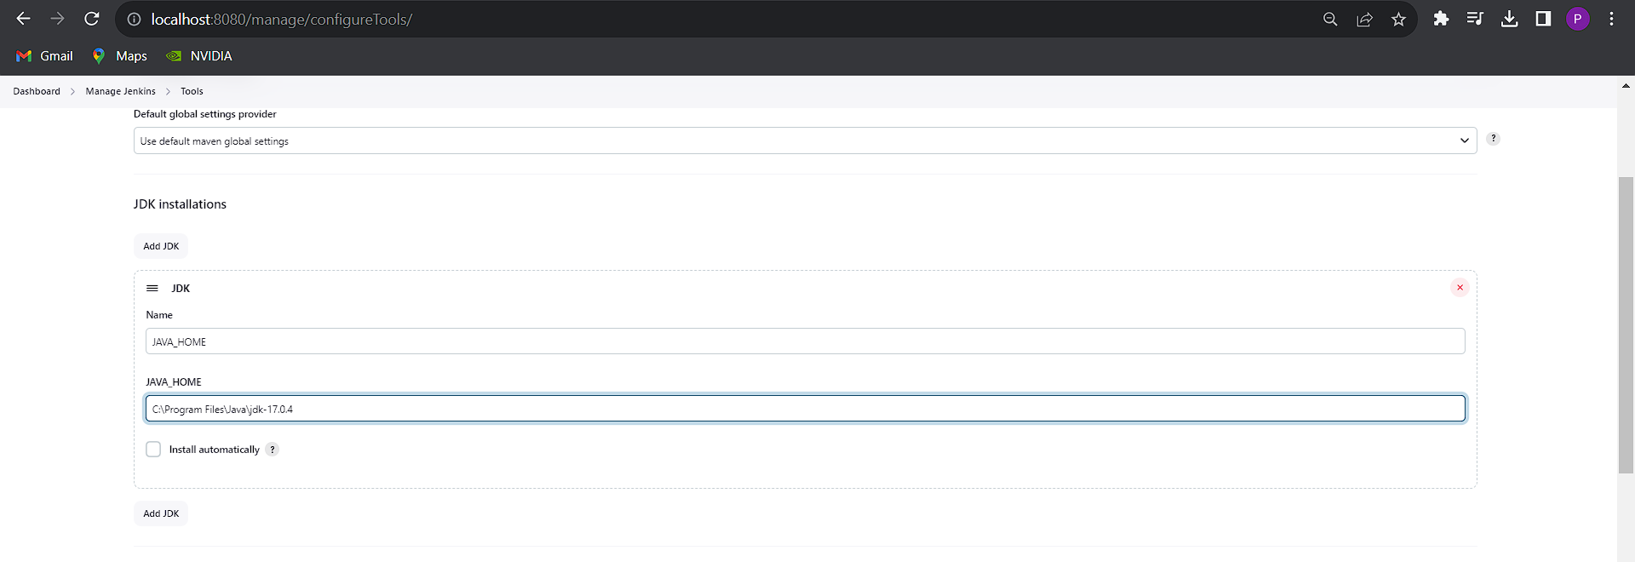

Then copy the path of your git.exe file from your local directory and padte it at the place of git.exe inside Path to Git executable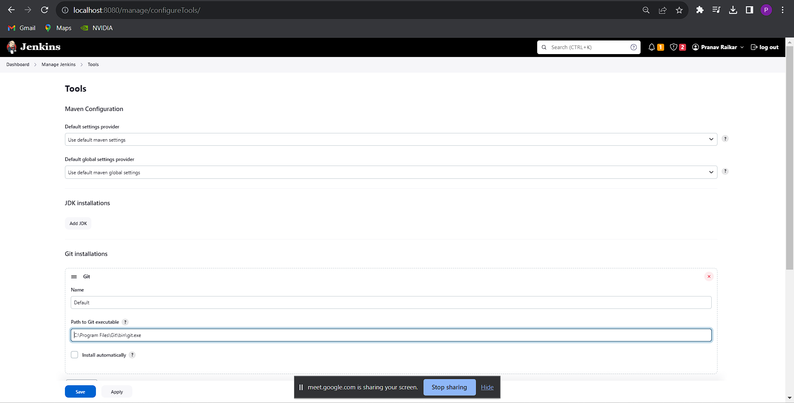

Similarly for maven:

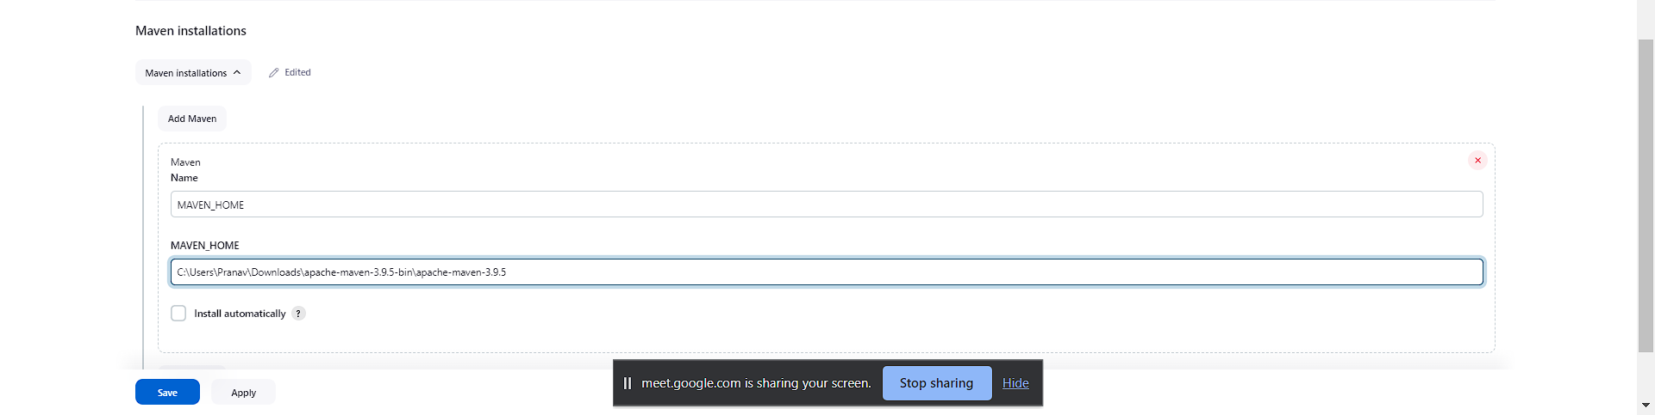

Then click on post-build actions

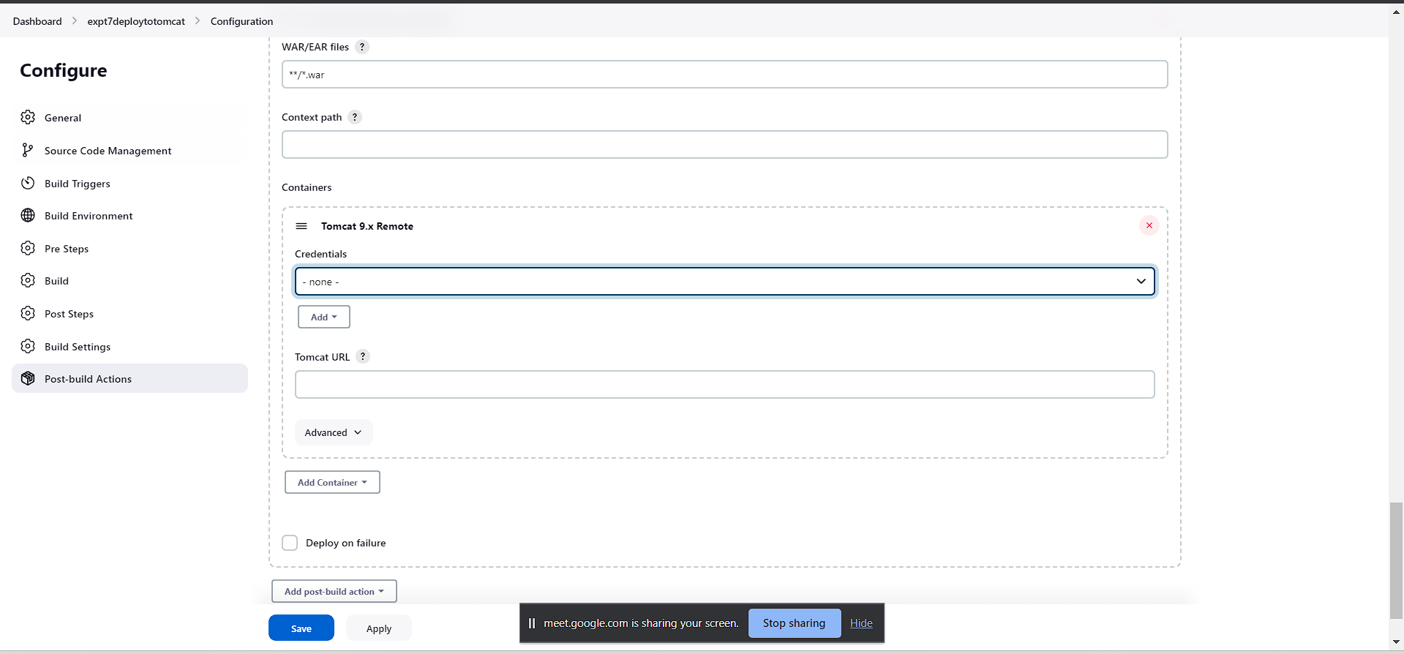

Then click on add credentials

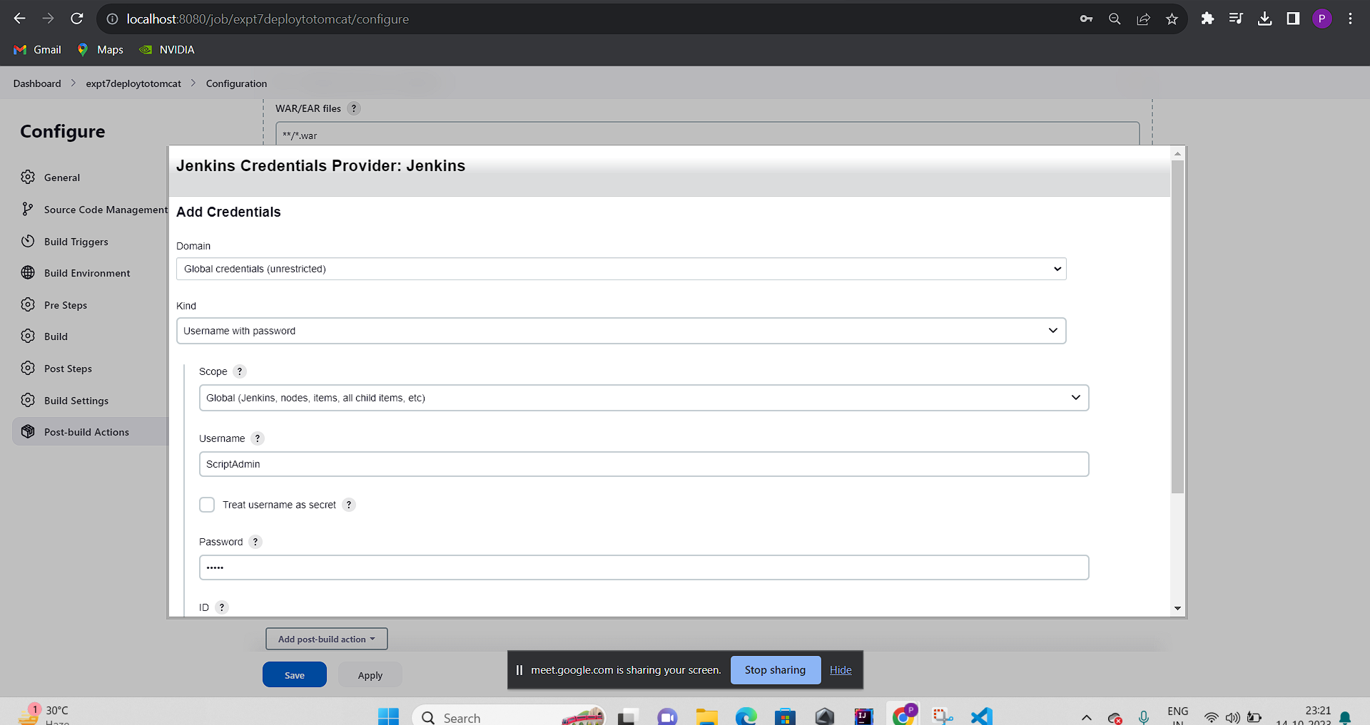

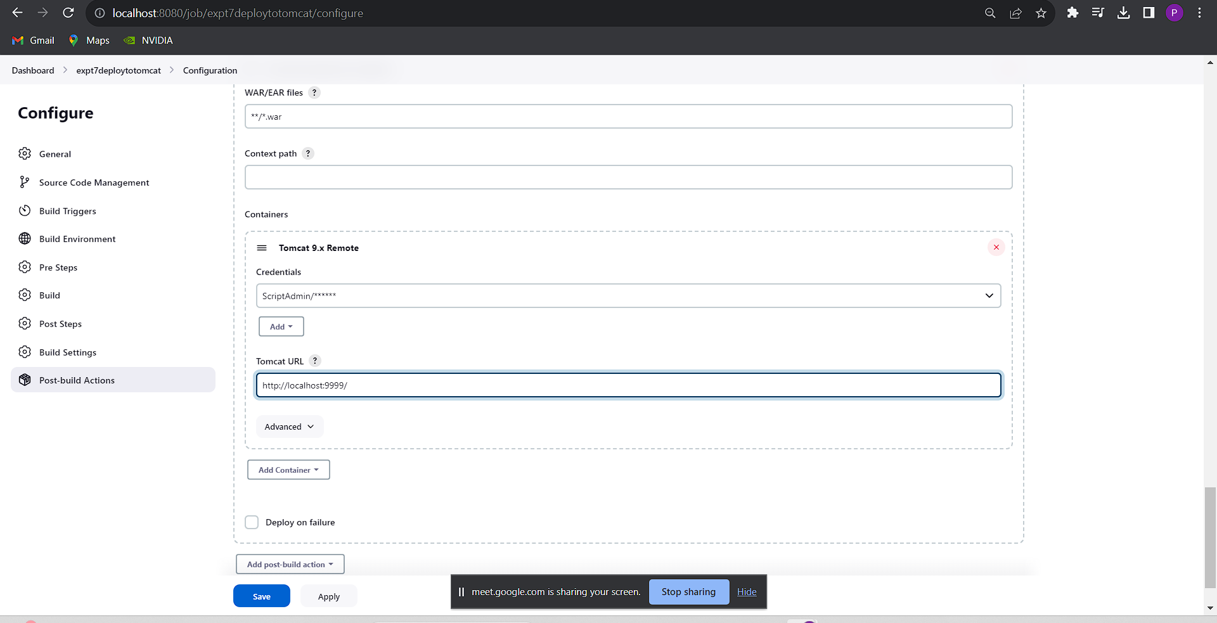

Then inside goals type clean package Note:This is a command so it must be typed as it is:

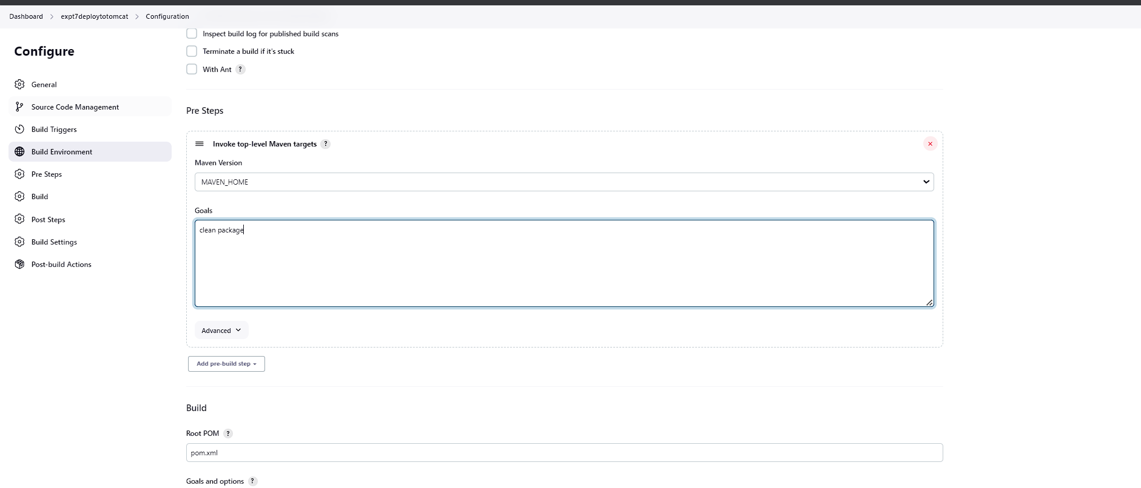

Then save

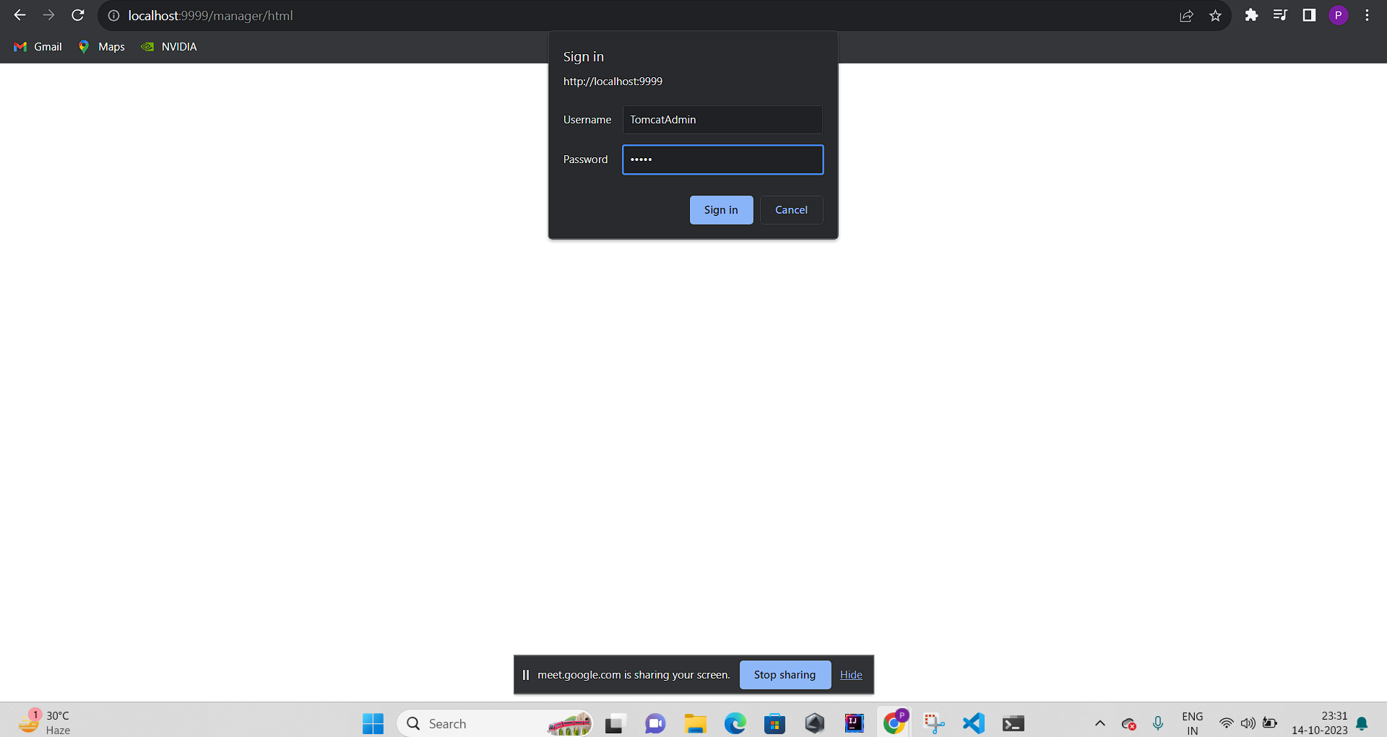

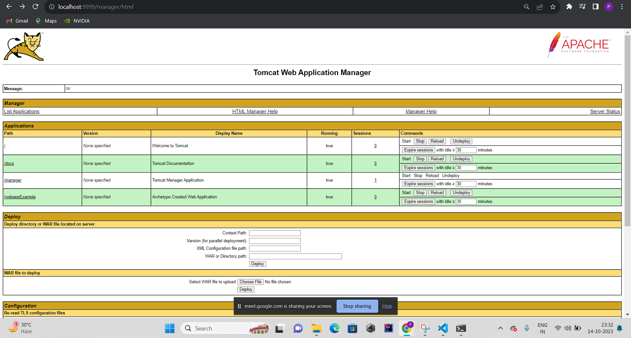

Then click on /webappexample

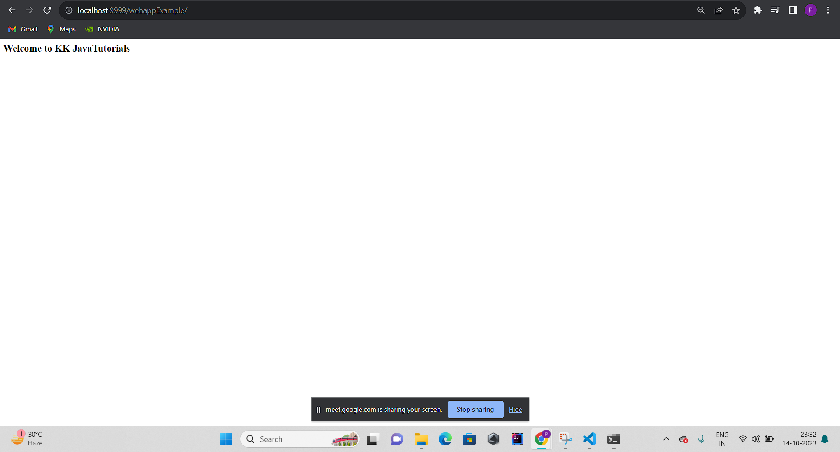

**Error:** The Jenkins project could not find pom.xml, even though proper path to the file was given.

**Conclusion:** Thus we have created a pipeline script to build and deploy an application over the tomcat server.