**DevOps Lab**

**LAB 9**

Shashwat Tripathi

Batch C

D15A Roll No: 64

**Aim -** To understand Docker Architecture and Container Life Cycle, install Docker and execute docker commands to manage images and interact with containers.

**Output-**

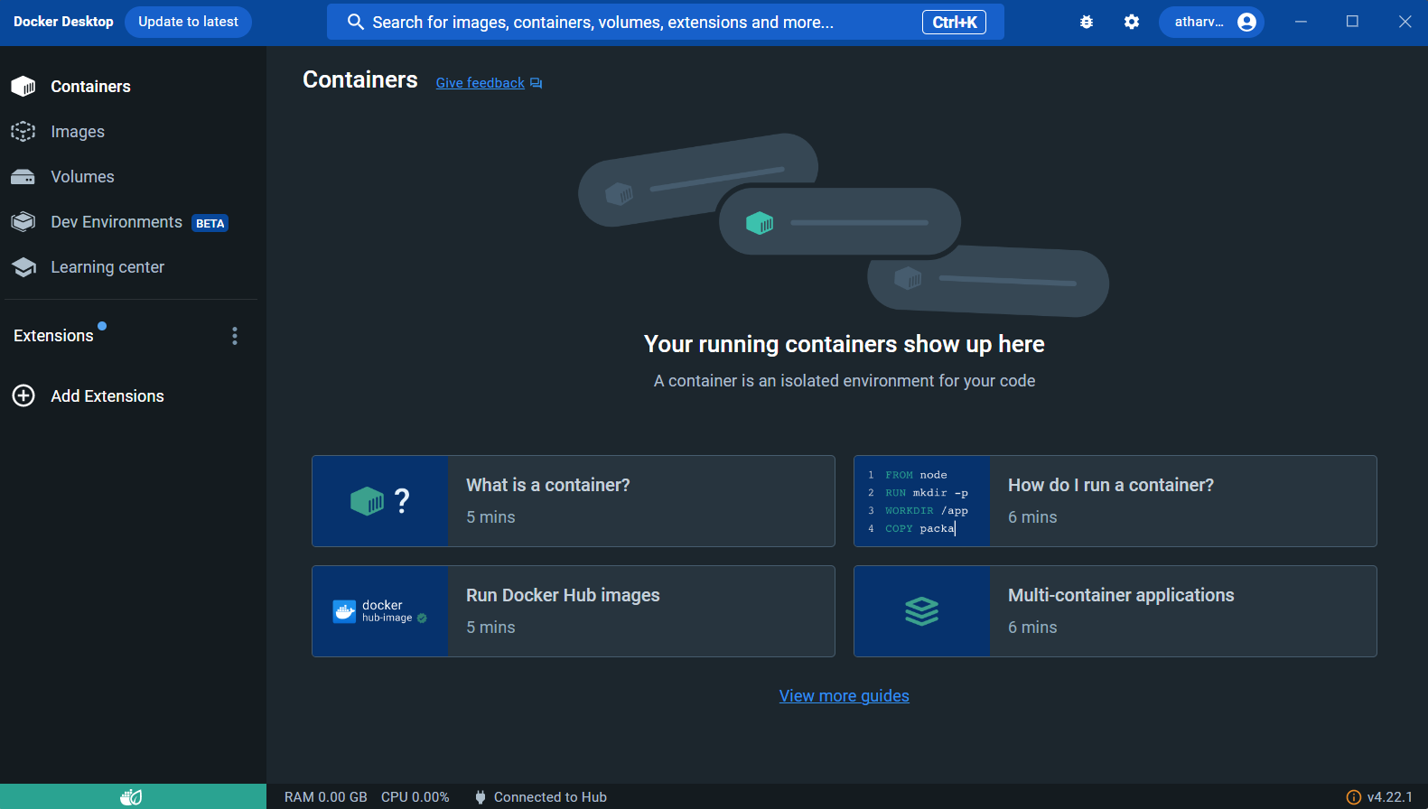

1. **docker info**

**docker version**

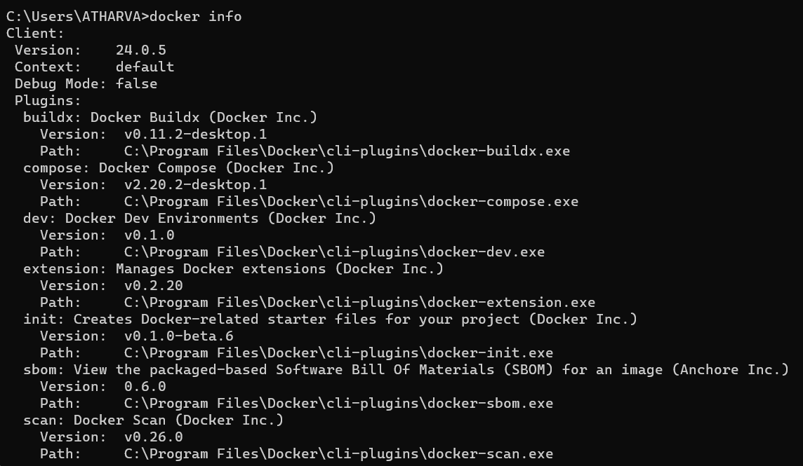

1. **Starting a Container from an Image**

We can run Docker Containers from a pre-existing image or docker will pull the specified image from the Docker hub. For this example, we will run an nginx server in a docker container on port 80.

docker container run --publish 80:80 -d nginx

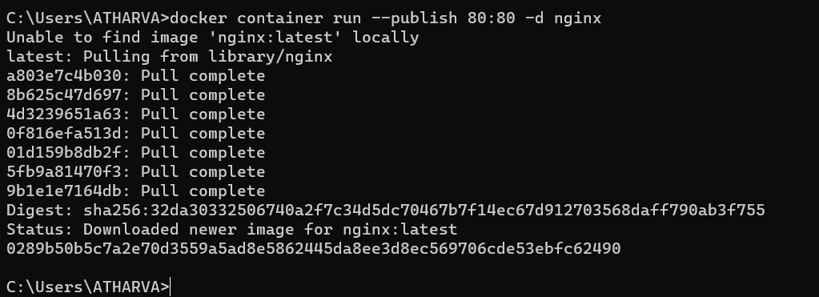

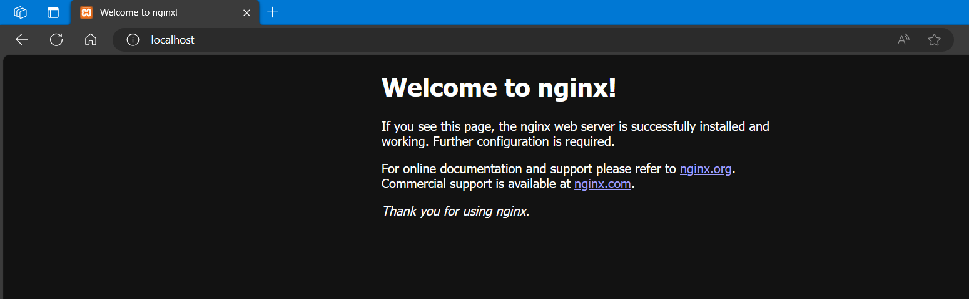

1. **Listing out Containers**

We can find a list of running containers on our machine.

docker container ls

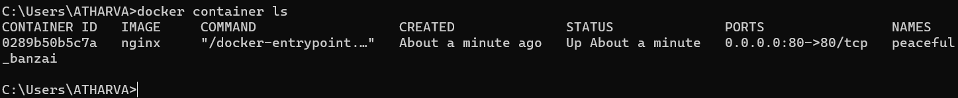

1. **Stopping a Container**

We can stop a running container using the docker container stop command by providing the id we found above.

We only need to provide the initial few letters of the id, until it’s totally unique.

docker container stop <id>

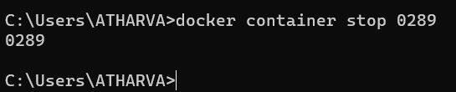

1. **Listing out All Containers**

We can use the -a flag to the previous list command to find a list of all containers, even those which have stopped.

docker container ls -a



1. **Show container logs**

We can use the command logs to show logs for a specified container -

docker container logs <id>

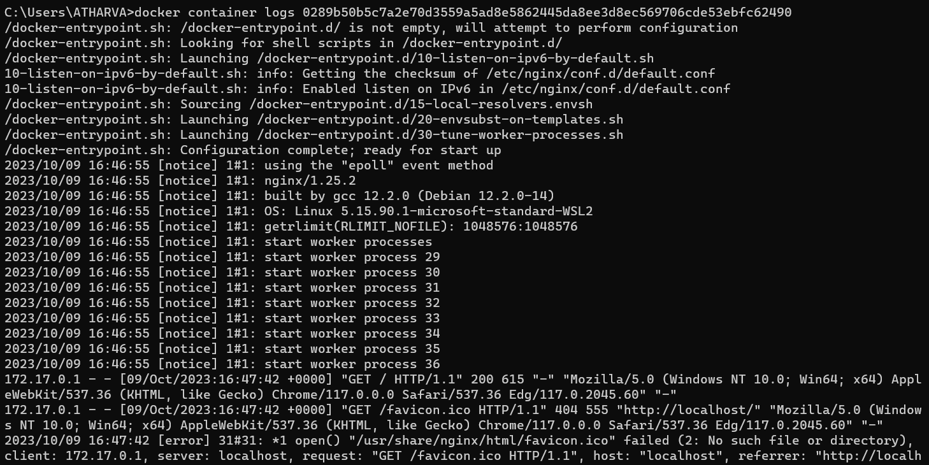

1. **Listing out Images**

We can use the docker images command to show a list of docker images we locally have.

docker images

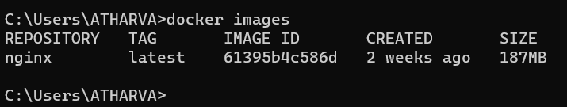

**Conclusion:** Thus, we have installed Docker and executed docker commands to manage images and interact with containers.