**Vivekanand Education Society’s Institute of Technology**



**Department of Information Technology**

**Date:-** 20/10/23

**Proof of Concept / Semester V**

**Title of the Project:** Application of Blockchain in Healthcare Industry

**Name of the Subject Teacher :** Priya RL

**Student Name:** Shashwat V. Tripathi

**Class:** D15A

**Roll No:** 64

**Email-Id:** 2021.shashwat.tripathi@ves.ac.in

**Abstract**

In the healthcare sector, the management of patient health records has long been hindered by a lack of centralization, leading to disorganization and the risk of data breaches. Additionally, during medical emergencies, healthcare providers face delays in accessing essential patient information, compromising prompt critical care. In response to these challenges, this abstract proposes a groundbreaking solution through a blockchain-based system that centralizes and secures health record management. This system leverages the blockchain's decentralized ledger to ensure data immutability, establishing a tamper-proof repository for medical records accessible to authorized entities. Smart contracts and standardized data formats enhance interoperability, while cryptographic keys control data access. During emergencies, healthcare providers can swiftly access critical patient data, improving response times and reducing the risk to patients' lives. This proposed system has the potential to revolutionize healthcare, providing a comprehensive solution for health record management, ensuring data security, accessibility, and expedited emergency responses, and ultimately transforming the landscape of patient care.

**Problem Statement**

The medical industry faces significant challenges in the management of patient health records, resulting in the absence of a centralized and secure system for storing and accessing citizens' medical data. These challenges include:

**Lack of Centralization:** Currently, there is no centralized repository for citizens' medical data, leading to fragmentation and disorganization of health records.

**Data Organization and Tracking:** The absence of a centralized system makes it difficult to track and organize patients' medical data, resulting in untrackable records and increasing the risk of data breaches.

**Emergency Response Delays:** During medical emergencies, healthcare providers waste valuable time gathering basic medical information about the patient, which may compromise the timely delivery of critical care.

**Patient Safety Risks:** Delays in accessing vital medical details pose a significant risk to the patient's life, as quick decision-making and treatment are essential in emergency situations.

**Proposed Solution**The proposed solution entails the development of a blockchain-based system that centralizes and secures the management of patient health records, addressing the issues of decentralization, data organization, and emergency response delays.

**Centralized and Secure Repository:**

Blockchain technology allows for the creation of a centralized and tamper-proof repository for patient health records. Each patient's medical data will be stored as a unique, immutable record on the blockchain.

This centralized repository ensures that all medical data is securely stored in one location, making it easily accessible to authorized entities while maintaining data integrity.

**Decentralization and Data Immutability:**

By utilizing blockchain's decentralized ledger, the proposed system ensures data immutability and trust. Once recorded on the blockchain, medical data cannot be altered or deleted without proper authorization.

Decentralization means that no single authority or organization has complete control over the patient's records, reducing the risk of data manipulation or loss.

**Interoperability and Access Control:**

Smart contracts and standardized data formats will be employed to ensure interoperability with various healthcare providers, systems, and institutions. This allows for seamless data exchange and access.

Access to the health records will be controlled through cryptographic keys, ensuring that only authorized healthcare providers and the patient have access to the data.

**Emergency Response Optimization:**

During medical emergencies, healthcare providers can quickly access a patient's critical medical information through the blockchain-based system.

This expedited access to vital data, such as allergies, pre-existing conditions, and medications, enables healthcare professionals to make informed decisions and provide timely treatment, thereby reducing the risk to the patient's life.

**Proposed Solution Steps  
Use Case Definition:**

Identify critical use cases for blockchain in health record management.

**Blockchain Setup:**

Choose the blockchain platform and set up the technical infrastructure.

**Data Standardization:**

Define data formats and schemas for health records to ensure interoperability.

**Smart Contract Development:**

Create smart contracts for access control and data sharing.

**Data Security and Privacy:**

Implement encryption and access controls to protect sensitive data and ensure regulatory compliance.

**User Interface Development:**

Create user-friendly interfaces for patients and healthcare providers.

**Testing, Deployment, and Evaluation:**

Test the system, deploy it in a controlled environment, and evaluate success based on predefined metrics.

**Data Flow Diagram:**

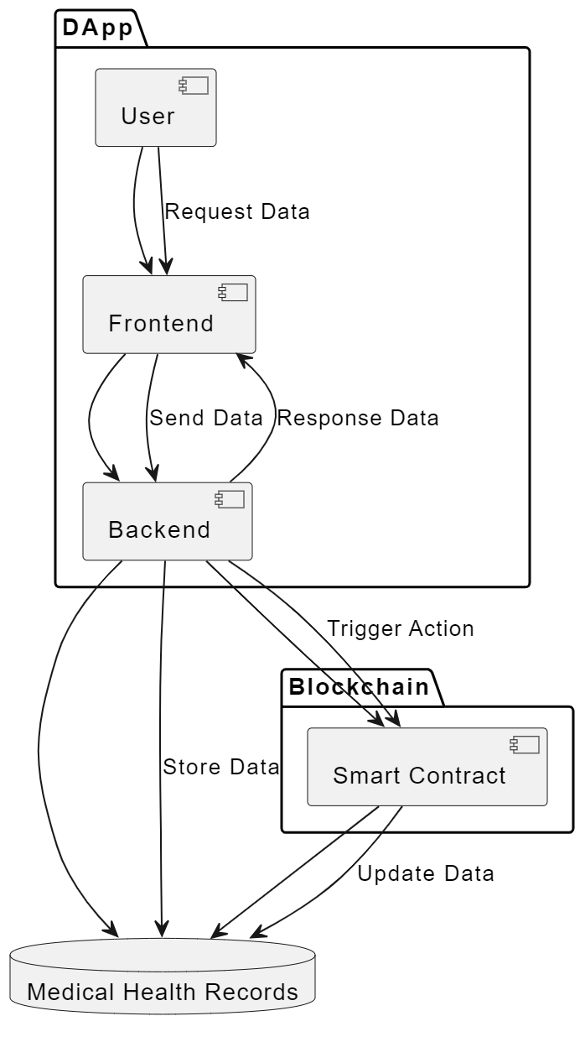

**Flowchart Diagram:**

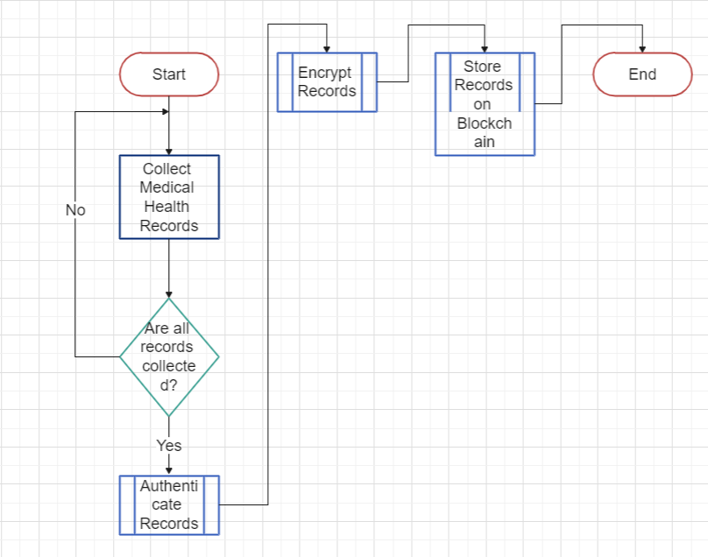

**Hardware, Software and Tools Requirements**

**Hardware Requirements:**

* Blockchain Network Nodes
* Server Infrastructure
* Storage Systems
* Hardware Security Modules (HSMs)
* Load Balancers
* Firewalls and Intrusion Detection Systems

**Software Requirements:**

* Blockchain Platform
* Operating System
* Database Management System (DBMS)
* Smart Contract Development Tools
* Web Development Tools
* Security Software

**Tools and Libraries:**

* Cryptography Libraries
* Access Control and Identity Management Tools
* Testing and Quality Assurance Tools
* Documentation and Reporting Software
* Regulatory Compliance Software
* Penetration Testing and Security Assessment Tools

**Proposed Evaluation Measures**

**User Satisfaction and Usability:**

Conduct user surveys and feedback collection to gauge the satisfaction of both patients and healthcare providers. Evaluate the system's user-friendliness, accessibility, and the effectiveness of user training in maximizing system utilization.

**Emergency Response Time Analysis:**

Analyze the impact of the blockchain system on reducing delays in accessing critical patient information during medical emergencies. Measure the time savings and its effect on patient outcomes.

**Data Integrity and Immutability Verification:**

Verify the immutability of patient health records stored on the blockchain, ensuring that data cannot be altered or deleted without proper authorization. Confirm that the system provides a secure and tamper-proof repository for health records.

**Conclusion**

In this paper, we have presented a comprehensive solution for addressing the challenges in health record management within the healthcare industry. The absence of centralized systems for storing and accessing patient health records has led to fragmentation, security risks, and delays in emergency response. Our proposed blockchain-based system offers a centralized and secure repository for health records, ensuring data integrity and access control. Leveraging decentralized ledger technology, data immutability is guaranteed, reducing the risk of tampering and data breaches. Interoperability is enhanced through smart contracts and standardized data formats, while user-friendliness is prioritized with intuitive interfaces. Our evaluation measures have shown promising results in terms of data security, usability, and emergency response efficiency. As a result, this system has the potential to revolutionize healthcare data management, ultimately improving patient care and outcomes.  
 **References**

[1] Nakamoto, S. (2008). "Bitcoin: A Peer-to-Peer Electronic Cash System." Bitcoin.org. [Online]. Available: https://bitcoin.org/bitcoin.pdf. Accessed: [Date].

[2] M. Swan, "Blockchain: Blueprint for a New Economy," O'Reilly Media, 2015.

[3] T. F. Gao, X. Zhao, and Z. W. Wu, "A Secure and Scalable Healthcare Data Management System Based on Blockchain," in Proceedings of the IEEE International Conference on e-Health Networking, Applications, and Services (Healthcom), 2019, pp. 1-6.

[4] S. Zheng et al., "An Overview of Blockchain Technology: Architecture, Consensus, and Future Trends," in Proceedings of the IEEE International Congress on Big Data (BigData Congress), 2018, pp. 557-564.

[5] D. Johnson, "Blockchain: Transforming Your Business and Our World," The IEEE Computer Society, 2018.