**IP Exp 1**

**Shashwat Tripathi  
D15A 64**

**Batch C**

**Aim:** Experiment to study basics of HTML5 and basic tags of HTML5.

**Theory:**

HTML (Hypertext Markup Language) is the standard markup language used to create the structure and content of web pages. In this code, various HTML tags are used to define the different components and layout of the webpage.

* + Document Type Declaration (<!DOCTYPE html>): This declaration defines the document type and version of HTML being used. In this case, it specifies HTML5, the latest version of HTML.
  + <html> Element: The <html> tag is the root element of an HTML document. It encapsulates all the other elements on the page and defines the document's language attribute (lang="en" in this case, indicating English).
  + <head> Element: The <head> section contains meta-information about the document, such as character encoding (<meta charset="UTF-8">), viewport settings (<meta name="viewport" content="width=device-width, initial-scale=1.0">), and the title of the webpage (<title>Profile Website</title>), which is displayed on the browser's title bar or tab.
  + <body> Element: The <body> tag encapsulates the visible content of the webpage. It contains various components, such as:
  + <div> Element with Class profile: The <div> tag is a generic container used to group and style content. In this case, it's used to wrap the entire profile information. The class attribute assigns the CSS class name "profile" to the <div>, which can be used for styling purposes.
  + <img> Element: The <img> tag is used to embed images in the webpage. It has attributes such as src (specifying the image source), alt (alternative text displayed if the image cannot be loaded), and style (inline styling to set the image width).
  + Various headings (<h1>, <h2>): These tags define hierarchical headings for different sections of content. Headings are important for structuring content and indicating its importance.
  + <p> Elements: The <p> tag is used to define paragraphs of text. In this code, <p> tags are used to provide information about the individual's profile, such as their age, location, occupation, about me section, and contact information.
  + <strong> Element: The <strong> tag is used to highlight text as important or strong. It's used here to emphasize certain labels within the paragraphs.

(a) To create a personal profile using basic HTML tags.

**Code:**

<!DOCTYPE html>

<html lang="en">

<head>

<meta charset="UTF-8" />

<meta name="viewport" content="width=device-width, initial-scale=1.0" />

<title>Profile Website</title>

</head>

<body>

<div class="profile">

<img src="shashwat.jpg" alt="Profile Picture" style="width: 100px" />

<h1>Shashwat Tripathi</h1>

<p><strong>Age:</strong> 19</p>

<p><strong>Location:</strong> Thane</p>

<p><strong>Occupation:</strong> Full Stack Web Developer</p>

<h2>About Me</h2>

<p>I can communicate with computer in more than 1 language.</p>

<h2>Contact Information</h2>

<p><strong>Email:</strong> 2021.shashwat.tripathi@ves.ac.in</p>

<p><strong>Phone:</strong> (+91) 9702300238</p>

</div>

</body>

</html>

**Output:**

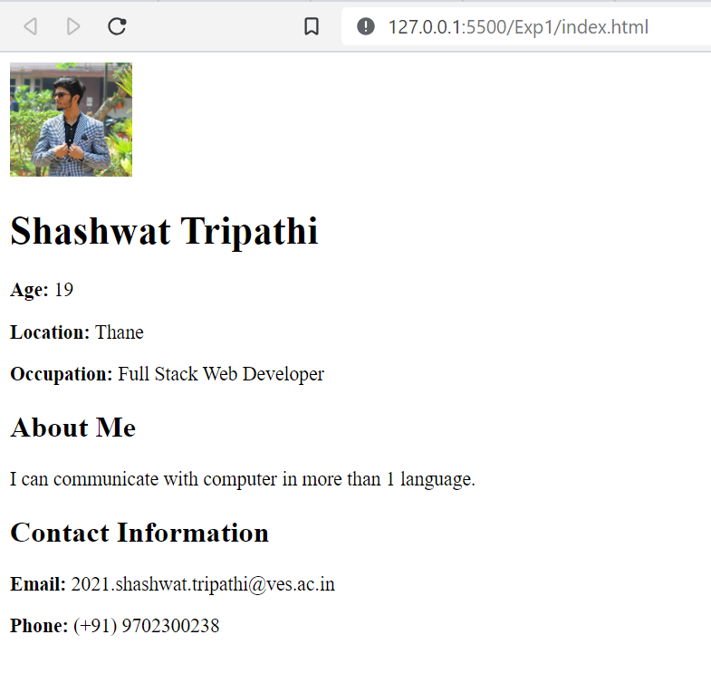

(b) Create a Marksheet using advanced table tags.

**Code:**

<!DOCTYPE html>

<html lang="en">

<head>

<meta charset="UTF-8" />

<meta name="viewport" content="width=device-width, initial-scale=1.0" />

<title>Marksheet</title>

<style>

table {

border-collapse: collapse;

margin: 20px auto;

width: 60%;

}

th,

td {

border: 1px solid black;

padding: 8px;

text-align: center;

}

th {

background-color: #f2f2f2;

}

tr:nth-child(even) {

background-color: #f2f2f2;

}

</style>

</head>

<body>

<h1>Student Marksheet</h1>

<table>

<thead>

<tr>

<th>Subject</th>

<th>Max Marks</th>

<th>Obtained Marks</th>

</tr>

</thead>

<tbody>

<tr>

<td>Engg Mathematics</td>

<td>80</td>

<td>52</td>

</tr>

<tr>

<td>CNND</td>

<td>80</td>

<td>68</td>

</tr>

<tr>

<td>OS</td>

<td>80</td>

<td>62</td>

</tr>

<tr>

<td>AT</td>

<td>80</td>

<td>46</td>

</tr>

<tr>

<td>COA</td>

<td>80</td>

<td>67</td>

</tr>

<tr>

<td>Total</td>

<td>400</td>

<td>295</td>

</tr>

<tr>

<td>Percentage</td>

<td colspan="2">73.75%</td>

</tr>

</tbody>

</table>

</body>

</html>

**Output:**

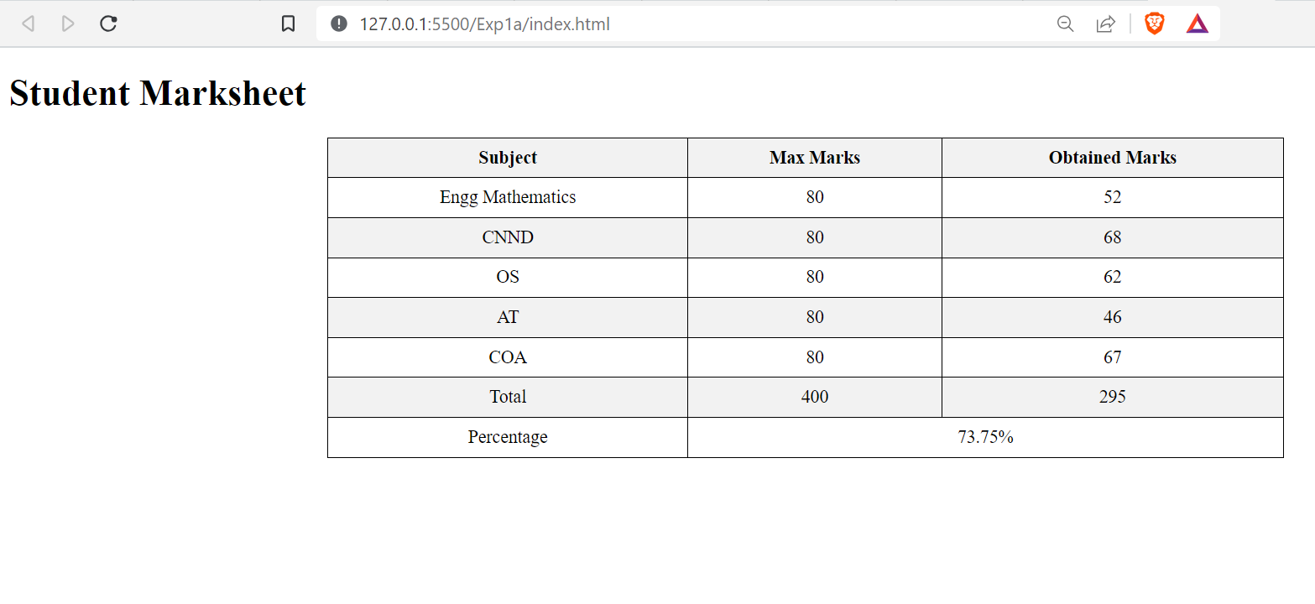

**Conclusion:**

In summary, the provided HTML code showcases how different HTML5 tags are used to structure and present content within a webpage.