**IP Exp 4**

**Shashwat Tripathi  
D15A 64**

**Batch C**

**Aim:** Experiment to study advanced features supported by CSS3.

**Theory:**

CSS3, which stands for Cascading Style Sheets Level 3, is the latest version of the CSS language used for styling web documents like HTML and XML. It introduced several new features and enhancements to its predecessors (CSS1 and CSS2), making it more powerful and versatile for web designers. Here are some basic concepts and features of CSS3:

1. Selectors: CSS3 provides a wide range of selectors that allow you to target HTML elements based on their attributes, relationship to other elements, and more. Common selectors include element selectors (e.g., p for paragraphs), class selectors (e.g., .my-class), and ID selectors (e.g., #my-id).
2. Box Model: The box model in CSS3 defines how elements are rendered in terms of content, padding, border, and margin. You can control the size and spacing of elements using properties like width, height, padding, margin, and border.
3. Colors and Backgrounds: CSS3 provides various ways to define colors, including named colors, hexadecimal values, RGB, RGBA (with transparency), and HSL. You can also set background colors and images using properties like background-color and background-image.
4. Typography: CSS3 allows you to control the typography of your web content by specifying fonts, font sizes, line heights, and text alignment using properties like font-family, font-size, line-height, and text-align.
5. Layout: CSS3 introduces advanced layout techniques, including:
   * Flexbox Layout: The Flexible Box Layout (Flexbox) model simplifies complex layouts by providing a more efficient way to distribute space among elements in a container.
   * Grid Layout: CSS Grid Layout allows you to create two-dimensional layouts with rows and columns, making it easier to create grid-based designs.
6. Transformations and Transitions: You can apply 2D and 3D transformations to elements, including scaling, rotating, skewing, and translating them in various ways. Transitions allow you to create smooth animations when properties change over time.
7. Animations: CSS3 supports keyframe animations, which let you define custom animations by specifying keyframes at different points in time. You can animate properties like transform, opacity, and more.
8. Media Queries: Media queries in CSS3 allow you to create responsive designs by specifying different styles for different screen sizes and devices. This is crucial for making websites that work well on both desktop and mobile devices.
9. Transparency and Opacity: CSS3 allows you to control the transparency of elements using the opacity property. RGBA and HSLA color notations also enable specifying colors with varying levels of transparency.
10. Rounded Corners and Shadows: CSS3 introduces properties like border-radius for creating rounded corners and box-shadow for adding drop shadows to elements.
11. Generated Content: CSS3 allows you to generate content before or after an element using the ::before and ::after pseudo-elements. This is often used for adding decorative elements or icons.
12. Box Shadow and Text Shadow: CSS3 allows for the creation of realistic shadows for elements, enhancing their visual depth and realism. Box shadow is used for elements like divs, while text shadow adds depth to text.
13. Border Radius: Border radius properties enable the creation of rounded corners for elements, offering design flexibility and reducing the need for complex background images or corner graphics.
14. Custom Fonts (Web Fonts): CSS3 supports the use of custom fonts, known as web fonts, which can be loaded from external sources like Google Fonts or self-hosted font files. This allows designers to choose unique typefaces for their websites.
15. Multiple Backgrounds: CSS3 enables the use of multiple background images and layers for an element. This is useful for creating intricate background designs and overlays.
16. Opacity and RGBA Colors: CSS3 allows for the control of element transparency using properties like opacity and rgba(). This is useful for creating semi-transparent elements and effects.
17. Gradient Backgrounds: CSS3 supports linear and radial gradients, allowing for the creation of smooth color transitions and gradients as background patterns.
18. CSS Variables (Custom Properties): CSS3 introduced custom properties, allowing designers to define and reuse their own variables for colors, fonts, and other styling properties. This improves code maintainability and flexibility.
19. Selectors: CSS3 introduced advanced selectors, such as attribute selectors, pseudo-elements (::before, ::after), and pseudo-classes (:nth-child, :not, :focus-within), providing more precise control over element targeting.

These are just some of the fundamental concepts and features of CSS3. It provides web designers with a powerful toolkit to control the layout and appearance of web pages, enabling the creation of visually appealing and responsive websites. CSS3 continues to evolve, with new features and modules being added to enhance web design capabilities further.

**Code:**

<!DOCTYPE html>

<html lang="en">

<head>

<meta charset="UTF-8" />

<meta name="viewport" content="width=device-width, initial-scale=1.0" />

<title>Travelo: Your world tourism guide</title>

<link rel="stylesheet" href="styles.css" />

</head>

<body>

<!-- Header Section -->

<header>

<nav>

<ul>

<li><a href="#">Home</a></li>

<li><a href="#">About Us</a></li>

<li><a href="#">Packages</a></li>

<li><a href="#">Destinations</a></li>

<li><a href="#">Contact</a></li>

</ul>

</nav>

<div class="hero">

<h1>Travelo: Your world tourism guide</h1>

<p>Your path to exploring the world starts here.</p>

<a href="#" class="cta-button">Vist Now</a>

</div>

</header>

<!-- Main Content Section -->

<section class="main-content">

<div class="sub-content">

<div class="sub-content1">

<div>

<h2>About Us</h2>

<p>

Welcome to Travelo, your ultimate guide to exploring the world's

most breathtaking destinations. Our mission is to inspire and

assist travelers in planning unforgettable adventures and

discovering hidden gems around the globe.

</p>

<p>

With years of travel experience and a deep passion for wanderlust,

our team of expert globetrotters curates the finest travel

resources and recommendations just for you. Whether you're a

seasoned traveler or embarking on your very first journey, we've

got something special in store for you.

</p>

</div>

<div>

<img class="img1" src="india.jpg" alt="India" />

</div>

</div>

<div>

<h3>Our Commitment</h3>

<p>At Travelo, we are committed to:</p>

<ul>

<li>Providing accurate and up-to-date travel information.</li>

<li>Showcasing diverse cultures, landscapes, and experiences.</li>

<li>

Offering tips and advice for responsible and sustainable travel.

</li>

<li>

Creating a welcoming and supportive community of fellow travelers.

</li>

</ul>

</div>

</div>

</section>

<!-- Footer Section -->

<footer>

<div class="footer-content">

<div class="footer-contact">

<h3>Contact Us</h3>

<address>

<p>Email: 2021.shashwat.tripathi@ves.ac.in</p>

<p>Phone: +91 98765 43210</p>

</address>

</div>

</div>

</footer>

</body>

</html>

**Website:**

This is the website created using advanced features of CSS3.

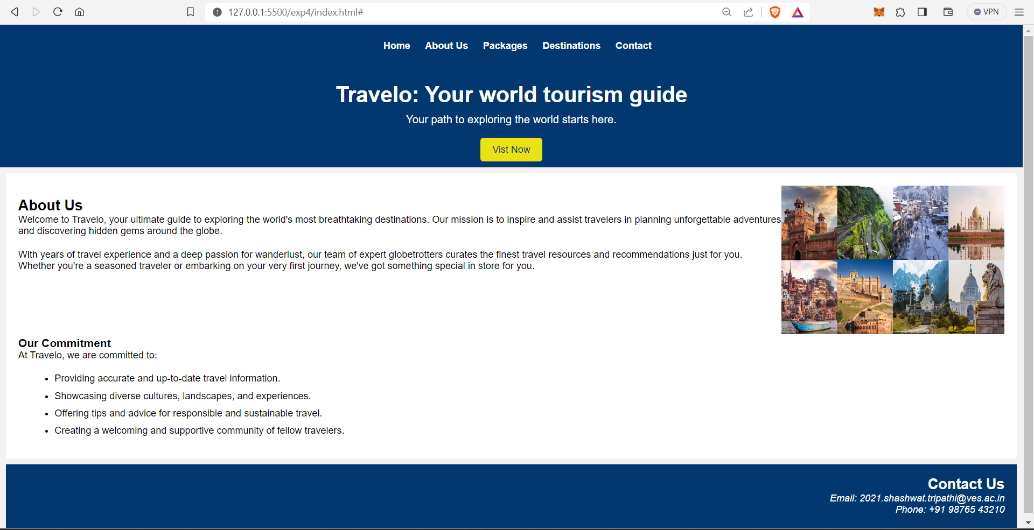

**Conclusion:**  
Thus, we have understood and implemented advanced features of CSS3 in our program and created a tourist website.