Module 1:

Introduction To Information Systems (IS):

Computer Based Infyormation Systems, Impact of IT on Organizations, Importance of IS to Society.

Organizational Strategy, Competitive Advantages, and IS.

introduction to MIS

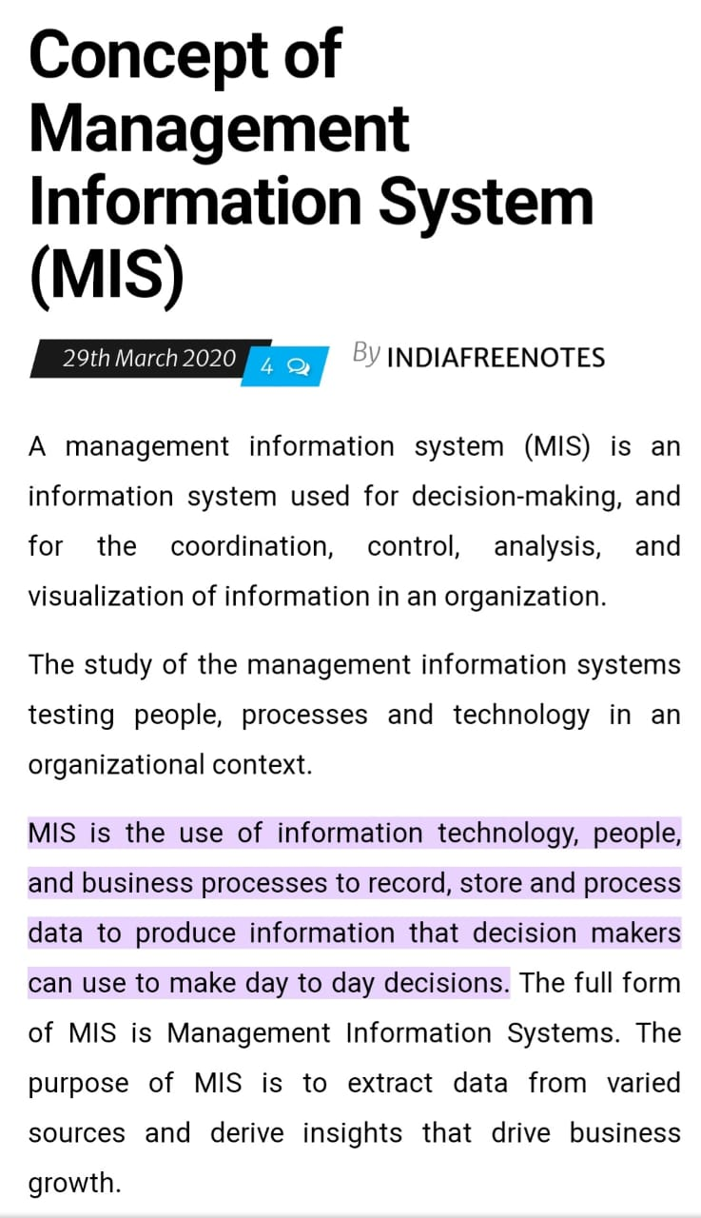

5 main components of MIS

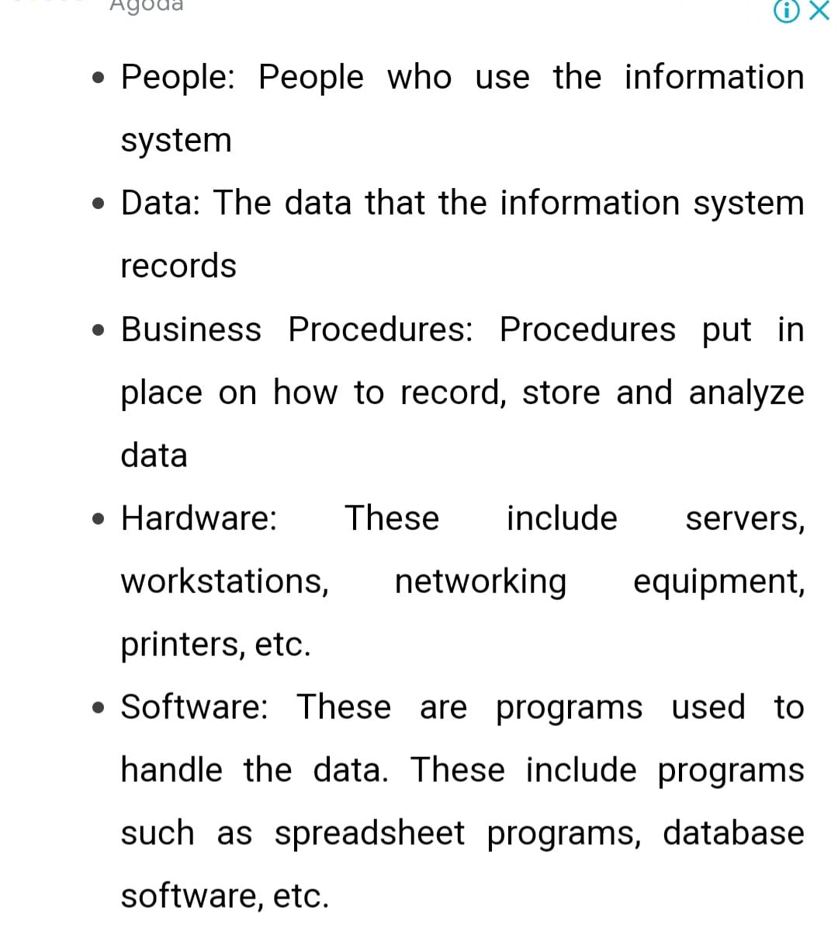

MIS functions

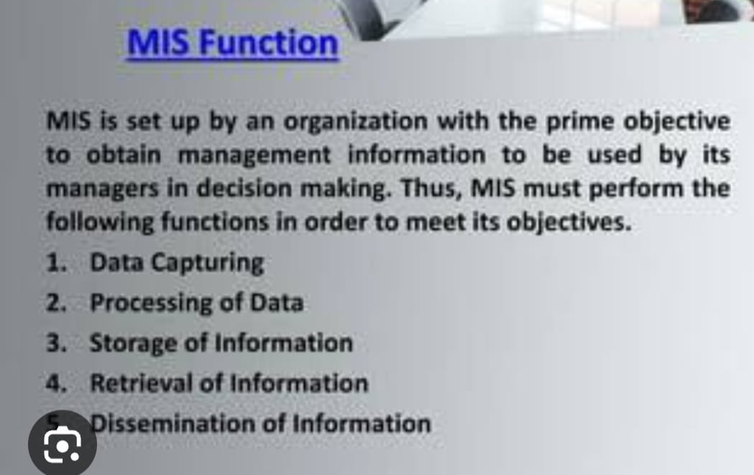

types of IS

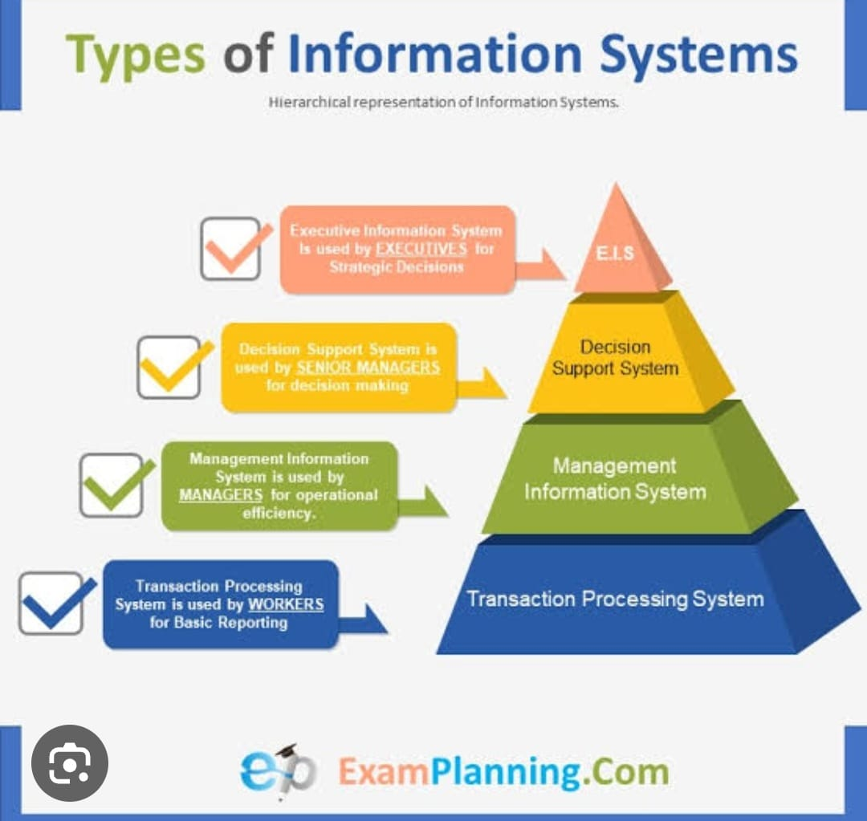

career in MIS / jobs

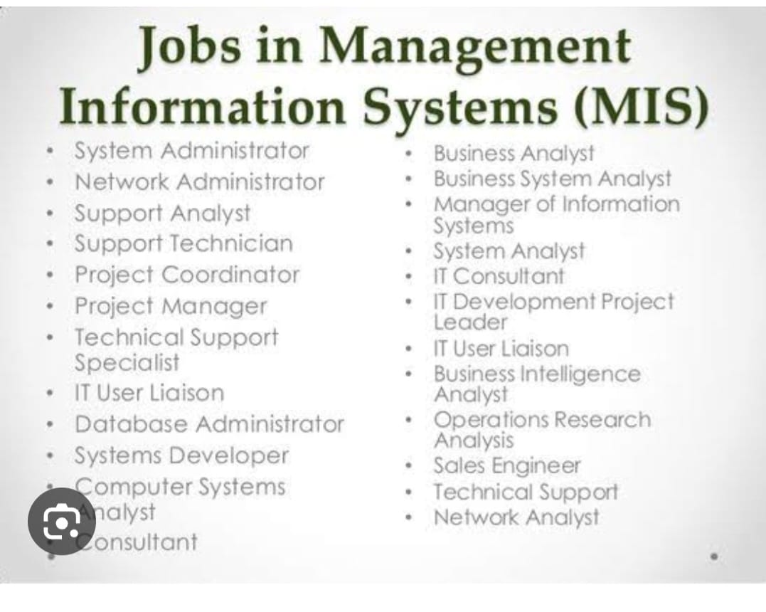

CBIS

CBIS types - TPS , MIS , DSS, ESS

Advantages / why CBIS r required

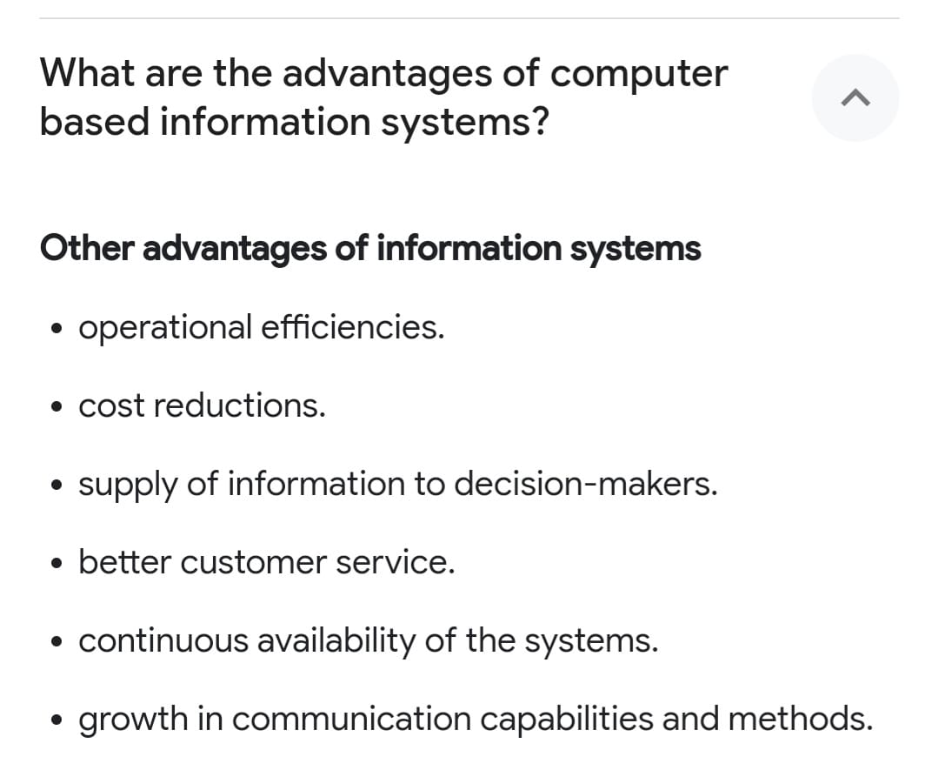

TPS

TPS application

MIS example

ERP enterprise resource planning

DSS decision support system

impact of IT on organisation & society

organisational strategy

4 ORGANISATIONAL strategy

E.g growth or cost cutting strategy

3 levels of strategy

porters model - competitive forced

Competitive advantage

e.g China labour cost is low , amazon e commerce

e.g differential adv - apple iphone

What is CBIS ?types

Compare TPS , MIS , DSS wrt application area.

What are the different Career opportunities in IT ?

What are the Objectives of studying MiS.

What is the importance of IS to society.

What are the levels of organisational strategy?

What is competitive advantage?give examples.

Draw & explain porters 5 force model for competitive advantage.

What is globalisation ?

What are Friedmans 10 flattners that changed the world.

Module 2:

Data and Knowledge Management: Database Approach, Big Data, Data warehouse and

Data Marts, Knowledge Management.

Business intelligence (BI): Managers and Decision-making, Bl for Data analysis and

Presenting Results

Module 3:

Ethical issues and Privacy: Information Security. Threat to IS, and Security Controls