Bitcoin Price Prediction

Shashwat Sharma

B21EE063

**I. INTRODUCTION**

Cryptocurrency is a type of digital or virtual currency that is used in financial systems. It is protected by cryptography, which prevents counterfeiting or double-spending. Cryptocurrencies are not issued by a central authority or central banks and can be converted through cryptographic procedures. There are hundreds of cryptocurrencies in digital marketplaces, but Bitcoin is the most popular and is affected and interacted with by external forces such as news, social media, and minor cryptocurrencies with a limited market share, which is frequently overlooked by investors and traders. Because of price volatility and dynamism, predicting cryptocurrency values is challenging. This report aims to showcase the performance of different machine learning algorithms i.e. Linear regression, Support Vector Regression, and Long Short Term Memory RNN in predicting future bitcoin prices.

***Dataset***

The file bitcoin.csv is used as the training dataset.

Number of samples: 1556

Number of features: 7

Bitcoin Prices are from April 2013 to July 2017

**II. METHODOLOGY**

***Overview***

There are various classification algorithms present out of which we shall implement the following

● *Linear Regression*

*● KNN*

*● Multilayer Perceptron*

*● Support Vector Machine*

*● Random Forest*

*● LightGBM*

*● LSTM*

***Exploring the dataset and pre-processing***

On counting the number of NULL values in the train dataset, it was found that there are 243 NULL values present which is around 15% of the samples, dropping the rows having null values would reault in loss of information, hence null values were interpolated using the ‘forward’ method. Next, converted the column containing Date string to Index column. Also created a column Difference, that contains difference between High and Low value of the sample. Then visualized the Open, Close, High and Low prices.

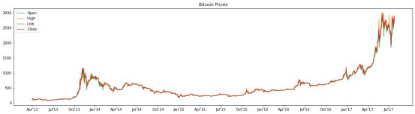Next, plotted the covariance matrix heatmap to check correlation among all the feature columns

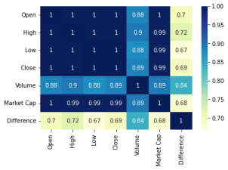

***Transforming the dataset and Implementation of dif erent algorithms***

1. Created a dataframe where Close price of 5 days is given as input and Close price of 6th day is to be predicted.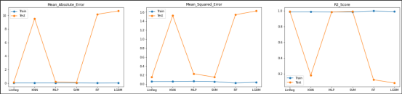

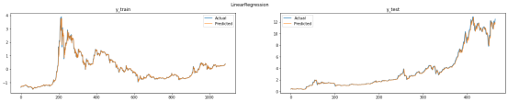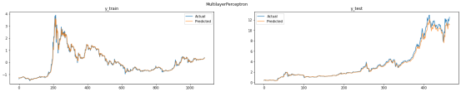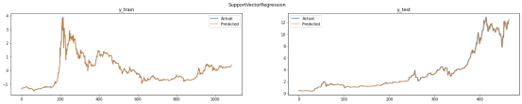

2. Created a dataframe Close Price of 25 previous days is given as input and Close price next 5 days is to be predicted.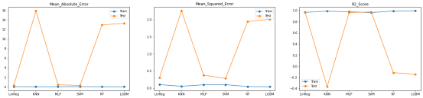

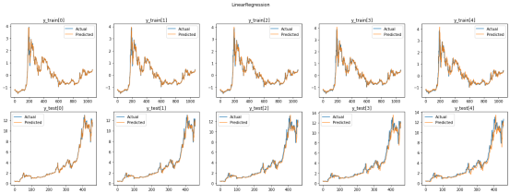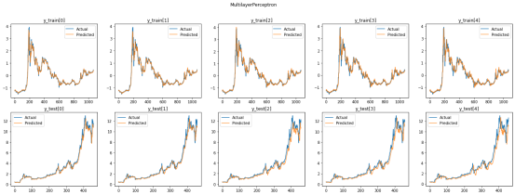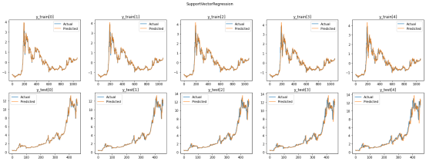

3. Created a dataframe where Close price of 5 days along with Difference (High - Low) is given as input and Close price of 6th day is to be predicted

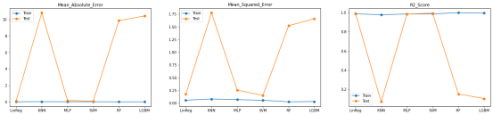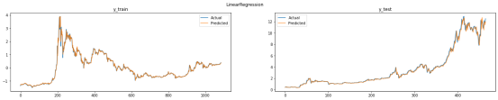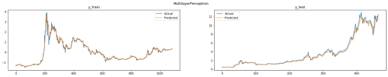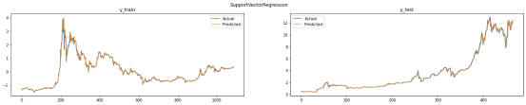

4. LSTM

Trained an LSTM model on Transformation 1 with following hyperparameters:

Epochs: 100

Batch size: 32

Optimizer: Adam

Loss: Root Mean Squared Error

Metrics: Mean Absolute Error

Activation: ReLu

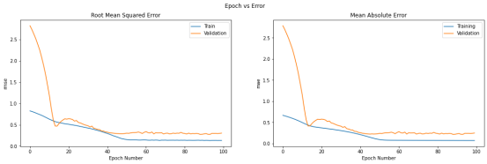

**III. EVALUATION OF MODELS**

Following table contains evaluation metrics of different models when applied on Transformation 1

|  | **Train Test** | | | |
| --- | --- | --- | --- | --- |
| MSE | MAE R2 MSE | MAE | R2 |
| **Linear Regression** | 0.013 | 0.055 0.986 0.087 | 0.156 | 0.992 |
| **KNN** | 0.012 | 0.056 0.987 9.541 | 1.525 | 0.180 |
| **MLP** | 0.016 | 0.063 0.983 0.231 | 0.263 | 0.980 |
| **SVM** | 0.014 | 0.054 0.985 0.082 | 0.146 | 0.993 |
| **Random Forest** | 0.002 | 0.024 0.997 10.348 | 1.558 | 0.111 |

**LightGBM** 0.009 0.041 0.990 10.674 1.626 0.083 **LSTM** 0.020 0.069 0.979 0.209 0.246 0.982

Linear Regression, MLP, SVM & LSTM - are the models that work great for bitcoin price prediction.

Random Forest and LightGBM tend to overfit greatly since they are ensemble models.



And KNN, the algorithm of selecting nearest neighbors and predicting value according to it, won’t work for bitcoin price prediction, since it tends to average out the high fluctuations in the graph



**IV. RESULTS AND ANALYSIS**

*The table shows that Linear Regression, MLP, SVM and LSTM performed equally good. SVM and Linear Regression outperformed the other models with R2_Score of 0.993 and 0.992 respectively.*