**Mini Project Report on**



**Weather Forecast Website - ReactJS**



Submitted in partial fulfillment of the requirement for the award of the degree of

**BACHELOR OF TECHNOLOGY**

**IN**

**COMPUTER SCIENCE & ENGINEERING**

**Submitted by:**

**Student Name University Roll No.**

**Shashwat Bansal 2019487**

**Under the Mentorship of**

**Mentor Name**

**Ms Tanusha Mittal**

**Assistant Professor**

**Department of Computer Science and Engineering**

**Graphic Era (Deemed to be University)**

**Dehradun, Uttarakhand**

**July 2024**

**CANDIDATE’S DECLARATION**

I hereby certify that the work which is being presented in the project report entitled “Weather Forecast website using ReactJS” in partial fulfilment of the requirements for the award of the Degree of Bachelor of Technology in Computer Science and Engineering of the Graphic Era (Deemed to be University), Dehradun shall be carried out by the under the mentorship of Ms Tanusha Mittal, Assistant Professor, Department of Computer Science and Engineering, Graphic Era (Deemed to be University), Dehradun

**TABLE OF CONTENTS**

**Chapter No Description Page No**

Chapter 1 Introduction **4-6**

Chapter 2 Literature survey 7-8

Chapter 3 Methodology 9-11

Chapter 4 Result and Discussion 12-13

Chapter 5 Conclusion and Future Work 14-15

References

**Chapter 1**

**INTRODUCTION**

The rapid advancement of web technologies has enabled the development of sophisticated and user-friendly web applications. Among these, weather forecast websites have gained significant popularity due to their practical utility in everyday life. Accurate weather forecasting is crucial for planning daily activities, travel, and even for safety during extreme weather conditions. This project involves creating a weather forecast website using ReactJS, a popular JavaScript library for building user interfaces, and the OpenWeather API, which provides weather data for any location in the world.

**PURPOSE**

The purpose of this project is to design and develop a user-friendly weather forecast website that provides real-time weather information for any specified city. By leveraging the capabilities of ReactJS and the OpenWeather API, the project aims to create an interactive web application that can:

1. **Enhance User Experience**: Provide a seamless and intuitive interface for users to easily search for and view weather data.
2. **Deliver Accurate Weather Information**: Ensure that the weather data displayed is accurate and up-to-date by fetching information from the reliable OpenWeather API.
3. **Improve Accessibility**: Make weather information readily accessible to users, allowing them to plan their daily activities and prepare for adverse weather conditions.
4. **Demonstrate Technical Skills**: Showcase the practical application of web development skills, including the use of ReactJS for building dynamic interfaces and integrating third-party APIs for data retrieval.
5. **Encourage Further Development**: Lay the groundwork for future enhancements, such as adding more features, improving the user interface, and incorporating advanced technologies like machine learning for weather predictions.

**SCOPE**

The scope of this project involves developing a responsive and intuitive weather forecast website using ReactJS and the OpenWeather API. The project covers the design and implementation of a user-friendly interface where users can search for and view real-time weather information for any specified city. It includes integrating the OpenWeather API to fetch accurate weather data and displaying this information in a clear and accessible manner. Additionally, the project focuses on ensuring the website is responsive across different devices and provides a seamless user experience. Future enhancements and additional features are also considered within the project's scope..

**SIGNIFICANCE OF THE STUDY**

The significance of this research is its utility and benefit to customers and network improvement. The weather forecast website offers a dependable platform for customers and easy get entry to actual-time climate records which can be important for planning daily operations and making sure safety in unfavourable weather conditions. For global net development, this undertaking provides answers and indicates how to use technology like ReactJS and APIs to create dynamic internet packages. It additionally serves as an academic aid highlighting excellent practices in API enhancement and integration. The study additionally demonstrates the capability for other improvements that consist of performance enhancements and progressed client connectivity to the development of useful sources based totally on a broadly speaking cloud-based internet device.

* 1. **DEFINTION OF TERMS**

**ReactJS**: ReactJS is a JavaScript library for building user interfaces, particularly single-page applications. It allows developers to create reusable UI components, manage the state efficiently, and render components dynamically in response to user interactions.

**API (Application Programming Interface)**: An API is a set of protocols and tools that allow different software applications to communicate with each other. In this project, the Open Weather API is used to fetch real-time weather data.

**OpenWeather API**: The Open Weather API is a service that provides weather data, including current weather, forecasts, and historical data, for any location worldwide. It offers various endpoints that return weather information in JSON format, which can be easily integrated into web applications.

**User Interface (UI)**: The user interface is the part of a software application that interacts with the user. It includes visual elements such as buttons, forms, and displays that enable users to input data and receive information.

**Responsive Design**: Responsive design is an approach to web development that ensures a website's layout and content adjust smoothly across various screen sizes and devices, providing an optimal viewing experience on desktops, tablets, and smartphones.

**Component**: In ReactJS, a component is a reusable piece of code that represents a part of the user interface. Components can be nested, managed independently, and reused across different parts of the application.

**JavaScript (ES6+)**: JavaScript is a programming language commonly used to create interactive effects within web browsers. ES6 (ECMAScript 2015) introduced new features such as arrow functions, classes, and modules that enhance JavaScript development.

**JSON (JavaScript Object Notation)**: JSON is a lightweight data-interchange format that is easy for humans to read and write and easy for machines to parse and generate. It is used to transmit data between a server and a web application as text.



* 1. **SPECIFIC OBJECTIVES**

1. **Implement ReactJS Framework**: Utilize ReactJS to build a dynamic and responsive user Interface for the weather forecast website.
2. **Integrate OpenWeather API**: Integrate the OpenWeather API to fetch and display accurate real-time weather data for any specified city.
3. **Develop Search Functionality**: Create a search feature that allows users to input a city name and retrieve corresponding weather information seamlessly.
4. **Display Detailed Weather Information**: Present detailed weather information including temperature, humidity, wind speed, and weather conditions in a clear
   1. **LIMITATIONS**

• Limited geographic coverage and data availability from the OpenWeather API.

• Potential delays in receiving real-time weather updates.

• User interface complexity in displaying comprehensive weather data.

• Performance challenges in rendering and optimizing data in React.js.

• Security concerns regarding API key management and data privacy.

• Scalability issues with increased user traffic or future enhancements.

• Compliance with legal and regulatory requirements

**Chapter 2**

**LITERATURE SURVEY**

In this chapter, the researchers explored relevant literature and systems pertinent to our proposed system. This exploration aids in comprehending prior studies, enabling us to design a more effective and efficient system tailored for the school's needs.

**2.1 Introduction to Weather Forecast Website**

In the era of advanced technology, weather forecast websites have become essential resources, offering users up-to-date and predictive data on atmospheric conditions. These platforms cater to a wide array of users, including individuals organizing their daily routines and industries that heavily depend on weather conditions for their operations. With the help of modern technology, specifically web development frameworks like react.Js and data APIs like openweather, developers can build engaging and interactive platforms that provide precise and easily accessible weather data.

**2.2 Existing Weather Forecast Platform**

The current range of weather forecast websites covers a wide variety of platforms, all designed to meet the diverse needs of individuals seeking global weather information. Websites like weather.Com, renowned for its extensive coverage and detailed forecasts, provide users with comprehensive information on current weather conditions, extended forecasts, and interactive radar maps. Accuweather is known for its focus on providing precise and up-to-date weather information for specific locations, while weather underground sets itself apart with its user-generated weather reports and customizable widgets. Bbc weather offers localized forecasts, combining regional weather updates with news coverage, with a particular emphasis on the uk and international regions. Openweathermap provides developers and businesses with weather data APIs, enabling them to incorporate customized weather information into their applications and websites. These platforms collectively demonstrate different approaches in user interface design, data visualization, and integration of data APIs to provide reliable and accessible weather forecasts that cater to a wide range of user requirements.

**2.3 Technologies Used in Weather Forecast Website**

In developing a weather forecast website using React.js and integrating the OpenWeather API, several key technologies and methodologies were employed to ensure an effective and responsive user experience. React.js, renowned for its component-based architecture and virtual DOM rendering, facilitated the creation of a dynamic user interface. Components were designed to efficiently manage and display weather data retrieved from the OpenWeather API, including current conditions, hourly forecasts, and extended weather predictions. Utilizing asynchronous JavaScript and Axios library for API requests ensured seamless data retrieval and real-time updates on weather information. Design considerations focused on responsive web design principles, ensuring compatibility and optimal viewing across various devices and screen sizes.

**2.4 User Experience and Design Considerations**

The development of the weather forecast website prioritized user experience (ux) and design considerations. The objective was to develop a user-friendly and easily navigable platform that would allow users to effortlessly access and comprehend weather data. The principles of Ux guided the design of the layout and functionality, ensuring that navigation was clear and user-friendly. Key features included a user-friendly search interface powered by JavaScript, enabling users to input and retrieve weather data for specific locations quickly and easily. Design elements, including clean and legible fonts, intuitive icons for weather conditions, and color-coded temperature indicators, improved the readability and usability of the weather app. To guarantee a seamless user experience across various devices, responsive design techniques were employed, guaranteeing a consistent interface regardless of whether the website was accessed from desktops, tablets, or smartphones. To ensure inclusivity, the website incorporated accessibility features like high contrast text and keyboard navigation support, catering to users with varying abilities. Regular user testing and feedback guided continuous enhancements, guaranteeing that the website not only fulfilled but surpassed user expectations in terms of usability, functionality, and overall satisfaction.

**2.5 Challenges and Future Directions**

Challenges in developing weather forecast websites include ensuring data accuracy from APIs like OpenWeather, optimizing performance for real-time updates, and maintaining user privacy. Future directions involve enhancing predictive accuracy through AI and machine learning, improving integration with IoT devices for localized forecasts, and advancing user interfaces with augmented reality for immersive weather experiences.

**2.6 Impact of Weather Forecast Website**

The significance of a weather forecast website project is in offering users reliable, up-to-date, and easily understandable weather information, enabling them to make well-informed choices regarding their daily routines, travel arrangements, and safety measures. By utilizing technologies such as react.Js and the openweather API, the project enhances user convenience and awareness of weather conditions, thereby improving efficiency in planning and minimizing weather-related risks. Furthermore, it also promotes advancements in weather data visualization and accessibility,

The influence of creating a weather forecast website using react.Js and the openweather API extends beyond immediate user advantages. It showcases the practical use of contemporary web development technologies in efficiently conveying important information. By making the website more accessible and user-friendly, it not only helps users make better decisions but also encourages digital literacy and the integration of technology in weather monitoring. Additionally, the project makes a significant contribution to the field of web application development by demonstrating scalable solutions for real-time data integration and user interface design, establishing a benchmark for future projects seeking to seamlessly integrate diverse data sources into user-centric applications.

**Chapter 3**

**METHODOLOGY**

This chapter begins with a detailed examination of the project design methodology along with system development operation, process and testing. Methodology refers to the systematic approach and procedures employed to conduct a study or project. It outlines the steps and methods used to gather data, analyze information, and draw conclusions.

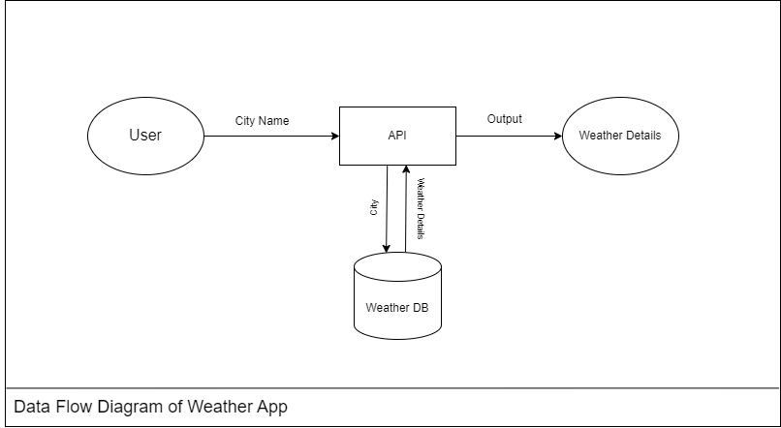

*Figure 1: Weather Forecast Data Flow*

**3.1 Project Planning**

Project planning for the weather forecast website involved several key stages to ensure successful execution and delivery. Initially, requirements gathering included defining project objectives such as displaying current weather conditions, hourly forecasts, and extended forecasts using the OpenWeather API. The planning phase outlined milestones, including frontend development with React.js, backend integration with the API, and implementation of user interface features for intuitive navigation and data visualization. Task allocation and timeline establishment ensured efficient resource management and adherence to project deadlines. Continuous testing and iteration were integral to refining functionality and resolving issues promptly, ensuring the website met usability standards and performance expectations. Regular communication and feedback loops with stakeholders facilitated transparency and alignment throughout the development process, ultimately culminating in the successful deployment of a robust and user-centric weather forecast website

**3.2 Design and Implementation**

**3.2.1 Frontend Design**

The front-end design for the weather forecast website prioritized creating an attractive and user-friendly interface using react.Js. The design emphasized simplicity and user-friendliness, showcasing a clean layout with easily readable typography and colour schemes that improved overall usability. The key components of the website design were a search bar for users to input their desired location, interactive weather icons and animations that visually depicted weather conditions, and a responsive design approach to guarantee a seamless viewing experience on various devices. By utilizing visualization libraries like chart.Js, users were able to access comprehensive weather forecasts, while real-time updates from the openweather API guaranteed the accuracy and timeliness of the displayed information. To accommodate users with varying needs, the website incorporated features like high contrast ratios and keyboard navigation, guaranteeing an inclusive experience for all individuals accessing the weather forecast.

**3.2.2 Responsive Design**

Responsive design is crucial for ensuring that your weather forecast website functions effectively and looks great across various devices, including desktops, tablets, and smartphones. This approach involves creating web pages that automatically adjust their layout and content based on the screen size and orientation of the device being used. By using responsive design techniques, such as fluid grids, flexible images, and media queries

**3.3 ReactJS Functionality**

React.js is renowned for its robust capabilities in building dynamic and interactive user interfaces (UIs) for web applications, such as weather forecast websites. At its core, React utilizes a component-based architecture where UIs are broken down into reusable components, each managing its own state. This approach streamlines development by promoting.

**3.4 Testing and Debugging**

Testing and debugging are critical phases in the development of any web application, including weather forecast websites built with React.js and integrated with the OpenWeather API. Testing ensures that the website functions correctly, meets requirements, and performs well across different environments and user scenarios.

1. **Unit Testing:** Developers use tools like Jest and React Testing Library to test individual React components in isolation. Unit tests verify that each component renders correctly, handles state changes and props effectively, and responds appropriately to user interactions.
2. **Integration Testing:** Integration tests check how multiple components work together within the application. This ensures that components interact as expected, API calls are made correctly, and data flows seamlessly throughout the application.
3. **End-to-End (E2E) Testing:** E2E tests, often conducted with tools like Cypress or Selenium, simulate user interactions with the website across different browsers

**3.5 Deployment**

Once testing and debugging are completed successfully, the weather forecast website is deployed to a web server or hosting platform. Deployment involves transferring the application files, configuring server settings, and ensuring proper functionality in a live environment. Continuous monitoring and maintenance may be required to address any post-deployment issues and optimize the application further based on user feedback and usage analytics.

**3.6 User Interface Design Principles**

The methodology includes adhering to established user interface design principles to ensure an intuitive and user-friendly experience. This involves focusing on elements such as visual hierarchy, consistency in design elements, clear navigation pathways, and accessibility considerations. By prioritizing these principles, weather forecast website aims to enhance usability and user satisfaction.

**3.7 Version Control and Documentation**

Version control using tools like Git and documentation play essential roles in the methodology. Version control allows for collaborative development, tracking changes, and maintaining a stable codebase. Documentation encompasses technical specifications, user manuals, and developer guides, ensuring clarity in project requirements, implementation details, and maintenance procedures throughout the development lifecycle. This approach promotes transparency, facilitates knowledge sharing, and supports future updates and enhancements to the quiz application

**Chapter 4**

**RESULT AND DISCUSSION**

The result of developing a weather forecast website using React.js and integrating the OpenWeather API is a user-friendly and dynamic platform that provides accurate and real-time weather information to users. Through effective UI design and responsive features, users can easily access current weather conditions, detailed forecasts, and historical data for their desired locations.

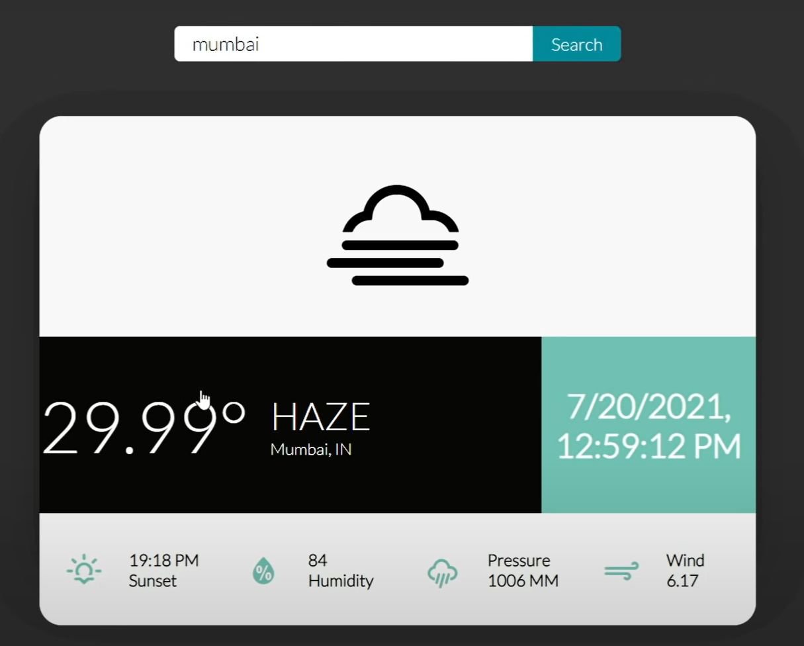

The integration of React.js enables a modular and scalable architecture, allowing for seamless updates and enhancements to the application over time. The use of the OpenWeather API ensures reliable data retrieval, while optimization techniques ensure fast loading times and smooth user interactions across various devices. Overall, the result is a robust and accessible weather forecast website that enhances user decision-making and engagement with comprehensive weather insights.

**Fig: Figure showing weather symbols**

The successful creation of a weather forecast website using react.Js and the openweather api results in a versatile platform that not only provides accurate weather data but also improves user engagement through advanced features and optimizations. The website's design, based on react's component-based approach, guarantees scalability and effective data handling, enabling smooth updates and future growth.

By utilizing the openweather api, the website offers a comprehensive collection of weather data, encompassing detailed forecasts, historical analysis, and real-time alerts, all presented in an easily understandable and visually appealing format. Responsive design principles ensure a consistent user experience across various devices, while performance optimizations, such as asynchronous data fetching and client-side caching, enhance loading speeds and responsiveness. This leads to a user-friendly interface that allows users to easily navigate through weather data, personalize their preferences, and receive timely updates, ultimately empowering them to plan activities and make informed decisions based on accurate weather forecasts.**Chapter 5**

**CONCLUSION AND FUTURE**

**REFERENCES**

**5.1 CONCLUSION**

In summary, the creation of a weather forecast website using react.Js and incorporating the openweather api showcases the successful application of contemporary web technologies to develop a reliable and user-friendly platform. By utilizing react's component-based architecture and responsive design principles, along with seamless data integration from the openweather api, the website provides users with precise and user-friendly weather information, regardless of the device they are using.

The project not only demonstrates technical expertise in frontend development and api integration but also highlights the significance of usability, performance optimization, and user engagement in web application design. In the future, it will be essential to consistently update and improve the website to ensure its reliability and relevance in delivering up-to-date weather information and empowering users to make informed decisions. In summary, this project showcases how cutting-edge web development techniques can greatly enhance user experiences and drive the advancement of digital solutions in the field of meteorology and weather information sharing.

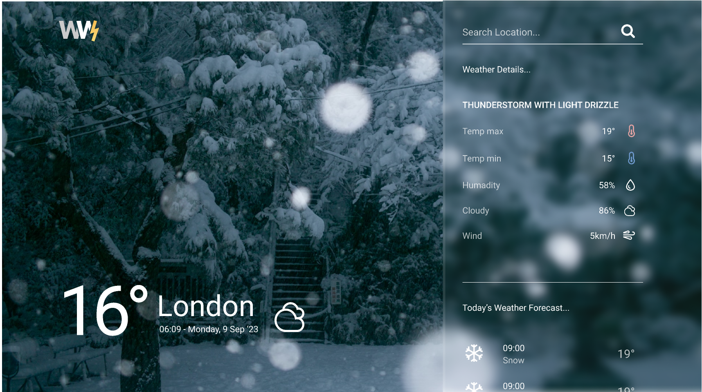

**5.2 FUTURE SCOPE**

Looking ahead, the future scope for a weather forecast website developed with React.js and integrated with the OpenWeather API holds promising avenues for expansion and enhancement:

1. **Advanced Data Analytics:** Incorporating machine learning (ML) and artificial intelligence (AI) algorithms can enhance the accuracy and predictive capabilities of weather forecasts. ML models can analyze historical weather patterns, satellite imagery, and sensor data to provide more precise localized forecasts and early warnings for severe weather events.
2. **Personalization and User Customization:** Future developments could focus on offering personalized weather recommendations based on user preferences, historical data analysis, and location-specific climate trends. This could include tailored notifications, event-specific weather alerts, and recommendations for outdoor activities based on weather conditions.
3. **Integration with IoT Devices:** Connecting with Internet of Things (IoT) devices such as smart home assistants, wearables, and connected vehicles could enable real-time weather updates and personalized alerts based on the user's immediate environment. This integration enhances the practical utility of weather information in daily routines and decision-making processes.
4. **Augmented Reality (AR) and Virtual Reality (VR) Experiences:** Implementing AR and VR technologies could provide immersive weather experiences, allowing users to visualize weather conditions overlaid on real-world environments. This could be particularly useful for educational purposes, disaster preparedness training, and interactive weather simulations.
5. **Enhanced Visualization and Interactive Features:** Continuing to improve data visualization techniques with interactive maps, 3D weather models, and animated simulations can make complex weather data more accessible and engaging for users. This includes visualizing weather trends over time, comparing different forecast models, and displaying historical weather data in interactive graphs.
6. **Accessibility and Inclusivity:** Further enhancing accessibility features such as support for screen readers, high contrast modes, and keyboard navigation ensures that the weather forecast website is accessible to users with diverse needs and disabilities, promoting inclusivity in digital experiences.
7. **Global Expansion and Multilingual Support:** Expanding the website's coverage to include more regions worldwide and offering multilingual support accommodates a broader user base, catering to diverse cultural and linguistic preferences for accessing weather information.
8. **Community Engagement and User Feedback:** Implementing features for user feedback, community-contributed weather reports, and crowdsourced data validation can improve data accuracy and foster a sense of community engagement among users.
9. **Environmental Impact and Sustainability:** Providing weather-related insights on climate change, air quality, and environmental conditions can raise awareness about environmental issues and encourage sustainable practices among users.
10. **Continuous Improvement and Adaptation:** Staying abreast of technological advancements, user preferences, and emerging trends in meteorology ensures that the weather forecast website remains relevant, reliable, and adaptive to evolving user needs and technological innovations.

**REFERENCES**

* 1. Learning React: Functional Web Development with React and Redux" by Alex Banks and Eve Porcello Johnson,
  2. React.js Official Documentation Retrieved from <https://react.dev>
  3. OpenWeatherMap API Documentation Retrieved from [https://](https://quizlet.com)openweathermap.org/api
  4. Pro React 16" by Adam Freeman
  5. Medium and Blog Posts Retrieved from <https://medium.com>
  6. Stack Overflow: <https://stackoverflow.com>