GIT

Version Control System (VCS) is a software that helps software developers to work together and maintain a complete history of their work.

Listed below are the functions of a VCS:

Allows developers to work simultaneously.

Does not allow overwriting each other’s changes.

Maintains a history of every version.

Following are the types of VCS:

Centralized version control system (CVCS). (Not good since 'single point of failure')

Distributed/Decentralized version control system (DVCS) (DVCS clients not only check out the latest snapshot of the directory but they also fully mirror the repository. If the server goes down, then the repository from any client can be copied back to the server to restore it. Every checkout is a full backup of the repository.)

Git does not rely on the central server and that is why you can perform many operations when you are offline. You can commit changes, create branches, view logs, and perform other operations when you are offline.

**Advantages**:-

* Free and Open Source- Source code can be downloaded and changes can be made accordingly
* Fast and Small – Speed since most actions are performed locally. Though Git mirrors entire repository, the size of the data on the client side is small. This illustrates the efficiency of Git at compressing and storing data on the client side
* Security- Git uses a common cryptographic hash function called secure hash function (SHA1), to name and identify objects within its database.
* No need for powerful hardware- The Devs don’t interact with server unless for pushing/pulling code. The actions are generally on the client side system hence the server hardware can be simple.
* Easier Branching- Takes less time compared to CVCS (uses cheap copy mechanism i.e. any new branch created from and older one copies all the existing content to the new branch). Creating, deleting and merging branches takes less time in Git.

After installing GIT we use the **‘git init’** command in the source location. This cmd is used to initiate tracking folders and files. This creates a **‘.git’** folder at the location.

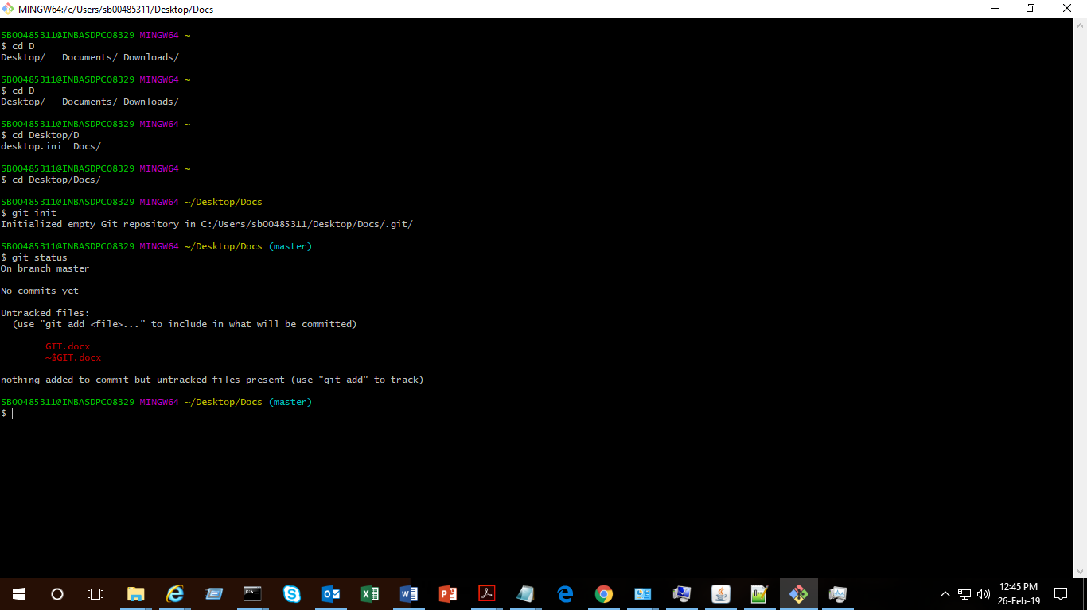

Fig1: gitbash UI for initializing and checking the status of new changes

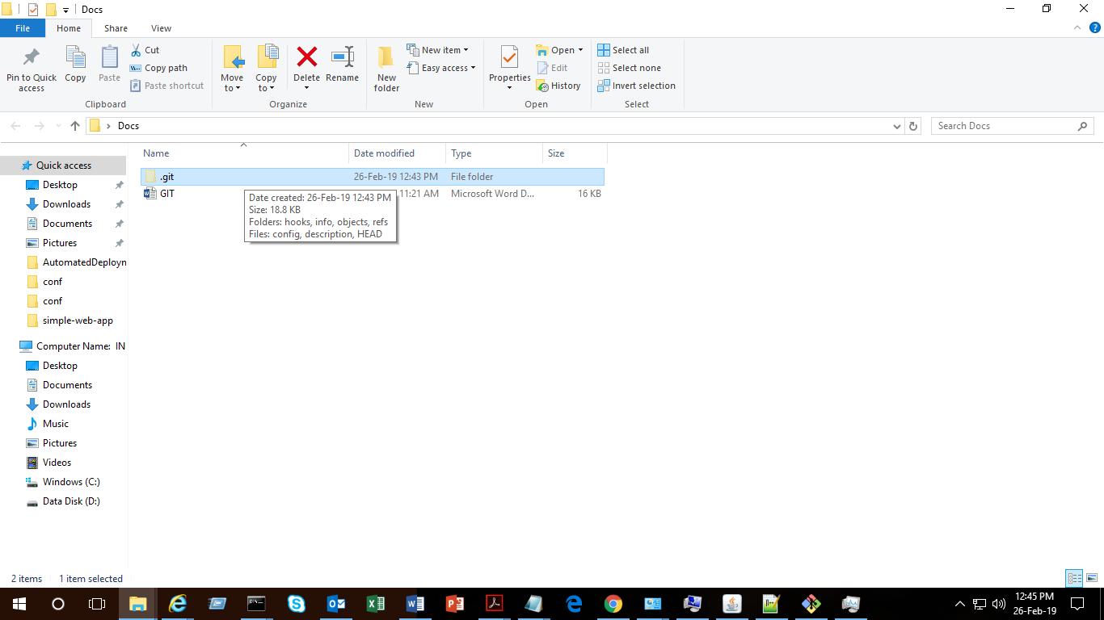

Fig2: .git folder is formed at the source location which contains the info on the repo

Using the **‘git status’** cmd we can see the status of the files at the location. It tells us about the changes that haven’t been added to staging yet. (Can be seen in the Fig1)

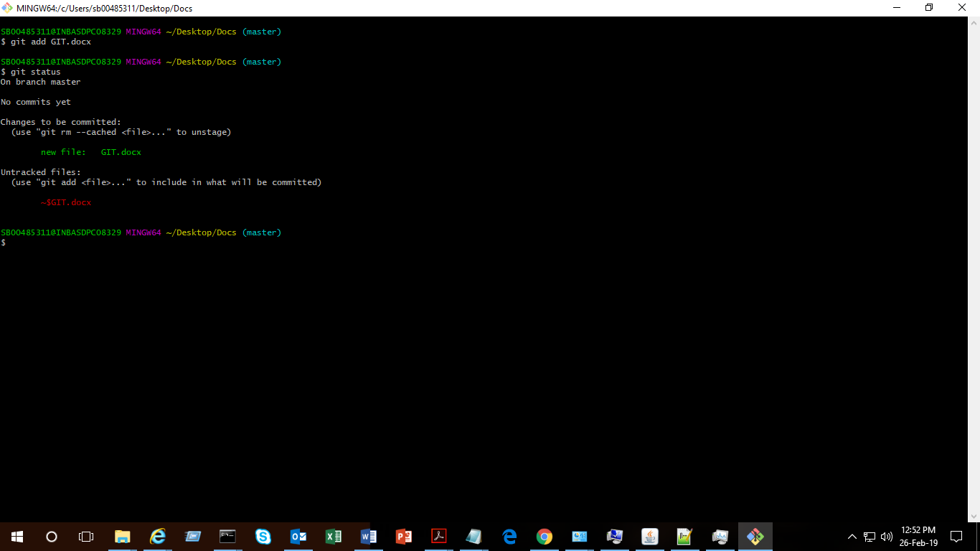

Fig2: using **‘git add *’** cmd

We use the ‘git add’ cmd to add the files.

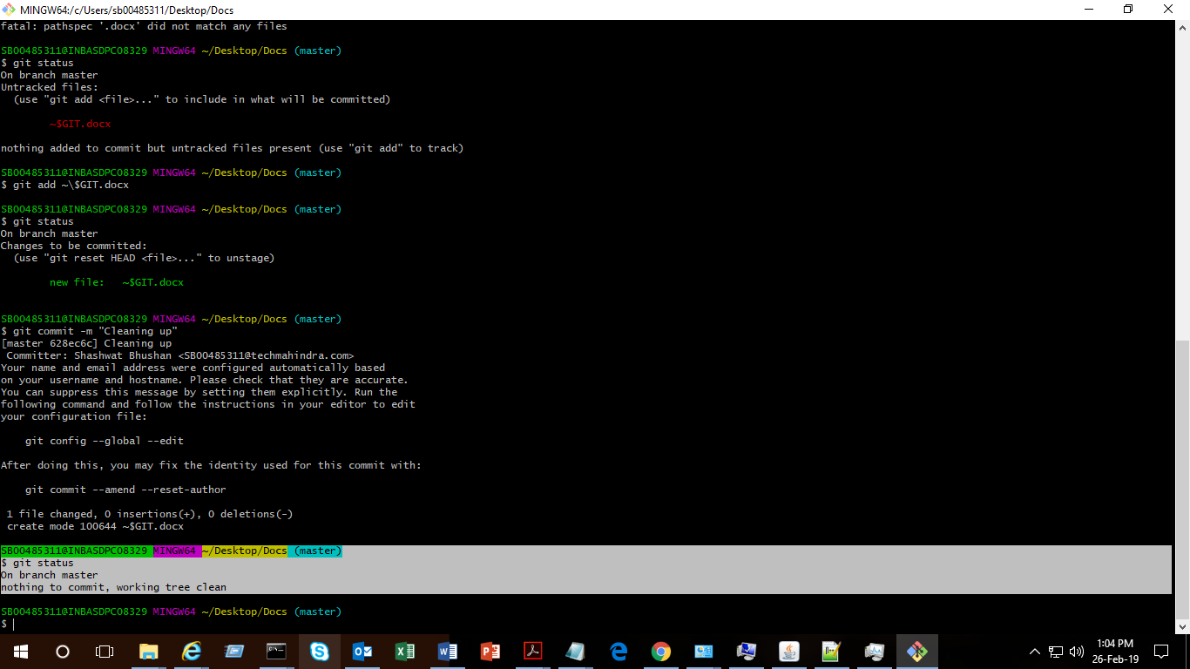

Fig3: Using **‘git commit’** command