**RESUME**

**SHASHWAT GANESH PUJARI** 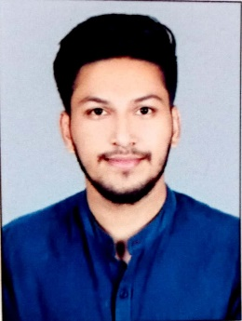

Email ID: shashwatpjr123@gmail.com

Contact No. +91 9890691620

+91 7743936218

**CAREER OBJECTIVE:**

Attaining a job and working with challenging position that will effectively utilize my skills, abilities to provide mutual growth and enhancement

**EDUCATIONAL QUALIFICATION:** 2021: MBA:Completed Masters in business management with the specialization in finance from Malla Reddy Institute of Management Hyderabad. Passed with first class from Osmania University Hyderabad. 2019:

B. Com: Completed graduation in commerce with the specialization in Cost and Works Accounting from MIT College Kothrud Pune. Passed with Second Class from Savitribai Phule Pune University.2015:

H.S.C: Pratibha Niketan college, Nanded.2013:

S.S.C: Pratibha Niketan high school, Nanded.

**WORK EXPERIENCE:**

**Financial Analyst**

**Genpact**

06/2021 – Present

* Maintained and monitored the fund and equity investments, data parsing from statements into excel sheets, data Management, ad hoc extraction and validation.
* Used to maintain positions and activity of daily, monthly and quarterly Feed and non-feed accounts data, Owner of the UAT portal.
* Worked on Securities processes like Securities Adjustments, Corporate Actions, Trade Operations and Pricing Concepts.

**OTHER QUALIFICATION:**

* Financial Modeling & Fundamental Analysis Certification.
* Completed P2P, O2C, R2R training along with SAP overview from Global Talent Track (GTT).
* Completed Tally ERP with ‘A’ grade.
* Completed MS-CIT with 88%.
* Typing speed English 30,40 And Marathi 30.

**SKILLS:**

* Good Communication
* Good listener
* Problem Solving
* Teamwork
* Competent

**CO-CURRICULAR ACTIVITIES:**

* Participated in state level U16 Football tournament(winner).
* Participated in College activities(sports).
* Volunteer work with The Art of Living.

**PERSONAL INFORMATION:**

Name: Shashwat Ganesh Pujari

Father’s Name: Ganesh Manohar Pujari

Address: B/127, Shobha Nagar police housing society, Nanded-431605.

Date of Birth: 30-01-1998

Marital Status: Unmarried  
Nationality: Indian

Languages Known: English, Hindi, Marathi

Hobbies: Playing cricket and football, Watching Tv series, Listening music

**DECLARATION**

I hereby declare that all the information mentioned here is true to the best of my knowledge and belief.

Date:

Place:

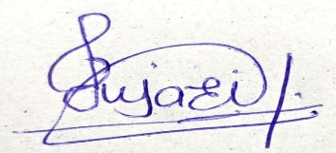

**Shashwat Ganesh Pujari**