**CP2406 Task 1 Name: Shashwat Shikhar**

**User Stories:**

User story 1

As a user, I want the vehicles to not collide with other vehicles on road so that the simulator runs freely without any hindrance. Priority is high and estimation time is 2 days. For testing, looking vehicles carefully while the simulator is running.

User story 2

As a user, I want the facility to add road and to decide where to add road which is as long as the length entered by me. Priority is high and estimate time is 3 days. For testing click on the frame from where you want to add the road, enter the length of the road and then add road finally and see the road where and how long it appears.

User story 3

As a user, I want direction indicator when adding road so that I am able to decide the direction of the traffic on the road. Priority is high and estimate time is 2 days. For testing choose the direction before adding the road and then add the road.

User Story 4

As a user, I want start and exit button in the simulator so that I am able to control when I want to start and exit the simulator. Priority is medium and estimate time is 1 day. For testing click the start button to see that the traffic starts and click on exit button to exit the simulator.

User Story 5

As a user, I should be able to add as many vehicles as I can within various vehicles options where all vehicles should be distinguished so that I am able to identify vehicles and be able to control how many vehicles I place on road. Priority is medium and estimate time is 2 days. For testing click on add vehicles button and see when more vehicles appear.

User Story 6

As a user, I should be able to decide where the road should be vertical or horizontal and also be able to remove the roads that I add. Priority is high and time estimate is 3 days. For testing click on the option vertical or horizontal as you would like to add the road and for removing the road click on remove road button and see the changes.

User Story 7

As a user, there should be traffic light rule to regulate traffic properly. Priority is high and time estimate is 2 days. For testing, run the simulator and see the change of colour of traffic light and that the traffic stops when colour is red whereas the traffic is resumed when colour is green.

**UML Diagram:**

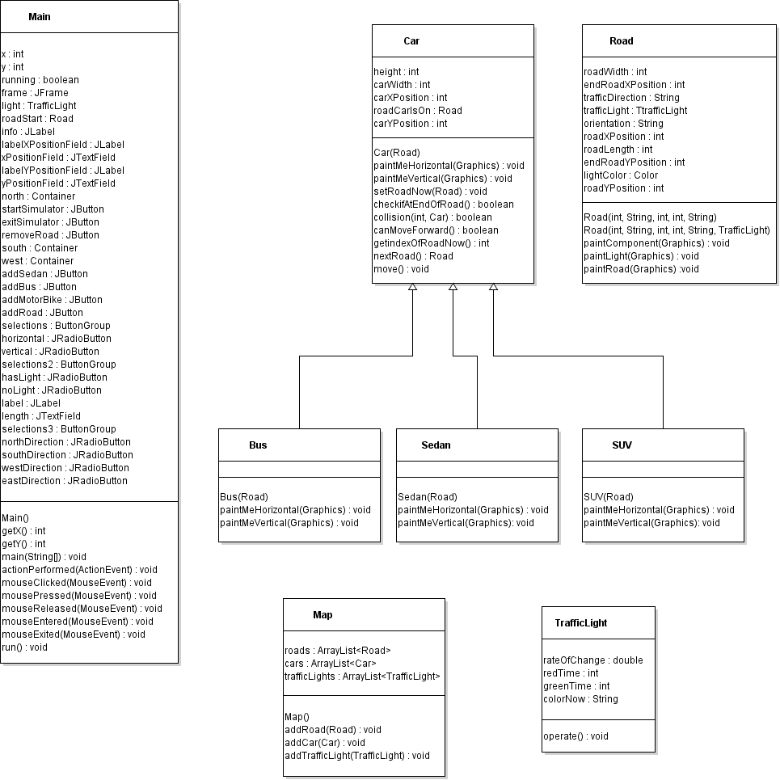

**GitHub Screenshot:**