LAB RECORD
OF
JAVA PROGRAMMING
(CSN 203)

BACHELOR OF TECHNOLOGY
IN
COMPUTER SCIENCE AND ENGINEERING



Session 2025-26

Submitted To: | Submitted By:
Dr. Deepshikha | Name:- Shashwat Singh
Assistant Professor | Roll No :- 24A09D0665
School of Computing | SAP ID :-1000024207
DIT University | Section/Batch :- B.Tech CSE(A)

SCHOOL OF COMPUTING
DIT UNIVERSITY, DEHRADUN
(State Private University through State Legislature Act No. 10 of 2013 of Uttarakhand and approved by UGC)
Mussoorie Diversion Road, Dehradun, Uttarakhand - 248009, India.

August 2025 – December 2025

INDEX
S. No. | Title | Date | Signature
 | Write a Java program that declares variables of all the numeric data types and prints their default values.
 | Write a program that demonstrates the use of binary, octal, and hexadecimal literals in Java.
 | Write a Java program that demonstrates implicit and explicit type conversion and print the result.
 | Write a Java program that accepts three integers from the user and prints the sum, the difference, the product, the average, the maximum and minimum of these numbers using ternary operator.
Write a Java program to input marks of five subjects Physics, Chemistry, Biology, Mathematics and Computer, calculate percentage and grade according to given conditions:
If percentage >= 90% : Grade A
If percentage >= 80% : Grade B
If percentage >= 70% : Grade C
If percentage >= 60% : Grade D
If percentage >= 40% : Grade E
If percentage < 40% : Grade F
Write programs to print following patterns:
a. 1 b.* c. 1
12 ** 01
123 *** 101
1234 **** 0101
 | Write a Java program to generate the Fibonacci series up to a certain number using recursive method. Write a Java program to generate the Fibonacci series up to a certain number using recursive method.
 | Write a Java program to sort Strings in alphabetical order along with printing the count of vowels and consonants in String.
 | Write a Java program for linear search by using method with array as argument.
 | Write a java program to implement the single level, multilevel inheritance using classes.
 | Write a java program to implement the multilevel inheritance using abstract classes.
 | Write a java program to implement the multiple inheritance using multiple interfaces.
 | Write a java program in java to the concept of polymorphism by method overloading .
 | Write a Java program to demonstrate the usage of constructor chaining using super and this.
 | Write a Java program to demonstrate method overloading and overriding.
 | Write a program in java to handle the exception using try and multiple catch block with finally and without finally.
 | Write a java program in Java to demonstrate the use of throw (user defined exception).
 | Write a Java program to demonstrate the various methods of String, StringBuilder/StringBuffer.

- Write a Java program that declares variables of all the numeric data types and prints their default values.
Sol -
public class DefaultValues {
byte b;
short s;
int i;
long l;
float f;
double d;

public static void main(String[] args) {
DefaultValues obj = new DefaultValues();
System.out.println("Default values of numeric data types:");
System.out.println("byte : " + obj.b);
System.out.println("short : " + obj.s);
System.out.println("int : " + obj.i);
System.out.println("long : " + obj.l);
System.out.println("float : " + obj.f);
System.out.println("double : " + obj.d);
}
}
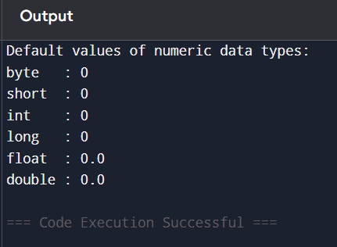

- Write a program that demonstrates the use of binary, octal, and hexadecimal literals in Java
Sol- public class NumberLiteralsDemo {
public static void main(String[] args) {
int binary = 0b1010;
int octal = 012;
int hex = 0xA;

System.out.println ("Binary literal 0b1010 = " + binary);
System.out.println("Octal literal 012 = " + octal);
System.out.println("Hexadecimal literal 0xA = " + hex);
}
}
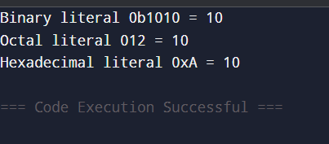

- Write a Java program that demonstrates implicit and explicit type conversion and print the result.

Sol- public class TypeConversionDemo {
public static void main(String[] args) {
int a = 10;
double b = a;

double x = 10.75;
int y = (int) x;

System.out.println("Implicit conversion int to double: " + b);
System.out.println("Explicit conversion double to int: " + y);
}
}
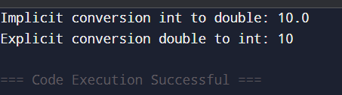

- Write a Java program that accepts three integers from the user and prints the sum, the difference, the product, the average, the maximum and minimum of these numbers using ternary operator.
Ans-
import java.util.Scanner;

public class ThreeNumbersOps {
public static void main(String[] args) {
Scanner sc = new Scanner(System.in);

int a = sc.nextInt();
int b = sc.nextInt();
int c = sc.nextInt();

int sum = a + b + c;
int diff = a - b - c;
int prod = a * b * c;
double avg = sum / 3.0;

int max = a > b ? (a > c ? a : c) : (b > c ? b : c);
int min = a < b ? (a < c ? a : c) : (b < c ? b : c);

System.out.println("Sum: " + sum);
System.out.println("Difference: " + diff);
System.out.println("Product: " + prod);
System.out.println("Average: " + avg);
System.out.println("Maximum: " + max);
System.out.println("Minimum: " + min);
}
}
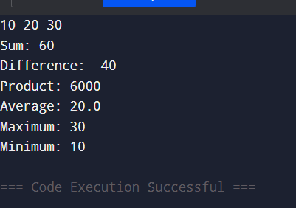

Q5.
Write a Java program to input marks of five subjects Physics, Chemistry, Biology, Mathematics and Computer, calculate percentage and grade according to given conditions:
If percentage >= 90% : Grade A
If percentage >= 80% : Grade B
If percentage >= 70% : Grade C
If percentage >= 60% : Grade D
If percentage >= 40% : Grade E
If percentage < 40% : Grade F

Ans- import java.util.Scanner;

public class GradeCalculator {
public static void main(String[] args) {
Scanner sc = new Scanner(System.in);
System.out.println("Enter Input for 5 Subjects");

int physics = sc.nextInt();
int chemistry = sc.nextInt();
int biology = sc.nextInt();
int math = sc.nextInt();
int computer = sc.nextInt();

int total = physics + chemistry + biology + math + computer;
double percentage = total / 5.0;

char grade;

if (percentage >= 90) grade = 'A';
else if (percentage >= 80) grade = 'B';
else if (percentage >= 70) grade = 'C';
else if (percentage >= 60) grade = 'D';
else if (percentage >= 40) grade = 'E';
else grade = 'F';

System.out.println("Percentage: " + percentage);
System.out.println("Grade: " + grade);
}
}

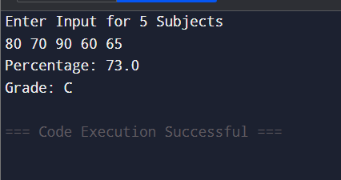

Q6. Write programs to print following patterns:
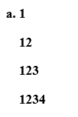
Ans- public class PatternNumbers {
public static void main (String [] args) {
for (int i = 1; i <= 4; i++) {
for (int j = 1; j <= i; j++) {
System.out.print(j);
}
System.out.println();
}
}
}

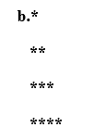

Ans- public class StarPattern {
public static void main(String[] args) {
for (int i = 1; i <= 4; i++) {
for (int j = 1; j <= i; j++) {
System.out.print("*");
}
System.out.println();
}
}
}

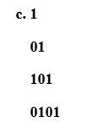
Ans-
public class BinaryPattern {
public static void main(String[] args) {
int start = 1;

for (int i = 1; i <= 4; i++) {
int val = start;
for (int j = 1; j <= i; j++) {
System.out.print(val);
val = 1 - val;
}
System.out.println();
start = 1 - start;
}
}
}

Q7. Write a Java program to generate the Fibonacci series up to a certain number using recursive method.
Ans- import java.util.Scanner;

public class FibonacciRec {
static int fib(int n) {
if (n <= 1) return n;
return fib(n - 1) + fib(n - 2);
}

public static void main(String[] args) {
Scanner sc = new Scanner(System.in);
int limit = sc.nextInt();

for (int i = 0; i < limit; i++) {
System.out.print(fib(i) + " ");
}
}
}
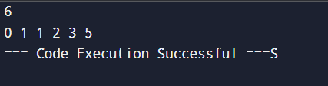

Q8. Write a Java program to sort Strings in alphabetical order along with printing the count of vowels and consonants in String.
Ans- import java.util.Arrays;

public class StringSortCount {
public static void main(String[] args) {
String[] arr = {"apple", "Orange", "banana", "grapes", "kiwi"};

Arrays.sort(arr, String.CASE_INSENSITIVE_ORDER);

for (String str : arr) {
int vowels = 0, consonants = 0;
String s = str.toLowerCase();

for (int i = 0; i < s.length(); i++) {
char ch = s.charAt(i);
if (ch >= 'a' && ch <= 'z') {
if (isVowel(ch)) vowels++;
else consonants++;
}
}

System.out.println(str + " → Vowels: " + vowels + ", Consonants: " + consonants);
}
}

static boolean isVowel(char ch) {
return "aeiou".indexOf(ch) != -1;
}
}
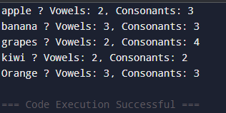

Q9. Write a Java program for linear search by using method with array as argument.
Ans- import java.util.Scanner;

public class LinearSearchMethod {
static int linearSearch(int[] arr, int key) {
for (int i = 0; i < arr.length; i++) {
if (arr[i] == key) return i;
}
return -1;
}

public static void main(String[] args) {
Scanner sc = new Scanner(System.in);

int[] arr = {10, 25, 30, 45, 50, 60};

System.out.print("Enter element to search: ");
int key = sc.nextInt();

int result = linearSearch(arr, key);

if (result == -1)
System.out.println("Element not found");
else
System.out.println("Element found at index: " + result);
}
}
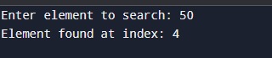
Q10. Write a java program to implement the single level, multilevel inheritance using classes.
Ans- class Animal {
void eat() {
System.out.println("Animal is eating");
}
}

class Dog extends Animal {
void bark() {
System.out.println("Dog is barking");
}
}

class Vehicle {
void start() {
System.out.println("Vehicle starts");
}
}

class Car extends Vehicle {
void drive() {
System.out.println("Car is driving");
}
}

class SportsCar extends Car {
void turbo() {
System.out.println("Sports Car turbo mode");
}
}

public class InheritanceDemo {
public static void main(String[] args) {

System.out.println("Single-Level Inheritance:");
Dog d = new Dog();
d.eat();
d.bark();

System.out.println("\nMultilevel Inheritance:");
SportsCar sc = new SportsCar();
sc.start();
sc.drive();
sc.turbo();
}
}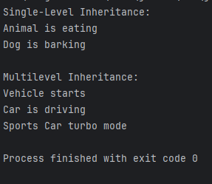

Q11. Write a java program to implement the multilevel inheritance using abstract classes.
Ans- abstract class A {
abstract void showA();
}

abstract class B extends A {
abstract void showB();
}

class C extends B {
void showA() {
System.out.println("Inside Class A");
}

void showB() {
System.out.println("Inside Class B");
}

void showC() {
System.out.println("Inside Class C");
}
}

public class MultilevelAbstract {
public static void main(String[] args) {
C obj = new C();
obj.showA();
obj.showB();
obj.showC();
}
} 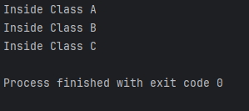

Q12. Write a java program to implement the multiple inheritance using multiple interfaces.
Ans- interface A {
void showA();
}

interface B {
void showB();
}

class C implements A, B {
public void showA() {
System.out.println("Inside Interface A");
}

public void showB() {
System.out.println("Inside Interface B");
}

void showC() {
System.out.println("Inside Class C");
}
}

public class MultipleInheritanceDemo {
public static void main(String[] args) {
C obj = new C();
obj.showA();
obj.showB();
obj.showC();
}
}
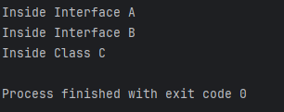
Q13. Write a java program in java to the concept of polymorphism by method overloading .
Ans- class OverloadDemo {
void show() {
System.out.println("No parameters");
}

void show(int a) {
System.out.println("One integer parameter: " + a);
}

void show(int a, int b) {
System.out.println("Two integer parameters: " + a + ", " + b);
}

void show(String s) {
System.out.println("String parameter: " + s);
}
}

public class MethodOverloadingDemo {
public static void main(String[] args) {
OverloadDemo obj = new OverloadDemo();
obj.show();
obj.show(10);
obj.show(10, 20);
obj.show("Hello");
}
}
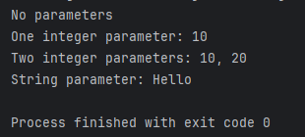
Q14. Write a Java program to demonstrate the usage of constructor chaining using super and this.
Ans- class Parent {
Parent() {
System.out.println("Parent: Default Constructor");
}

Parent(int a) {
System.out.println("Parent: Parameterized Constructor " + a);
}
}

class Child extends Parent {

Child() {
this(10);
System.out.println("Child: Default Constructor");
}

Child(int x) {
super(20);
System.out.println("Child: Parameterized Constructor " + x);
}
}

public class ConstructorChainingDemo {
public static void main(String[] args) {
Child obj = new Child();
}
}
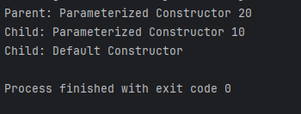
Q15. Write a Java program to demonstrate method overloading and overriding.
Ans- class Parent {
void show() {
System.out.println("Parent show()");
}
}

class Child extends Parent {
void show() {
System.out.println("Child show()");
}

void show(int x) {
System.out.println("Overloaded show(): " + x);
}
}

public class OverloadOverrideDemo {
public static void main(String[] args) {
Parent p = new Parent();
p.show();

Child c = new Child();
c.show();
c.show(10);

Parent ref = new Child();
ref.show();
}
}
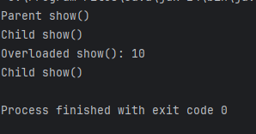
Q16: Write a program in java to handle the exception using try and multiple catch block with finally and without finally.
Code:

WITH FINALLY
public class MultipleCatchWithFinally {
public static void main(String[] args) {
try {
int num = 10 / 0;
int arr[] = new int[5];
System.out.println(arr[10]);
}
catch (ArithmeticException e) {
System.out.println("Arithmetic Exception: " + e.getMessage());
}
catch (ArrayIndexOutOfBoundsException e) {
System.out.println("Array Index Exception: " + e.getMessage());
}
catch (Exception e) {
System.out.println("General Exception: " + e.getMessage());
}
finally {
System.out.println("Finally block executed.");
}
}
}
OUTPUT:
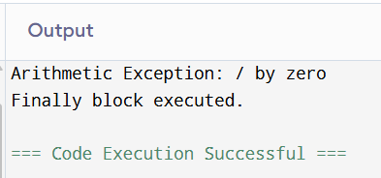
WITHOUT FINALLY
public class MultipleCatchWithoutFinally {
public static void main(String[] args) {
try {
String str = null;
System.out.println(str.length()); // NullPointerException
}
catch (NullPointerException e) {
System.out.println("Null Pointer Exception caught: " + e.getMessage());
}
catch (Exception e) {
System.out.println("General Exception: " + e.getMessage());
}

System.out.println("Program continues normally after catch block.");
}
}
OUTPUT:
