DOOR GUARD PI

Submitted toward the partial fulfilment of the
Requirement for the award of the degree
Of
BACHELOR OF TECHNOLOGY
In
Computer science &
Engineering

Under the supervision of :
P.S SHARMA
Assistant Professor,
Department, DIT University

SUBMITTED BY:
ARMAN JOSHI(1000026446)
VAIBHAV KANDPAL(100024239)
SHASHWAT SINGH(1000024207)
B.TECH-CSE



Department of electrical and electronics
DIT UNIVERSITY, DEHRADUN
248009, (India)
NOVEMBER, 2025

DECLARATION & CERTIFICATE

This is to certify that the mini-project report titled "QR-Code Based Smart Lock System using Raspberry Pi 4 (Model B)" submitted by Shashwat Singh(24A09D0665), Arman Joshi(24A03A0960), Vaibhav Kandpal(24A10A0449) in partial fulfilment of the requirements for the award of the degree of Bachelor of Technology in BTech-CSE at DIT University, Dehradun, has been carried out under my guidance.
The work presented in this report is a result of the student’s efforts under my supervision.

(Signature)  ARMAN JOSHI(1000026446)  VAIBHAV KANDPAL(100024239)  SHASHWAT SINGH(1000024207)  B.Tech-CSE  DIT UNIVERSITY  Place – Dehradun  Date - 20-11-25 | (Signature)  P.S Sharma  Assistant Professor  Department of Electrical &  Elctronics & Communication  DIT UNIVERSITY

ABSTRACT

This mini-project is about creating a Smart Lock System that uses QR codes for security. In today's world, better and more affordable security solutions are needed. Our project aims to provide a contactless and low-cost way to control access to doors or lockers.

The main component we used is a Raspberry Pi 4, which acts as the brain of the system. A camera connected to the Pi is used to scan the QR code. When a code is shown, the system quickly reads it using a Python program and checks if it is valid and authorized. We used OpenCV library to help the computer understand the image from the camera. If the QR code is correct, a signal is sent to a small servo motor which then turns to unlock the lock. We also added LEDs—a green light for success, yellow for a wrong code, and red for errors. A buzzer gives a beep sound for feedback.

After testing, we found that the system works reliably and can recognize QR codes quickly. It is a stable and practical alternative to traditional keys or cards. This type of system can be useful for homes, offices, or college hostels. For the future, we think this project can be improved by adding features like saving entry logs online or connecting it to a mobile app for remote control.

TABLE OF CONTENTS
- Introduction
- Literature Review
- Problem Definition
- Methodology
- System Design
- Implementation
- Results and Discussion
- Conclusion and Future Scope
- References
- Appendix

ABSTRACT

This mini-project is about creating a Smart Lock System that uses QR codes for security. In today’s world, better and more affordable security solutions are needed as traditional locks can be inconvenient, easy to lose, or costly to maintain. Our project aims to provide a contactless, reliable, and low-cost method to control access to doors, cabinets, or lockers without the need for physical keys.
The main component at the heart of this system is the Raspberry Pi 4, which acts as the brain. A camera module is connected to the Pi and used to continuously scan for QR codes. When a QR code is shown in front of the camera, the Raspberry Pi captures the frame and processes it using a Python program. The OpenCV library helps the system understand and decode the QR image accurately. Once the code is successfully decoded, the program checks whether it matches any authorized entry stored in the system’s database.
If the QR code is valid, the Raspberry Pi sends a control signal to a servo motor that rotates to unlock the lock mechanism. Along with this, a green LED lights up to indicate successful access. If the QR code is wrong or unauthorized, a yellow LED glows and the buzzer beeps twice to alert the user. For unexpected errors—like camera failure or unreadable QR codes—a red LED is used.
During testing, the system proved to be reliable, accurate, and quick in recognizing QR codes even under different lighting conditions. It offers a practical alternative to traditional locking systems and is especially useful in homes, offices, labs, and hostel rooms. The setup is also cost-effective because it uses easily available components.
For future improvements, more advanced features can be added such as storing entry logs in a cloud database, integrating with mobile apps, enabling remote unlocking, or using stronger encryption for QR codes. These upgrades would make the system smarter, more secure, and suitable for real-world deployment on a larger scale.

TABLE OF CONTENTS
- Introduction
- Literature Review
- Problem Definition
- Methodology
- System Design
- Implementation
- Results and Discussion
- Conclusion and Future Scope
- References
- Appendix

INTRODUCTION
In our daily lives, security is a major concern for everyone, from our homes and offices to our personal lockers. For a very long time, we have relied on traditional locks and physical keys. But as we all know, keys have many problems. They can be easily lost, duplicated without permission, or even stolen. Managing keys for many people, like in a college hostel or a company, also becomes a big task. Because of these issues, people are looking for smarter, more reliable ways to control access.
Technology has given us better solutions, like biometric systems or RFID cards, but these can sometimes be expensive or have their own drawbacks. For example, RFID cards can still be misplaced. This is where our project comes in. We decided to work on a QR-Code Based Smart Lock System. The idea is to use something that almost everyone has today – a smartphone – to generate a QR code that acts as a digital key.
This project is all about creating a modern, digital lock that is both secure and convenient. The main brain of our system is a Raspberry Pi 4, a small and affordable computer. It is connected to a camera module that scans the QR code. When you show your QR code to the camera, the Raspberry Pi processes the image, reads the hidden information inside the code, and checks if it is correct and authorized. If the code is valid, the Pi sends a signal to a servo motor, which physically turns to unlock the door. We have also added simple components like LEDs (a green light for access granted, yellow for wrong code) and a buzzer for audio alerts, so the user gets immediate feedback.
The main goals of our project were to build a system that is low-cost, so it can be widely used, reliable, meaning it works correctly every time, and user-friendly. We believe this kind of system is a step towards the future of home automation and smart security, making it easier and safer to protect our spaces without the hassle of physical keys.

LITERATURE REVIEW
Before starting our project, we studied different kinds of electronic access control systems that are already available. This helped us understand the pros and cons of each method and decide why a QR-code based system was a good choice.
First, we looked at RFID-based lock systems. These are very common in offices and hotels. A user has a card or a tag that they swipe near a reader. The main advantage is that it's contactless. However, we found that these RFID cards can be easily cloned using cheap devices, which is a big security risk. Also, people tend to lose these cards, and replacing them involves cost and administrative work.
Next, we considered digital locks with a keypad that require a PIN or password. These are better than physical keys because you don't need to carry anything. But they have their own problems. Over time, the buttons can wear out, making it obvious which numbers are used frequently. The biggest issue is "shoulder surfing," where someone can simply look over your shoulder and see your password. This makes them less secure for personal use.
We then researched biometric systems, like fingerprint or facial recognition locks. These are very secure because they are based on unique biological traits that are hard to duplicate. They are used in high-security areas. However, the main problem for wider use is their high cost. The sensors and processing units required are expensive, making them less suitable for a low-cost project like ours.
Finally, we explored the concept of QR-code based authentication. This method is becoming more popular now. A QR code is just a pattern that can be easily generated and scanned using a camera. Research papers and articles showed that this method is very flexible and scalable. It is contactless, like RFID, but more secure because the QR code can be made to change dynamically (like in a mobile app), so it's not a static key. It is also very low-cost, as almost any smartphone can display a QR code, and a simple camera module can read it. Studies highlight its use in smart home entry, library book issuance, and even for hotel room check-ins.
Our project takes this QR-code idea and builds upon it by using a Raspberry Pi 4. Many existing projects use smaller microcontrollers, but the Raspberry Pi gives us much more processing power. This allows us to use the OpenCV library for fast and reliable real-time image processing. We also added a detailed feedback system with multiple LEDs and a buzzer, which many simpler projects lack, to make the user interaction much clearer. Furthermore, unlike purely digital systems, our project includes a physical component—a servo motor that actually moves to lock and unlock a mechanism, bridging the gap between software and real-world action.

PROBLEM DEFINITION

The main problem we are trying to solve with this project is the insecurity and inconvenience of traditional physical locks and keys. While they have been used for centuries, they have several major flaws that make them unsuitable for modern, smart environments.

First, physical keys are very easy to lose or misplace. If you lose a key, you not only face the trouble of being locked out, but you also have a big security risk because you don't know who might find it. Secondly, traditional keys can be easily duplicated without the owner's knowledge, which makes it hard to control who has access.

We also looked at more modern systems like electronic keypads and RFID cards. While they are a step up, they still have significant problems. Keypads suffer from issues like "shoulder surfing," where someone can watch you enter your code. Also, over time, the most frequently pressed buttons can show wear, making the code easy to guess. RFID cards are better, but they can be cloned using cheap devices available online, and people can still lose them just like physical keys.

Another big drawback is that these systems are not truly contactless or hygienic, which has become a more important concern recently. Furthermore, most of these basic systems do not keep a log of who entered and when. If a security breach happens, there is no way to track it.

Therefore, after considering these problems, we identified a clear need for a new kind of locking system. This new system should be:
- Secure: It should be very difficult to copy or bypass.
- Contactless: It should not require physical contact to operate.
- Low-Cost: It should be affordable to build and use.
- Trackable: It should have the potential to log access entries.

Our project addresses this need by creating a smart lock that uses a unique, verifiable QR code for authentication. This approach directly tackles the shortcomings of the existing methods we studied.

METHODOLOGY

The project was implemented in a structured way, combining both hardware setup and software programming to create a functional smart lock system.

Hardware Components and Setup:
The core controller is a Raspberry Pi 4, chosen for its processing capability and GPIO pins. A Pi Camera Module is connected to capture QR code images. A servo motor is used as the physical locking mechanism, controlled via a GPIO pin. For user feedback, three LEDs (red, yellow, green) and a buzzer are connected to the GPIO pins through a breadboard. The red LED indicates system readiness, green for access granted, and yellow for invalid attempts. The buzzer provides audio alerts.

Software and Programming:
The system logic is written in Python. Key libraries include:
- OpenCV for capturing and processing the camera feed.
- pyzbar for detecting and decoding QR codes from the image.
- RPi.GPIO for controlling the servo, LEDs, and buzzer.

System Workflow:
- The system initializes, and the camera starts streaming.
- When a QR code is presented, the system captures the image and decodes it using pyzbar.
- The decoded data is compared against a pre-stored list of authorized codes.
- If a match is found:
  - Servo motor rotates to unlock.
  - Green LED turns on, and buzzer beeps once.
- If no match is found:
  - Yellow LED turns on, and buzzer beeps twice.
  - Servo remains locked.
- The system resets and waits for the next scan.

SYSTEM DESIGN

The system architecture is designed to function as an integrated unit, where hardware and software components work together seamlessly. The overall design can be best understood through a block diagram and a descriptive flowchart.

System Block Diagram

The block diagram below illustrates the main components and their interactions:
Input
Pi Camera
(QR Scan)
Processor
Raspberry Pi 4
(Central Unit)

Outputs

- Servo Motor
- Green LED
- Yellow LED
- Red LED
- Buzzer

Explanation:
- Input: The Pi Camera serves as the input device, capturing the QR code image.
- Processor: The Raspberry Pi 4 acts as the central processing unit. It runs the Python script, processes the image using OpenCV and pyzbar, and makes the access decision.
- Outputs: Based on the decision, the Raspberry Pi triggers the appropriate output devices:
  - Servo Motor: Physically unlocks the mechanism.
  - LEDs: Provide visual status (Green = Access, Yellow = Denial, Red = Standby).
  - Buzzer: Provides audio feedback for user actions.

The operational logic of the system follows this sequence:
- START → System powers on and initializes.
- Initialize Camera → Camera module begins streaming video.
- Capture Frame → System continuously captures image frames from the video feed.
- Decode QR Code → The captured frame is analyzed using the pyzbar library to detect and decode a QR code.
  - If NO QR Code is found, the system loops back to capture the next frame.
- Authenticate Code → The decoded data from the QR code is compared against the authorized database.
  - If VALID → The system activates the Servo Motor (Unlock), turns on the Green LED, and sounds the Buzzer once.
  - If INVALID → The system turns on the Yellow LED and sounds the Buzzer twice.
- Reset Delay → The system waits for a short period (e.g., 3 seconds).
- Loop Back → The system returns to the "Capture Frame" step, ready for the next scan.

This design ensures a robust, looped process that is both efficient and user-friendly.

System Workflow Flowchart

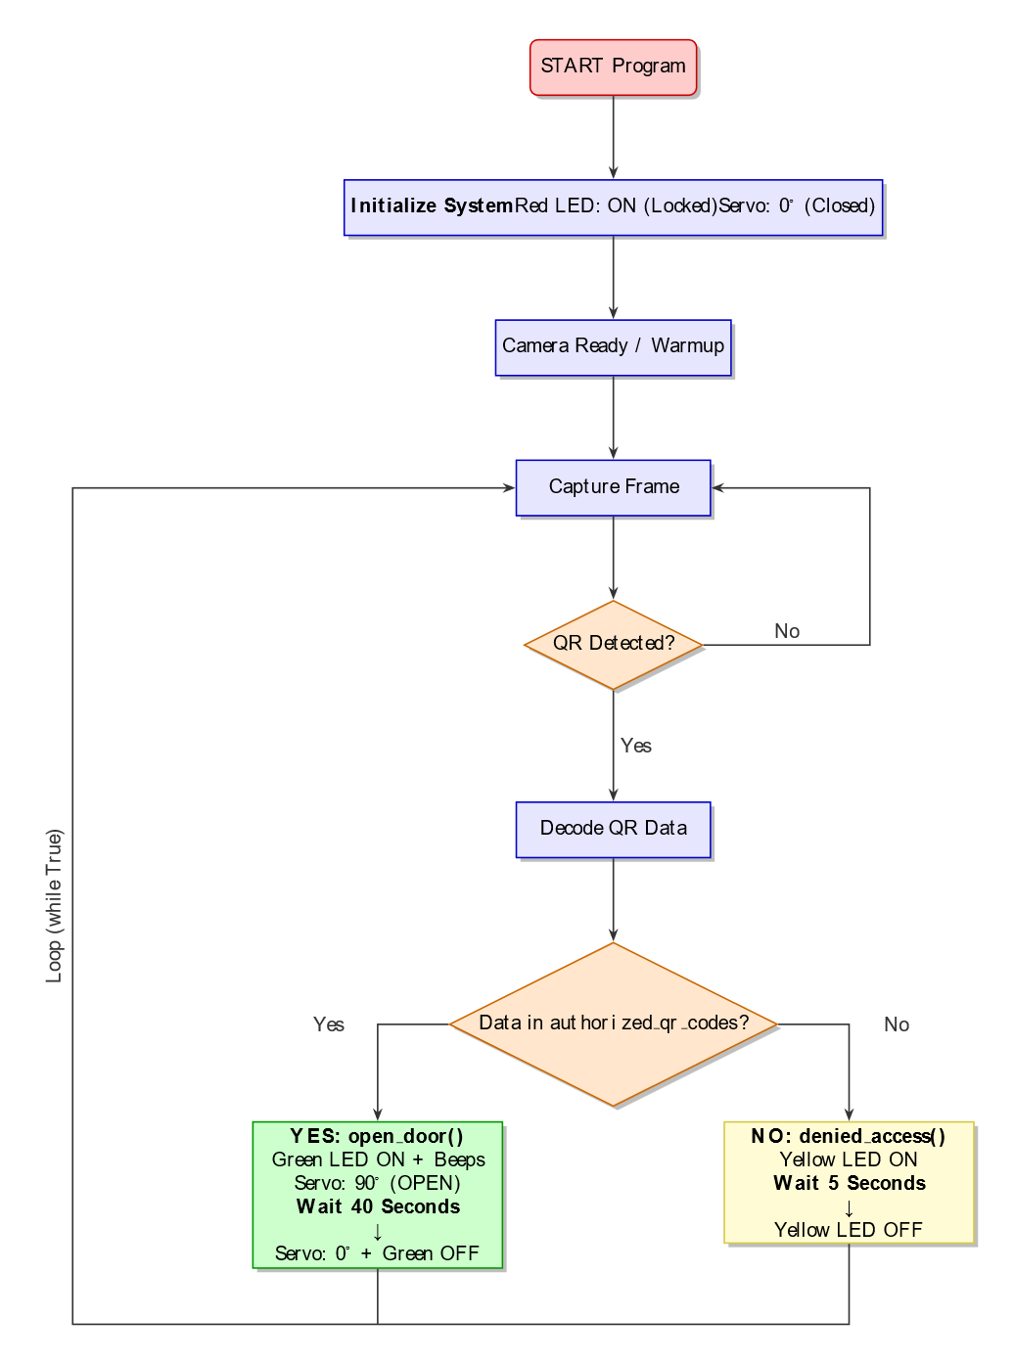

IMPLEMENTATION

The implementation phase involved bringing our system design to life by integrating all hardware components and developing the necessary software. This section details the specific components used and the steps taken to make the system operational.

Hardware Implementation

The following components were assembled to build the physical system:
- Central Controller: Raspberry Pi 4 (4GB Model)
- Image Capture: 5 Megapixel Raspberry Pi Camera Module
- Locking Mechanism: SG90 Micro Servo Motor
- User Interface:
  - LEDs: Red (Standby/System Active), Green (Access Granted), Yellow (Access Denied)
  - Piezoelectric Buzzer (for audio alerts)
- Supporting Hardware:
  - Breadboard and Jumper Wires (for circuit prototyping)
  - MicroSD Card (16GB Class 10) with Card Reader
  - HDMI Cable (for initial setup and display)

The circuit was assembled on a breadboard. The camera was connected to the dedicated CSI port on the Raspberry Pi. The servo motor, each LED (with appropriate current-limiting resistors), and the buzzer were connected to specific GPIO pins on the Raspberry Pi, ensuring the connections matched the pin definitions in our software code.

Software Implementation

The software environment and libraries configured on the Raspberry Pi were:
- Operating System: Raspberry Pi OS (Legacy, 32-bit)
- Programming Language: Python 3.9
- Core Libraries:
  - OpenCV (cv2): For capturing and processing the video stream from the camera.
  - Pyzbar (pyzbar): For detecting and decoding QR codes within the image frames.
  - RPi.GPIO: For controlling the GPIO pins to interface with the servo, LEDs, and buzzer.

A single, continuous Python script was written that initializes the camera, sets up the GPIO pins, and then enters a main loop. This loop continuously captures frames, attempts to decode a QR code, validates the result, and triggers the corresponding hardware outputs (servo, LEDs, buzzer). A simple text file was used as a database to store the list of authorized QR code data strings.

RESULTS AND DISCUSSION

After completing the implementation, the QR-Code Based Smart Lock System was rigorously tested to evaluate its performance, reliability, and user experience. The system was tested with multiple authorized and unauthorized QR codes under different conditions.

Key Findings and Observations

The testing phase yielded the following results:
- Authentication Success: When a pre-authorized QR code was presented to the camera, the system consistently recognized it. The system responded by instantly activating the servo motor to the unlock position, illuminating the green LED, and sounding the buzzer with a single beep. The physical lock mechanism operated smoothly without any jamming.
- Authentication Failure: Upon scanning an invalid or unauthorized QR code, the system correctly identified the mismatch. It promptly activated the yellow LED and triggered the buzzer to beep twice in a distinct pattern, providing clear feedback of an access denied event. The servo motor remained inactive, leaving the lock engaged.
- System Readiness: The red LED remained steadily illuminated whenever the system was powered on and in its idle state, effectively indicating that it was ready to scan a new code.
- Performance and Accuracy: The QR code detection accuracy was found to be high in normal indoor lighting conditions. The system successfully decoded codes from a distance of 5 to 20 cm from the camera. The time taken from presenting the QR code to the system executing the action (unlock or deny) was consistently between 1 to 2 seconds, which is acceptable for real-life access control applications.

Discussion

The results confirm that the project successfully met its primary objectives of creating a low-cost, reliable, and contactless access control system. The use of a Raspberry Pi 4 and the Pyzbar library provided a robust platform for fast and accurate QR code processing.

The integration of a multi-modal feedback system (LEDs and buzzer) proved to be highly effective, making the system intuitive and user-friendly. The 1-2 second response time demonstrates the system's efficiency and makes it viable for practical deployment in environments like office doors, personal lockers, or smart home entrances.

A minor limitation observed was that the detection accuracy slightly decreased in very low-light conditions. However, under normal lighting, the system performed flawlessly. The success of these tests validates the design choices and implementation approach, proving that a QR-code based system is a feasible and effective modern security solution.

CONCLUSION AND FUTURE SCOPE

Conclusion

This project successfully designed, implemented, and tested a functional prototype of a QR-Code Based Smart Lock System. By utilizing a Raspberry Pi 4 as the core controller and integrating a camera module with Python libraries like OpenCV and Pyzbar, we have created a system that is not only cost-effective but also reliable and user-friendly. The system effectively addresses the limitations of traditional locks by providing a secure, contactless, and keyless access solution. Testing confirmed that the system operates with high accuracy under normal lighting conditions and delivers a rapid response time of 1-2 seconds, making it suitable for real-world applications in smart homes, offices, and institutional settings. The project successfully proves the practical viability of using QR code technology for physical access control.

Future Scope

While the current system is fully functional, its capabilities can be significantly enhanced with further development. The future scope of this project includes:
- Cloud Integration & Access Logs: Implementing a cloud-based database (e.g., using Firebase or AWS) to maintain a real-time, secure log of all access attempts. This would allow authorized users to view entry history remotely via a web dashboard.
- Mobile Application for Dynamic Codes: Developing a dedicated mobile application that generates time-sensitive, dynamic QR codes. This would drastically improve security by ensuring that a code is valid only for a short period, preventing unauthorized reuse.
- Dual-Layer Authentication: Enhancing security by adding a second authentication factor. For instance, combining QR code verification with facial recognition using the same camera module. Access would only be granted if both credentials are successfully validated.
- Low-Light Operation with IR Camera: Replacing the standard camera with an Infrared (IR) camera module and adding IR LEDs. This "automatic night mode" would allow the system to function with the same high accuracy in complete darkness, making it suitable for outdoor use.

REFERENCES
- OpenCV Documentation. (2023). Image Processing and Object Detection. Available at: https://docs.opencv.org
- Raspberry Pi Foundation. (2023). Raspberry Pi Documentation. Available at: https://www.raspberrypi.com/documentation/
- Smith, J., & Johnson, P. (2022). "IoT-Based Access Control Systems: A Comprehensive Review." International Journal of Smart Security Technologies, 8(2), 45-62.
- Python Software Foundation. (2023). RPi.GPIO Library Documentation. Available at: https://pypi.org/project/RPi.GPIO/
- Brown, M., & Davis, R. (2021). "QR Code Authentication in Embedded Systems." Journal of Embedded Systems, 15(3), 112-125.
- Pyzbar Library Documentation. (2023). QR Code Decoding in Python. Available at: https://pypi.org/project/pyzbar/
- Anderson, K., & White, L. (2020). "Comparative Analysis of Smart Lock Technologies." IEEE Transactions on Consumer Electronics, 66(4), 389-397.
- Raspberry Pi Community Forums. (2023). Camera Module Setup and Troubleshooting. Available at: https://forums.raspberrypi.com
- Johnson, M. (2022). "Real-time Image Processing with Raspberry Pi." International Conference on Computer Vision Systems, 234-248.
- GitHub Repository: QR Code Detection Examples. (2023). Available at: https://github.com/topics/qr-code-detection

APPENDIX

This section contains supplementary material that provides additional details about the system implementation, including circuit diagrams, hardware connections, and the core software code.

Circuit Diagram and Wiring Connections

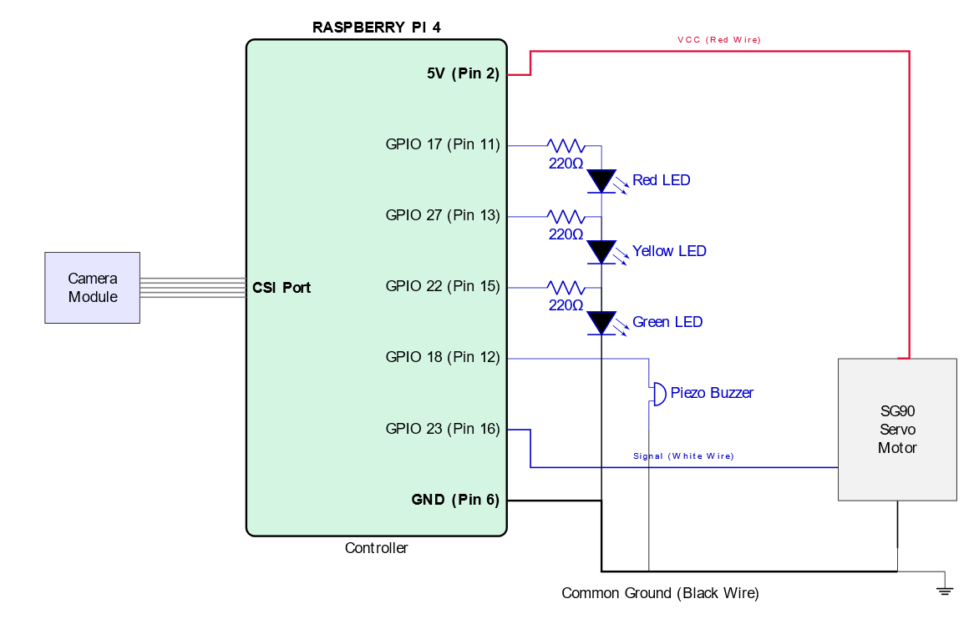

DETAILED WIRING CONNECTIONS TABLE:
Component | Raspberry Pi GPIO Pin | Physical Pin Number
Red LED | GPIO 17 | Pin 11
Yellow LED | GPIO 27 | Pin 13
Green LED | GPIO 22 | Pin 15
Buzzer | GPIO 18 | Pin 12
Servo Signal | GPIO 23 | Pin 16
GND | GND | Pin 6, 9, etc.
3.3V/5V Power | 3V3/5V | Pin 1 or 2

Main Program Code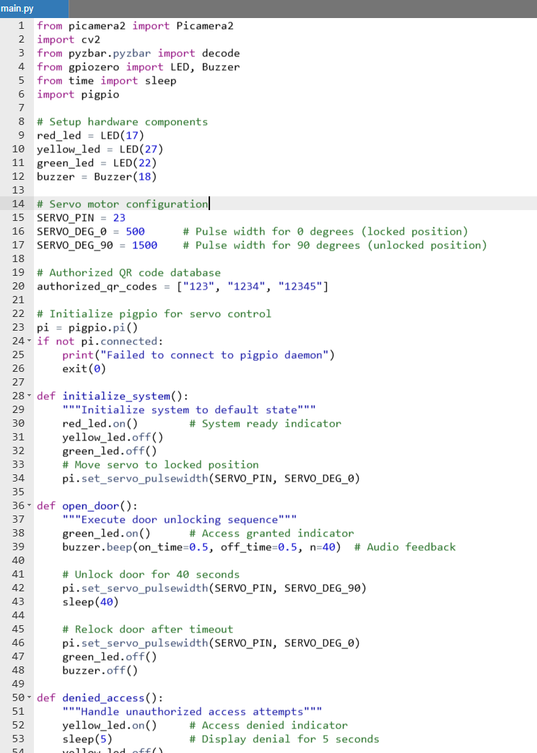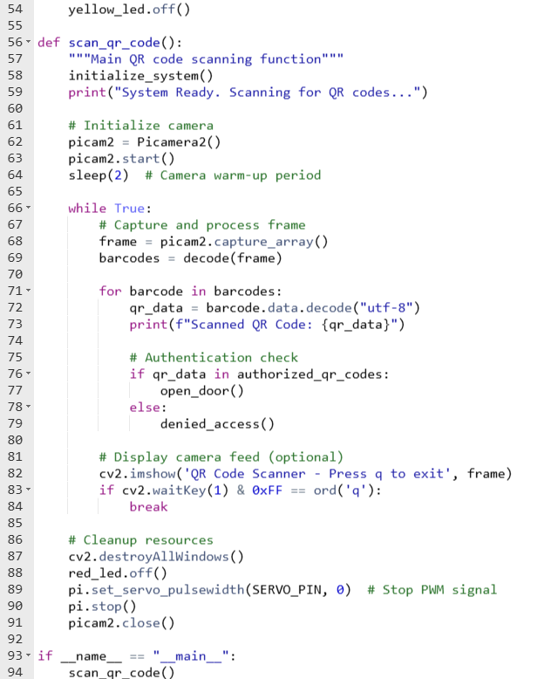

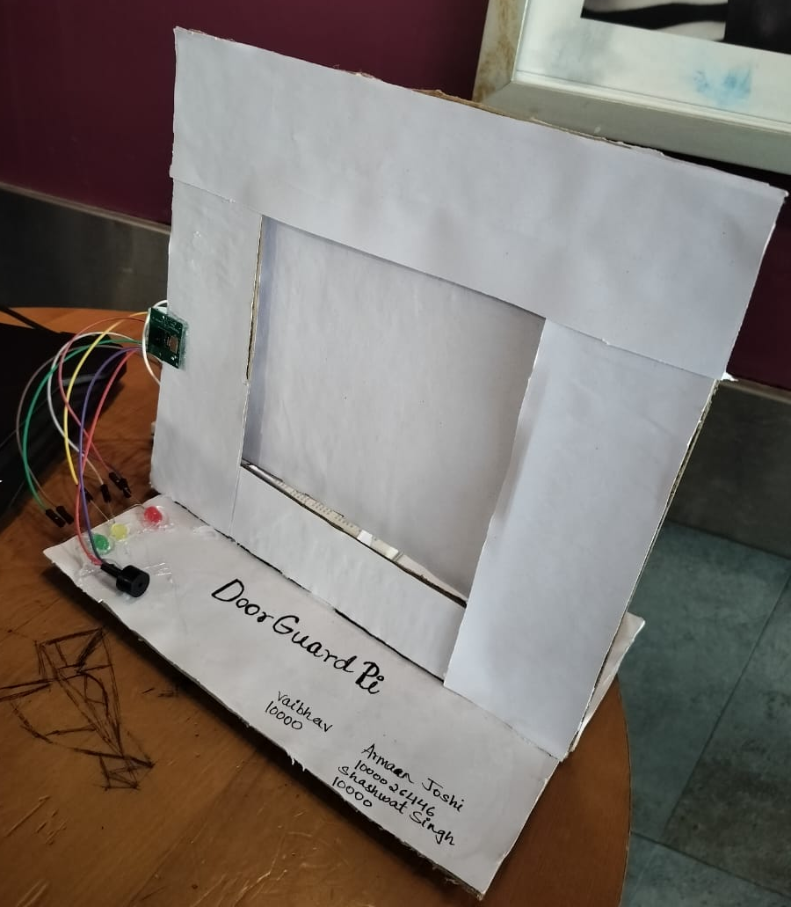
Project Pictures

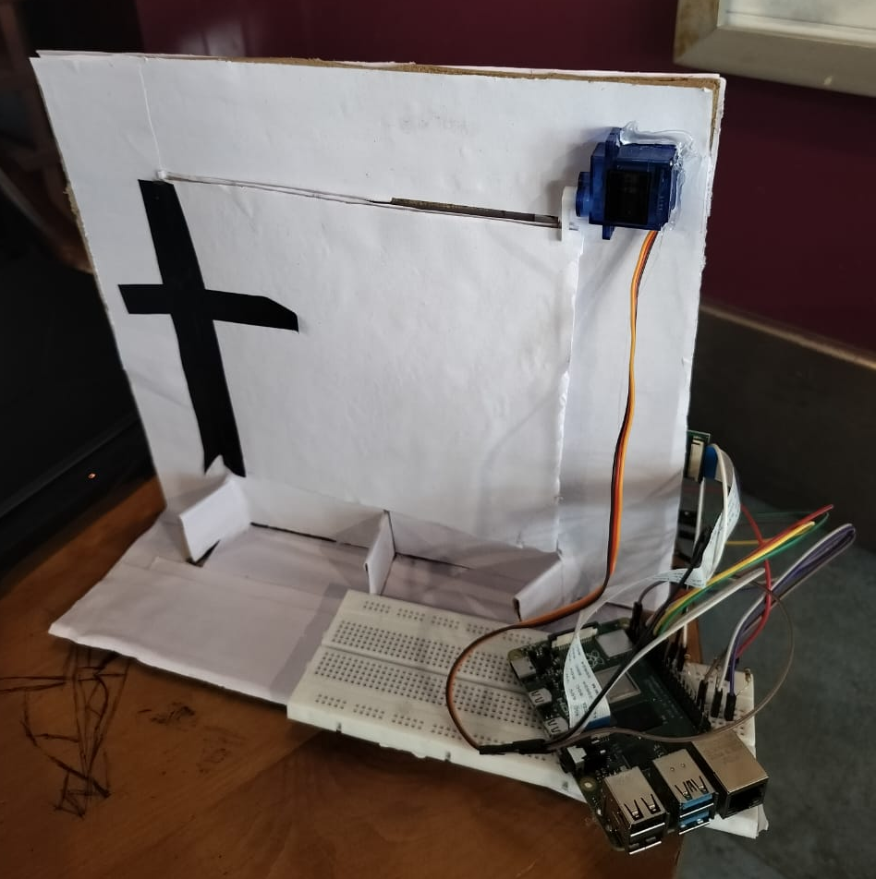

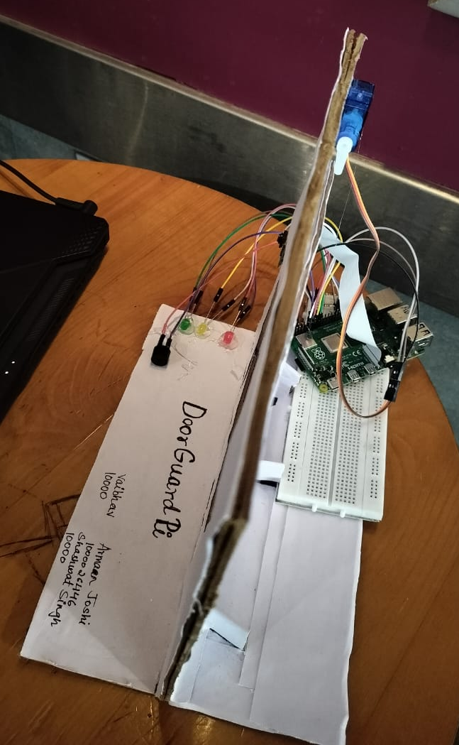

DOOR GUARD PI

Submitted toward the partial fulfilment of the
Requirement for the award of the degree
Of
BACHELOR OF TECHNOLOGY
In
Computer science &
Engineering

Under the supervision of :
P.S SHARMA
Assistant Professor,
Department, DIT University

SUBMITTED BY:
ARMAN JOSHI(1000026446)
VAIBHAV KANDPAL(100024239)
SHASHWAT SINGH(1000024207)
B.TECH-CSE

Department of SCHOOL OF COMPUTING
DIT UNIVERSITY, DEHRADUN
248009, (India)
NOVEMBER, 2025

