**JUnit Testing Exercises**

**Exercise 1: Setting Up Junit**

<?xml version="1.0" encoding="UTF-8"?>

<project xmlns="http://maven.apache.org/POM/4.0.0"

xmlns:xsi="http://www.w3.org/2001/XMLSchema-instance"

xsi:schemaLocation="http://maven.apache.org/POM/4.0.0 http://maven.apache.org/xsd/maven-4.0.0.xsd">

<modelVersion>4.0.0</modelVersion>

<groupId>org.example</groupId>

<artifactId>Junit</artifactId>

<version>1.0-SNAPSHOT</version>

<properties>

<maven.compiler.source>21</maven.compiler.source>

<maven.compiler.target>21</maven.compiler.target>

<project.build.sourceEncoding>UTF-8</project.build.sourceEncoding>

</properties>

<dependencies>

<dependency>

<groupId>junit</groupId>

<artifactId>junit</artifactId>

<version>4.13.2</version>

<scope>test</scope>

</dependency>

</dependencies>

</project>

**Exercise 3: Assertions in Junit**

package org.example;

import org.junit.Test;

import static org.junit.Assert.*;

public class AssertionsTest {

@Test

public void testAssertions() {

assertEquals(5, 2 + 3);

assertTrue(5 > 3);

assertFalse(5 < 3);

assertNull(null);

assertNotNull(new Object());

}

}

Output:

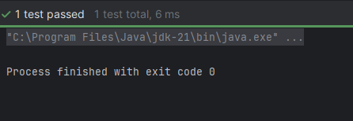

**Exercise 4: Arrange-Act-Assert (AAA) Pattern, Test Fixtures, Setup and Teardown Methods in Junit**

package org.example;

import org.junit.After;

import org.junit.Before;

import org.junit.Test;

import static org.junit.Assert.*;

public class CalculatorTest {

private Calculator calculator;

@Before

public void setUp() {

calculator = new Calculator();

}

@After

public void tearDown() {

calculator = null;

}

@Test

public void testAdd() {

int result = calculator.add(2, 3);

assertEquals(5, result);

}

@Test

public void testSubtract() {

int result = calculator.subtract(5, 3);

assertEquals(2, result);

}

}

package org.example;

public class Calculator {

public int add(int a, int b) {

return a + b;

}

public int subtract(int a, int b) {

return a - b;

}

}

Output:

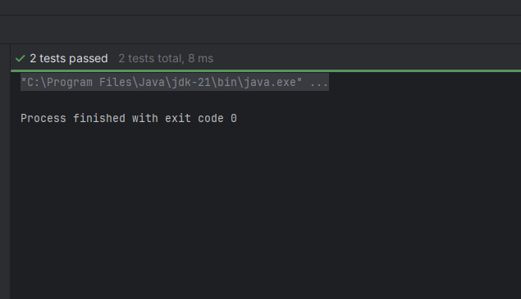

**Exercise 1: Mocking and Stubbing**

package org.example;  
  
public class MyService {  
 private final ExternalApi api;  
  
 public MyService(ExternalApi api) {  
 this.api = api;  
 }  
  
 public String fetchData() {  
 return api.getData();  
 }  
}

package org.example;  
  
public interface ExternalApi {  
 String getData();  
}

package org.example;  
  
import org.junit.jupiter.api.Test;  
import org.mockito.Mockito;  
  
import static org.mockito.Mockito.*;  
import static org.junit.jupiter.api.Assertions.*;  
  
public class MyServiceTest {  
  
 @Test  
 public void testExternalApi() {  
 ExternalApi mockApi = Mockito.*mock*(ExternalApi.class);  
   
 *when*(mockApi.getData()).thenReturn("Mock Data");  
  
 MyService service = new MyService(mockApi);  
 String result = service.fetchData();  
  
 *assertEquals*("Mock Data", result);  
 }  
  
 @Test  
 public void testVerifyInteraction() {  
 ExternalApi mockApi = Mockito.*mock*(ExternalApi.class);  
 MyService service = new MyService(mockApi);  
 service.fetchData();  
  
 *verify*(mockApi).getData();  
 }  
}

Output:

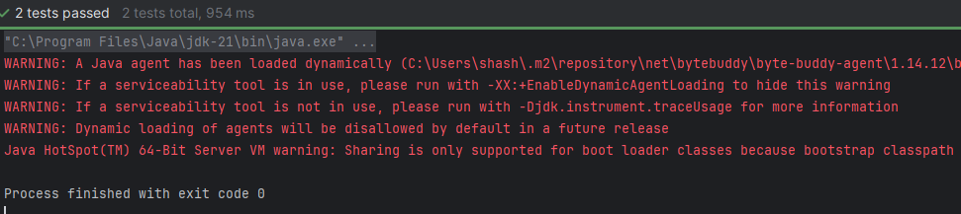

**Exercise 2: Verifying Interactions**

package org.example;

public interface ExternalApi {

String getDataById(String id);

}

package org.example;

public class MyService {

private final ExternalApi api;

public MyService(ExternalApi api) {

this.api = api;

}

public String fetchDataById(String id) {

return api.getDataById(id);

}

}

package org.example;

import org.junit.jupiter.api.Test;

import org.mockito.Mockito;

import static org.mockito.Mockito.*;

public class MyServiceTest {

@Test

public void testVerifyInteractionWithArgument() {

ExternalApi mockApi = Mockito.mock(ExternalApi.class);

when(mockApi.getDataById("123")).thenReturn("Mocked Response");

MyService service = new MyService(mockApi);

service.fetchDataById("123");

verify(mockApi).getDataById("123");

}

}

Output:

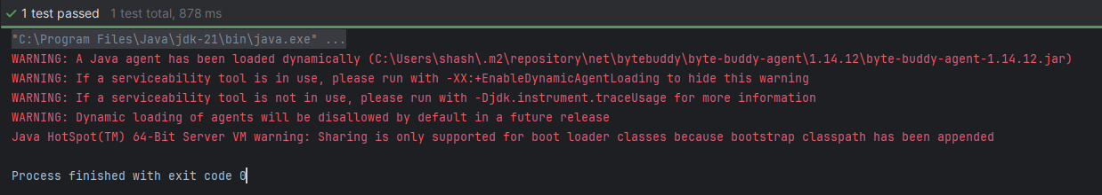

**Logging using SLF4J**

**Exercise 1: Logging Error Messages and Warning Levels**

<dependencies>

<dependency>

<groupId>org.slf4j</groupId>

<artifactId>slf4j-api</artifactId>

<version>1.7.30</version>

</dependency>

<dependency>

<groupId>ch.qos.logback</groupId>

<artifactId>logback-classic</artifactId>

<version>1.2.3</version>

</dependency>

</dependencies>

</project>

package org.example;

import org.slf4j.Logger;

import org.slf4j.LoggerFactory;

public class LoggingExample {

private static final Logger logger = LoggerFactory.getLogger(LoggingExample.class);

public static void main(String[] args) {

logger.error("This is an error message");

logger.warn("This is a warning message");

}

}

