**Microservices with Spring Boot 3 and Spring Cloud**

**Exercise - 2**

**Creating Microservices for account and loan**

**Account Microservice:**

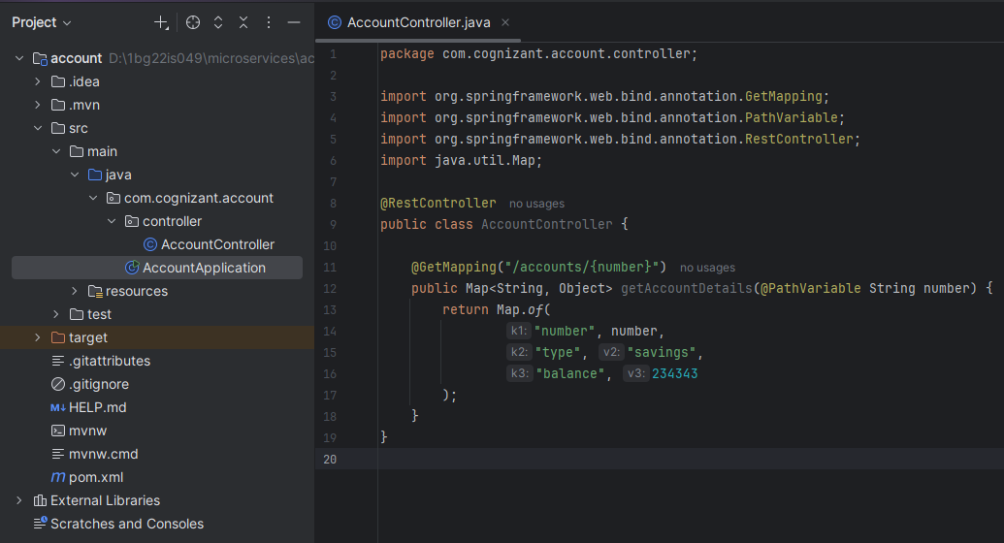

**Output:**

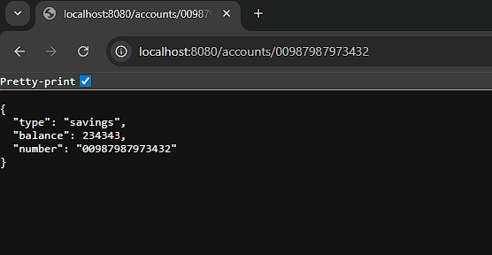

**Loan Microservice:**

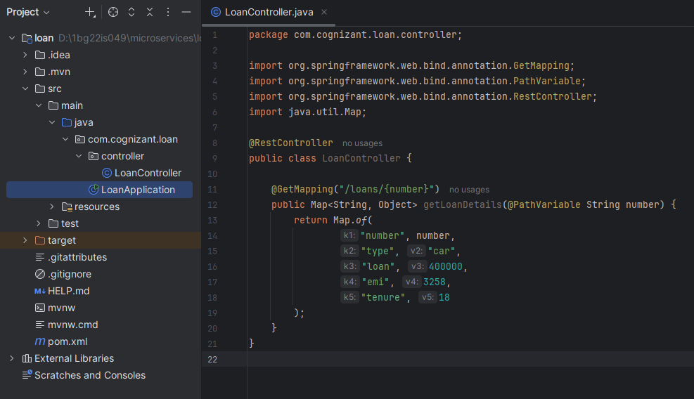

**Output:**

