**Exercise – 1**

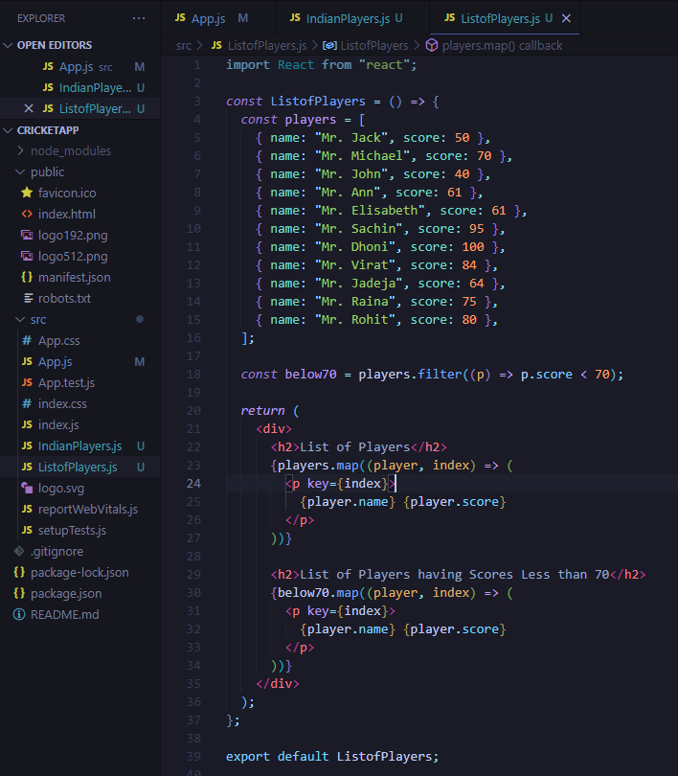

**Output:**

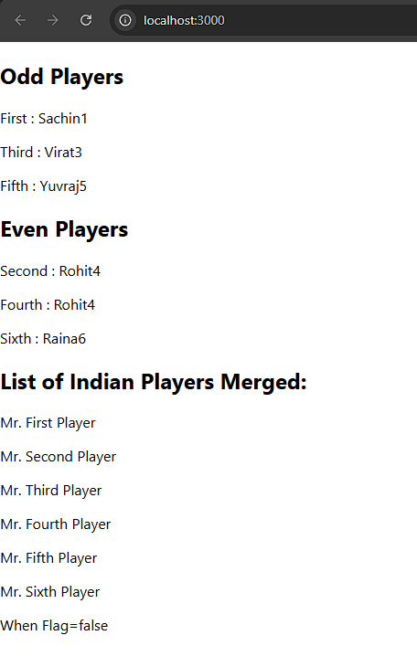

**Exercise 2**

**Output:**

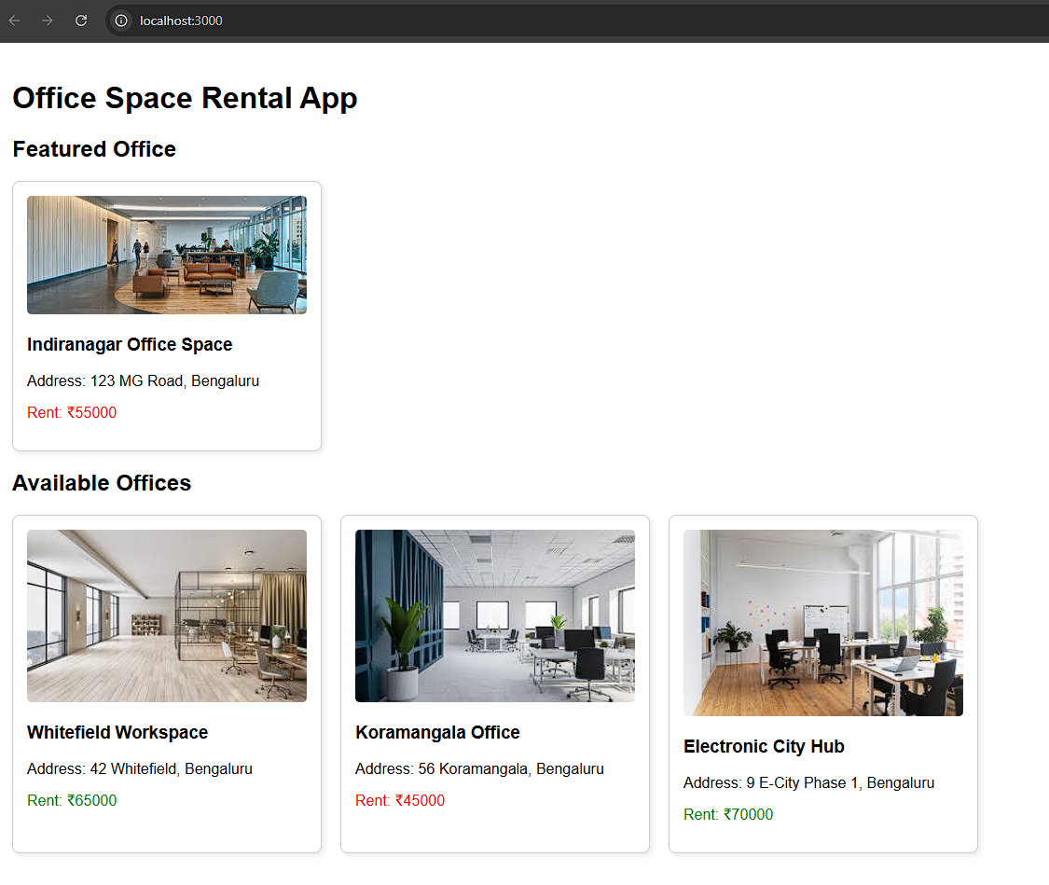

**Exercise 3**

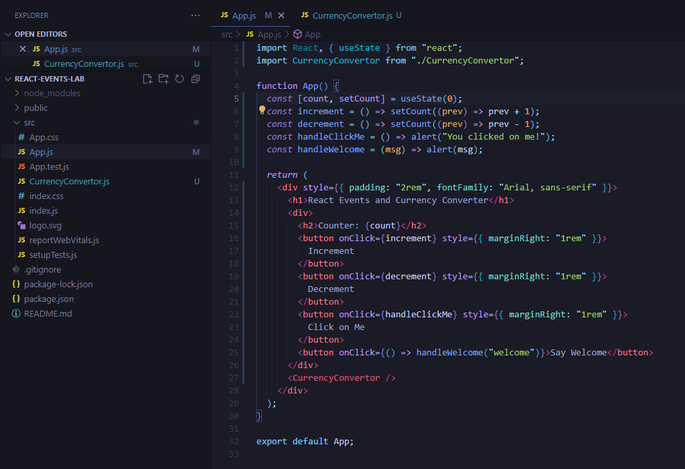

**Output:**

**Exercise 4**

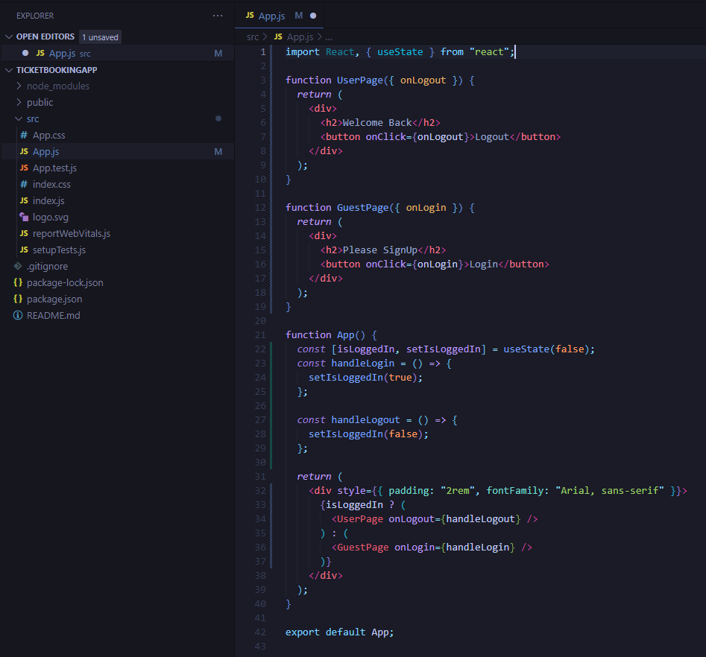

**Output:**

**Exercise 5**

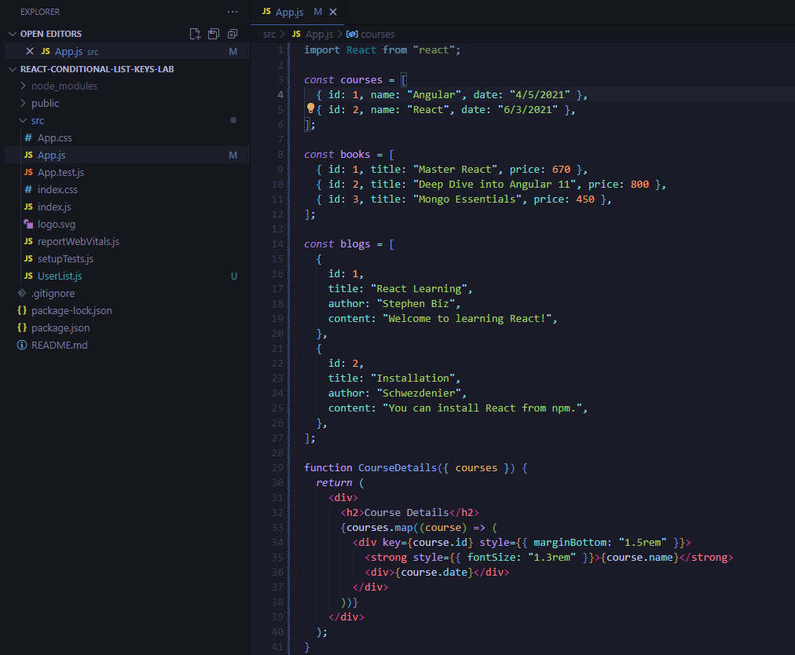

**Output:**

