**WEEK4**

**Exercise 1: Create a Spring Web Project using Maven**

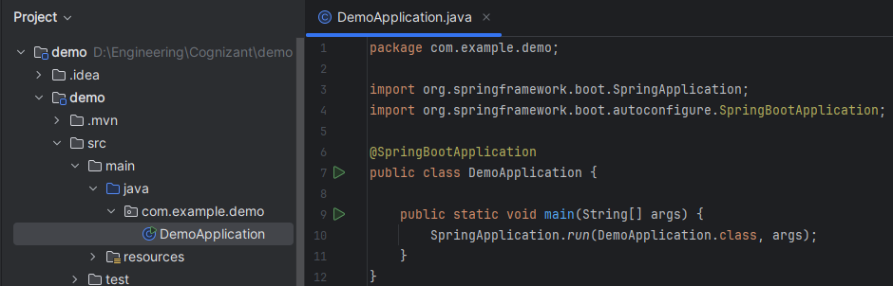

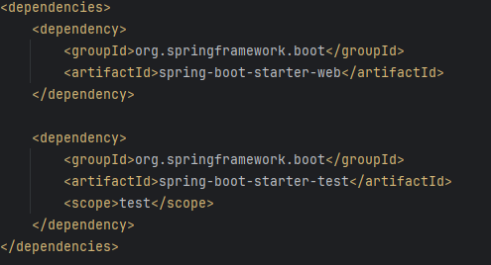

Output:

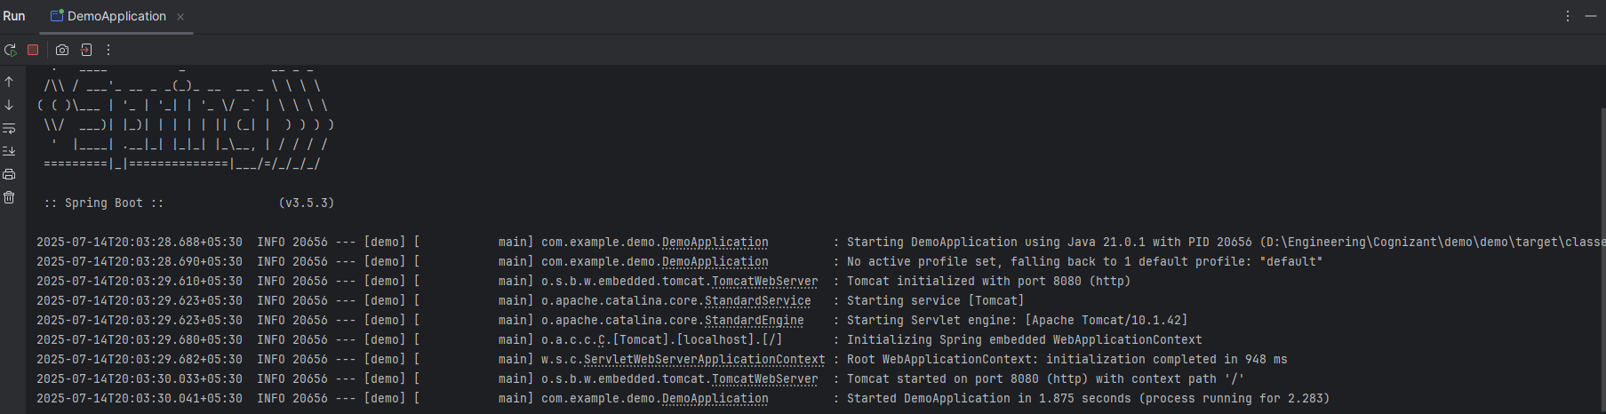

**Exercise 2: Spring Core – Load Country from Spring Configuration XML**

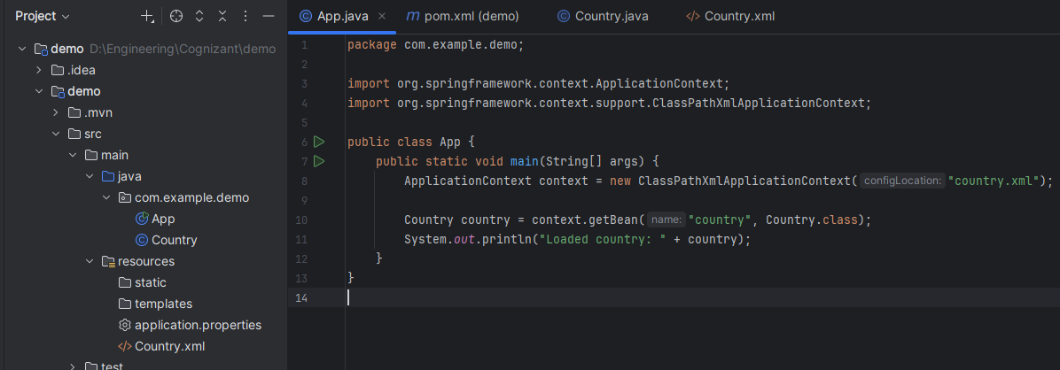

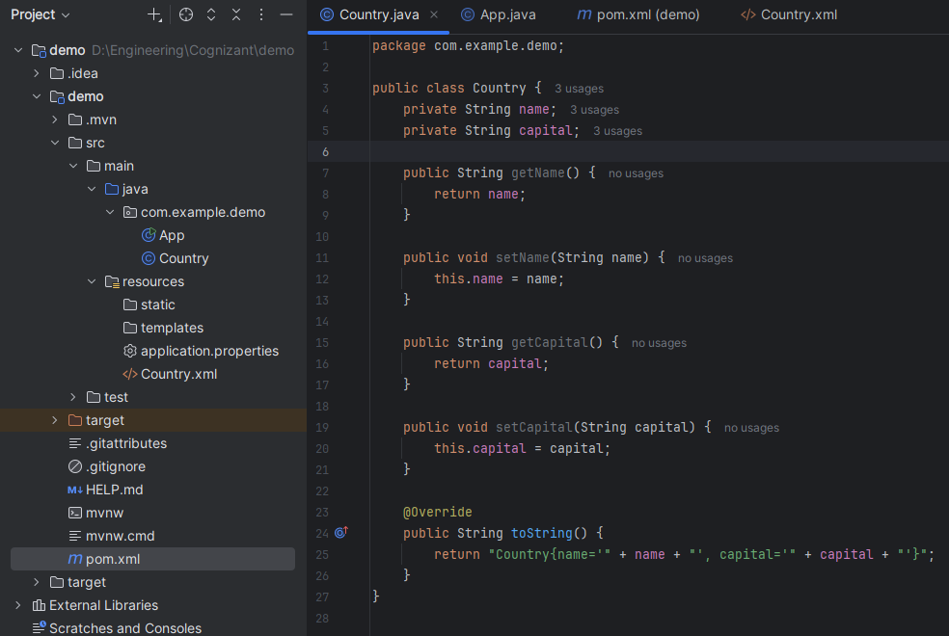

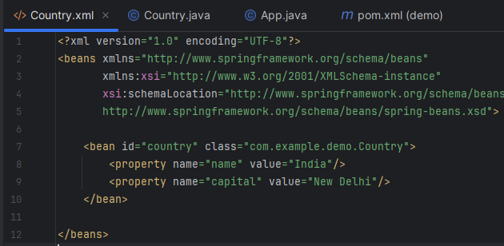

Output:

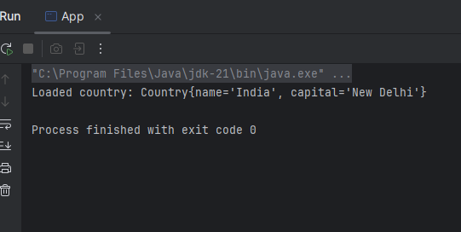

**Exercise 3: Hello World RESTful Web Service**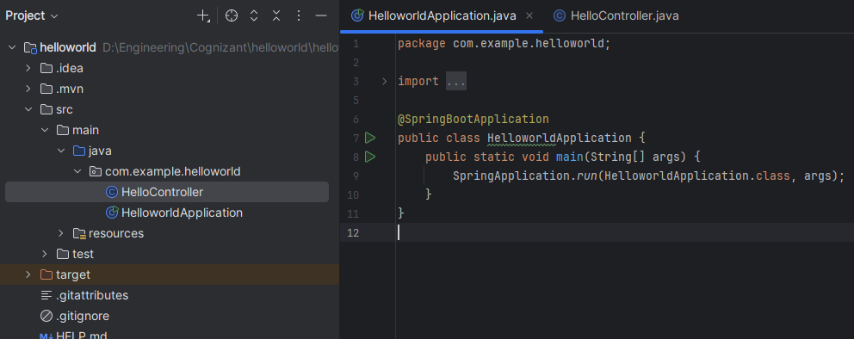

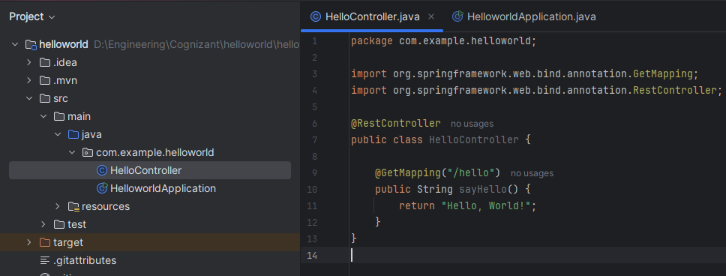

**Output:**

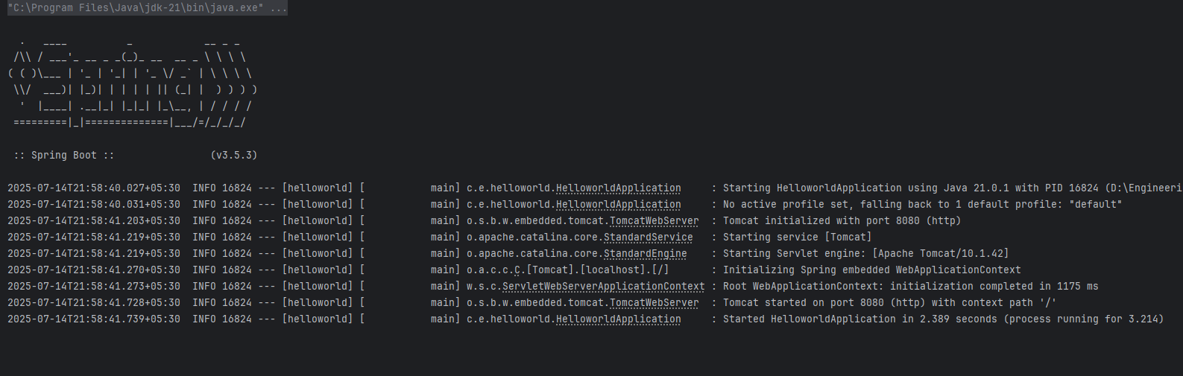

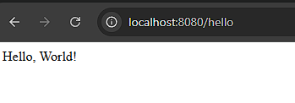

**Exercise 4: REST - Country Web Service**

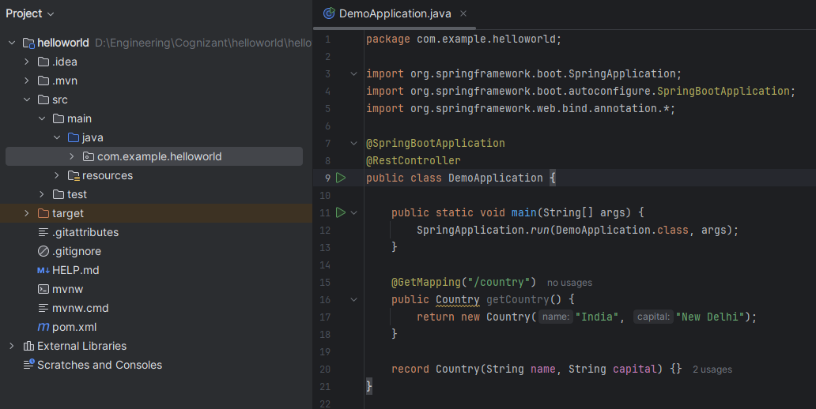

**Output:**

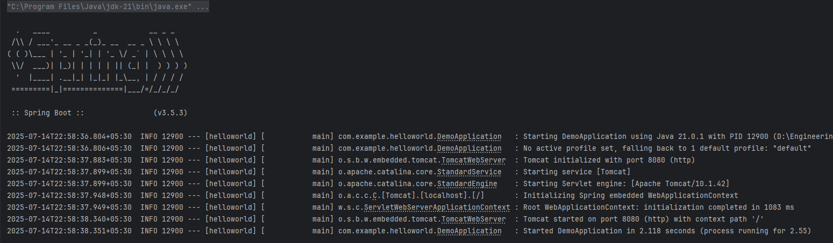

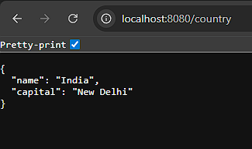

**Exercise 5: REST - Get country based on country code**

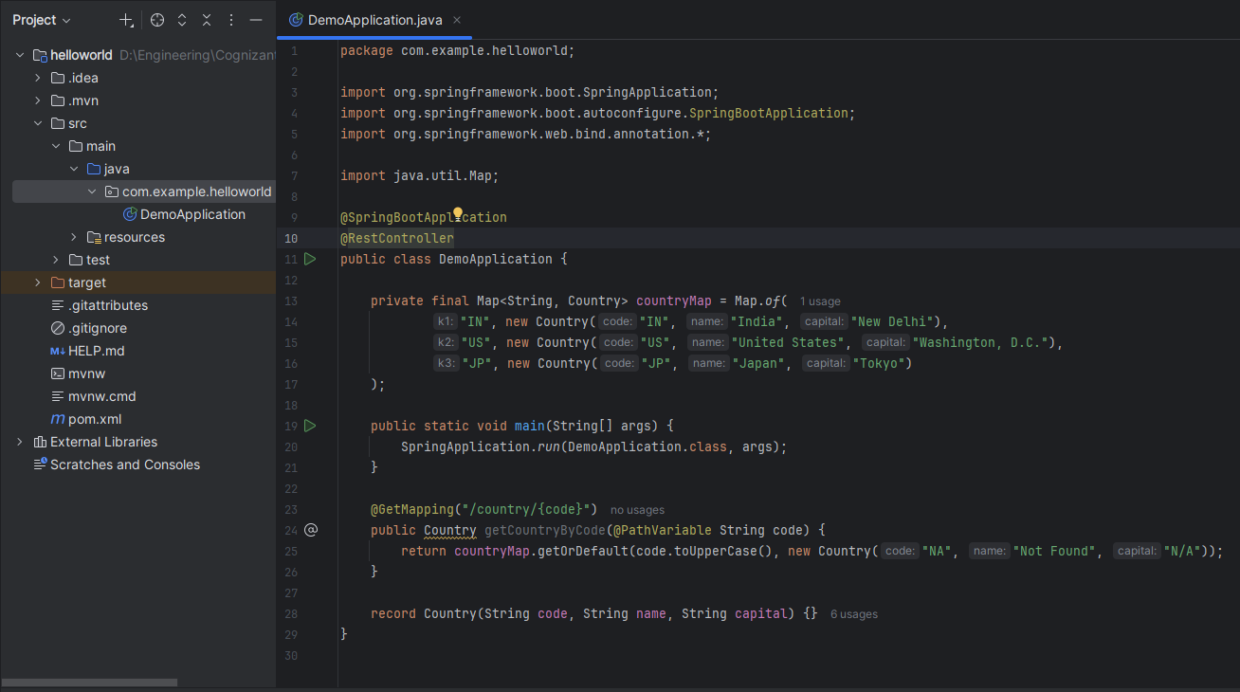

**Output:**

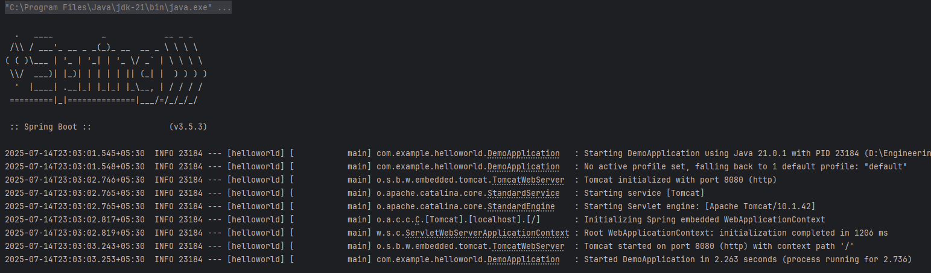

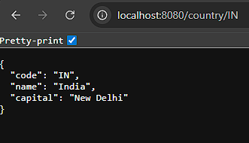

**Exercise 6: Create authentication service that returns JWT**

**Pom.xml**

<dependencies>

<dependency>

<groupId>org.springframework.boot</groupId>

<artifactId>spring-boot-starter-web</artifactId>

</dependency>

<dependency>

<groupId>org.springframework.boot</groupId>

<artifactId>spring-boot-starter-security</artifactId>

</dependency>

<dependency>

<groupId>io.jsonwebtoken</groupId>

<artifactId>jjwt</artifactId>

<version>0.9.1</version>

</dependency>

</dependencies>

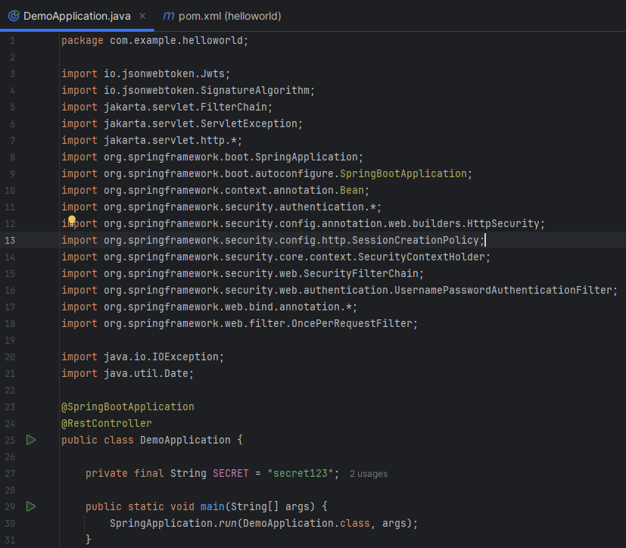

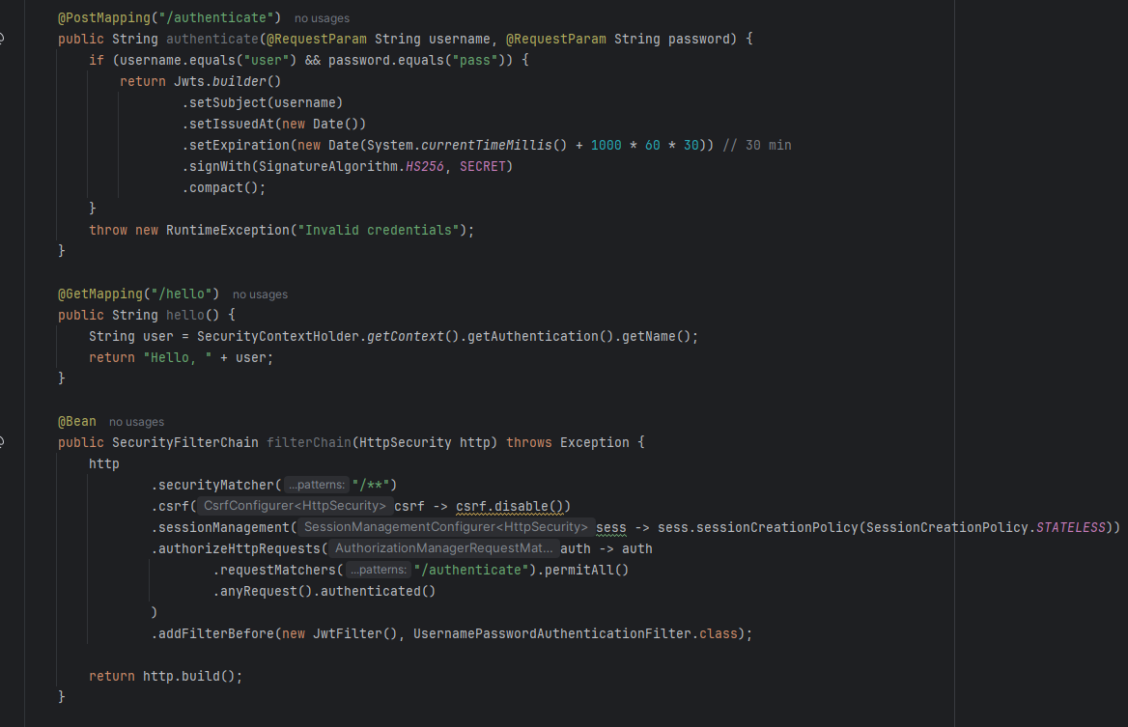

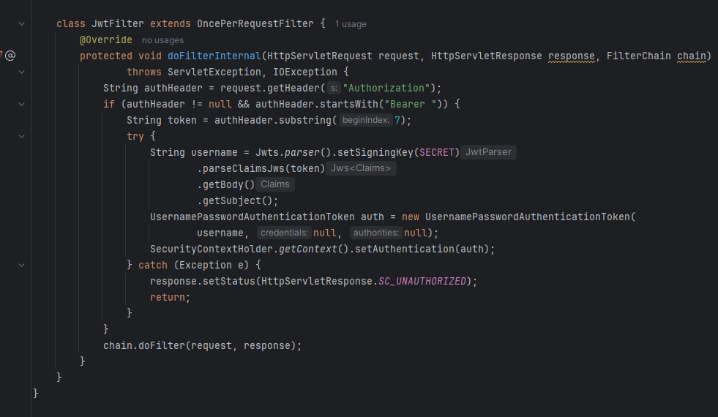  
**Output:**

