Experiment 3
Aim of Experiment
Implement Logistic Regression
Theory / Algorithm / Conceptual Description
Logistic regression is a statistical method used for binary classification problems where the goal is to predict a binary outcome (e.g., yes/no, 0/1) based on one or more predictor variables. It is a type of generalized linear model that uses a logistic function (also known as the sigmoid function) to transform a linear combination of the predictor variables into a probability value between 0 and 1.
The logistic function is defined as follows:
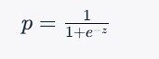where $p$ is the predicted probability of the positive outcome, $z$ is
the linear combination of the predictor variables and their coefficients, and $e$ is the mathematical constant known as the Euler's number.
The linear combination $z$ is given by:
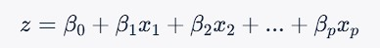
where $\beta_0$ is the intercept or bias term, $\beta_1, \beta_2, ..., \beta_p$ are the coefficients or weights assigned to the predictor variables $x_1, x_2, ..., x_p$ respectively.
To fit a logistic regression model, we use maximum likelihood estimation to find the values of the coefficients that maximize the likelihood of the observed data. This involves finding the set of coefficients that make the predicted probabilities as close as possible to the actual binary outcomes in the training data.
Once the model is trained, we can use it to predict the probability of the positive outcome for new data points by plugging in the values of the predictor variables into the logistic function and computing the predicted probability. We can then use a threshold (usually 0.5) to convert the predicted probabilities into binary predictions.
Logistic regression has many extensions, such as multinomial logistic regression for multi-class classification problems and ordinal logistic regression for ordered categorical outcomes. It is widely used in many fields, such as healthcare, finance, marketing, and social sciences.
Program
import pandas as pd from sklearn.model_selection import train_test_split from sklearn.preprocessing import LabelEncoder import numpy as np
import matplotlib.pyplot as plt

df = pd.read_csv('diabetes.csv')

df.shape

# le = LabelEncoder()
# df['age'] = le.fit_transform(df['age'])
# df['income'] = le.fit_transform(df['income'])
# df['student'] = le.fit_transform(df['student'])
# df['credit_rating'] = le.fit_transform(df['credit_rating'])
# df['buys_computer'] = le.fit_transform(df['buys_computer'])

- = df.iloc[:, :-1]
- = df.iloc[:, -1]
X_train, X_test, y_train, y_test = train_test_split(X, Y, test_size=0.2, random_state=42)

def sigmoid(z):
return 1.0/(1 + np.exp(-z))

def gradients(X, y, y_hat):

m = X.shape[0]

dw = (1/m)*np.dot(X.T, (y_hat - y)) return dw

def train(X, y,epochs, lr):
m, n = X.shape w = np.zeros((n,1)) y = y.reshape(m,1)
x = X for epoch in range(epochs): for i in range(m):

xb = X
yb = y
y_hat = sigmoid(np.dot(xb, w)) dw = gradients(xb, yb, y_hat) w -= lr*dw

return w

w = train(X_train.values, y_train.values, epochs=1000, lr=0.01)

print(w)

def predict(X):

preds = sigmoid(np.dot(X, w))

pred_class = []
pred_class = [1 if i > 0.5 else 0 for i in preds]

return np.array(pred_class)

def accuracy(y, y_hat): accuracy = np.sum(y == y_hat) / len(y) return accuracy

predict(X_test.values)

accuracy(y_test.values, predict(X_test.values))

# Logistic Regression

## Importing the libraries

import numpy as np
import matplotlib.pyplot as plt import pandas as pd

## Importing the dataset

dataset = pd.read_csv('Social_Network_Ads.csv')
X = dataset.iloc[:, :-1].values y = dataset.iloc[:, -1].values

## Splitting the dataset into the Training set and Test set

from sklearn.model_selection import train_test_split

X_train, X_test, y_train, y_test = train_test_split(X, y, test_size = 0.25, random_state = 0)

print(X_train)

print(y_train)

print(X_test)

print(y_test)

## Feature Scaling

from sklearn.preprocessing import StandardScaler sc = StandardScaler()
X_train = sc.fit_transform(X_train)
X_test = sc.transform(X_test)

print(X_train)

print(X_test)

## Training the Logistic Regression model on the Training set

from sklearn.linear_model import LogisticRegression classifier = LogisticRegression(random_state = 0) classifier.fit(X_train, y_train)

## Predicting a new result

print(classifier.predict(sc.transform([[30,87000]])))

## Predicting the Test set results

y_pred = classifier.predict(X_test)
print(np.concatenate((y_pred.reshape(len(y_pred),1), y_test.reshape(len(y_test),1)),1))

## Making the Confusion Matrix

from sklearn.metrics import confusion_matrix, accuracy_score cm = confusion_matrix(y_test, y_pred) print(cm)
accuracy_score(y_test, y_pred)

## Visualising the Training set results

from matplotlib.colors import ListedColormap X_set, y_set = sc.inverse_transform(X_train), y_train
X1, X2 = np.meshgrid(np.arange(start = X_set[:, 0].min() - 10, stop = X_set[:, 0].max() + 10, step =
0.25),
np.arange(start = X_set[:, 1].min() - 1000, stop = X_set[:, 1].max() + 1000, step = 0.25)) plt.contourf(X1, X2, classifier.predict(sc.transform(np.array([X1.ravel(), X2.ravel()]).T)).reshape(X1.shape),
alpha = 0.75, cmap = ListedColormap(('salmon', 'dodgerblue'))) plt.xlim(X1.min(), X1.max()) plt.ylim(X2.min(), X2.max()) for i, j in enumerate(np.unique(y_set)):
plt.scatter(X_set[y_set == j, 0], X_set[y_set == j, 1], c = ListedColormap(('salmon', 'dodgerblue'))(i), label = j)
plt.title('Logistic Regression (Training set)') plt.xlabel('Age')
plt.ylabel('Estimated Salary') plt.legend() plt.show()

## Visualising the Test set results

from matplotlib.colors import ListedColormap X_set, y_set = sc.inverse_transform(X_test), y_test
X1, X2 = np.meshgrid(np.arange(start = X_set[:, 0].min() - 10, stop = X_set[:, 0].max() + 10, step =
0.25), np.arange(start = X_set[:, 1].min() - 1000, stop = X_set[:, 1].max() + 1000, step = 0.25)) plt.contourf(X1, X2, classifier.predict(sc.transform(np.array([X1.ravel(), X2.ravel()]).T)).reshape(X1.shape),
alpha = 0.75, cmap = ListedColormap(('salmon', 'dodgerblue'))) plt.xlim(X1.min(), X1.max()) plt.ylim(X2.min(), X2.max()) for i, j in enumerate(np.unique(y_set)): plt.scatter(X_set[y_set == j, 0], X_set[y_set == j, 1], c = ListedColormap(('salmon', 'dodgerblue'))(i), label = j)
plt.title('Logistic Regression (Test set)') plt.xlabel('Age')
plt.ylabel('Estimated Salary') plt.legend() plt.show()

Output
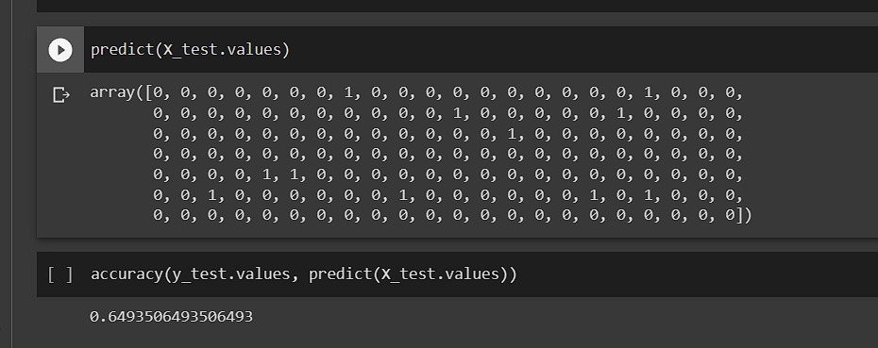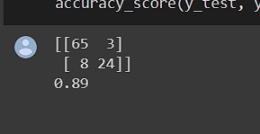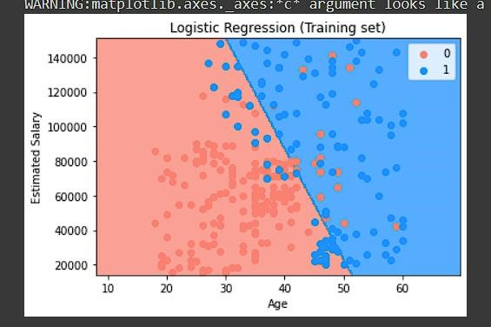

I
n
built functions

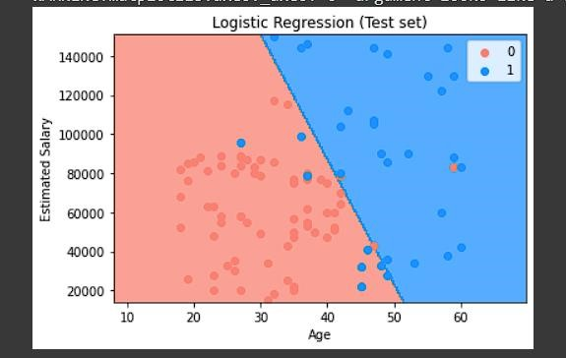

Conclusion: Logistic Regression was implemented from scratch and using the Sci Kit Learn Library

