Pricing Strategy Analytics Report

Business Objective
Assess pricing effectiveness, validate pricing governance, identify commercial performance drivers, and provide executive pricing recommendations.

Project Objectives
- Validate pricing calculations.
- Audit pricing policy compliance.
- Analyze product performance.
- Compare lifecycle performance.
- Evaluate customer segmentation.
- Assess pricing optimization opportunities.
- Develop executive recommendations.

Business Metrics
Metric | Value
Total Opportunities | 638
Won Opportunities | 427
Overall Win Rate | 66.93%
Revenue | $79.20M
Gross Profit | $47.72M

Key Findings
- Enterprise Suite generated 48% of total revenue with the lowest average discount.
- Renewal and Expansion deals consistently outperformed New Business.
- Legal and Technology Enterprise customers generated the highest strategic revenue.
- Nexus AI Assistant requires pricing strategy review.
- Nexus Insights presents pricing optimization opportunities.

Dashboard Screenshots
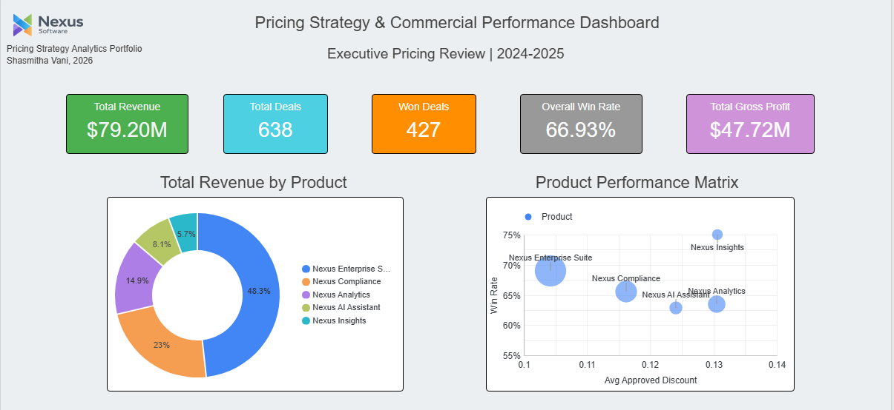
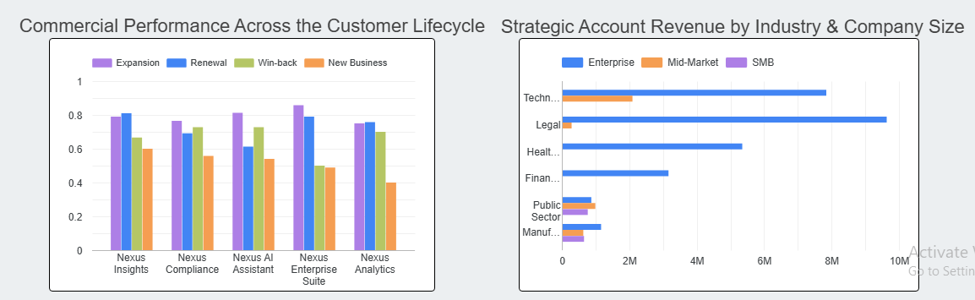
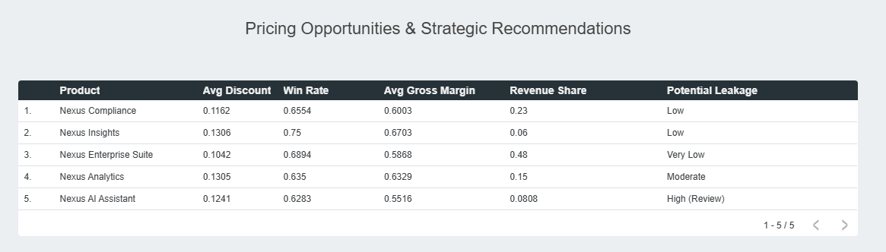

Executive Recommendations
- Protect Enterprise Suite pricing discipline.
- Review AI Assistant pricing and positioning.
- Optimize discounts for Nexus Insights through controlled testing.
- Focus growth on Enterprise Legal and Technology accounts.
- Investigate non-pricing factors in lower-performing segments.

