S3 task -01

- Create an S3 bucket and upload some objects to S3. 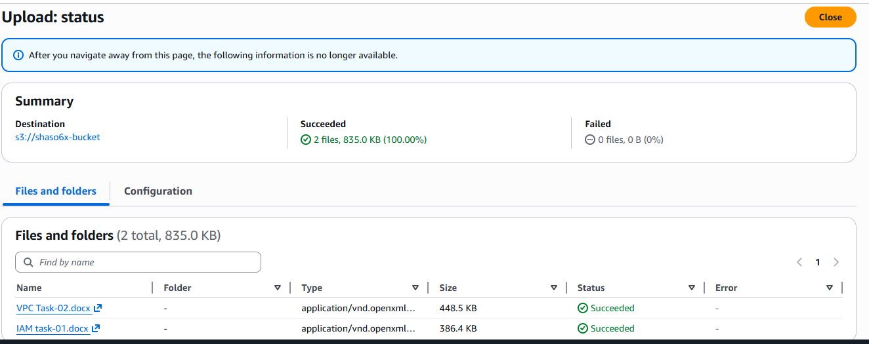
- Deploy a static website in the S3 bucket.
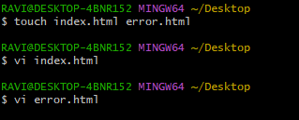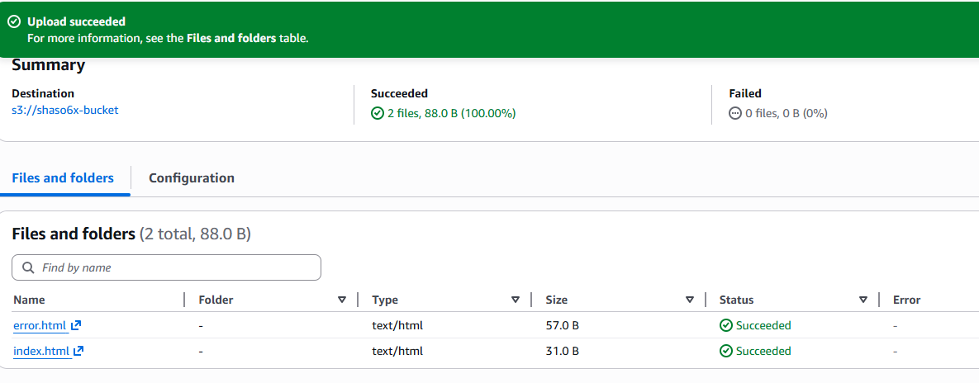
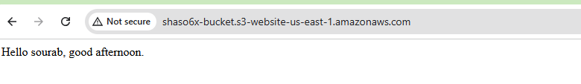

- Enable cross-region replication on S3 buckets. 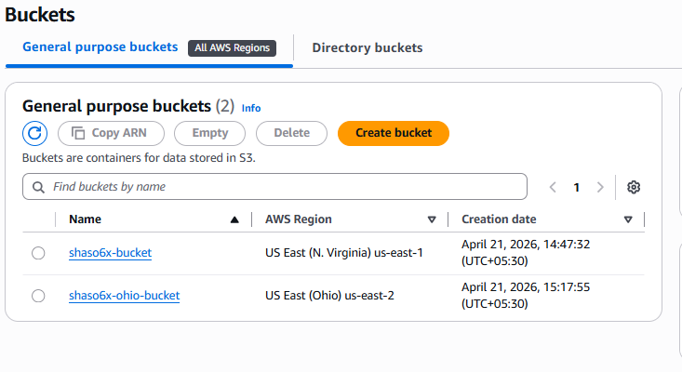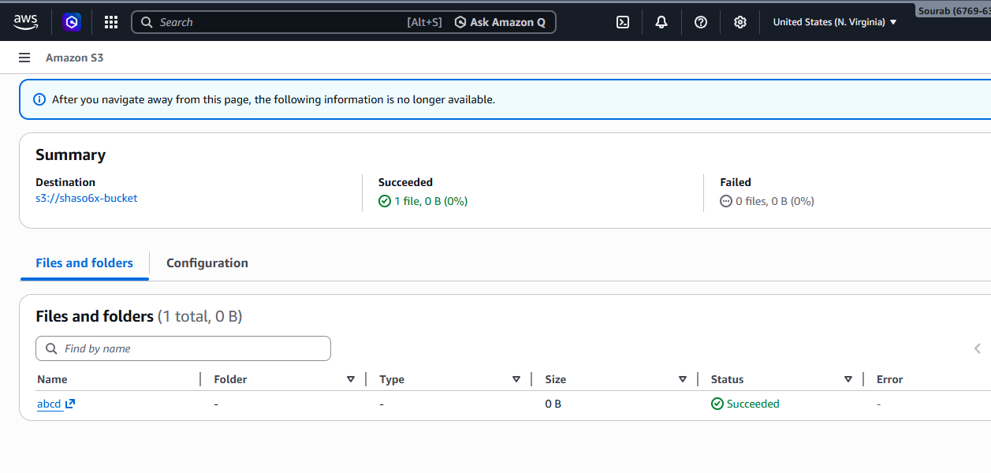 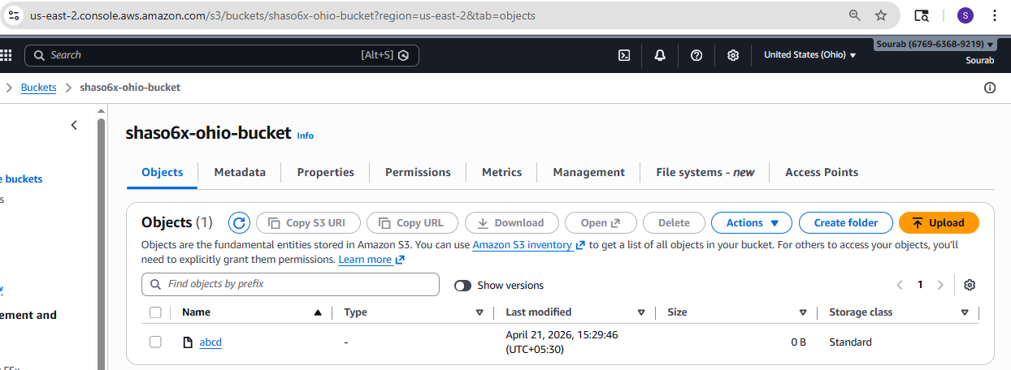

- Configure a bucket policy so only the Admin user can see the objects of the S3 bucket.
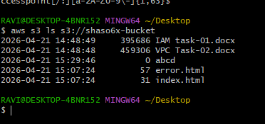
- Set up lifecycle policies to automatically transition or delete objects based on specific criteria.
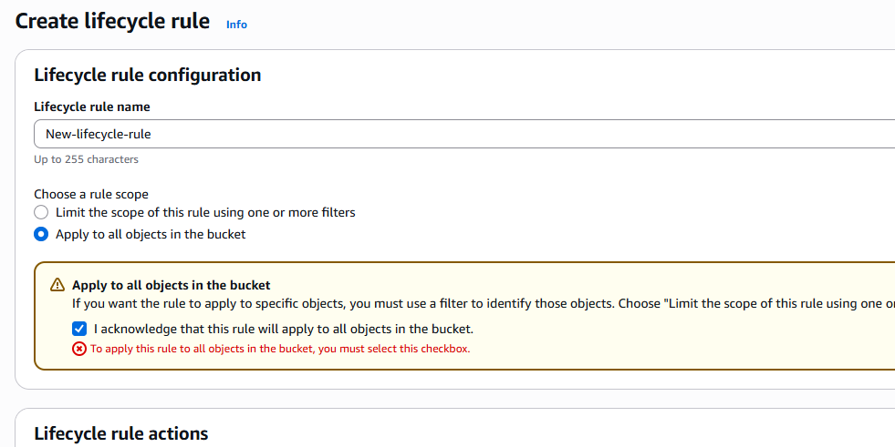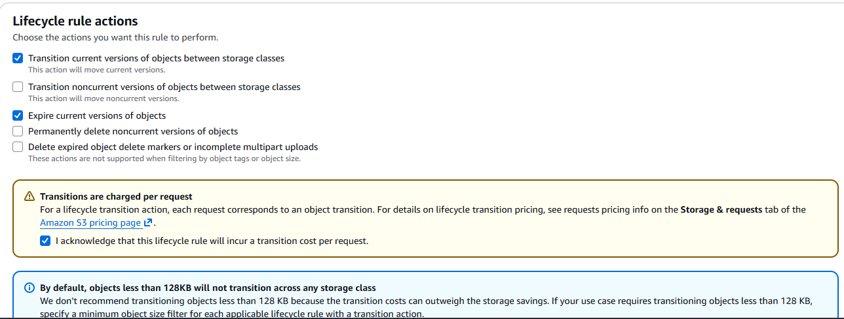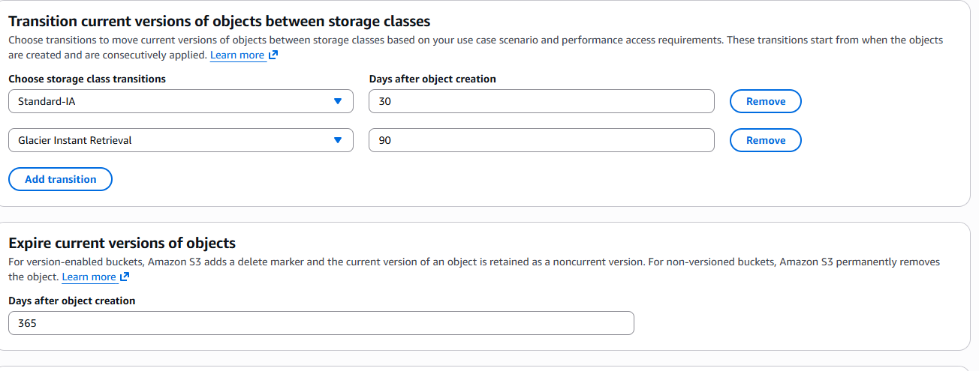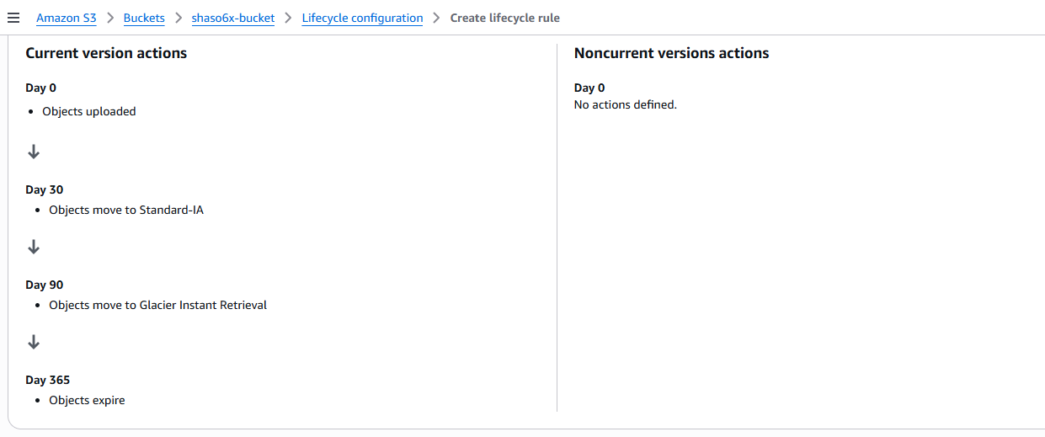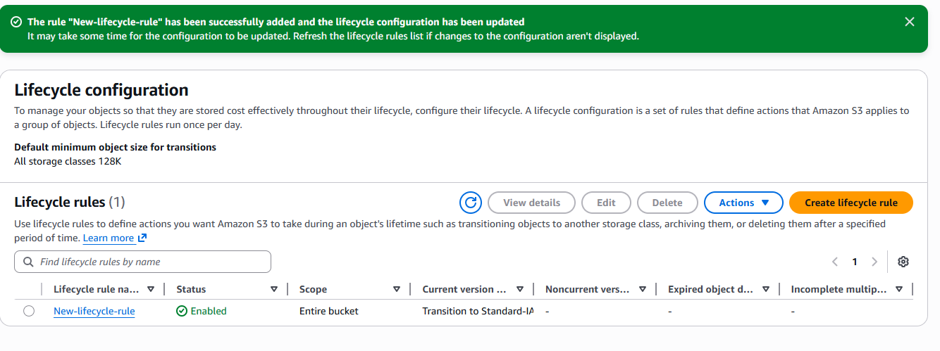
- Push some objects to S3 using the AWS CLI. 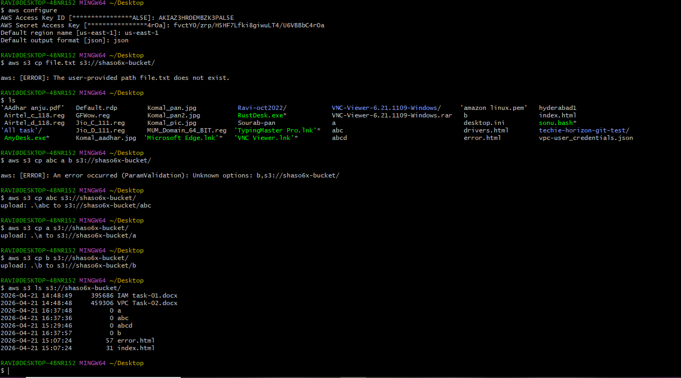

- Write a Bash script to create an S3 bucket.

#!/bin/bash

# Variables
BUCKET_NAME="my-unique-bucket-800866"
REGION="ap-south-1"

# Check if bucket name is provided as argument
if [ ! -z "$1" ]; then
BUCKET_NAME=$1
fi

echo "Creating bucket: $BUCKET_NAME in region: $REGION"

# Create bucket (special handling for us-east-1)
if [ "$REGION" == "us-east-1" ]; then
aws s3api create-bucket \
--bucket "$BUCKET_NAME"
else
aws s3api create-bucket \
--bucket "$BUCKET_NAME" \
--region "$REGION" \
--create-bucket-configuration LocationConstraint="$REGION"
fi

# Check if command was successful
if [ $? -eq 0 ]; then
echo "✅ Bucket created successfully!"
else
echo "❌ Failed to create bucket"
exit 1
fi

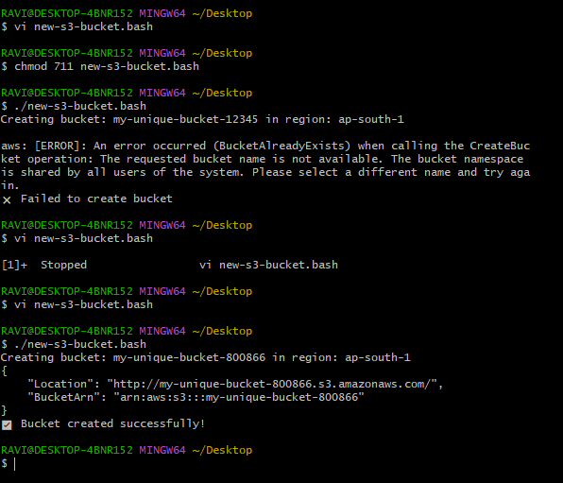

- Upload a 1 GB file to S3 using the CLI.

Create a 1 GB Test File:-
dd if=/dev/zero of=bigfile.bin bs=1M count=1024

To upload the file to s3:-
aws s3 cp bigfile.bin s3://shaso6x-bucket/
