Axiata Deployment Guide

Code Structure

Setting up XOCL

Setting up SACL

Configuring Secure Vault

## 

## Code Structure

“ProtocolConverter” is a multi-maven project which has XOCL and SACL ESB configuration projects. XOCL project has the synapse configuration for XOCL layer and so on.

## 

## Setting up XOCL

1. Download wso2esb-4.8.1.zip from <http://wso2.com/products/enterprise-service-bus/> and extract the downloaded file. DO_ESB_HOME denotes the unzipped folder location. Change the port offset if required.

2. Configure system secure vault

3. Get the code for XOCL from <LOCATION>

4. Configure the endpoints [Refer Axiata-ProtocolCoverter Documentation for details]

5. Build the XOCL Project

6. Deploy the XOCL.CAR in ESB

## Setting up SACL

1. Download wso2esb-4.8.1.zip from <http://wso2.com/products/enterprise-service-bus/> and extract the downloaded file. DO_ESB_HOME denotes the unzipped folder location. Change the port offset if required.

2. Configure system secure vault

3. Get the code for SACL from <LOCATION>

4. Configure the endpoints [Refer Axiata-ProtocolCoverter Documentation for details]

5. Add properties to the secure vault as defined in “Configuring Secure Vault”

6. Build the SACL Project

7store. Deploy the SACL.CAR in ESB

List of entries to in secure vault

- exchanage_hub_credentials

- hub_token

## Configuring Secure Vault

Configuring secure vault helps to protect the passwords stored in the ESB instance.

The following documentation helps to configure secure vault in detailed manner. This has to be followed when it is required to secure system specific passwords such management console password, user store password and so on. <https://docs.wso2.org/display/Carbon420/WSO2+Carbon+Secure+Vault>

To protect the application specific passwords, using management console of the ESB is simple.

The steps are following,

1. Setup secure vault as in the previous tutorial.

2. Start the ESB server.

3. In the management console, go to ‘Manage Passwords’ under ‘Secure Vault Tool’.

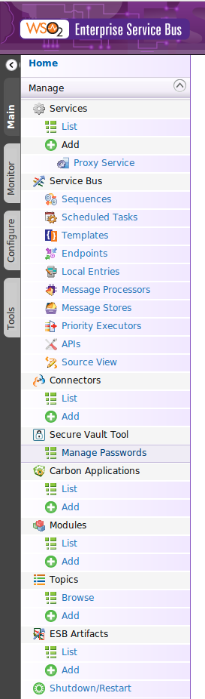

4. Click ‘Add New Password to encrypt and store’

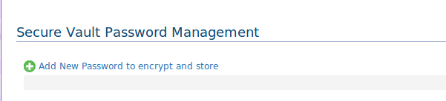

5. Add the key and corresponding password

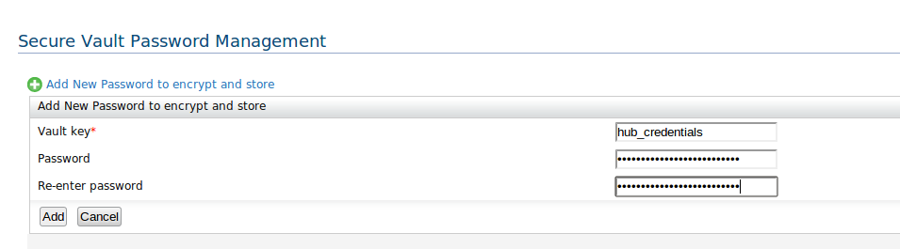

6. In the synapse configuration this credentials will be referred as wso2:vault-lookup(‘hub_credentials’)