PIZZA PLACE
Sales & Customer Ordering Analysis

Introduction
The project focuses on analyzing the sales and customer ordering behaviour of Pizza Place using data analytics techniques. The dataset contains information about different pizza types, sizes, prices, orders, and quantities sold. The analysis helps in understanding customer preferences, identifying popular products, and examining sales trends. The insights obtained from the analysis can support better business decisions related to inventory, product management, sales, and customer demand.

Dataset Description
The project uses four datasets related to the sales and ordering activities of Pizza Place. These datasets provide information about pizza products, their categories, prices, customer orders, and quantities purchased. By combining the datasets using common fields, a complete view of the sales transactions can be obtained and analyzed.

The datasets are as follows:
# | Dataset | Contents
1 | pizzas.csv | Contains pizza ID, pizza type ID, size, and price information.
2 | pizza_types.csv | Contains pizza type ID, pizza name, category, and ingredients.
3 | orders.csv | Contains order ID, order date, and order time.
4 | order_details.csv | Contains order detail ID, order ID, pizza ID, and quantity purchased.

Dataset Relationship – The datasets are connected using common fields such as pizza_id, pizza_type_id, and order_id, which allows the data to be combined for detailed sales and customer behavior analysis.

Objective
The main objective of this project is to analyze the sales data of Pizza Place and identify useful patterns in customer ordering and product performance. The analysis aims to provide meaningful insights that can help understand business performance and support better decision-making.

The key objectives are:
- To analyze overall sales performance of Pizza Place.
- To identify the best-selling pizza types based on quantity and sales.
- To analyze pizza categories and determine their contribution to sales.
- To understand customer preferences for different pizza sizes.
- To identify peak ordering days and hours based on order data.
- To analyze sales trends across different dates and time periods.
- To perform Exploratory Data Analysis (EDA) on the available datasets.
- To generate meaningful business insights from the analyzed data.
- To present the results through an interactive dashboard for easy understanding and decision-making.

Insights
01 Total number of orders placed
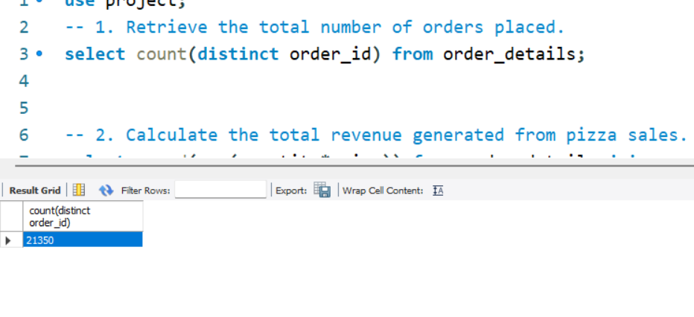
02 Total revenue generated from pizza sales
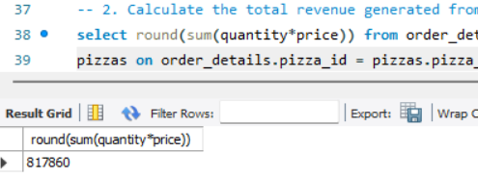

03 The highest-priced pizza
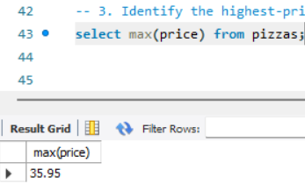
04 The most common pizza size ordered
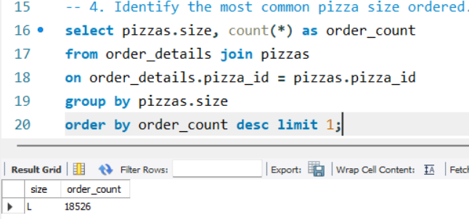
05 The top 5 most ordered pizza types along with their quantities
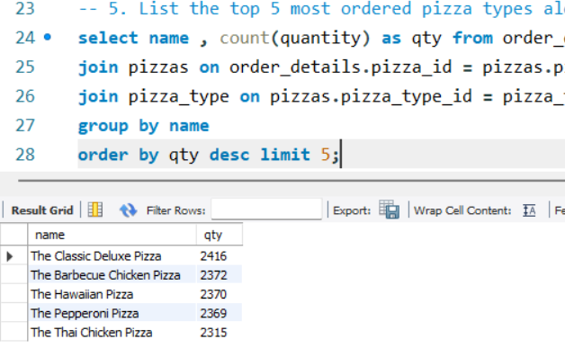
06 The total quantity of each pizza category ordered
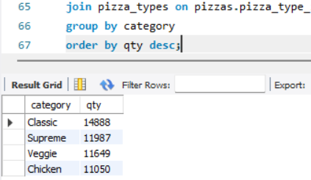
07 The distribution of orders by hour of the day
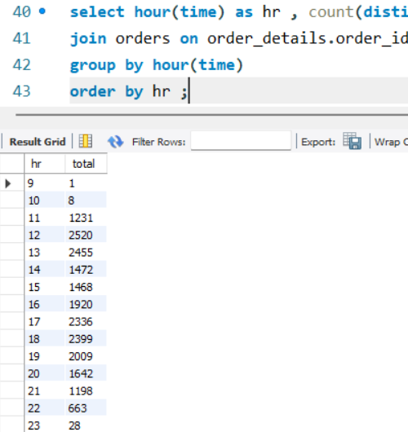
08 The category-wise distribution of pizzas
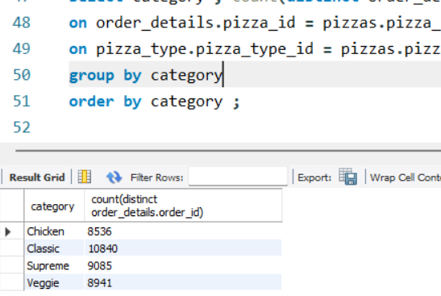
09 Grouping the orders by date
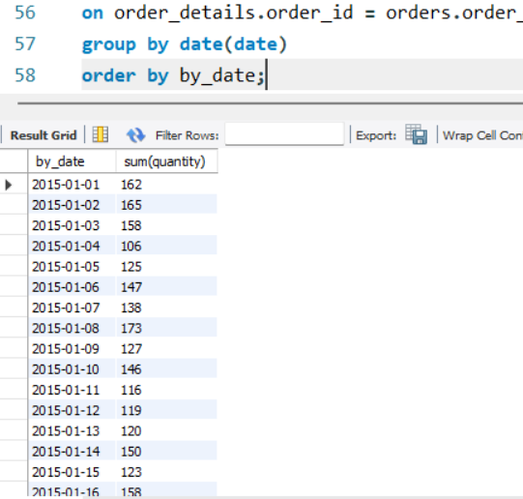
10 The average number of pizzas ordered per day
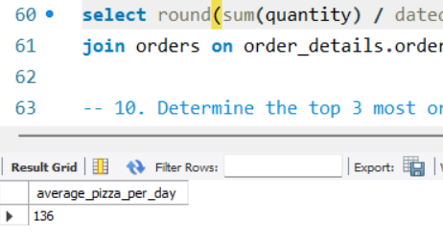
11 Top 3 most ordered pizza types based on revenue
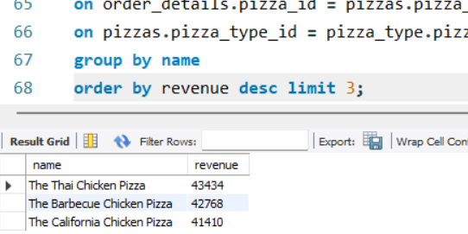

Conclusion
21,350  Total orders | ₹ 8,17,860  Total revenue | ₹ 38.31  Avg. order value | 18,526  Large (L) orders

1. Overall Sales Performance
- Total distinct orders placed are 21,350 in one operating year.
- Total revenue generated is ₹ 8,17,860 from sale of nearly 50,000 pizzas.
- Average order value is ₹ 38.31, which shows customers order more than one pizza per bill and have good spending capacity.
- This indicates stable daily sales of approx. 136 pizzas per day.

2. Pricing Analysis
- The highest-priced pizza in the menu is ₹ 35.95.
- Despite being the costliest item, it is still selling, which proves premium pricing is accepted by customers.
- Pricing strategy is optimal as it has generated ₹ 8.18 Lakh revenue without affecting demand.

3. Customer Preference for Pizza Size
- Most common ordered size is Large (L) with 18,526 orders.
- L size contributes more than 86% of total orders, which clearly shows customers prefer Large for sharing and value for money.
- Small, Medium, XL and XXL are very low in comparison.
- Business should keep 80% inventory of dough, cheese and boxes for L size only.

4. Best-Selling Pizza Types (Top 5 by Quantity)
Rank | Pizza Type | Quantity
1 | The Classic Deluxe Pizza | 2,416 qty
2 | The Barbecue Chicken Pizza | 2,372 qty
3 | The Hawaiian Pizza | 2,370 qty
4 | The Pepperoni Pizza | 2,369 qty
5 | The Thai Chicken Pizza | 2,315 qty

- The difference between 1st and 5th is only 101 pizzas, which shows demand is balanced but Classic Deluxe is the clear winner and should be kept as hero product.

5. Category-wise Contribution
Category | Quantity | Share
Classic | 14,888 qty | 30% – Highest contributor
Supreme | 11,987 qty | 24.2%
Veggie | 11,649 qty | 23.5%
Chicken | 11,050 qty | 22.3%

- Classic + Supreme together contribute 54% of total business, which proves that core Classic and Supreme menu options drive revenue stability as mentioned in your doc Page 7.

6. Peak Hours and Time Trend
- Peak operating hours are 12 PM, 1 PM, 5 PM, 6 PM which is lunch and dinner rush.
- Orders grouped by date show weekends (Friday and Saturday) have highest sales.
- This requires double staffing during 12-2 PM and 5-7 PM to manage rush efficiently.

7. Final Business Conclusion
Pizza Place demonstrates strong revenue stability of ₹ 8,17,860 driven by consistent demand in Classic and Supreme categories.
With 21,350 orders and 18,526 L size orders, primary growth lever is inventory precision for large size and top 5 pizzas.
By streamlining raw material purchasing based on high-performing recipes and nudging basket size above current ₹ 38.31 average through combo offers, the brand can significantly increase operating margins without compromising quality.

