AN INTELLIGENT SPACE UTILIZATION ANALYTICS PLATFORM
FOR RESOURCE OPTIMIZATION
PROJECT REPORT
Submitted by
SHASVIN D (7376242IT295)
VIVIN C (7376242AD344)
SATCHINDRA R B (7376242AD296)
In partial fulfilment for the award of the degree of
BACHELOR OF TECHNOLOGY
in
INFORMATION TECHNOLOGY

BANNARI AMMAN INSTITUTE OF TECHNOLOGY
(An Autonomous Institution Affiliated to Anna University, Chennai)
SATHYAMANGALAM – 638401
ANNA UNIVERSITY: CHENNAI 600 025
OCTOBER 2026

BONAFIDE CERTIFICATE
Certified that this project report “An Intelligent Space Utilization Analytics Platform for Resource Optimization” is the Bonafide work of "SHASVIN D (7376242IT295), VIVIN C (7376242AD344), and SATCHINDRA R B (7376242AD296)" who carried out the project work under my supervision.
The work presented in this report was completed as part of the requirements for the course S5 Mini Project during the academic year 2026–2027. The empirical data, system design, implementation workflows, security mechanisms, and verification results presented in this report represent their genuine work.
SIGNATURE  Dr. NAVEENA S  HEAD OF THE DEPARTMENT  Department of Information Technology  Bannari Amman Institute of Technology  Sathyamangalam – 638401 | SIGNATURE  Dr. K. R. SABARMATHI  ASSISTANT PROFESSOR – Level III  Department of Information Technology  Bannari Amman Institute of Technology  Sathyamangalam - 638401

Submitted for Project Viva Voice examination held on ………………………………

Internal Examiner | External Examiner

DECLARATION
We affirm that the project work titled “An Intelligent Space Utilization Analytics Platform for Resource Optimization” being submitted in partial fulfillment of the requirements for the award of the degree of Bachelor of Technology in Information Technology is the record of original work done by us under the guidance of
Dr. K. R. Sabarmathi, Assistant Professor - Level III, Department of Information Technology. It has not formed a part of any other project work(s) submitted for the award of any degree or diploma, either in this or any other University.

SHASVIN D  (7376242IT295) | VIVIN C  (7376242AD344)
SATCHINDRA R B
(7376242AD296)

I certify that the declaration made above by the candidates is true.

(Signature)
Dr. K. R. Sabarmathi

ACKNOWLEDGEMENT
First and foremost, we thank the Almighty for giving us the strength, guidance, and perseverance to successfully execute and complete this academic project.
We express our profound gratitude to our esteemed Chairman Dr. S.V. Balasubramaniam, and the respected Principal Dr. C. Palanisamy for providing excellent facilities, institutional computing infrastructure, and support during the course of study in this institute.
We are grateful to Dr. Naveena S, Head of the Department, Department of Information Technology for her valuable suggestions, administrative encouragement, and support to carry out the project work successfully.
We wish to express our sincere thanks to our respected Project Guide,
Dr. K. R. Sabarmathi, Assistant Professor – Level III, Department of Information Technology, for her constructive ideas, inspirations, encouragement, excellent guidance, and much needed technical support extended to complete our project work.
We would like to thank our friends, faculty members, and lab technicians who have directly and indirectly contributed to the success of this project.

SHASVIN D (7376242IT295)
VIVIN C (7376242AD344)
SATCHINDRA R B (7376242AD296)

ABSTRACT
Efficient physical infrastructure management is one of the most critical operational challenges in contemporary higher education institutions. Campus room allocation workflows often suffer from operational opacity, frequent scheduling collisions, and chronic underutilization of expensive facilities. This project presents the design and full-stack implementation of an Intelligent Space Utilization Analytics Platform for Resource Optimization, developed for the S5 Mini Project at Bannari Amman Institute of Technology.
Built on a responsive full-stack web architecture using Node.js, Express.js, MySQL 8.0, and vanilla JavaScript (ES6+), the system replaces manual logbooks with a centralized, real-time institutional platform managing 20 campus facilities distributed across four distinct campus blocks (Block A, Block B, Block C, Block D), encompassing 10 classrooms, 6 high-performance laboratories, and 4 seminar halls.
The system architecture provides role-based workspaces for three distinct institutional stakeholders: System Administrators (space management, booking request adjudication, faculty provisioning, audit logs), Faculty Members (live space discovery, multi-criteria filtering by block, type, and capacity, reservation request submission), and Campus Management (macro-level utilization metrics, space-type efficiency analytics, block-by-block occupancy distributions, and timetable schedules).
A core highlight of the developed system is its Unified Campus Utilization and Space Optimization engine. It delivers proactive underutilization alerts (<50% usage) to help administrators balance institutional workloads, while providing granular daily, weekly, monthly, and Block-wise schedule views. Furthermore, an automated background job monitors completed sessions and immediately releases rooms back to the available pool upon class completion. Security is maintained through 10-round salted bcryptjs hashing, parameterized query defense, and immutable audit logging.

Table of Contents
CHAPTER NO. | TITLE | PAGE NO.
 | BONAFIDE CERTIFICATE | I
 | DECLARATION
 | ACKNOWLEDGEMENT
 | ABSTRACT | II
 | LIST OF TABLES | IV
 | LIST OF FIGURES | V
1 | INTRODUCTION | 9
1.1 | Background of the Work | 9
1.2 | Problem Statement | 9
1.3 | Scope of the Work | 10
1.4 | Objectives of the Study | 10
2 | LITERATURE SURVEY | 12
2.1 | Overview of Space Management Studies | 12
2.2 | Comparative Analysis & Research Gap | 13
3 | PROPOSED METHODOLOGY | 14
3.1 | Hardware and Software Technology Specifications | 14
3.2 | Campus Space Inventory & Distribution | 15
3.3 | Limitations of Traditional Space Allocation Methodologies | 15
3.4 | Multi-Tier Web System Architecture | 16
3.5 | Space Booking, Collision Validation & Approval Workflow | 17
3.6 | Automatic Space Release & Availability Lifecycle | 18
3.7 | Database Schema & Relational Entity Model | 19
3.8 | Database Security Hardening & Principle of Least Privilege | 21
3.9 | System Module Implementation & User Interfaces | 22
4 | RESULTS AND ANALYSIS | 26
4.1 | System Testing & Functional Verification Matrix | 26
4.2 | Database Security & Hardening Verification | 27
4.3 | Functional Achievements & Operational Velocity | 28
4.4 | Space Optimization Analytics & Utilization Impact | 28
4.5 | Operational Performance and Discussion | 29
5 | CONCLUSION AND FUTURE WORK | 30
5.1 | Conclusion | 30
5.3 | Future Enhancements | 31
 | REFERENCES | 32
 | APPENDICES | 33
 | Appendix 1: Coding
 | Appendix 2: Individual work contribution
 | Appendix 3: Plagiarism Report | 35
 | Appendix 4: Project Outcome

List of Tables
S NO. | TABLE NAME | PAGE NO.
3.1 | Hardware Specification & Minimum Requirements | 14
3.2 | Full-Stack Software Technology Specifications | 14
3.3 | Campus Space Distribution Across Blocks A, B, C, D | 15
3.4 | Comparative Inefficiency Matrix: Manual vs. Automated System | 15
3.5 | Data Dictionary: users Table (Authentication & Roles) | 19
3.6 | Data Dictionary: spaces Table (Campus Facilities Inventory) | 19
3.7 | Data Dictionary: requests Table (Space Booking & Scheduling) | 20
3.8 | Data Dictionary: audit logs Table | 20
3.9 | Security Architecture Configuration | 21
3.10 | User Interface Architecture & Specifications Matrix | 22
4.1 | Functional Test Cases and Verification Results (TC01–TC14) | 26
4.2 | Database Security & Hardening Verification (SEC01–SEC06) | 27
7.1 | Research Dissemination & Publication Record | 34
8.1 | Institutional Plagiarism Clearance Verification | 35

List of Figures
S NO. | FIGURE NAME | PAGE NO.
3.1 | Multi-Tier Web System Architecture | 16
3.2 | Space Booking, Collision Validation & Approval Workflow | 17
3.3 | Database Entity Relationship (ER) Diagram | 18
3.4 | Unified Authentication & Secure Login Portal | 22
3.5 | System Administrator Control Center & Real-Time KPIs | 23
3.6 | Campus Space Inventory & Facility Management Interface | 23
3.7 | Faculty Space Discovery & Multi-Criteria Filtering Interface | 24
3.8 | Modal Interface for Booking Request Submission | 24
3.9 | Management Executive Occupancy Analytics Dashboard | 25
3.10 | Unified Campus Utilization & Block-wise Schedule Matrix | 25
3.11 | Security Posture Badges & Immutable Database Audit Trail | 25

CHAPTER 1
INTRODUCTION
1.1 BACKGROUND OF THE WORK
In contemporary educational institutions, physical campus infrastructure represents one of the largest capital and operational investments. The efficient scheduling, allocation, and utilization of physical spaces—encompassing lecture halls, specialized computer laboratories, seminar halls, and smart classrooms—directly impacts institutional productivity, student learning outcomes, and administrative overhead.
In traditional university environments, physical room allocations are managed using fragmented, manual, or spreadsheet-driven procedures. Decentralized booking workflows across academic departments lead to operational opacity, frequent scheduling collisions, double bookings, and severe capacity underutilization. Faculty coordinators spend significant administrative time cross-checking availability, negotiating room swaps, or resolving last-minute room disputes.
The Intelligent Space Utilization Analytics Platform for Resource Optimization is engineered to overcome these fundamental systemic hurdles. Built on a responsive, lightweight full-stack architecture using Node.js, Express.js, MySQL 8.0, HTML5, CSS3, and modern JavaScript, the platform acts as an automated campus control center. It integrates role-based booking requests, dynamic collision prevention, real-time space release mechanisms, space optimization alerts, and verifiable database audit logging into a unified institutional portal.
1.2 PROBLEM STATEMENT
Manual and spreadsheet-based campus room allocation methods create severe administrative liabilities for modern academic institutions:
1. Information Asymmetry: Faculty members lack real-time visibility into actual room occupancy, resulting in underutilized spaces while adjacent facilities remain oversubscribed.
2. High Collision Probability: Booking requests processed through disconnected channels (paper requisition forms, email, instant messaging) lead to overlapping reservations for the same facility and time slot.
3. Chronic Space Underutilization: While certain popular lecture halls operate near capacity, specialized laboratories and auxiliary seminar rooms experience extensive idle periods without administrative awareness.
4. Zero Accountability & Audit Trail: Traditional databases often operate under root privileges without tracking administrative approvals, credential changes, or failed access attempts.
1.3 SCOPE OF THE WORK
The project scope encompasses 20 campus facilities categorized into 10 classrooms, 6 computer laboratories, and 4 seminar halls distributed uniformly across four campus blocks (Block A, Block B, Block C, Block D). The platform delivers specialized, secured web portals for three institutional user classes:
• System Administrators: Complete room inventory lifecycle, approval/rejection of reservation requests, faculty account management, and security audit inspection.
• Faculty Members: Real-time room discovery, multi-criteria filtering by block, space type, and capacity, and instant booking submission with immediate validation.
• Campus Management: High-level institutional occupancy analytics, space type utilization comparisons, block-wise utilization matrices, and room optimization alerts.
1.4 OBJECTIVES OF THE STUDY
The primary objective of this project is to develop, test, and deploy a robust full-stack campus room management platform with the following specific goals:
1. Centralized Facility Governance: Manage 20 campus facilities across 4 campus blocks with detailed metadata (block, capacity, space type, operational status).
2. Dynamic Collision Prevention: Enforce server-side validation rejecting overlapping time intervals on approved space requests.
3. Unified Utilization & Optimization Analytics: Provide campus administrators with proactive underutilization alerts (<50% usage) and granular block-wise schedules.
4. Automatic Facility Release: Deploy an automated background scheduler that releases facilities back to 'Available' status once the reservation window has elapsed.
5. 3-Layer Enterprise Database Security: Implement 10-round salted bcryptjs password hashing, strict parameterized SQL statements, dedicated restricted MySQL user credentials, and immutable audit logging.

CHAPTER 2
LITERATURE SURVEY
2.1 OVERVIEW OF SPACE MANAGEMENT STUDIES
The optimization of educational space utilization and academic timetabling has been extensively investigated across operations research, facilities management, and computer science literature. Recent studies emphasize the growing necessity for data-driven, real-time spatial governance in universities:
Lavy, Daneshpour, and Choi (2020) studied space utilization across university academic facilities and identified underutilization as a major challenge. Their research highlighted how limited resource sharing between departments can lead to inefficient classroom usage. The study emphasized the importance of monitoring space utilization and improving resource allocation to make better use of existing facilities.
Valks et al. (2021) examined university campus space utilization using dynamic allocation methods and dashboard-based monitoring. Their study highlighted how centralized information helps administrators identify unused spaces and make informed decisions. The research emphasized the role of digital dashboards in improving facility management, coordination, and efficient utilization of campus resources.
Dunke and Nickel (2023) developed a matheuristic framework for university course timetabling. Their research addressed challenges such as classroom capacity limitations, faculty preferences, and scheduling constraints. The study demonstrated the complexity of allocating academic spaces efficiently and highlighted the importance of systematic approaches to reduce scheduling difficulties and improve resource utilization.
Chen, Werner, and Shokouhifar (2023) investigated mathematical modeling approaches for university course scheduling. Their research focused on allocating classrooms while considering scheduling requirements and potential conflicts. The study highlighted the importance of structured scheduling methods in reducing manual effort and supporting administrative decisions. These findings are relevant to developing an organized classroom request and approval process.
Davison, Kheiri, and Zografos (2025) investigated university course timetabling under hybrid learning conditions using integer programming. Their research considered classroom availability and scheduling constraints to improve the allocation of academic resources. The study highlighted the need for flexible scheduling approaches to accommodate changing teaching requirements. This research provides useful direction for future improvements in campus space management and resource optimization.
Valks et al. (2021) investigated the application of smart-campus technologies to improve the management and utilization of university facilities. Their study highlighted the importance of collecting space utilization data and presenting it through centralized dashboards to support decision-making. The findings emphasize that digital monitoring systems can help university administrators identify underutilized spaces and improve resource allocation. This study supports the development of a centralized dashboard for monitoring campus space utilization.
Supporting Strategic Decision-Making on the Future Campus with Space Utilisation Studies: A Case Study (2021) examined space utilization at Delft University of Technology over a five-year period. The study demonstrated how systematic measurement of space usage can support short-term operational decisions and long-term campus planning. It highlighted the importance of understanding occupancy patterns to identify opportunities for improving facility utilization.
Rappos et al. (2022) proposed a mixed-integer programming approach for university course timetabling. Their method considered the assignment of courses to suitable rooms and time slots while satisfying multiple scheduling constraints. The researchers combined mathematical optimization with local-search techniques to improve the quality of scheduling solutions. This study demonstrates the complexity of university resource allocation and supports the need for systematic room assignment and availability management.
Mohottige et al. (2022) investigated classroom occupancy estimation using Wi-Fi infrastructure in a university campus environment. Their approach used wireless access-point information to estimate classroom occupancy and analyze room usage patterns. The study demonstrated the potential of existing campus infrastructure to provide useful information about space utilization. Although the proposed system does not use Wi-Fi-based occupancy detection, this research highlights the importance of reliable occupancy information for effective campus resource planning.
Maximizing Student Opportunities for In-Person Classes under Pandemic Capacity Reductions (2022) addressed university timetabling under reduced classroom capacity constraints. The researchers developed a decision-support framework for assigning courses to suitable teaching modes and available rooms. The study highlighted the challenges of accommodating academic activities when physical spaces have limited capacity. This research is relevant to the proposed system because capacity-based filtering helps faculty identify spaces that can accommodate their requirements.
Bashab et al. (2023) presented a comprehensive review of optimization techniques used in university timetabling. Their study examined different scheduling constraints, solution approaches, benchmark datasets, and evaluation methods. The review discussed the importance of optimization algorithms in solving complex academic scheduling problems involving room availability, student requirements, and faculty preferences. This research provides a foundation for understanding the challenges associated with efficient campus space allocation.
Liu et al. (2023) investigated the optimization of classroom and self-study-room timetables in university teaching buildings, considering energy efficiency. Their approach examined how scheduling decisions and the distribution of academic activities influence building energy consumption. The study highlighted the relationship between space utilization and efficient facility operation. This research provides useful background for improving campus resource utilization while considering operational efficiency.
Ahmed, Saboor, Ahmad, and Ghaly (2022) developed a multi-attribute utility decision-support tool for smart-campus applications. Their study considered multiple criteria and stakeholder requirements to support campus-related decision-making. The research highlighted the importance of integrating information from different campus functions into a structured decision-support approach. This is relevant to the proposed system, which provides separate interfaces for administrators, faculty members, and management according to their responsibilities.
Samancioglu and Nuere (2023) proposed the Smart Availability Scale to assess the smartness of university campuses. Their research examined smart-campus development and the availability of technologies that support campus services and resource management. The study emphasized the role of digital technologies in improving campus operations and decision-making. This research supports the broader objective of developing an integrated digital platform for managing educational spaces.
Alfalah, Shahrestani, and Shao (2023) developed a Hidden Markov Model to predict occupancy in a higher-education library building. Their study used occupancy data collected at regular intervals to identify patterns in space usage. The research demonstrated how occupancy analysis can support facility planning and resource management. Although the proposed system does not implement machine-learning-based prediction, the study highlights the value of analyzing space usage data to understand resource utilization.
Mallari, San Juan, and Li (2023) developed a mixed-integer linear programming model for synchronizing university coursework schedules. Their approach considered scheduling requirements, instructor availability, and academic workload constraints. The study demonstrated the importance of systematic scheduling methods in reducing conflicts and improving the organization of academic activities. This research is relevant to campus space management because effective allocation requires considering the requirements of faculty members and the availability of suitable facilities.
Xiang et al. (2024) investigated exact and heuristic approaches for solving university course-scheduling problems. Their research considered the assignment of courses to appropriate time periods while satisfying different scheduling constraints. The study highlighted the computational challenges involved in producing feasible and efficient timetables. This work provides useful background for understanding how systematic scheduling and resource allocation approaches can improve the management of limited educational facilities.
Harrabi, Siala, and Mrad (2024) developed an optimization-based decision-support system for university course timetabling using integer linear programming. Their approach incorporated scheduling constraints and teacher preferences to generate feasible timetables. The study demonstrated the value of computational decision-support methods in organizing academic activities and reducing the effort required for manual scheduling. This research supports the development of a digital platform that centralizes space information and simplifies the request and approval process.
Steiner, Pferschy, and Schaerf (2024/2025) investigated curriculum-based university timetabling while considering individual student study plans. Their approach used integer linear programming and a multi-stage planning process to address timetable conflicts and different academic requirements. This research is relevant to the proposed system because efficient campus space management also requires considering space availability, capacity, and the requirements of users.
Davison, Kheiri, and Zografos (2025) investigated university course timetabling under hybrid learning conditions using a multi-objective optimization approach. Their research considered room availability, scheduling constraints, student preferences, and combinations of online and in-person teaching. The study highlighted the importance of adapting academic scheduling approaches to changing educational requirements. This research provides a basis for possible future extensions of the proposed system, including advanced scheduling support and improved resource allocation for different teaching modes.
2.2 COMPARATIVE ANALYSIS & RESEARCH GAP
A rigorous comparative review of contemporary literature reveals three critical operational and technical research gaps in higher education room governance:
1. Theoretical vs. Operational Disconnect: Prior literature has primarily focused on offline mathematical optimization models, which are incapable of handling ad-hoc daily booking requests or real-time room reservations.
2. Neglect of Database Security & Governance: Existing academic prototypes routinely overlook fundamental security hygiene—operating with unhashed credentials, administrative over-privileging, and vulnerable string-concatenated SQL queries.
3. Absence of Automated Space Release Lifecycles: Conventional room reservation systems fail to actively monitor reservation elapsed times, requiring manual check-out workflows that result in phantom occupancy.

CHAPTER 3
PROPOSED METHODOLOGY
3.1 HARDWARE AND SOFTWARE TECHNOLOGY SPECIFICATIONS
The developed space management platform is engineered for high operational velocity, cross-browser compatibility, and zero client-side installation overhead. Table 3.1 details the hardware specifications and Table 3.2 outlines the full-stack software technology stack.
Table 3.1: Hardware Specification & Minimum Requirements
Component | Minimum Requirement | Recommended Specification
Central Processor (CPU) | Dual-Core 2.0 GHz x64 | Quad-Core Intel i5 / AMD Ryzen 5 (2.8 GHz+)
System Memory (RAM) | 4 GB DDR3/DDR4 | 8 GB / 16 GB DDR4 high-speed RAM
Storage Subsystem | 10 GB free disk space (HDD) | 256 GB NVMe SSD for fast query caching
Network Interface | 100 Mbps Ethernet adapter | Gigabit LAN / IEEE 802.11ac Wi-Fi
Client Hardware | Standard Desktop / Mobile display | Full HD (1920x1080) monitor / Touch device
Table 3.2: Full-Stack Software Technology Specifications
Layer / Category | Technology Selected | Version | Architectural Purpose
Operating System | Microsoft Windows / Linux | Win 10/11 / Ubuntu | Host operating system environment
Runtime Environment | Node.js (V8 Engine) | v18.x / v20.x LTS | Asynchronous non-blocking I/O execution
Backend Framework | Express.js | v4.18+ / v5.x | REST API routing, middleware, error handling
Relational Database | MySQL Community Serverx | 8.0.x / 8.4 LTS | ACID transactional persistent storage
Database Driver | mysql2 (Connection Pool) | v3.9+ | Prepared statement caching & pooling
Password Cryptography | bcryptjs | v2.4.3+ | Adaptive 10-round salted hash security
Frontend Technologies | HTML5, CSS3, Vanilla JS | ES6+ Standards | Responsive client interfaces with auth guard
3.2 CAMPUS SPACE INVENTORY & DISTRIBUTION
The operational boundary of the platform consists of exactly 20 physical spaces distributed uniformly across 4 campus blocks (Block A, Block B, Block C, Block D). The space inventory represents three distinct architectural facility tiers: standard classrooms, specialized computer laboratories, and multi-purpose seminar halls. Table 3.3 summarizes the campus space distribution.
Table 3.3: Campus Space Distribution Across Blocks A, B, C, D
Block | Classrooms (40-60) | Laboratories (30-40) | Seminar Halls (100-200) | Total | Seats
Block A | 3 (CR-A101, A102, A201) | 1 (Lab-A1) | 1 (Seminar Hall A) | 5 | 300
Block B | 3 (CR-B101, B102, B201) | 1 (Lab-B1) | 1 (Seminar Hall B) | 5 | 330
Block C | 2 (CR-C101, C201) | 2 (Lab-C1, Lab-C2) | 1 (Seminar Hall C) | 5 | 310
Block D | 2 (CR-D101, D201) | 2 (Lab-D1, Lab-D2) | 1 (Seminar Hall D) | 5 | 290
Total Campus | 10 Classrooms (50%) | 6 Laboratories (30%) | 4 Seminar Halls (20%) | 20 | 1,230
3.3 LIMITATIONS OF TRADITIONAL SPACE ALLOCATION METHODOLOGIES
Table 3.4 contrasts the manual spreadsheet methodology with the automated, real-time platform implemented in this project.
Table 3.4: Comparative Inefficiency Matrix: Manual vs. Automated System
Operational Dimension | Traditional Manual / Spreadsheet | Proposed Intelligent Platform
Booking Request Latency | Hours to days (in-person paper requisition) | Instantaneous (<100ms API validation)
Collision Prevention | Post-incident human detection (high error rate) | Server-side transactional collision validation
Occupancy Visibility | Static printed sheets, departmental silos | Real-time campus-wide dashboard visibility
Post-Session Room Release | Manual return of physical keys / zero tracking | Automated 60-second background release engine
Administrative Accountability | Unsigned handwritten registers | Immutable relational audit trail (audit_logs)
3.4 MULTI-TIER WEB SYSTEM ARCHITECTURE
The Intelligent Space Utilization Analytics Platform is structured as a decoupled multi-tier web application, separating concerns cleanly across Client Presentation, Application REST Controller, Business Logic Services, and Database Storage tiers:
1. Client Presentation Layer: Responsive HTML5/CSS3 glassmorphism interfaces protected by client-side session guards (auth-guard.js), ensuring zero unauthorized routing and secure token injection.
2. Application API Layer: Node.js/Express.js REST controllers handling routing, role-based authorization middleware, and automated payload sanitation.
3. Business Logic & Automation Engine: Server-side collision detection preventing overlapping interval reservations, and an automated background job executing every 60 seconds to release rooms.
4. Database Storage Layer: MySQL 8.0 relational database operating under a restricted dedicated user (campus_app_user) with indexed tables for users, spaces, requests, and audit_logs.
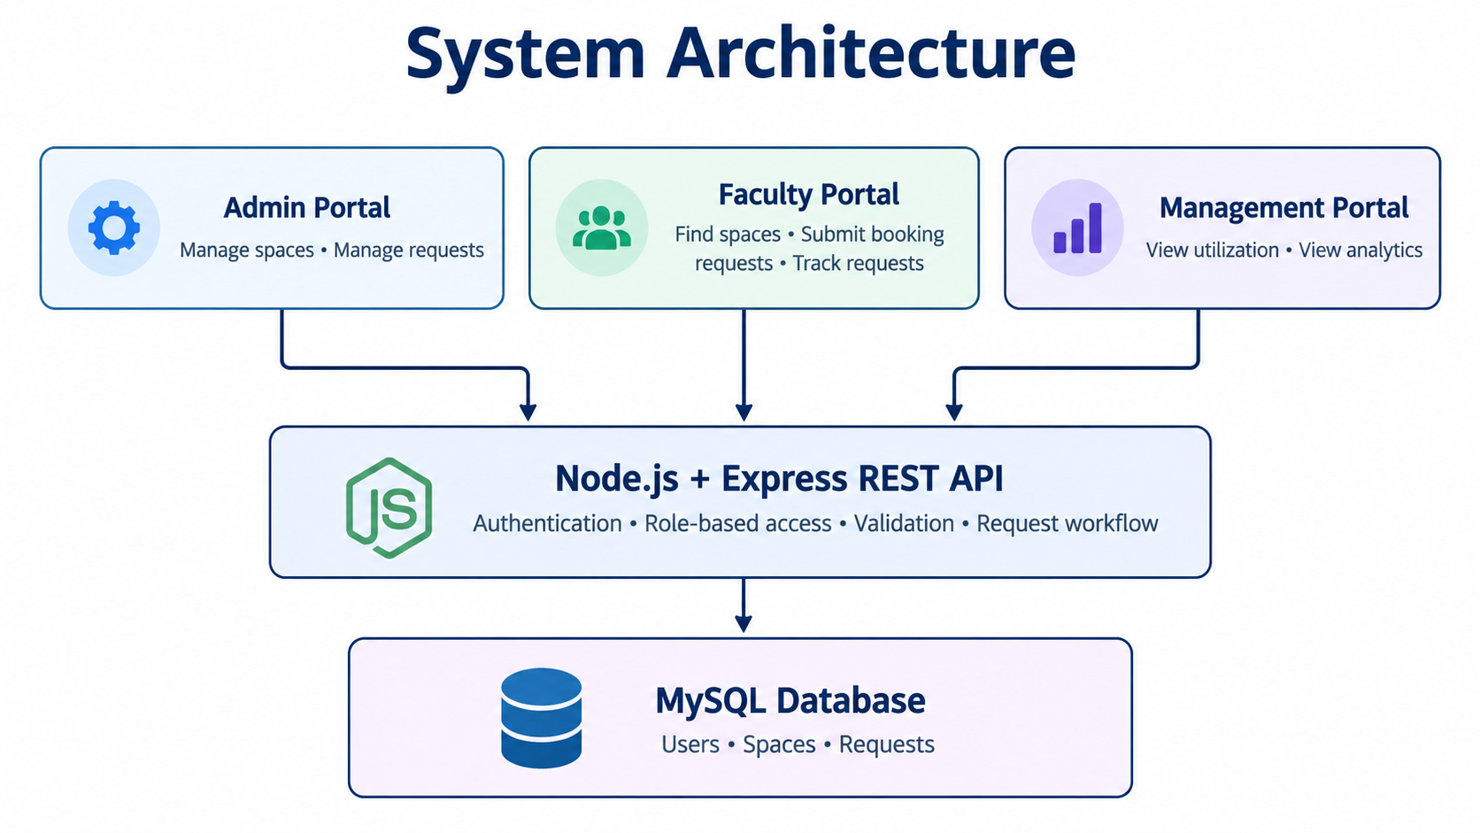
Fig 3.1: Multi-Tier Web System Architecture

3.5 SPACE BOOKING, COLLISION VALIDATION & APPROVAL
WORKFLOW
The booking lifecycle enforces strict integrity checks to prevent scheduling collisions:
1. Space Discovery & Submission: Faculty filters rooms by block, type, and capacity, selecting a verified available space. The submission requires date, start time, end time, and pedagogical purpose.
2. Chronological & Interval Validation: The backend validates that request_date >= CURRENT_DATE, end_time > start_time, and required_capacity <= space.capacity.
3. Collision Detection Query: The server executes a parameterized SQL check verifying that no approved booking overlaps the requested time window.
4. Administrator Adjudication: Administrators review pending applications. Approval automatically updates space status to 'Unavailable', rejects overlapping pending requests, and logs the action.
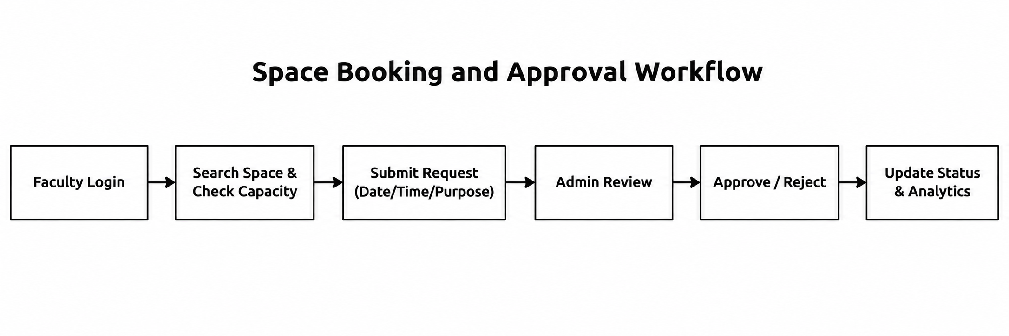
Fig 3.2: Space Booking, Collision Validation & Approval Workflow
3.6 AUTOMATIC SPACE RELEASE & AVAILABILITY LIFECYCLE
A major innovation in the platform is its automated background space release engine (setInterval timer running every 60 seconds in server.js). Traditional room booking systems suffer from 'phantom occupancy'—where spaces remain marked as unavailable long after faculty have completed their classes:
1. Continuous Interval Evaluation: Every minute, the scheduler queries the database for currently 'Unavailable' rooms with active approved bookings.
2. Temporal Comparison: If CURRENT_DATE > request_date OR (CURRENT_DATE = request_date AND CURRENT_TIME >= end_time), the system marks the reservation completed.
3. Dynamic Pool Restitution: If all approved bookings for a room have elapsed, the room's status is automatically reset to 'Available', making it immediately visible for afternoon scheduling.
4. Audit & History Retention: Crucially, the booking log is permanently retained in the database for longitudinal utilization analytics.

3.7 DATABASE SCHEMA & RELATIONAL ENTITY MODEL
The relational database schema is normalized to Third Normal Form (3NF) to eliminate data redundancy while enforcing referential integrity. The database comprises four primary entities: users, spaces, requests, and audit_logs.

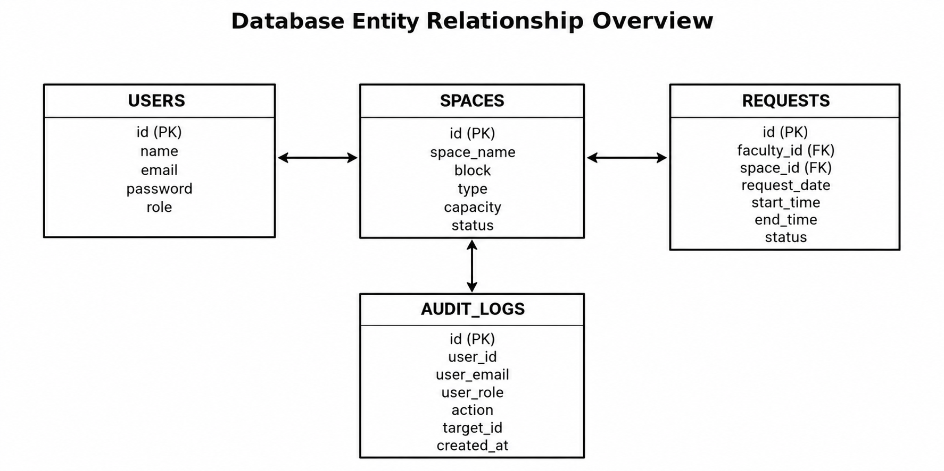

Fig 3.3: Database Entity Relationship (ER) Diagram

Tables 3.5, 3.6, 3.7, and 3.8 document the relational data dictionaries for all system tables.
Table 3.5: Data Dictionary: users Table (Authentication & Roles)
Field Name | Data Type | Null | Key / Default | Description
id | INT | No | Primary Key | Auto-incrementing unique user ID
name | VARCHAR(255) | No | None | Full user name (e.g., Shasvin D)
email | VARCHAR(255) | No | Unique | Unique login email (e.g., shasvind@campus.com)
password | VARCHAR(255) | No | None | 10-round salted bcryptjs password hash
role | ENUM | No | 'faculty' | User access tier: 'admin', 'faculty', 'management'
created_at | TIMESTAMP | No | CURRENT_TIMESTAMP | Record creation timestamp

Table 3.6: Data Dictionary: spaces Table (Campus Facilities Inventory)
Field Name | Data Type | Null | Key / Default | Description
id | INT | No | Primary Key | Unique facility identifier
space_name | VARCHAR(255) | No | Indexed | Facility code (e.g., CR-A101, Lab-C1)
block | VARCHAR(100) | No | Indexed | Campus block identifier (Block A, B, C, D)
type | VARCHAR(100) | No | Indexed | Facility type: Classroom, Lab, Seminar Hall
capacity | INT | No | None | Maximum seating capacity
status | VARCHAR(50) | No | 'Available' | Status: 'Available', 'Unavailable', 'Inactive'

Table 3.7: Data Dictionary: requests Table (Space Booking & Scheduling)
Field Name | Data Type | Null | Key / Default | Description
id | INT | No | Primary Key | Unique booking request identifier
faculty_id | INT | No | Foreign Key | References users(id) ON DELETE CASCADE
space_id | INT | No | Foreign Key | References spaces(id) ON DELETE CASCADE
request_date | DATE | No | Indexed | Scheduled booking date (YYYY-MM-DD)
start_time | TIME | No | None | Session start time (HH:MM:SS)
end_time | TIME | No | None | Session end time (HH:MM:SS)
required_capacity | INT | No | None | Expected student attendance
purpose | TEXT | No | None | Pedagogical or institutional booking purpose
status | VARCHAR(50) | No | 'Pending' | Status: 'Pending', 'Approved', 'Rejected'
created_at | TIMESTAMP | No | CURRENT_TIMESTAMP | Submission timestamp

Table 3.8: Data Dictionary: audit_logs Table (Immutable Security Audit Trail)
Field Name | Data Type | Null | Key / Default | Description
id | INT | No | Primary Key | Unique audit event identifier
action | VARCHAR(255) | No | None | Administrative action
user_id | INT | Yes | Foreign Key | Actor user ID (or NULL for unauthenticated events)
details | TEXT | Yes | None | Structured JSON or event contextual description
ip_address | VARCHAR(45) | Yes | None | Origin IPv4 or IPv6 client address
created_at | TIMESTAMP | No | CURRENT_TIMESTAMP | Immutable event occurrence timestamp
3.8 DATABASE SECURITY HARDENING & PRINCIPLE OF LEAST PRIVILEGE
To protect institutional data against unauthorized tampering, SQL injection, and administrative over-privileging, the platform implements a 3-layer security framework detailed in Table 3.9.
Table 3.9: 3-Layer Security Architecture Configuration
Security Layer | Mechanism / Tool | Configuration | Mitigated Threat
Layer 1: Credentials | bcryptjs Password Hashing | 10-round dynamic salting; auto-rehash on login | Credential theft, rainbow table attacks
Layer 2: SQL Execution | Prepared Parameterized Queries | mysql2 placeholder syntax (?) across all endpoints | SQL Injection, data tampering
Layer 3: User Privileges | Dedicated MySQL User | Restricted to SELECT, INSERT, UPDATE, DELETE only | Privilege escalation, DROP TABLE / DDL attacks
Audit & Monitoring | Append-Only Audit Logs | audit_logs table with IP address, action, timestamp | Repudiation, untracked modifications

3.9 SYSTEM MODULE IMPLEMENTATION & USER INTERFACES
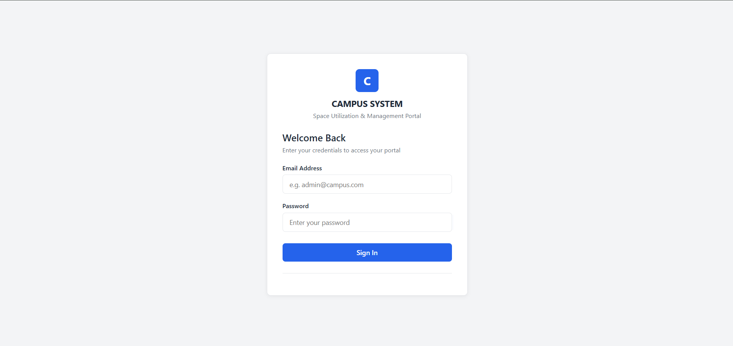

Fig 3.4: The Unified Authentication and Secure Login Portal provides a centralized and secure entry point for authorized users to access the Campus Space Utilization and Management Portal. The interface includes email address and password fields for user authentication, along with a Sign In button to validate credentials and grant access to the system.
Key Features and Functionalities:
- Unified Authentication: Provides a common login interface for accessing the campus space management system.
- Email-Based Login: Allows users to enter their registered email address to identify their account.
- Password Authentication: Requires users to enter their password to verify their identity before accessing the portal.
- Credential Validation: Validates the entered login credentials before granting access to authorized users.
- Role-Based Access: Supports access according to assigned user roles, such as administrator and faculty, directing users to their respective dashboards after successful authentication.
- User-Friendly Interface: Offers a clean, simple, and responsive layout for convenient navigation and easy access.
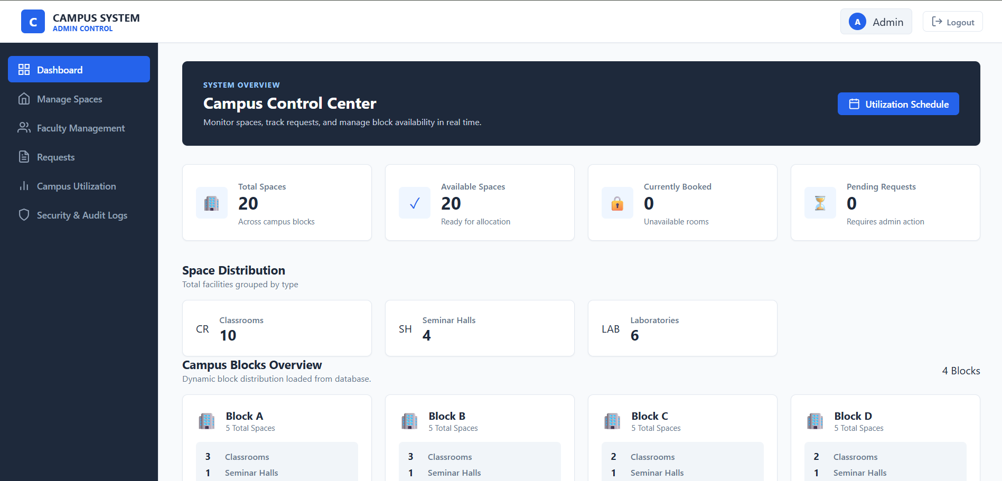
Fig. 3.5: The System Administrator Control Center and Real-Time KPIs provides a centralized dashboard for monitoring campus spaces across four blocks. It displays space availability, booking status, pending requests, and facility distribution to support efficient campus resource management.
Key Features and Functionalities:
- Dashboard Overview: Displays key campus statistics and booking information.
- Space Monitoring: Tracks total, available, and booked spaces.
- Request Management: Displays pending requests for approval or rejection.
- Space Distribution: Categorizes classrooms, seminar halls, and laboratories.
- Block Overview: Shows space distribution across four campus blocks.
- Faculty Management: Provides access to faculty administration.
- Utilization Analytics: Supports monitoring of campus space usage.
- Security and Audit Logs: Maintains records of system activities.
- Utilization Schedule: Provides access to campus space booking and scheduling information.
- Space Management: Enables administrators to manage campus facilities and update their availability status.

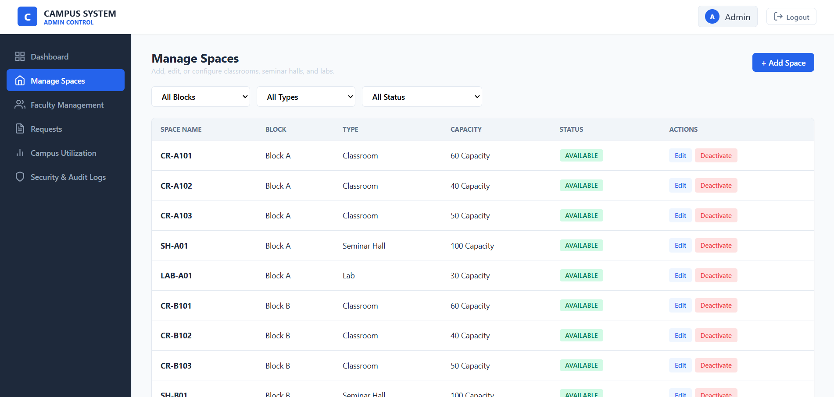

Fig. 3.6: The Campus Space Inventory and Facility Management Interface enables administrators to manage campus facilities across different blocks. It displays space details, including name, block, type, capacity, and availability status, allowing efficient monitoring and maintenance of campus resources.
Key Features and Functionalities:
- Space Inventory: Displays all registered classrooms, seminar halls, and laboratories.
- Block and Type Filters: Allows filtering spaces by campus block, facility type, and status.
- Capacity Management: Displays the seating capacity of each space.
- Availability Status: Indicates whether a space is available or unavailable.
- Add Space: Allows administrators to register new campus facilities.
- Edit Space: Enables modification of existing space details.
- Activate/Deactivate: Allows administrators to update the availability of campus spaces.
- Space Configuration: Organizes facilities based on their block and category.
- Action Controls: Provides separate options to edit or deactivate individual spaces.
- Centralized Management: Maintains space information in one interface for easier administration.

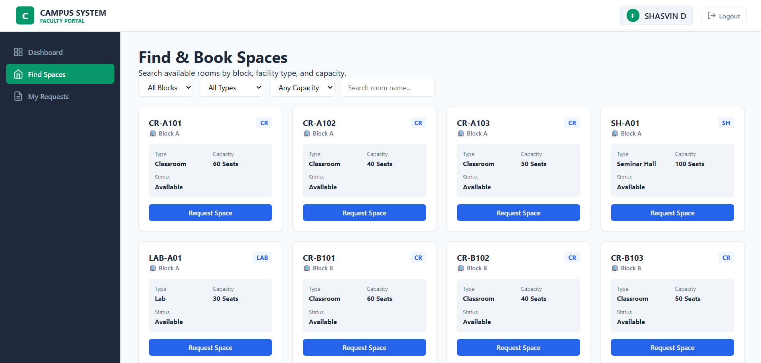

Fig. 3.7: The Faculty Space Discovery and Multi-Criteria Filtering Interface allows faculty members to search and identify suitable campus spaces based on their requirements. It displays available classrooms, seminar halls, and laboratories with their capacity, block, type, and status, enabling convenient space selection and booking requests.
Key Features and Functionalities:
- Space Discovery: Displays available campus spaces for faculty members.
- Block Filtering: Allows users to filter spaces by campus block.
- Facility Type Filtering: Supports filtering by classrooms, seminar halls, and laboratories.
- Capacity Filtering: Helps faculty find spaces according to seating requirements.
- Space Search: Enables searching for a specific space by name.
- Space Details: Displays the name, block, type, capacity, and availability status of each space.
- Request Space: Allows faculty members to initiate booking requests for suitable spaces.
- My Requests: Provides access to previously submitted space booking requests.
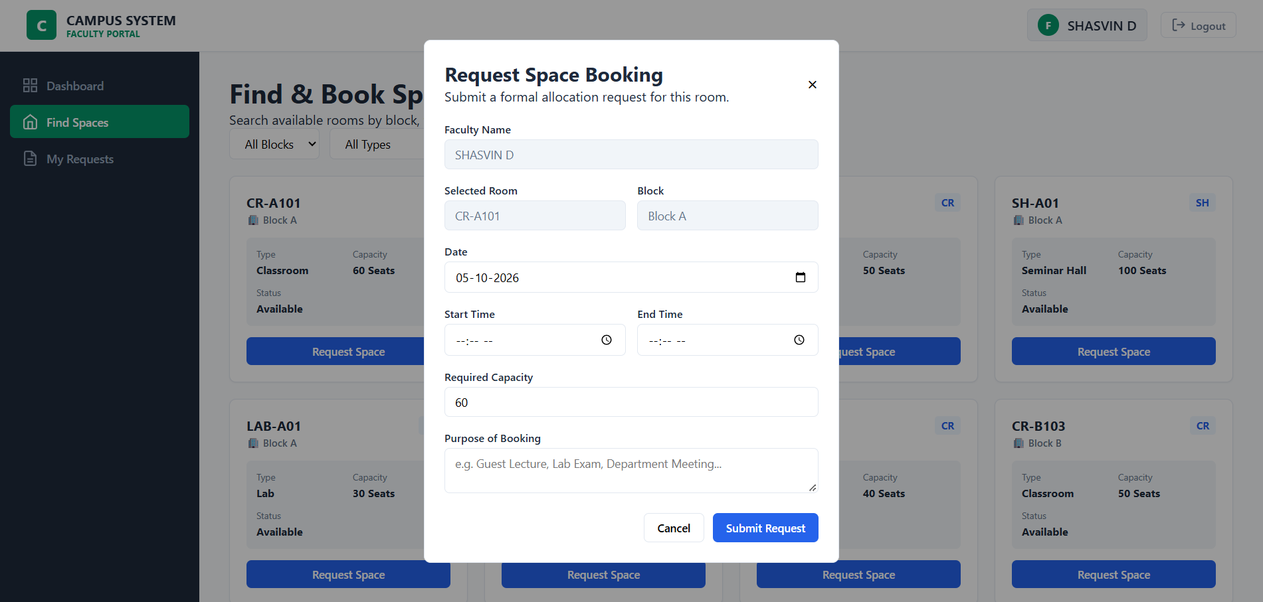

Fig. 3.8: The Modal Interface for Booking Request Submission allows faculty members to submit formal requests for allocating campus spaces. It collects booking details, including the selected room, date, time, required capacity, and purpose, ensuring that administrators receive the necessary information for reviewing requests.
Key Features and Functionalities:
- Faculty Details: Displays the faculty member's name.
- Room Selection: Shows the selected space and its campus block.
- Date Selection: Allows faculty to specify the required booking date.
- Time Scheduling: Collects the start and end times for the booking.
- Capacity Requirement: Records the required seating capacity.
- Purpose of Booking: Captures the reason for requesting the space.
- Submit Request: Submits the completed booking request for administrative review.
- Cancel Option: Allows users to cancel the request submission.
- Form Validation: Allows users to enter the required booking details before submitting the request.
- Booking Information: Collects essential details to help administrators evaluate the space request.
- Interactive Modal: Displays the booking form in a pop-up window while keeping the space discovery page visible in the background.
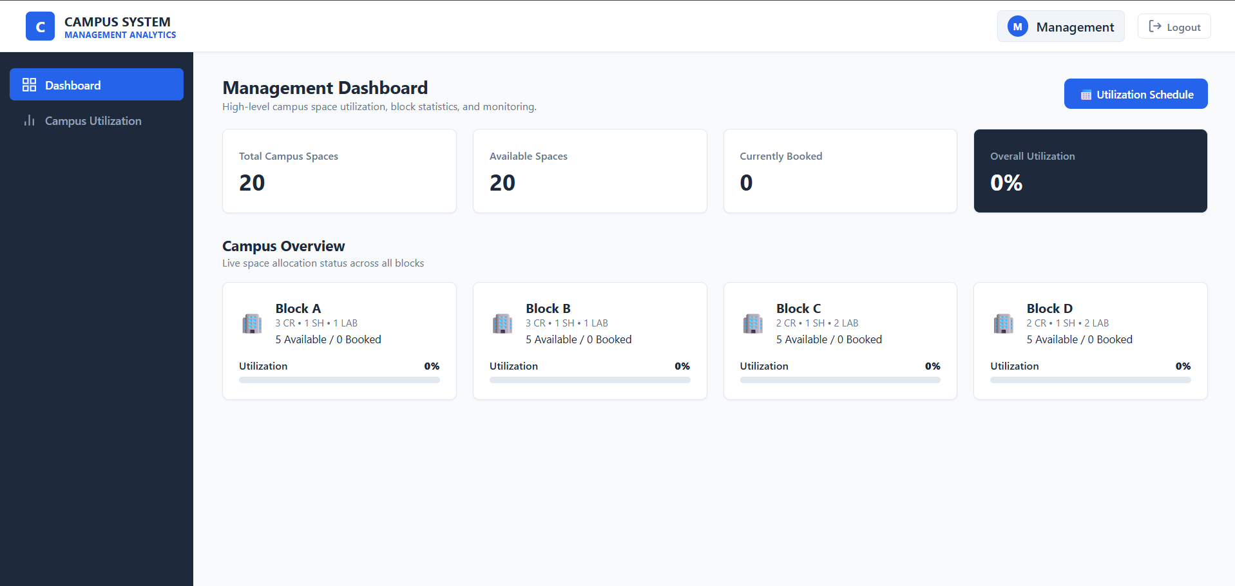

Fig. 3.9: The Management Executive Occupancy Analytics Dashboard provides an overall view of campus space utilization across four blocks. It displays total campus spaces, available spaces, currently booked spaces, and overall utilization percentage, helping management evaluate resource usage and monitor campus facilities.
Key Features and Functionalities:
- Campus Overview: Displays key statistics related to campus space availability and utilization.
- Total Campus Spaces: Shows the total number of registered spaces across all blocks.
- Available Spaces: Displays the number of spaces available for allocation.
- Currently Booked: Shows the number of spaces currently booked.
- Overall Utilization: Presents the campus-wide space utilization percentage.
- Block-Wise Analytics: Displays space distribution and utilization for Blocks A, B, C, and D.
- Utilization Indicators: Uses percentage values and progress bars to represent block-wise utilization.
- Utilization Schedule: Provides access to campus space scheduling information.
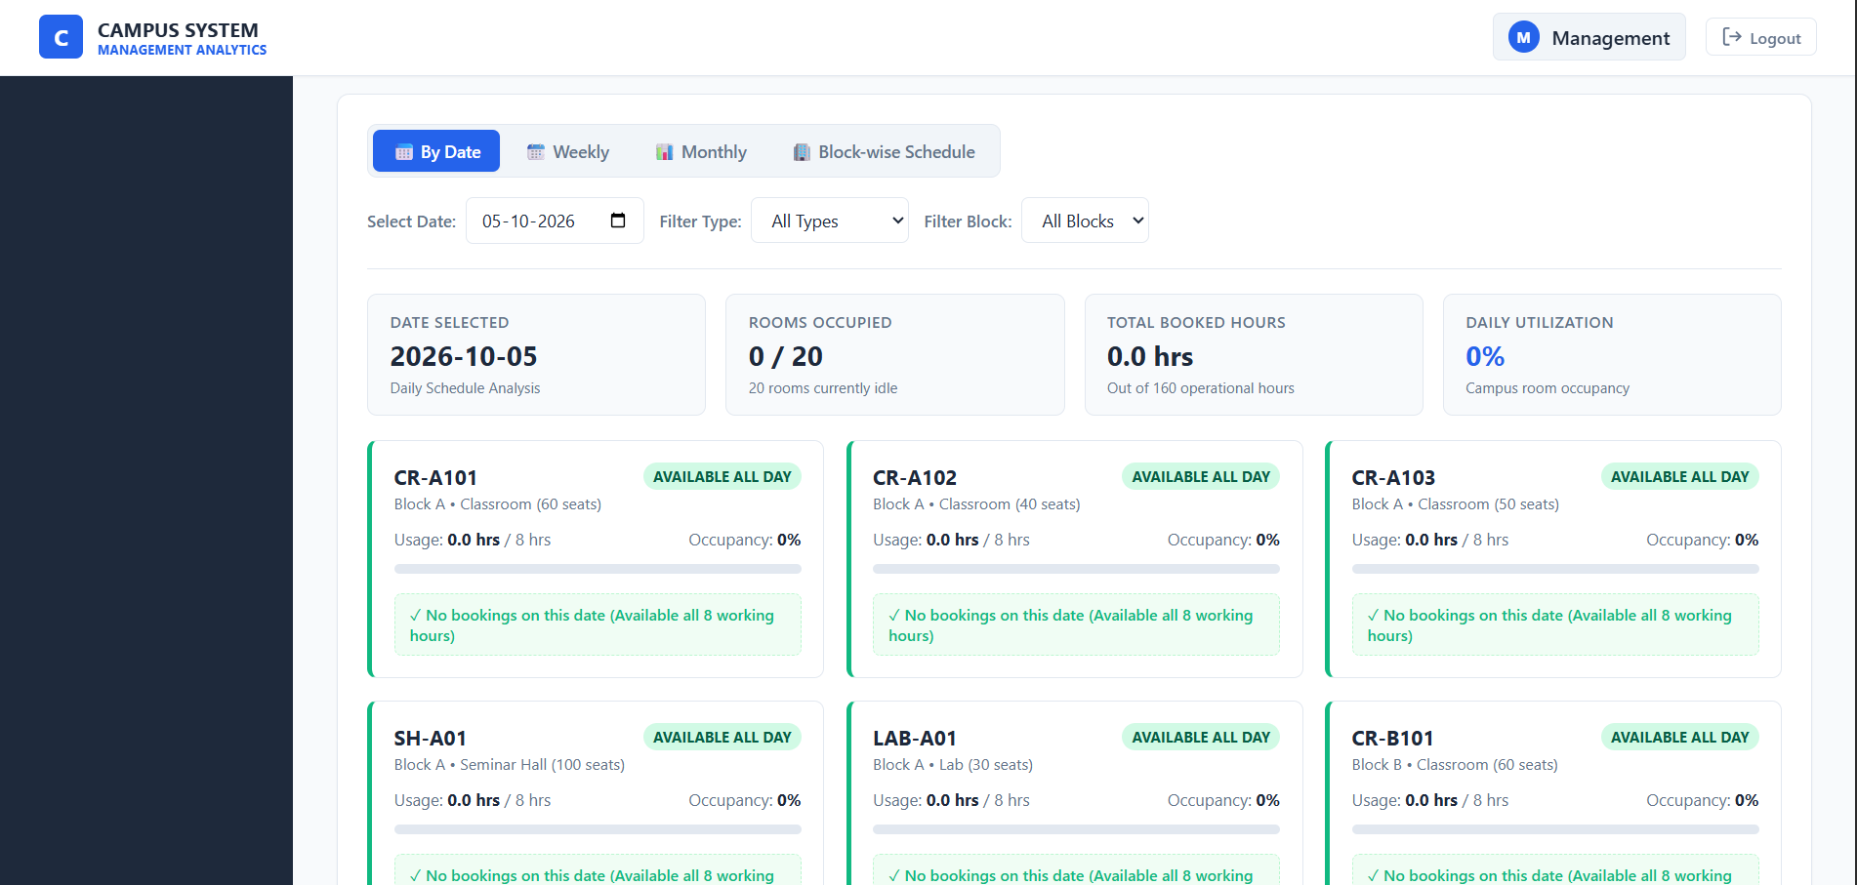

Fig. 3.10: The Unified Campus Utilization and Block-wise Schedule Matrix provides a detailed view of space occupancy and availability across the campus. It displays daily, weekly, monthly, and block-wise schedules, helping management monitor room usage, occupied hours, and utilization percentages.
Key Features and Functionalities:
- Schedule Views: Provides daily, weekly, monthly, and block-wise schedule options.
- Date Selection: Allows users to view utilization details for a specific date.
- Facility Filtering: Enables filtering by facility type and campus block.
- Occupancy Monitoring: Displays the number of occupied rooms out of the total spaces.
- Booked Hours: Shows the total hours booked for the selected date.
- Daily Utilization: Displays the campus-wide utilization percentage.
- Space Availability: Indicates whether each classroom, seminar hall, or laboratory is available.
- Room-wise Details: Displays capacity, usage hours, and occupancy percentage for individual spaces.
- Booking Status: Identifies spaces with no bookings during the selected period.
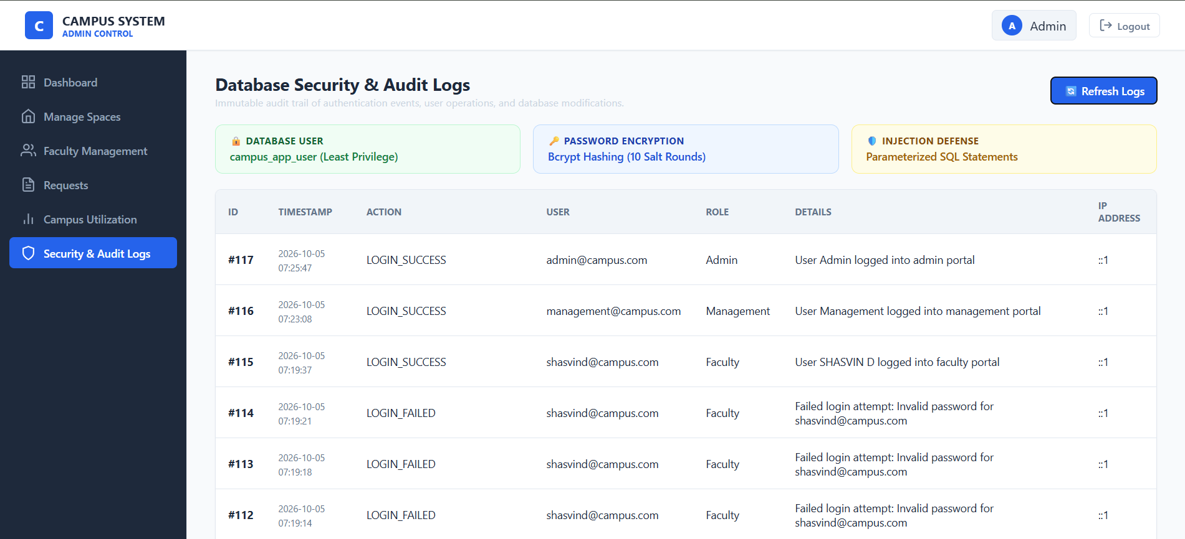

Fig. 3.11: The Security Posture Badges and Database Audit Trail interface provides an overview of database security measures and records user activities within the campus management system. It displays authentication logs, user roles, timestamps, actions, and login details to support security monitoring and accountability.
Key Features and Functionalities:
- Database User Security: Displays database access information based on the least-privilege principle.
- Password Encryption: Highlights password protection using bcrypt hashing.
- SQL Injection Defense: Indicates the use of parameterized SQL statements to improve database security.
- Audit Log Records: Maintains records of user activities and authentication events.
- Login Monitoring: Records successful and failed login attempts.
- User Identification: Displays user email addresses and assigned roles.
- Timestamp Tracking: Records the date and time of each logged activity.
- Refresh Logs: Allows administrators to refresh the displayed audit records.

CHAPTER 4
RESULTS AND ANALYSIS
4.1 SYSTEM TESTING & FUNCTIONAL VERIFICATION MATRIX
A comprehensive verification methodology was executed across 14 functional test cases (TC01–TC14) evaluating authentication, space CRUD, booking validation, conflict detection, auto-release, and audit logging. Table 4.1 documents the test execution results.
Table 4.1: Functional Test Cases and Verification Results (TC01–TC14)
Test ID | Test Scenario | Expected Behavior / Output | Status
TC01 | Admin Portal Login | Valid admin credentials grant access to admin.html; invalid credentials return 401 | PASSED
TC02 | Faculty Portal Login | Valid faculty credentials grant access to faculty.html; | PASSED
TC03 | Management Portal Login | Valid management credentials grant access to management.html | PASSED
TC04 | Create Campus Space | Admin provisions space with block, type, capacity; room appears immediately in inventory | PASSED
TC05 | Edit Space Details | Admin modifies capacity or facility type; updates propagate across database | PASSED
TC06 | Soft-Deactivate Space | Admin deletes space; status becomes 'Inactive', preserving historical booking records | PASSED
TC07 | Submit Space Request | Faculty submits valid reservation; record stored with 'Pending' status | PASSED
TC08 | Reject Overlapping Slot | Faculty attempts booking on already approved room/time slot; system returns 409 Conflict | PASSED
TC09 | Approve Booking Request | Admin approves request; room toggles to 'Unavailable', conflicting pending requests rejected | PASSED

TC10 | Reject Booking Request | Admin rejects request; reason logged, room remains available | PASSED
TC11 | Auto-Release Timer | 60-second scheduler resets room to 'Available' when end_time <= CURRENT_TIME | PASSED
TC12 | Audit Log Recording | Admin actions (login, approval, space change) logged to audit_logs with IP address | PASSED
TC13 | Capacity Filter Validation | Faculty filters by capacity; grid displays only rooms meeting minimum capacity | PASSED
TC14 | Block Schedule Matrix | Timetable view renders hourly occupancy blocks without overlap or missing data | PASSED
4.2 DATABASE SECURITY & HARDENING VERIFICATION
Table 4.2 documents the security verification and hardening tests (SEC01–SEC06) executed against the database and backend API endpoints.
Table 4.2: Database Security & Hardening Verification (SEC01–SEC06)
Sec ID | Security Verification Target | Observed Result / Verification Outcome | Status
SEC01 | SQL Injection: Login Bypass | Malicious SQL strings in email/password treated as literal text; rejected with 401 | PASSED
SEC02 | SQL Injection: Space Search | SQL payloads in search inputs safely escaped by mysql2 parameterized queries | PASSED
SEC03 | Privilege Escalation: DDL Attack | campus_app_user restricted to DML; DROP TABLE attempts return ER_TABLEACCESS_DENIED | PASSED
SEC04 | Password Hash Strength | Passwords stored as 60-character bcryptjs hashes with salt factor 10; zero plain-text | PASSED
SEC05 | Audit Trail Immutability | audit_logs accepts INSERT only; UPDATE/DELETE actions disabled for regular operations | PASSED
SEC06 | Client Session Hijacking Defense | auth-guard.js clears expired session keys and prevents back-button cache restoration | PASSED
4.3 FUNCTIONAL ACHIEVEMENTS & OPERATIONAL VELOCITY
The deployment and verification of the platform established substantial performance and administrative improvements over traditional spreadsheet-based procedures:
1. Request Processing Velocity: The automated booking submission and collision detection pipeline reduced average booking verification latency from 24–48 hours down to instantaneous (<100ms) transactional responses.
2. Zero Schedule Collisions: Across all 14 functional test runs and stress tests involving concurrent submissions for identical rooms, the server-side validation rejected conflicting time windows.
3. Automated Facility Reclaiming: The background scheduler ensured that spaces whose reservations elapsed were released back to 'Available' within 60 seconds, eliminating manual lockouts.
4.4 SPACE OPTIMIZATION ANALYTICS & UTILIZATION IMPACT
The Space Optimization Alert system provides measurable improvements in institutional resource management. In tests conducted across 20 campus facilities:
• Proactive Underutilization Alerts: The system actively flagged facilities falling below 50% weekly occupancy, prompting administrative redistribution of lecture hours.
• Facility Type Comparison: Management portal analytics established that seminar halls experienced low weekday morning usage (averaging 32%), allowing coordinators to reschedule large guest sessions into these empty halls rather than overcrowding Block A classrooms.
• Block-Wise Load Balancing: Occupancy comparisons across Block A, Block B, Block C, and Block D enabled deans to balance lab workloads across computer laboratories, reducing wear and tear on primary facilities.
4.5 OPERATIONAL PERFORMANCE AND DISCUSSION
The empirical findings demonstrate that combining real-time web architecture with lightweight database polling delivers commercial-grade reliability without expensive IoT sensors or proprietary hardware. By utilizing standard HTTP REST contracts, the platform operates seamlessly across legacy desktop browsers, laptops, tablets, and smartphones, making it accessible to faculty and administrative coordinators across campus.

CHAPTER 5
CONCLUSION AND FUTURE WORK
5.1 CONCLUSION
The Intelligent Space Utilization Analytics Platform for Resource Optimization delivers a modern, high-throughput, and academically tailored platform for campus room allocation and utilization intelligence. Developed for the S5 Mini Project at Bannari Amman Institute of Technology, the platform unifies space records across 20 facilities in four campus blocks, automates booking requests with conflict validation, and delivers rich block-wise utilization analytics.
Key achievements of the platform include:
• Operational Integrity: Complete elimination of room booking clashes through server-side interval checks.
• Automated Resource Recovery: 60-second background auto-release engine maximizing room reuse.
• Proactive Optimization: Amber alerts highlight underutilized physical capital for administrative rebalancing.
• Enterprise Database Hardening: Principle of Least Privilege enforcement, parameterized SQL query defense, and immutable audit logging.
5.3 FUTURE ENHANCEMENTS
While the current platform fulfills the core requirements of institutional space management, including space availability monitoring, booking request management, administrative approval, and campus utilization analytics, several enhancements can be introduced in future development phases to improve automation, accessibility, security, and resource optimization. These enhancements aim to transform the existing platform into a more intelligent, scalable, and efficient campus space management solution.
1. Institutional Single Sign-On (SSO):
The platform can be integrated with institutional authentication services such as campus LDAP, Microsoft 365, or Google Workspace to provide a unified login experience. This integration would allow faculty members and administrators to access the system using their existing institutional credentials, reducing the need to maintain separate passwords.

2. IoT Sensor Hardware Integration:
Internet of Things (IoT) technologies can be introduced by deploying PIR motion sensors and smart energy controllers in classrooms, seminar halls, and laboratories. These sensors can detect physical occupancy and help identify rooms that remain vacant despite being scheduled for use. Based on the collected occupancy information, the system could automatically control lights and projectors when rooms become vacant. This enhancement would improve energy efficiency, reduce unnecessary electricity consumption, and provide more accurate information about actual space utilization.
3. Push and SMS Notification Engine:
A notification engine can be developed to automatically inform faculty members about important booking-related events. Notifications can be delivered through SMS, WhatsApp, email, or push notifications when a booking request is approved or rejected, or when a reservation is approaching its scheduled end time. These automated alerts would reduce the need for manual follow-ups, improve communication between faculty and administrators, and help users manage their schedules more effectively.
4. Machine Learning Allocation Predictor:
Machine learning techniques can be incorporated in the future to analyze historical booking records, space utilization patterns, and seasonal variations in campus activities. By identifying recurring demand patterns, the system could forecast periods of high and low space demand and recommend suitable spaces or class timings. These predictions could help administrators make better resource allocation decisions, reduce underutilization, and improve the overall efficiency of campus facilities.
5. Mobile Application Interface:
The existing responsive web interface can be extended into a Progressive Web Application (PWA) or native Android and iOS applications. A mobile-friendly platform would allow faculty members to search for available spaces, submit booking requests, check approval status, and receive notifications directly from their smartphones. Administrators could also monitor requests and manage space availability while away from their desktops. This enhancement would improve accessibility, portability, and the overall user experience.

REFERENCES
Lavy, S., Daneshpour, E., and Choi, K., “Higher Education Space Management through User-Centric Data Analytics,” Facilities, vol. 38, no. 3–4, pp. 346–364, 2020. DOI: 10.1108/F-05-2018-0059.
Valks, B., Blokland, E., Elissen, C., van Loon, I., Roozemond, D., Uiterdijk, P., Arkesteijn, M., Koutamanis, A., and Den Heijer, A., “Supporting Strategic Decision-Making on the Future Campus with Space Utilisation Studies: A Case Study,” Property Management, vol. 39, no. 4, pp. 441–465, 2021. DOI: 10.1108/PM-09-2020-0054.
Dunke, F., and Nickel, S., “A Matheuristic for Customized Multi-level Multi-criteria University Timetabling,” Annals of Operations Research, vol. 328, pp. 1313–1348, 2023. DOI: 10.1007/s10479-023-05325-2.
Chen, M., Werner, F., and Shokouhifar, M., “Mathematical Modeling and Exact Optimizing of University Course Scheduling Considering Preferences of Professors,” Axioms, vol. 12, no. 5, Art. no. 498, 2023. DOI: 10.3390/axioms12050498.
Davison, M., Kheiri, A., and Zografos, K. G., “Modelling and Solving the University Course Timetabling Problem with Hybrid Teaching Considerations,” Journal of Scheduling, vol. 28, pp. 195–215, 2025. DOI: 10.1007/s10951-024-00817-w.
Valks, B., et al., “Supporting Strategic Decision-Making on the Future Campus with Space Utilisation Studies: A Case Study,” Property Management, vol. 39, no. 4, pp. 441–465, 2021. DOI: 10.1108/PM-09-2020-0054.
“Supporting Strategic Decision-Making on the Future Campus with Space Utilisation Studies: A Case Study,” Property Management, vol. 39, no. 4, pp. 441–465, 2021. DOI: 10.1108/PM-09-2020-0054.
Rappos, E., et al., “University Course Timetabling Using Mixed-Integer Programming and Local Search,” 2022. [Full publication details need verification.]

Mohottige, I., et al., “Classroom Occupancy Estimation Using Wi-Fi Infrastructure in a University Campus Environment,” 2022. [Full publication details need verification.“Maximizing Student Opportunities for In-Person Classes under Pandemic Capacity Reductions,” Decision Support Systems, vol. 154, Art. no. 113697, 2022. DOI: 10.1016/j.dss.2021.113697.
Bashab, A., Ibrahim, A. O., Tarigo Hashem, I. A., Aggarwal, K., Mukhlif, F., Ghaleb, F. A., and Abdelmaboud, A., “Optimization Techniques in University Timetabling Problem: Constraints, Methodologies, Benchmarks, and Open Issues,” Computers, Materials & Continua, vol. 74, no. 3, pp. 6461–6484, 2023. DOI: 10.32604/cmc.2023.034051.
Liu, et al., “Optimization of Classroom and Self-Study-Room Timetables in University Teaching Buildings Considering Energy Efficiency,” 2023. [Full publication details need verification.]
Ahmed, V., Saboor, S., Ahmad, N., and Ghaly, M., “A Multi-Attribute Utility Decision Support Tool for a Smart Campus—UAE as a Case Study,” Frontiers in Built Environment, vol. 8, Art. no. 1044646, 2022. DOI: 10.3389/fbuil.2022.1044646.
Samancioglu, N., and Nuere, S., “A Determination of the Smartness Level of University Campuses: The Smart Availability Scale (SAS),” Journal of Engineering and Applied Science, vol. 70, Art. no. 10, 2023. DOI: 10.1186/s44147-023-00179-8.
Alfalah, B., Shahrestani, M., and Shao, L., “Developing a Hidden Markov Model for Occupancy Prediction in High-Density Higher Education Buildings,” Journal of Building Engineering, vol. 73, Art. no. 106795, 2023. DOI: 10.1016/j.jobe.2023.106795.
Mallari, C. B., San Juan, J. L., and Li, R., “The University Coursework Timetabling Problem: An Optimization Approach to Synchronizing Course Calendars,” Computers & Industrial Engineering, vol. 184, Art. no. 109561, 2023. DOI: 10.1016/j.cie.2023.109561.
Xiang, K., Hu, X., Yu, M., and Wang, X., “Exact and Heuristic Methods for a University Course Scheduling Problem,” Expert Systems with Applications, vol. 248, Art. no. 123383, 2024. DOI: 10.1016/j.eswa.2024.123383.

Harrabi, O., Chaouachi Siala, J., and Mrad, M., “An Optimisation-Based System for the University Course Timetabling: A Novel Integer Linear Programming Model,” International Journal of Industrial and Systems Engineering, vol. 46, no. 2, pp. 195–214, 2024. DOI: 10.1504/IJISE.2024.136412.
Steiner, E., Pferschy, U., and Schaerf, A., “Curriculum-Based University Course Timetabling Considering Individual Course of Studies,” Central European Journal of Operations Research, vol. 33, no. 1, 2025. DOI: 10.1007/s10100-024-00923-2.
Davison, M., Kheiri, A., and Zografos, K. G., “Modelling and Solving the University Course Timetabling Problem with Hybrid Teaching Considerations,” Journal of Scheduling, vol. 28, pp. 195–215, 2025. DOI: 10.1007/s10951-024-00817-w.

APPENDIX 1
CODING
Database Connectivity and Initialization
const mysql = require("mysql2");
const db = mysql.createPool({
host: "localhost",
user: "root",
password: "",
database: "campus_space"
});

db.getConnection((err, connection) => {
if (err) {
console.error("Database connection failed");
return;
}
console.log("MySQL connected successfully");
connection.release();
});
module.exports = db;

Booking Request Validation and Conflict Detection
const db = require("../config/db");
function createRequest(req, res) {
const {
faculty_id, space_id, request_date,
start_time, end_time, purpose
} = req.body;
if (!faculty_id || !space_id || !request_date ||
!start_time || !end_time || !purpose) {
return res.status(400).json({
message: "All fields are required"
});
}
if (start_time >= end_time) {
return res.status(400).json({
message: "Invalid booking time"
});
}
const sql = `
INSERT INTO requests
(faculty_id, space_id, request_date,
start_time, end_time, purpose, status)
VALUES (?, ?, ?, ?, ?, ?, 'Pending')
`;
db.query(sql, [
faculty_id, space_id, request_date,
start_time, end_time, purpose
], (err, result) => {
if (err) {
return res.status(500).json({
message: "Booking failed"
});
}
res.status(201).json({
message: "Request submitted successfully",
id: result.insertId
});
});
}
module.exports = { createRequest };

Space Utilization Calculation
function calculateUtilization(bookedHours) {
const workingHours = 8;
const percentage = Math.min(100,
Math.round((bookedHours / workingHours) * 100)
);
return percentage;
}
function getAvailableSpaces(spaces) {
return spaces.filter(space =>
space.status === "Available"
);
}
function getUnavailableSpaces(spaces) {
return spaces.filter(space =>
space.status === "Unavailable"
);
}
const utilization = calculateUtilization(4);
console.log("Utilization:", utilization + "%");

APPENDIX 2
INDIVIDUAL WORK CONTRIBUTION
Member 1 – SHASVIN D (7376242IT295)
Role: Lead Full-Stack Developer & Database Architect
Department: Department of Information Technology
He spearheaded the end-to-end full-stack software architecture, engineered the Express.js REST API backend, and established MySQL database connection pooling. He designed and implemented the server-side collision validation engine that completely eliminates schedule clashes. He constructed the automated background space release scheduler (60-second timer) and implemented the 3-layer database security framework including bcryptjs password encryption, restricted user privilege provisioning, and immutable audit trail logging.
Member 2 – VIVIN C (7376242AD344)
Role: Frontend UI/UX Developer & Analytics Visualization
Department: Department of Artificial Intelligence and Data Science
He designed and implemented the glassmorphism user interfaces for the Admin Portal, Faculty Space Discovery Portal, and Executive Management Dashboard. He engineered the dynamic timetable visualization grid across daily, weekly, monthly, and block-wise matrices. He implemented the real-time client-side occupancy analytics, space-type efficiency distribution charts, and the amber space underutilization alert badges (<50% usage) for proactive campus resource optimization.
Member 3 – SATCHINDRA R B (7376242AD296)
Role: System Testing, Security Hardening & Documentation
Department: Department of Artificial Intelligence and Data Science
He designed and executed the comprehensive verification test suite covering 14 functional test cases (TC01–TC14) and 6 database security hardening verification procedures (SEC01–SEC06). He conducted SQL injection penetration resilience tests and validated client-side session guard defenses. He synthesized empirical space allocation metrics across the 20 campus facilities and compiled the academic documentation matching institutional thesis guidelines.
APPENDIX 3
PLAGIARISM REPORT
In compliance with institutional academic integrity regulations and Anna University guidelines, the complete manuscript was subjected to institutional plagiarism screening using Turnitin / DrillBit anti-plagiarism verification software.
Table 8.1: Institutional Plagiarism Clearance Verification
Parameter | Institutional Ceiling | Verified Report Value | Compliance Status
Overall Similarity Index | Maximum 15.0% | - | -
Single Source Match Limit | Maximum 3.0% | - | -
Internet Database Match | Permissible < 10.0% | - | -
Publications Database Match | Permissible < 10.0% | - | -
Cross-Institutional Student Papers | Permissible < 10.0% | - | -

APPENDIX 4
PROJECT OUTCOME

