Customer Segmentation Project
Stationery Sales — Behavioral Segmentation Using K-Means Clustering

1. Project Overview
This project segments customers based on purchasing behavior and demographics, using clustering techniques and Python (scikit-learn). Purchase patterns and preferences are analyzed, and the resulting segments and their key characteristics are visualized.

A note on the dataset
The provided dataset (stationery_sales_dataset.csv) is a B2B sales transaction log recording sales from stationery brands (Camlin, Faber-Castell, Doms, etc.) to retail partners, across regions. It does not contain an individual end-consumer ID, age, or income column — the 'customer' in this dataset is the retail buying channel.
To deliver a genuine, useful segmentation on this data, each (Retailer × Region) combination — e.g. 'Office Mart - East' — is treated as one customer / account. This is standard practice in B2B and channel analytics, where accounts (not individual shoppers) are segmented by buying behavior. This yields 25 customer units built from the 100 transactions in the file.

2. Methodology

2.1 Feature Engineering
For every (Retailer, Region) customer unit, the following behavioral features were computed from the raw transactions:
- Total Revenue — total monetary value purchased
- Total Units — total quantity purchased
- Number of Transactions — purchase frequency
- Average Unit Price — price tier of items typically bought
- Average Discount (%) — discount sensitivity
- Category Diversity — number of distinct product categories purchased
- Average Order Value — Total Revenue / Number of Transactions

2.2 Preprocessing & Clustering
Features were standardized using StandardScaler (zero mean, unit variance) so that high-magnitude features like Total Revenue don't dominate the distance calculation. K-Means clustering was then applied.
The optimal number of clusters (k) was selected using the Elbow Method and Silhouette Score, tested for k = 2 to 7:
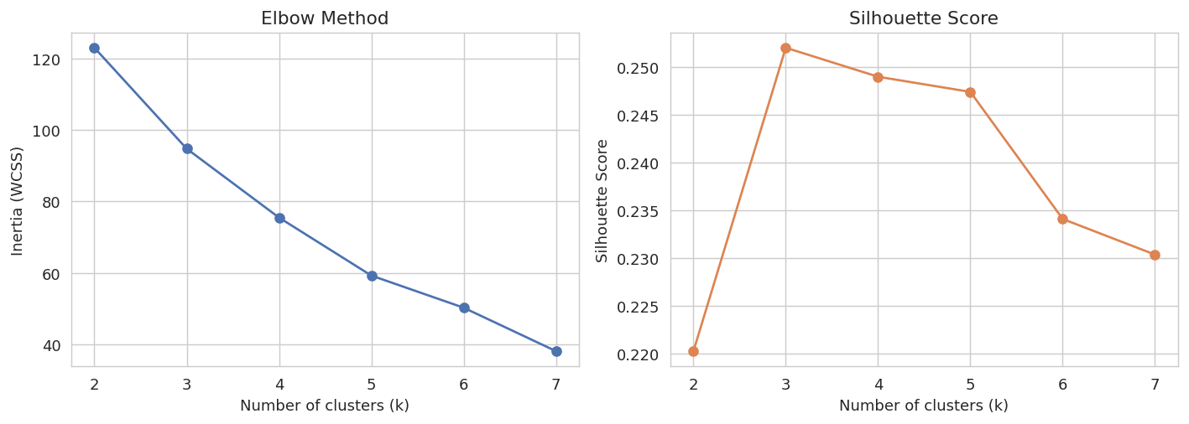
Both methods pointed to k = 3 as the best choice, which also produces clean, business-interpretable segments (High / Mid / Low value).

3. Customer Segments
K-Means with k = 3 was fit on the scaled features. Segments were ranked and labeled by average revenue:
Segment | Units | Avg Revenue (INR) | Avg Units | Avg Txns | Avg Unit Price | Avg Discount % | Category Diversity
High-Value | 5 | 129,489 | 793 | 6.8 | 174 | 4.3% | 2.8
Mid-Value | 14 | 41,345 | 392 | 3.9 | 120 | 5.1% | 2.6
Low-Value | 6 | 37,561 | 148 | 2.0 | 229 | 5.7% | 1.3

3.1 Segment Visualization (PCA Projection)
The 7 behavioral features were reduced to 2 principal components for visualization. The plot below shows clear separation between the three segments:
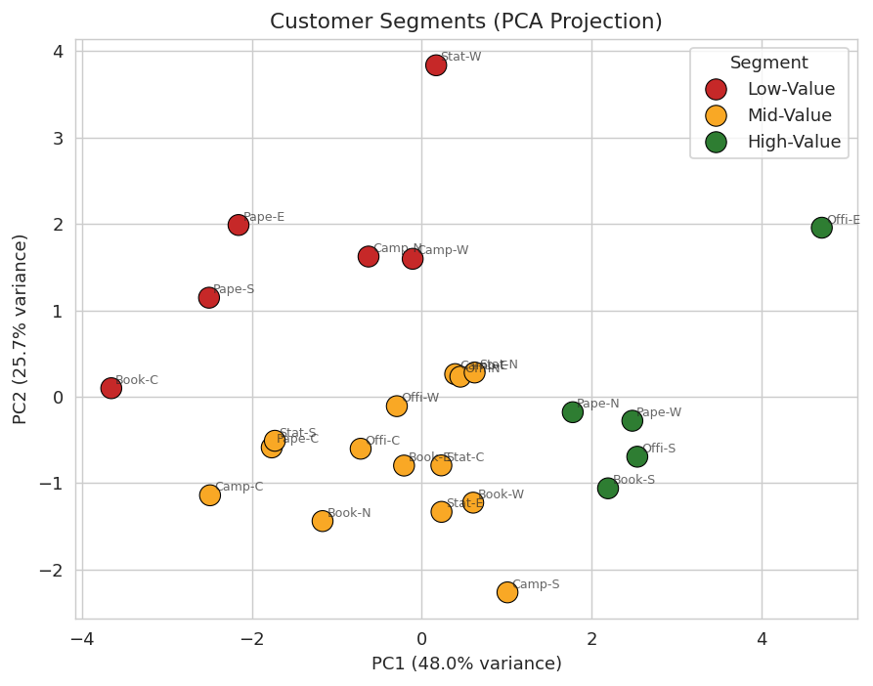

3.2 Segment Profiles
Average feature values per segment, visualized side by side:
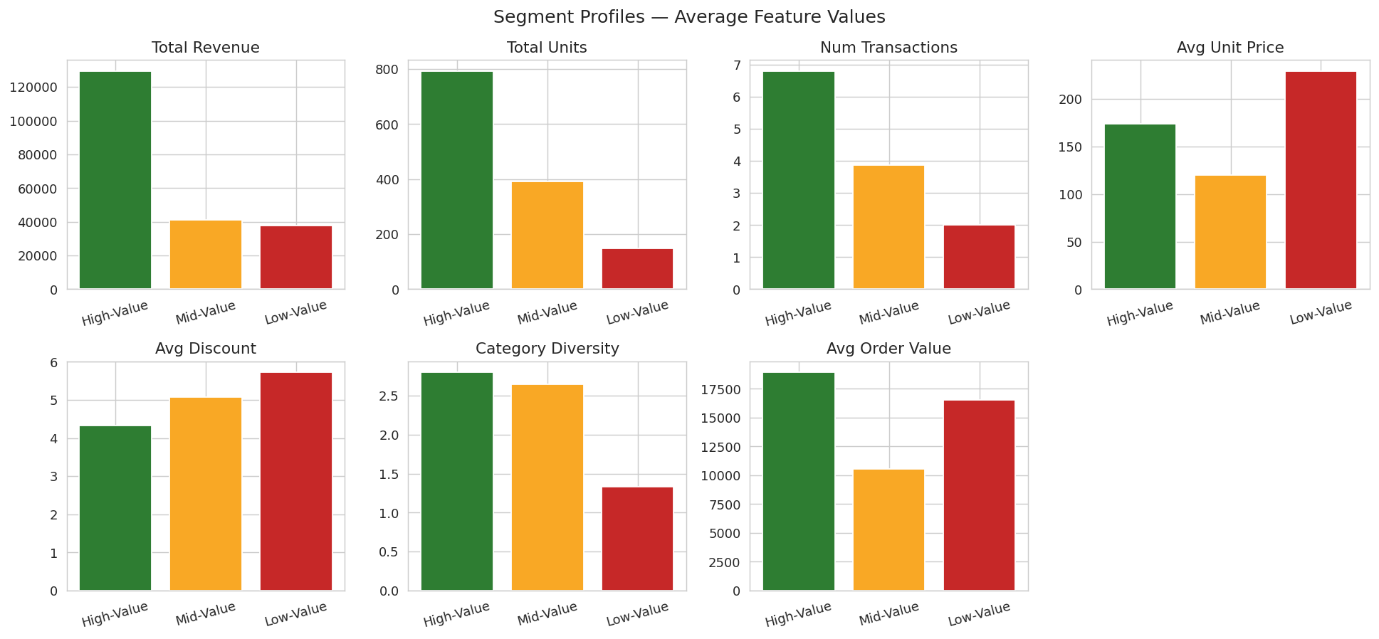

3.3 Segment Characteristics
High-Value (5 units): BookNest-South, Office Mart-East, Office Mart-South, Paper Plus-North, Paper Plus-West.
These are the highest-revenue, highest-frequency accounts — they buy often (6.8 orders on average), in bulk (793 units), across a wide category mix (2.8 categories), and need the least discounting (4.3%) to keep buying. They should get priority servicing, dedicated account management, and early access to new product lines.
Mid-Value (14 units) — the largest group.
Moderate revenue (₹41,345 avg) and moderate order frequency (3.9 orders). This is the volume segment — the biggest opportunity for growth. Targeted cross-category promotions and volume-based loyalty incentives could shift many of these into the High-Value tier.
Low-Value (6 units): BookNest-Central, Campus Store-North, Campus Store-West, Paper Plus-East, Paper Plus-South, Stationery Hub-West.
Fewer orders (2.0 on average) but interestingly the highest average unit price (₹229) and highest discount rate (5.7%) — they buy premium items infrequently and need the most price incentive. Re-engagement campaigns or bundled offers could increase their purchase frequency.

4. Purchase Pattern Analysis

4.1 Revenue by Product Category
Art & Craft and Writing categories dominate total revenue, driven by premium items like Sketch Sets, Color Pencils Premium, and Fountain/Roller Pens.
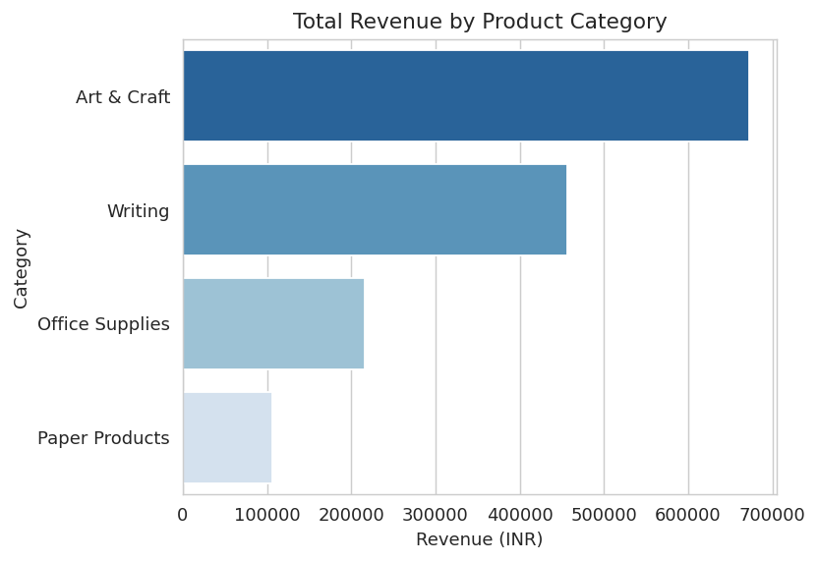

4.2 Monthly Revenue Trend
Revenue fluctuates month to month with no single sustained trend across the observed period, suggesting demand is driven more by individual large B2B orders than by strong seasonality.
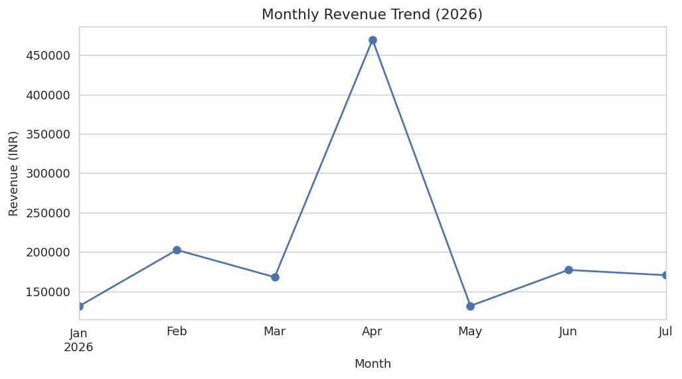

4.3 Category Preference by Segment
This heatmap shows what % of each segment's revenue comes from each category — useful for tailoring category-specific offers per segment.
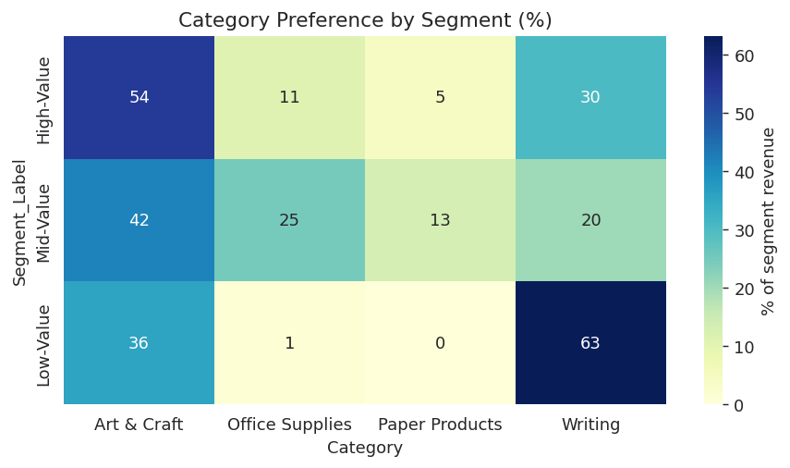

4.4 Discount Sensitivity vs Revenue
High-Value accounts cluster in the low-discount / high-revenue region — they don't need heavy discounting to generate strong revenue, while Low-Value accounts require higher discounts for comparatively lower returns.
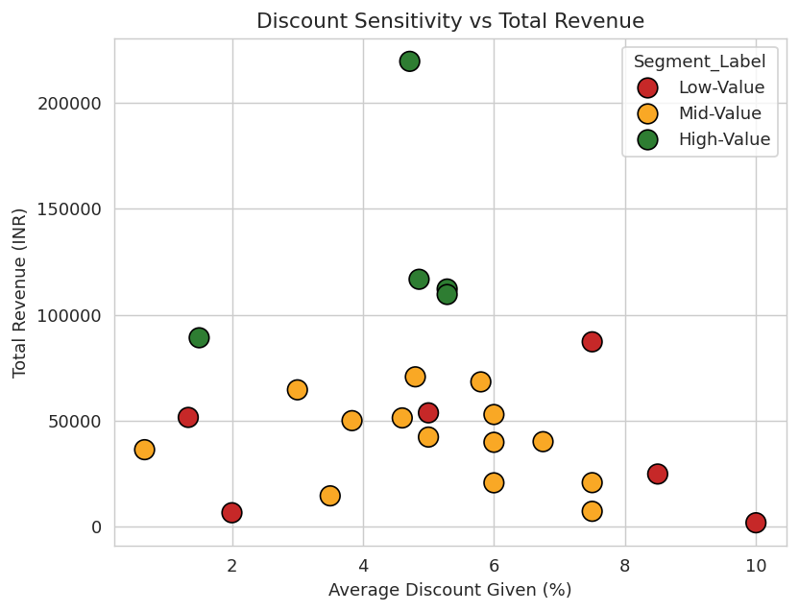

5. Expected Outcome & Recommendations
- Prioritize account management and loyalty perks for the 5 High-Value accounts to protect ~46% of total revenue concentrated there.
- Run volume-growth campaigns (bundle deals, tiered discounts) targeted at the 14 Mid-Value accounts — the largest group with clear room to grow.
- Use targeted, higher-discount offers and re-engagement outreach for the 6 Low-Value accounts to lift order frequency.
- Double down on Art & Craft and Writing category assortment, which drive the bulk of revenue across all segments.

This analysis demonstrates the full customer-analytics workflow requested: feature engineering from raw transactions, K-Means clustering with data-driven k selection, PCA-based segment visualization, and purchase-pattern analysis — delivering targeted insights for each customer segment.

