Abstract

This report replays the analysis from the paper "Forecasting Apple Inc. Stock Prices Using S&P 500 – An OLS Regression Approach with Structural Break" and extends it. While the original paper focused on stock prices, the present study shifts to the daily returns from January 2021 to December 2023 as a more appropriate approach toward volatility analysis. The paper applies Ordinary Least Squares regression to model the relationship of returns between Apple and the S&P 500 with the S&P 500 IT sector indices. Volatility clustering and persistence are integrated into the GARCH framework. Jarque-Bera, Durbin-Watson, and Breusch-Pagan tests for residual diagnostics justify the assumptions of the model. Furthermore, ARIMA was fitted on residuals and does not indicate important temporal dependencies. The approach provides a far greater insight into the drivers of returns of Apple, in terms of sectoral influences and volatility behaviour.

**An Empirical Analysis of Returns and Volatility: A Study of Apple Stock Using OLS, ARIMA, and GARCH**

Replication of “Forecasting Apple Inc. Stock Prices Using

S&P500– An OLS Regression Approach with Structural Break”

Trishit Banerjee

*Department of Basic Engineering and Sciences*

*Netaji Subhash Engineering College*

Kolkata, India trishit.banerjee@nsec.ac.in

By Shatakshi Bansode

Student number**:** 24201471

Module: Financial Econometrics FIN41660

Academic Year: 2024/2025

Contents

1. Introduction 2

2. Literature Review 6

3. Data Collection and Preparation 7

4. Methodology 11

6. Results and Discussion 31

7. Conclusion 34

8. Bibliography 36

**"An Empirical Analysis of Returns and Volatility: A Study of Apple Stock Using OLS, ARIMA, and GARCH"**

## Introduction

The aim of this study is to analyse the daily returns of Apple Inc. stock and key market indices, namely the S&P 500 and the S&P 500 Information Technology (IT) sector index. The choice of the subject was informed by an extensive review of existing research on financial modelling and forecasting. Initially, a paper titled "Forecasting Apple Inc. Stock Prices Using S&P 500 – An OLS Regression Approach with Structural Break" was chosen as a foundational reference for the analysis. The paper emphasizes the use of OLS regression to examine the relationship between Apple stock prices and broader market indices, with a particular focus on identifying structural breaks that signal shifts in price trends. The reference paper basically tried to identify and interpret such structural changes in Apple's price movements using regression-based techniques.

However, given the some challenges that were experienced in trying to replicate certain aspects of the data, it became important to consider an approach that was different from that in the particular work by changing focus towards the daily stock returns from levels. This therefore made room for the deep exploration in volatility clustering and the return dynamics essential in the risk analysis and short-term forecasting. Whereas the original paper had its main focus on detecting structural breaks in price levels, this report attempts to quantify the linear relationship between Apple returns with the key market indices S&P 500 and S&P 500 IT sector, and also model volatility using some of the advanced techniques such as Generalized Autoregressive Conditional Heteroskedasticity (GARCH). A step-down approach of this kind carries more functional insight into the management of risks, sectors, and, therefore, shorter-run market behaviours, while returns would be more appropriate because of better capture of persistence volatility in financial markets.

Apple Inc. is one of the largest and most influential technology companies in the world, thus playing a pivotal role in shaping the performance of the technology sector. Apple, Inc. designs, manufactures, and markets smartphones, personal computers, tablets, wearables and accessories, and other variety of related services. Its products and services include iPhone, Mac, iPad, AirPods, Apple TV, Apple Watch, Beats products, Apple Care, iCloud, digital content stores, streaming, and licensing services.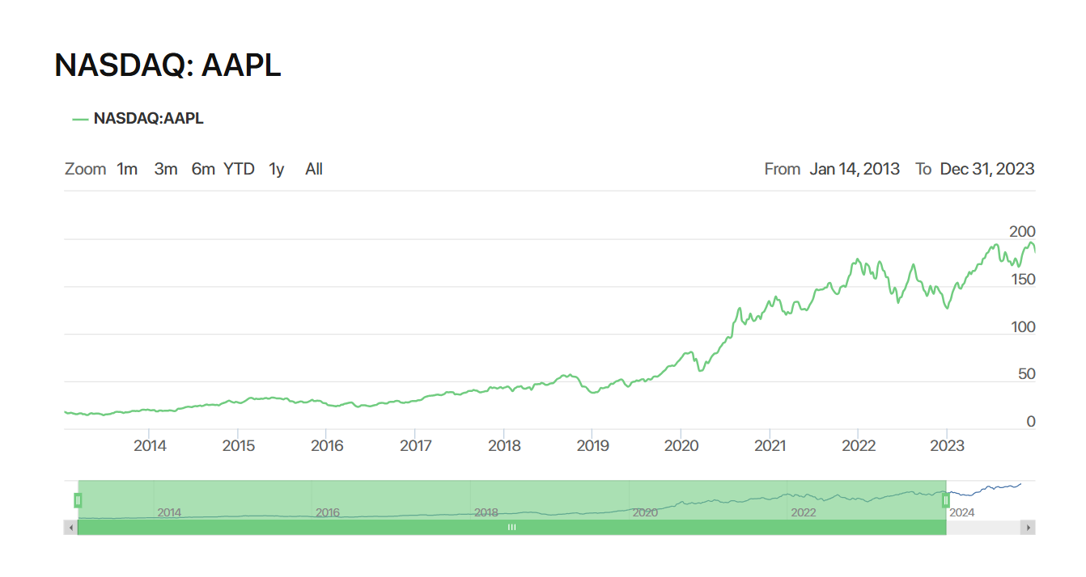

The historical trend of the stock price of Apple Inc. (AAPL), represented in the graph below, shows the remarkable long-term growth trajectory of the stock amidst periods of volatility. The stock price increased from around $20 in 2013 to approximately $200 by the end of 2023, reflecting Apple's dominant position in the technology sector and consistent market performance.

It highlights a period of growth since 2019, consistent with the boom in the technology industry due to innovation within Apple's product ecosystem and an increase in market demand. However, fluctuations experienced during 2020 and 2022 indicate some form of volatility clustering, thus confirming the findings in the GARCH analysis section of this report.

The strong correlation of Apple's stock price movement to broader market indices, especially the S&P 500 IT sector index, proves the appropriateness of the analysis based on returns instead of price levels. The returns are stationary, which enables one to model the relationships and volatility robustly, as shown by the methodologies employed in this paper: OLS regression, ARIMA, and GARCH. This graph provides the background necessary for setting up the study's objective-that is, to investigate return dynamics and volatility behaviour in Apple's stock.

The S&P 500 serves as a benchmark for broader market performance, The S&P 500 index, or Standard & Poor's 500, is a very important index that tracks the performance of the stocks of 500 large-cap companies in the U.S. The ticker symbol for the S&P 500 index is ^GSPC.

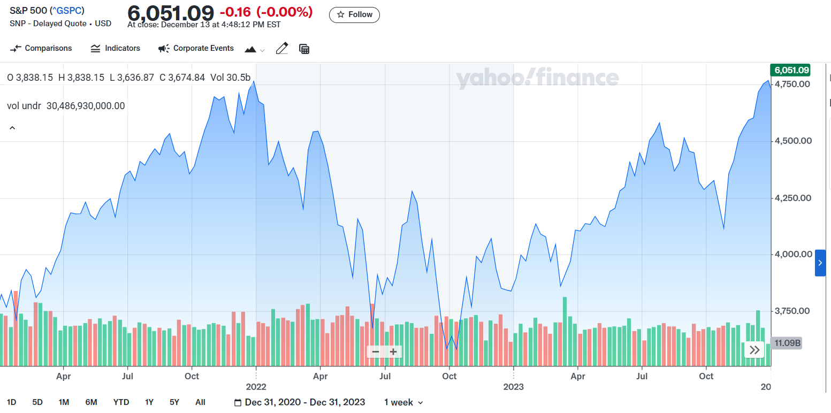

The graph above depicting S&P 500 Index performance from December 2020 through December 2023 furnishes crucial background regarding stock returns of Apple Inc. During that time span, the index rapidly accelerated into the year 2021 due to general recovery on a post-economic slowdown instigated by the pandemic situation worldwide. It reflected high volatility in 2022 owing to growing concern related to inflation, higher rates of interest, and geopolitical conflicts causing it to slump sometime thereafter.

By 2023, the S&P 500 regained its upward trajectory reflective of renewed investor confidence and economic stabilization. The periods of growth and correction seen in the index also closely correspond to the findings of this study, as Apple's returns show a strong relationship with wider market movements. This is further supported by the OLS regression results, which indicate that the returns of the S&P 500, while positive, become less significant in combination with sector-specific indices.

This graph underlines again the relevance of volatility modelling, as realized in GARCH analysis. The oscillations of the S&P 500 index confirm the presence of volatility clustering in financial markets and, therefore, justify the use of sophisticated models to accurately capture such dynamics. In the context of the market, where both market-wide trends and sector-specific drivers are at play, Apple's stock performance has fared well.

The S&P 500 IT sector index isolates the performance of technology companies, trying to show accurate representation for listed companies engaged in technology hardware, storage, and peripherals; software; communications equipment; semiconductors and semiconductor equipment; IT services; and electronic equipment, instruments, and components industries. It shall enable investors to take positions strategically or tactically at a more pinpoint level compared to traditional style-based investing. It would also be offering a sector-focused perspective aligned more with Apple's operations.

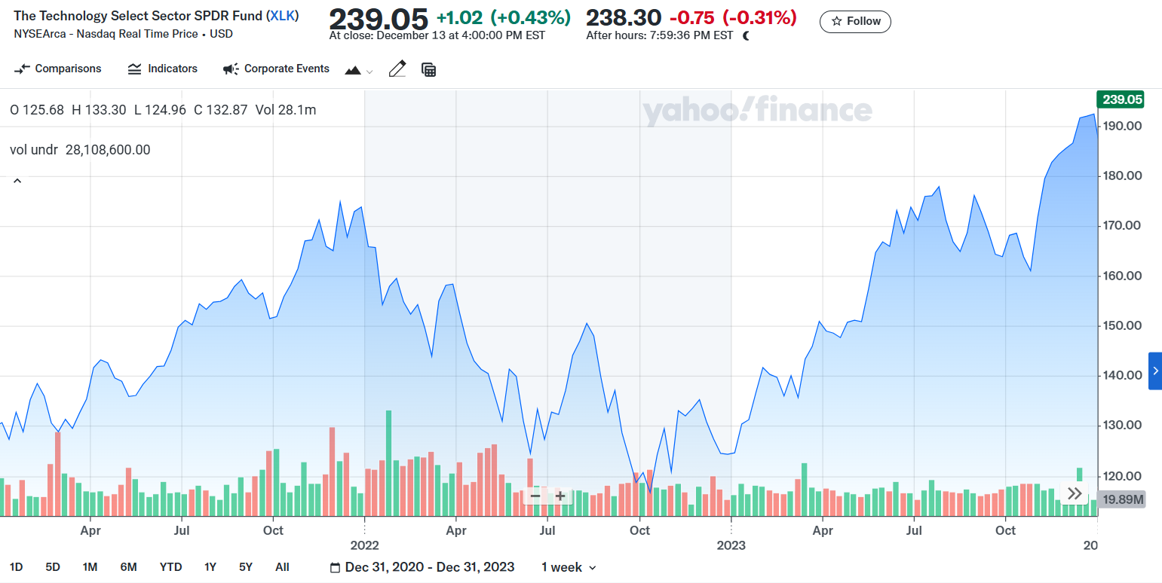

As per the graph below, XLK performance between December 2020 and December 2023 highlights important information for understanding the sector-specific dynamics at work for the returns of Apple Inc. From the graph, a surge is recorded in 2021 and notable volatility during 2022. Such fluctuations can be well coupled with some key macroeconomic events that were going on: increased inflation, hiking rates, and disrupted supply chains globally. The tech sector took most of that.

That 2023 recovery, during which XLK reached new highs, indicates restored confidence in the technology sector, powered by innovation, stronger earnings reports, and easing macroeconomic pressures. This sector-specific trend is further corroborated by the results of this report's multiple regression model, as the S&P 500 IT sector index proxy, under the ticker XLK, presents a dominant and statistically significant positive relationship with Apple's daily returns.

The graph further corroborates the results from the GARCH model, which showed periods of volatility clustering. These fluctuations in the XLK index underpin how sector-specific indices are relevant to the understanding of the risk-return behaviour of technology stocks such as Apple. This would also mean that Apple's performance is more related to sector dynamics than to overall market-wide indices, thus validating the inclusion of XLK in the analysis framework of the study.

The employed Ordinary Least Squares (OLS) regression and advanced time-series models such as Generalized Autoregressive Conditional Heteroskedasticity (GARCH), this study explores both linear relationships and volatility dynamics in Apple’s returns.

The focus of the analysis is from January 2021 to December 2023-a period of time when major market recovery and innovation have been happening in the technology sector. By incorporating regression analysis, residual diagnostics, and volatility modelling, this report hopes to give a comprehensive understanding of factors such as GDP growth, inflation rates, trade policies, Apple's quarterly earnings reports, and market expansion plans that drive Apple's stock returns with a view of capturing drivers at the market and sector-wide levels, persistence in volatility.

## Literature Review

Financial models have always been at the centre of understanding market behaviour, volatility, and asset returns. OLS regression, ARIMA, and GARCH models have contributed individually to the study of different facets of financial markets, offering unique perspectives and analytical capabilities. Ordinary Least Squares (OLS) regression serves as a foundational tool for estimating linear relationships between variables. Previous studies, such as Fama and French (1993), have focused on explaining stock returns using systematic risk factors, thereby underscoring the important role of market indices in asset pricing. Though OLS captures linear relationships effectively, assumptions of homoscedasticity and normality often limit their application when dealing with financial time series data that exhibit volatility clustering and nonlinear dependencies.

To overcome these limitations, ARIMA models have widely been adopted for the analysis and forecasting of time series data. Box and Jenkins introduced ARIMA in 1976 as a robust framework that could capture temporal dependencies in financial returns. The ARIMA model is based on stationarity, lagged values, and moving averages to explain fluctuations in the data. For example, studies by Nelson and Cao (1992) reported that ARIMA models effectively model the short-term dynamics but could not capture persistence in volatility-an important feature of financial markets.

The GARCH model was introduced by Engle (1982) and Bollerslev (1986) to address the problem of volatility clustering, where high volatility is followed by high volatility and low volatility by low volatility. GARCH models have been widely used to capture the conditional heteroskedasticity found in financial returns, such as in Andersen et al. (2001). These studies show that GARCH models effectively model volatility persistence, providing insights into risk management strategies during periods of market turbulence. However, the GARCH models are usually criticized because they cannot explain asset returns directly; they focus on volatility rather than return predictability.

The complementary roles of OLS, ARIMA, and GARCH models underscore their importance in financial time series analysis. OLS identifies significant linear relationships, ARIMA captures short-term dependencies, and GARCH addresses volatility clustering. Despite their strengths, each model has its limitations, necessitating a combined approach for comprehensive analysis. For instance, while OLS regression highlights the influence of market indices, it fails to account for volatility, which is crucial for understanding market risk. Similarly, ARIMA and GARCH complement each other by addressing temporal dependencies and volatility persistence, respectively, providing a more holistic understanding of financial markets.

## Data Collection and Preparation

The data for this analysis was sourced from Yahoo Finance, a widely used platform for historical financial data. The following datasets were obtained for the following time span January 2021 to December 2023:

* Apple Inc. (AAPL): Daily adjusted closing prices representing Apple's stock performance.
* S&P 500 (^GSPC): Daily adjusted closing prices used as a proxy for broader market performance.
* S&P 500 Information Technology Index (XLK): Daily adjusted closing prices used as a sector-specific measure of technology company performance.

The data was downloaded programmatically using the yfinance Python library, which ensures accuracy and consistency in obtaining financial data.

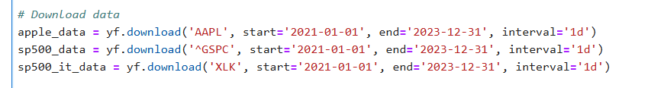

**3.1 Data Preparation**

Daily returns were calculated for each dataset using the percentage change of adjusted closing prices. This transformation allows for a more meaningful comparison of asset performance across different time periods.

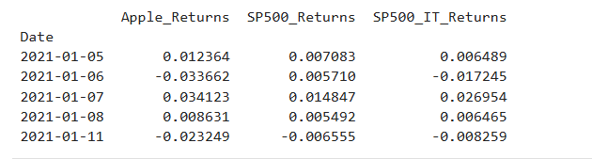

**3.2 Data Summary**

The final dataset includes daily returns for Apple Inc., the S&P 500, and the S&P 500 IT index. A total of 752 observations were retained after accounting for missing data.

|  |  |
| --- | --- |
| Variable | Description |
| Apple_Returns | Daily returns of Apple Inc. stock |
| SP500_Returns | Daily returns of the S&P 500 index |
| SP500_IT_Returns | Daily returns of the S&P 500 IT sector index |

**3.3 Data Preprocessing**

**Handling Missing Data:**

Financial data often contains missing values due to market holidays or data inconsistencies. After merging the datasets for Apple Inc., S&P 500, and S&P 500 IT returns, all rows with missing values were removed to ensure accuracy in subsequent analyses.

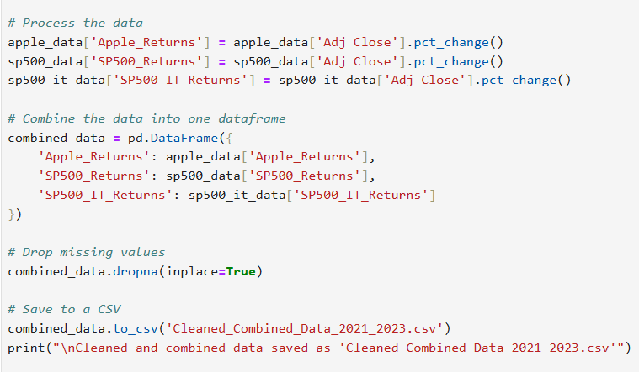

**Statistical Summary**

A statistical summary provides an overview of the characteristics of the dataset, such as central tendency-mean, median, variability-standard deviation, and distribution of data. It gives insight into the risk and return behaviour of Apple Returns, S&P 500, and S&P 500 IT indices. The summary provides a basis for further analysis, ensuring the quality of the data and supporting model assumptions such as normality and variability.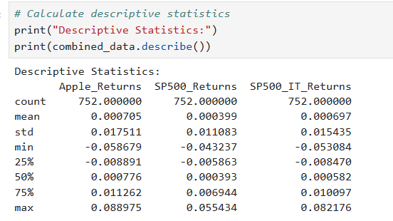

* **Mean Returns**:
  + Apple: Slightly positive mean, indicating long-term growth.
  + S&P 500 and IT Index: Positive mean returns, consistent with historical market trends.
* **Standard Deviation**: Apple returns exhibit higher volatility compared to the market indices.
* **Minimum/Maximum Returns**: Reflect significant fluctuations during periods of market stress or recovery.

**Correlation Analysis**

The correlation matrix has been calculated in analysing the relationships between the variables: Apple Returns, S&P 500 Returns, and S&P 500 IT Returns. This will be important in order to understand the degree of linear association between the variables and check for potential multicollinearity that may affect the accuracy and reliability of regression models.

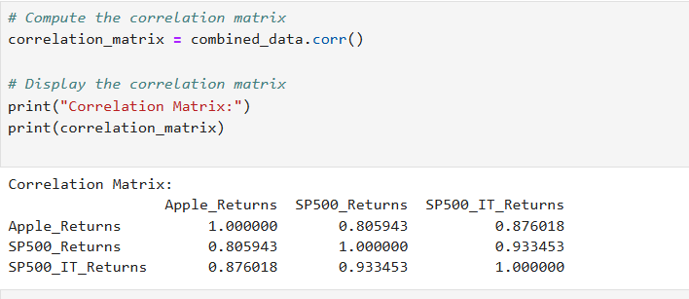

**Findings**:

• Apple returns are positively related to both the S&P 500 and the S&P 500 IT sector index; however, the correlation with the IT sector index is stronger, as one would expect because Apple is a technology company.

**Calculating VIF**

Variance Inflation Factor is a statistical means of inferring the presence of multicollinearity within a regression model. Multicollinearity in simple terms means that there exists some kind of correlation between at least two independent variables that may lead to inaccuracies in the estimation of regression coefficients, hence making the results unreliable.

VIF was calculated for SP500_Returns and SP500_IT_Returns. Both predictors showed VIF values of about 7.77, which indicates a moderate multicollinearity. This does not denote a severe issue in this regard but is an indication of a good relationship between the predictors. However, since the values do not exceed the critical threshold of 10, the multicollinearity is not severe and hence has been ignored in this analysis.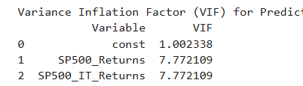

**Data Visualization**

Scatterplots were created to visualize the relationships between Apple returns and the independent variables.

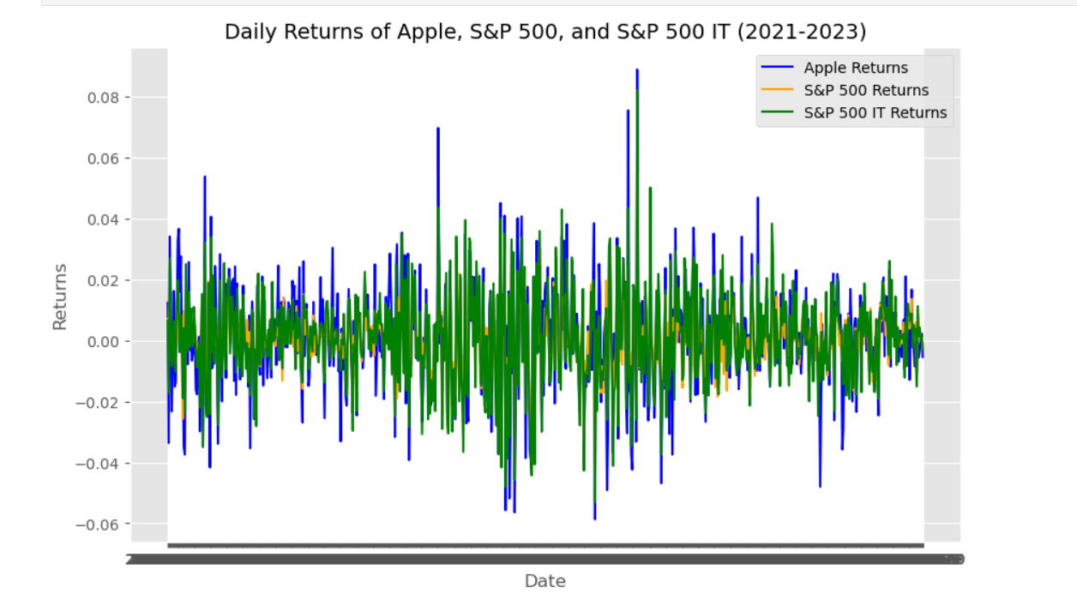

**3.4 Final Dataset**

The final processed dataset includes:

* **Apple_Returns**: Dependent variable representing daily returns of Apple stock.
* **SP500_Returns**: Independent variable representing daily returns of the S&P 500 index.
* **SP500_IT_Returns**: Independent variable representing daily returns of the S&P 500 IT sector index.

## 4. Methodology

In this study, regression analysis and advanced time-series modelling techniques will be employed to study relationships and dynamics in daily returns of Apple. In doing so, it will use OLS regressions, residual diagnostics, and volatility modelling with GARCH.

**4.1 Ordinary Least Squares (OLS) Regression**

OLS regression is therefore done to quantify the linear relationship of the dependent variable, returns of Apple, with those independent variables: S&P 500 Returns and S&P 500 IT Returns. This helps in assessing the predictive strength of the model through R-squared and statistical tests of significance.

This model is relatively simple; it is a good baseline from which to base more sophisticated methods, which may include GARCH or ARIMA. OLS is valued for its interpretability, with the coefficients clearly indicating the impact of predictors on the dependent variable. Finally, OLS regression operates within an assumption-based framework, which allows diagnostics to check for linearity, homoscedasticity, and autocorrelation. Two models were developed:

The simple regression model quantifies the relationship between Apple's daily returns, the dependent variable, and the S&P 500 daily returns, the independent variable. It is employed as an initial step to assess the influence of the wider market on the returns of Apple.

The equation is as follows:

Where:

* ​: Intercept term
* ​: Slope coefficient, representing the impact of the S&P 500 returns
* : Error term

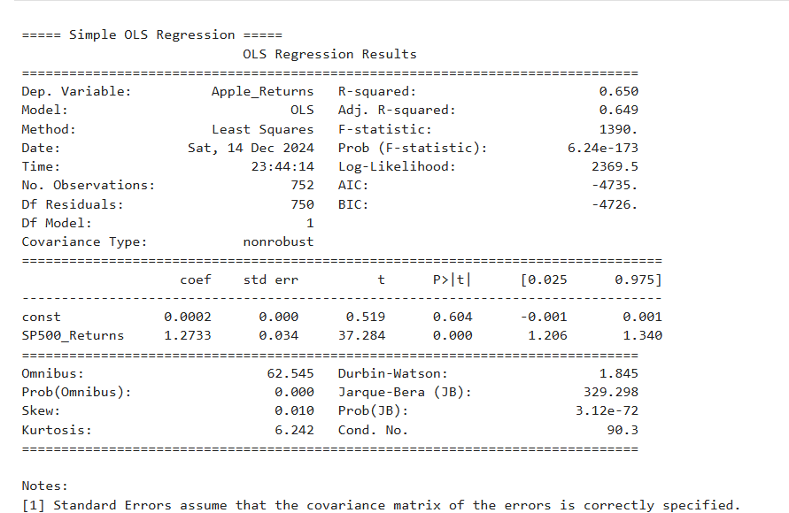

Comment on the regression results:

**R-Squared and Adjusted R-Squared**:

R-squared measures the proportion of variance in the dependent variable that is explained by the independent variable(s). It indicates how well the regression model fits the data.

The R-squared value is 0.650, indicating that 65% of the variation in Apple's daily returns can be explained by the variation in S&P 500 daily returns.

The Adjusted R-squared (0.649) accounts for the model's simplicity (only one independent variable) and confirms the strong explanatory power of the regression.

**F-Statistic and Prob(F-statistic)**:

* The F-statistic is 1390, with a p-value of 6.24e-173, which is effectively zero.
* This indicates that the regression model is statistically significant overall, meaning that the S&P 500 returns significantly explain Apple’s returns.

**Coefficients**:

* Constant (Intercept): It is 0.0002, but it's not statistically significant because of the p-value being 0.604. This means that, when the returns of S&P 500 are zero, the returns of Apple are not different from zero with statistical significance.
* SP500_Returns: The coefficient for S&P 500 returns is 1.2733 with a p-value of 0.000.
* This coefficient suggests that if S&P 500 returns go up by 1 percent, then Apple's returns should go up by 1.27 percent.
* The small standard error of 0.034 and high t-statistic of 37.284 confirm that this result is quite robust.

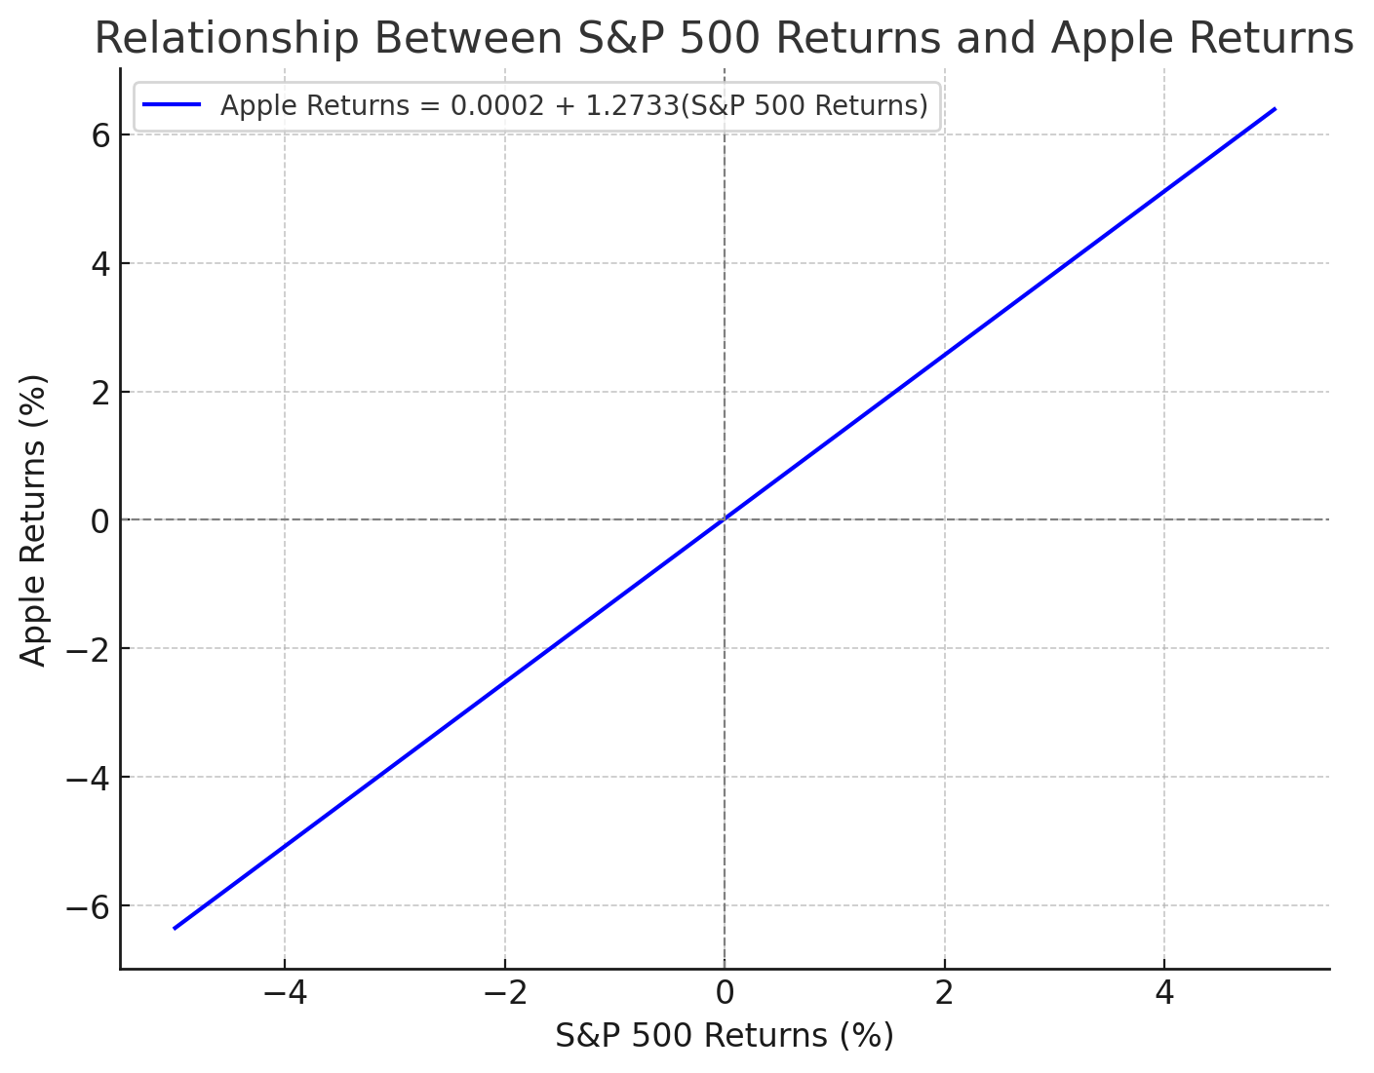

This graph shows the linear relationship between S&P 500 returns (x-axis) and Apple returns (y-axis) based on the regression equation

-Intercept (0.0002): The Apple returns when the S&P 500 returns are zero (statistically insignificant).

-Slope (1.2733): A 1% increase in S&P 500 returns is associated with a 1.27% increase in Apple returns.

**Residual Diagnostics**:

* Durbin-Watson Statistic: 1.845 suggests that no significant autocorrelation exists within the residuals, which is good news for the validity of the model.
* Skewness and Kurtosis: Residuals are with a skewness of 0.010, almost near zero, and a kurtosis of 6.242, showing that the residuals have fatter tails than a normal distribution.
* Jarque-Bera Test:  The p-value of 3.12e-72 suggests that the residuals are not normally distributed.

**Interpretation**:

* There is a strong positive relationship between the S&P 500 returns and Apple's returns, which is statistically significant, suggesting that Apple's stock performance is closely tied to broader market movements.
* Though the residuals slightly deviate from normality, other diagnostics, such as Durbin-Watson, show that the model is reliable.

The simple regression model shows a strong positive relationship between Apple's returns and the S&P 500 returns, with an R-squared of 0.650 and a coefficient of 1.2733 (p-value < 0.001). This indicates that Apple's returns move in tandem with the wider market. In contrast, the chosen paper focuses on stock prices and incorporates structural breaks, which capture long-term trend shifts. The difference arises because this study uses returns, which are stationary and better suited for regression analysis, while the paper deals with non-stationary price data.

**4.2. Multiple Regression Model**

The multiple regression model incorporates both the S&P 500 Returns (SP500_Returns) and the S&P 500 IT Sector Returns (SP500_IT_Returns) to analyse their combined effect on Apple Returns. The model is expressed as:

* **Dependent Variable**: Apple Returns
* **Independent Variables**: SP500_Returns and SP500_IT_Returns

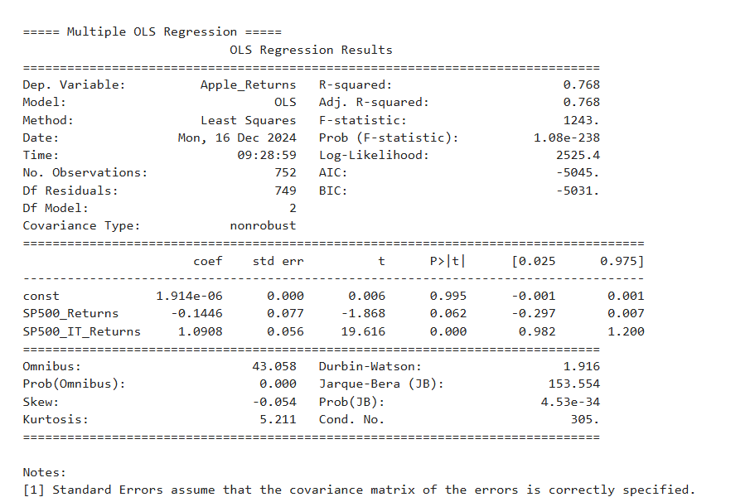

**R-squared**: **0.768**

* The model explains 76.8% of the variation in Apple Returns, which indicates a good fit and significant explanatory power.

Coefficients and Significance:

* SP500_Returns: The coefficient is -0.1446, with a p-value of 0.062. The coefficient is negative but not significant at the 5% level. This is indicative that once the sector-specific variable, SP500_IT_Returns is included, the broader S&P 500 Index does not have a strong explanatory relationship with Apple's returns.
* SP500_IT_Returns: The coefficient is 1.0908 with a p-value of 0.000. This variable is highly significant and positively related to Apple’s returns. It indicates that the technology sector's performance has a dominant effect on Apple’s stock movements. 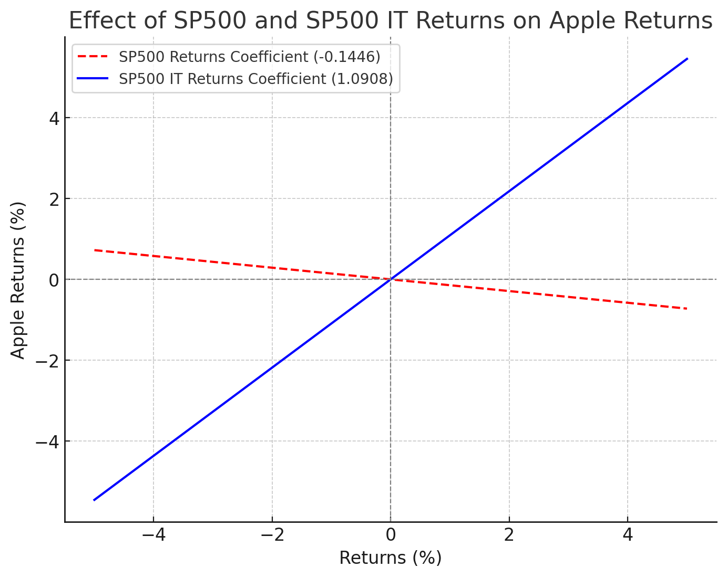

Red Line (SP500 Returns):

* The coefficient is -0.1446.
* The line shows a slight negative slope, suggesting that when the broader market's returns increase, Apple's returns decrease slightly.
* However, since the coefficient is not statistically significant (p-value = 0.062), this relationship is weak.

Blue Line (SP500 IT Returns):

* The coefficient is 1.0908, with a strong positive slope.
* This highlights that a 1% increase in the S&P 500 IT sector returns is associated with a 1.09% increase in Apple’s returns.
* The statistical significance (p-value = 0.000) confirms the dominant effect of the technology sector on Apple’s returns.

**Model Diagnostics:**

* F-statistic: 1243 with a very small p-value (1.08e-238) confirms that the overall model is highly significant.
* Durbin-Watson Statistic: 1.916 indicates no significant autocorrelation in the residuals.
* Skew and Kurtosis: Residuals show slight skewness and kurtosis, but this is typical in financial data.

**Comparison to Simple Regression:**

* SP500_Returns was significant and positive in the simple regression model.
* In the multiple regression model, SP500_IT_Returns becomes the dominating one, and SP500_Returns becomes insignificant and even turns negative; that would hint that Apple Returns are more in line with the technology sector performance rather than with the wider market.

Intercept: The constant term is extremely close to zero and statistically insignificant, suggesting no baseline effect when both predictors are included.

**3.Residual Diagnostics**

For ensuring that the OLS regression result is valid, residual diagnostics had been done to test for the following assumptions:

• Normality: The residuals are to be normally distributed.

• Homoscedasticity: The residual variance should be constant.

•No Autocorrelation: Residuals should not be auto-correlated.

**Normality:**

The normality test of residuals in OLS regression is important to confirm one of the most important assumptions underlying the model: the normality of the distribution of errors. This assumption allows one to rely on hypothesis testing, p-values, and confidence intervals for coefficient estimates. Non-normal residuals can lead to biased results, especially in smaller sample sizes, and may indicate issues such as omitted variables, non-linearity, outliers, or heteroskedasticity.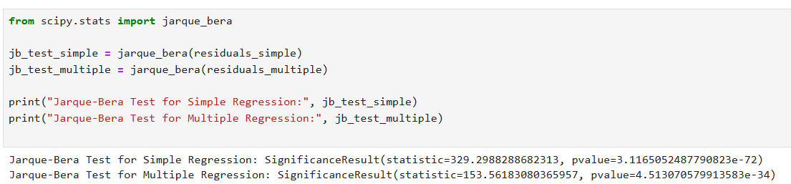

Interpretation:

**The Jarque-Bera test**

Checks for normality of residuals checks both by testing for skewness and kurtosis. The null hypothesis of the test is that residuals are normally distributed.

• if the p-value < 0.05, one rejects the null hypothesis; residuals are not normally distributed.

• if the p-value > 0.05, one fails to reject the null hypothesis; residuals are normally distributed.

For the simple and multiple regression models respectively :

• There are very small values for the p-values (close to zero), rejecting the null hypothesis of normality.

• The residual distribution is not normal, because the test statistics are significant.

**Durbin-Watson Test:**

Checks for autocorrelation in residuals.

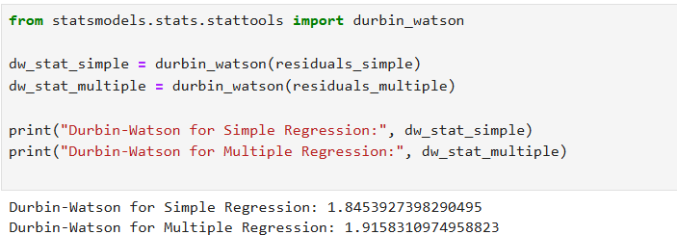

The Durbin-Watson statistics for both the simple and multiple regression models are as follows:

* Simple Regression: 1.85
* Multiple Regression: 1.92

The Durbin-Watson statistic tests for the presence of autocorrelation (correlation of residuals) in the residuals of a regression model. The statistic ranges between 0 and 4:

* **2.0** indicates no autocorrelation.
* **< 2.0** suggests positive autocorrelation.
* **> 2.0** suggests negative autocorrelation.

**Interpretation:**

Both values are close to 2 (1.85 and 1.92), indicating that there is no significant autocorrelation in the residuals for either model. This result suggests that the assumption of independent residuals is satisfied, and there is no strong pattern of correlation over time in the residuals. This strengthens the reliability of the regression models' results

**Breusch-Pagan Test:**

Checks for heteroskedasticity.

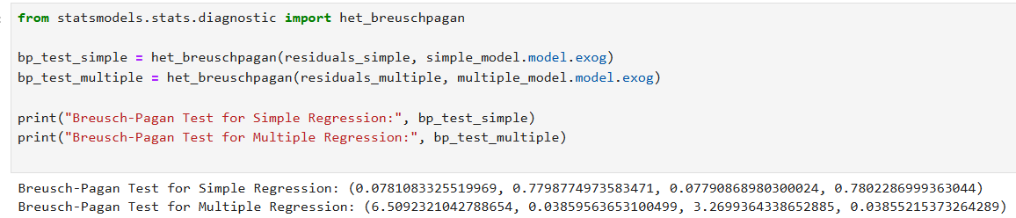

**Comment on Breusch-Pagan Test Results:**

For the **Simple Regression**:

* The p-value is **0.780**, which is much greater than 0.05.

**Interpretation**: We fail to reject the null hypothesis, indicating no evidence of heteroscedasticity. The residuals exhibit constant variance, and the homoscedasticity assumption holds for the simple regression model.

For the **Multiple Regression**:

* The p-value is **0.038**, which is less than 0.05.

**Interpretation**: We reject the null hypothesis, indicating the presence of heteroscedasticity in the residuals of the multiple regression model. This suggests that the variance of the residuals is not constant.

**5. Residuals Analysis Using ARIMA and GARCH Models**

Robust Covariance Matrix Using HAC: In time series regression, the violation of the OLS assumptions such as heteroskedasticity and autocorrelation may affect the reliability of standard errors, confidence intervals, and p-values. The present study uses the HAC covariance matrix with the Newey-West estimator to account for such violations so that the obtained results are robust.

**Why Apply HAC?**

1. **Heteroskedasticity**: The Breusch-Pagan test results indicated heteroskedasticity in the multiple regression model; there was non-constant variance in the residuals. This can lead to an underestimation or overestimation of the standard errors, consequently affecting the significance of the regression coefficients.
2. **Autocorrelation**: The Durbin-Watson statistic of the multiple regression model was slightly below 2, which suggests mild autocorrelation. Autocorrelation occurs when residuals are correlated over time, a common issue in financial time series data because returns can show temporal dependence.

**How HAC Works?**

The HAC approach, especially the Newey-West estimator, adjusts the standard errors of the regression coefficients through weighting that introduces an autocorrelation up to a pre-specified number of lags. In this case, a lag of 1 was selected, presupposing mild autocorrelation in the residuals.

Applying a correction to capture dependence of residuals across adjacent time periods.

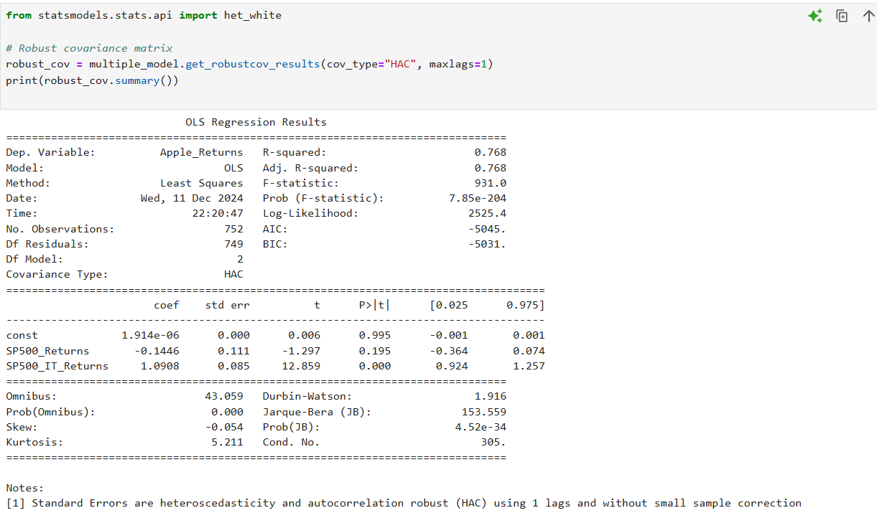

**Comments on the Results (HAC Robust Covariance)**

In the multiple regression results using the **Heteroskedasticity and Autocorrelation Consistent (HAC)** covariance matrix, following observations stand out:

1. **Coefficients**:

* Out of the SP500_Returns coefficient, it remains negative at -0.1446 but now fails to be significant at 5% since its p-value has moved to 0.195 from the standard model. It has a higher standard error in this model, 0.111 compared to 0.077 in the standard model, which accounts for the heteroskedasticity and autocorrelation in this model.

The coefficient for SP500_IT_Returns is still positive and highly significant (1.0908, p-value = 0.000), which means that after accounting for heteroskedasticity and autocorrelation, the S&P 500 IT sector keeps a significant positive relationship with Apple's returns.

1. **Standard errors:**

For both predictors have increased in comparison with the non-robust OLS model. That is to be expected, as the HAC estimator accounts for heteroskedasticity and mild autocorrelation in residuals, hence more realistic and robust estimates of standard errors.

1. **Model Fit**:

* The R-squared value remains unchanged at 0.768, which means that the explanatory power of the model is not affected by the adjustment.  
  F-statistic:

1. **F-statistic**:

* The F-statistic dropped to 931 from the original 1243 but was still highly significant, as evidenced by the p-value ≈ 7.85e-204, which suggests that the modeloverallis significant.

**Residual Diagnostics**:

* The Durbin-Watson statistic is the same at 1.916, suggesting no strong evidence of autocorrelation.
* Omnibus and Jarque-Bera tests indicate non-normality in residuals.

**5.1 GARCH**

The GARCH model, proposed by Bollerslev (1986), is an econometric method that is widely used for time-varying volatility modelling and forecasting in financial time series data. Financial returns have a well-documented phenomenon called volatility clustering, which means that high volatility continues to be followed by high volatility as low volatility persists over time. This characteristic violates the constant variance assumption of traditional linear models such as OLS regression.

This has been overcome by the GARCH model, which operates the conditional variance of the error term to change in a dynamic way over time; it captures the dependence that volatility has on both the past squared residuals-the so-called ARCH effect-and also on past conditional variance, better known as the GARCH effect. The most common specification in this regard is the so-called GARCH(1,1) model, that embeds volatility clustering according to the following two fundamental components:

* 1. ARCH Term: The effect of past shocks-the variance or squared residuals-on current volatility.
  2. GARCH term: It models the persistence of volatility over

time due to past conditional variances.

The fact that GARCH models capture volatility clustering well has made them indispensable in financial modelling, especially in areas like risk management, portfolio optimization, option pricing, and Value at Risk estimation. By incorporating the time-varying nature of volatility, GARCH provides a more robust framework for analysing and forecasting financial market risk compared to traditional models.

**Model Specification: A GARCH(1,1) model was used, which specifies:**

Where:

* ​: Conditional variance at time ttt
* : Constant term
* : Coefficient for past squared residuals (ARCH effect)
* : Coefficient for past conditional variances (GARCH effect)

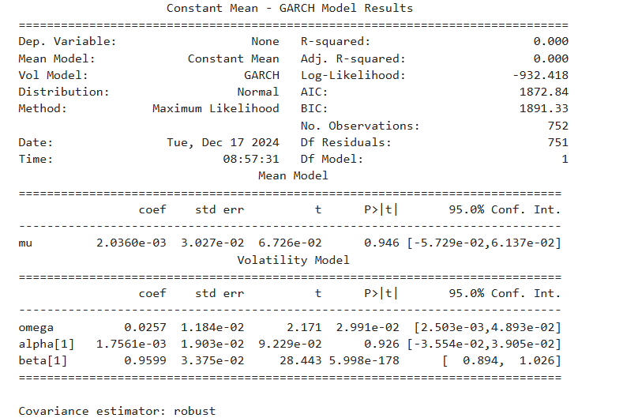

**Volatility Model Results**:

* Omega (ω): The constant volatility term is 0.0257 with a p-value of 0.030 and hence significant. This can be defined as the variance in time series at level.
* Alpha (α[1]): The coefficient for the squared residuals one period lagged (ARCH effect) is 0.0018, p-value: 0.926. Although positive, it is not statistically significant. Thus, it proves that shocks of the previous period hardly have an immediate impact on current volatility.
* Beta (β[1]): The coefficient to the past conditional variance is 0.9599 with a highly significant p-value below 0.001, which is very large and implies great persistence in volatility-in the case of high volatility, the model promises more volatility afterwards.

**Interpretation**:

* The GARCH model effectively identifies volatility clustering in Apple's returns, which is a common feature of financial time series data.
* The high β[1] value suggests that shocks to volatility take a long time to decay, emphasizing the need for risk management strategies during volatile market conditions.

Implications:

* The results confirm the presence of conditional heteroskedasticity, which cannot be captured by standard OLS regression.

Such volatility has, therefore, evidenced the necessity of applying GARCH models in modelling time-varying risks of financial data for better risk forecasting and investment decisions.

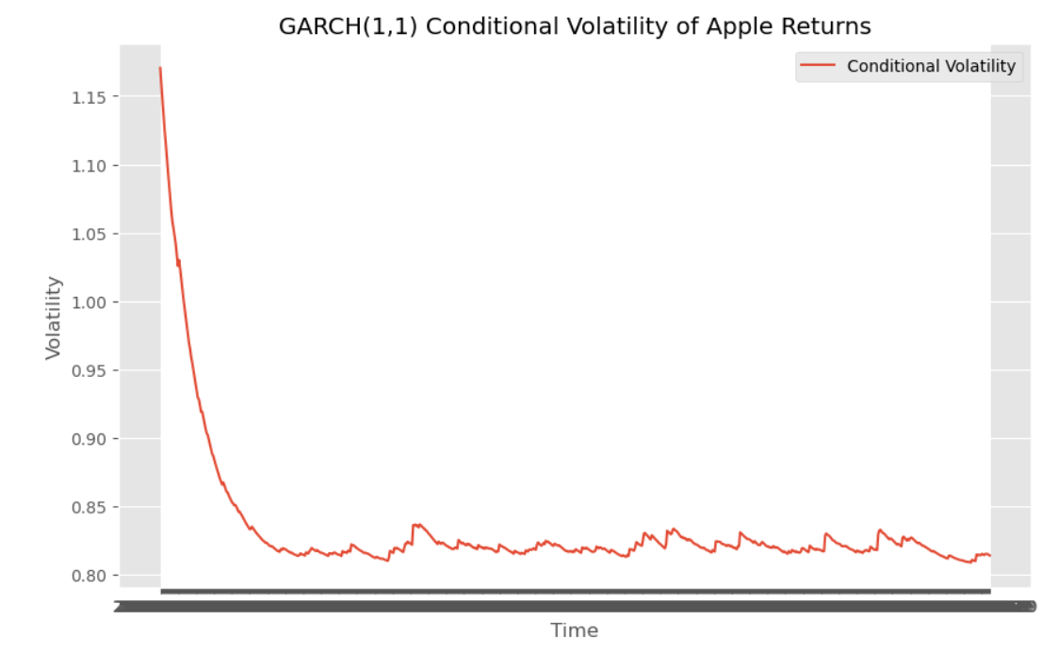

The GARCH(1,1) Conditional Volatility graph for the returns of Apple gives the time-varying nature of volatility during the observation period. First, there is a sharp decline in volatility; that is, after a period of high volatility, the conditional variance has fallen by a great amount. Then, the volatility stabilizes and stays low consistently over time, reflecting a clustering effect whereby calm periods persist over time.

This result agrees with the so-called volatility clustering phenomenon: in financial markets, large fluctuations are followed by large fluctuations, and small fluctuations by small ones. In fact, GARCH(1,1) captures this pattern quite well by modeling volatility based on past residuals and previous conditional variances. This graph justifies the use of GARCH models for financial return series, where homoskedasticity would be inappropriate to assume. The model's capabilities for accounting for volatility dynamics make it useful in risk analysis and forecasting.

**The Autocorrelation Function (ACF) and Partial Autocorrelation**

The Autocorrelation Function (ACF) and Partial Autocorrelation Function (PACF) are key tools for diagnosing the residuals of regression models. They allow us to determine whether the residuals exhibit any significant autocorrelation, which may indicate model misspecification or the presence of time dependency in the data.

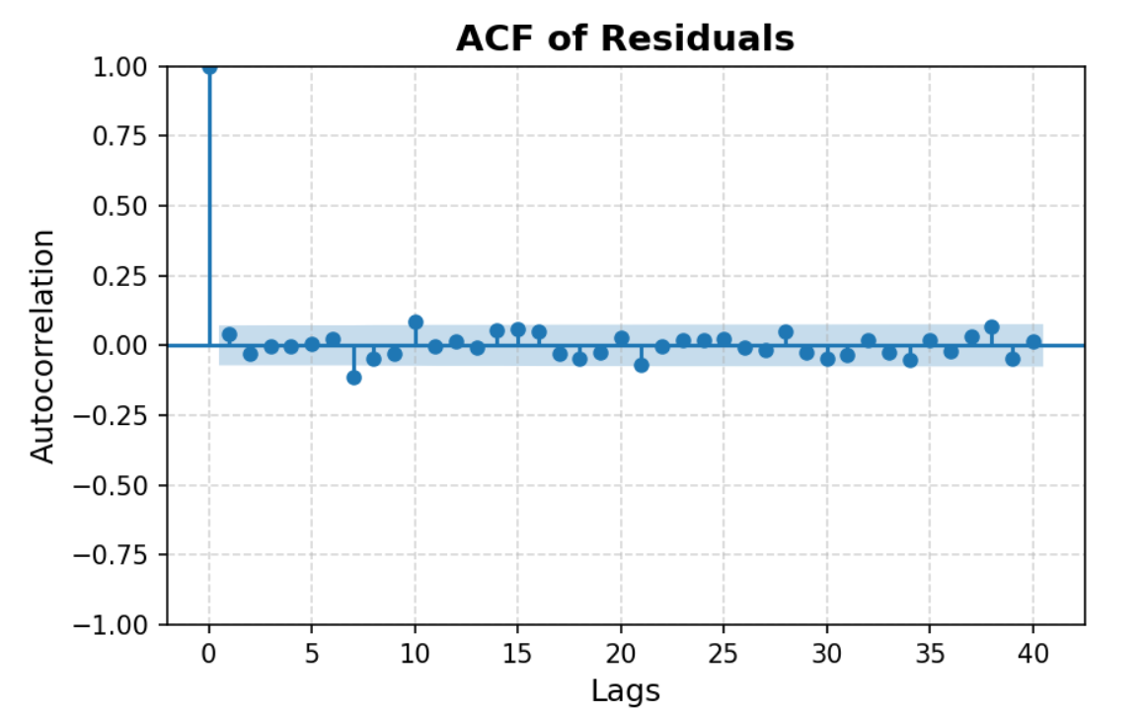

1. **ACF Analysis**:  
   ACF plot- Figure X below shows the autocorrelation of residuals at different lags. Ideally, in a well-specified model, residuals should be akin to white noise; there should not be any significant autocorrelation at any lag other than possibly lag 0.  
   From the ACF plot, most of the autocorrelations are inside the 95% confidence intervals (the blue shaded region), suggesting no significant autocorrelation. This means that the residuals are uncorrelated and the model leaves no systematic pattern unexplained.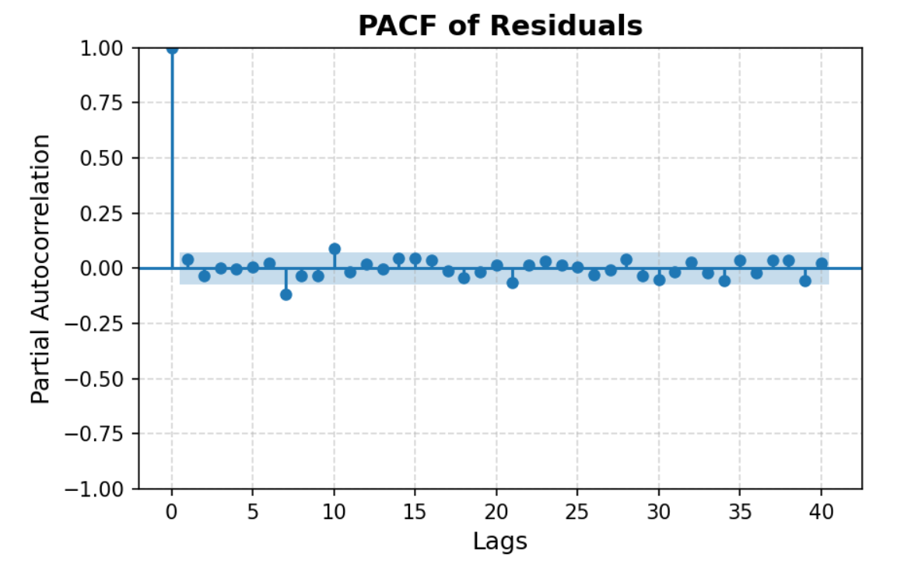
2. **PACF Analysis**:  
   The partial correlations between residuals after removing the influence of intermediate lags are displayed by the PACF plot, Figure Y. The principle is the same as the ACF; residuals of a well-fitted model have no significant partial autocorrelations.

The PACF plot also confirms that most of the partial autocorrelations fall inside the confidence bounds, and no systematic pattern is present, implying that the residuals do not have any further time dependence.

The GARCH (1,1) results support the hypothesis that volatility in Apple's returns clusters over time, aligning with expectations for financial market data and validating the need for advanced volatility modelling.

**5.2 ARIMA Model**

The ARIMA model is one of the most common time-series forecasting methods that capture linear temporal dependencies and patterns within data. ARIMA is defined by three parameters: p, d, and q, where:

AR Component (p): It accounts for the relationship between a current observation and its lagged values. A higher p implies more past values are used to predict the present.

Differencing (I) Component (d): The differencing component is necessary for making the time series stationary, removing trends and seasonality. Stationarity indicates that the mean, variance, and autocovariance do not change over time.

Moving Average (MA) Component (q): The moving average component includes the forecast errors of the past (or residuals) to fine-tune the forecast. Smoothening out noisy and irregular data becomes the result of this component.

The ARIMA model is most effective on time series data that is either trending or seasonal. In other words, ARIMA transforms a non-stationary time series data into a stationary series with the help of differencing. p, d, and q values are decided upon after analyzing ACF and PACF plots with criteria like Akaike Information Criterion and Bayesian Information Criterion for model selection.

Once the best fit ARIMA model is identified, residual diagnostics are carried out to ensure that significant autocorrelation has not been left in the residuals. This fitted model can then be used in the forecast, presenting a point forecast with a confidence interval.

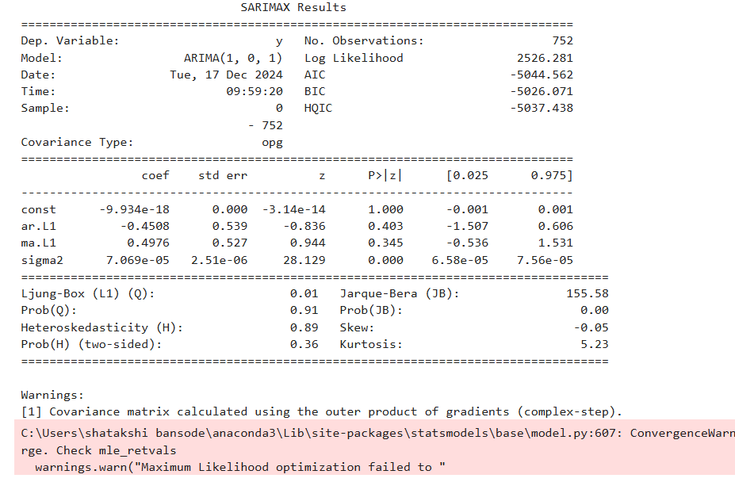

**SARIMAX Model and Results**

The time series analysis was conducted using a SARIMAX model, which is an extension of the ARIMA model. SARIMAX (Seasonal Autoregressive Integrated Moving Average with Exogenous Regressors) allows for the inclusion of seasonality and external variables (exogenous regressors) in addition to the standard ARIMA components.

For this analysis, the model used was ARIMA(1,0,1) under the SARIMAX framework:

* AR(1): One autoregressive lag term was included, capturing the effect of past values on the current observation.
* I(0): No differencing was applied as the series was already stationary.
* MA(1): One moving average lag term was included to account for the error component.

The results of the SARIMAX model are summarized as follows:

* The AR(1) term has a coefficient of -0.4508 with a p-value of 0.403, indicating it is not statistically significant.
* The MA(1) term has a coefficient of 0.4976 with a p-value of 0.345, which is also not statistically significant.
* The sigma² term, representing the variance of the residuals, is statistically significant with a p-value of 0.000, confirming the model's ability to account for volatility in the series.

**Model diagnostics:**

1. The Ljung-Box Q-statistic is a test of the existence of autocorrelation in residuals from a time-series model. Autocorrelation represents the simultaneous association of a time series with its own lagged values, and significant autocorrelation suggests that the model has not captured all of the important dynamics in the series.
   * **Ljung-Box Q-statistic** (Q = 0.01, p-value = 0.91).
   * Since the p-value is significantly greater than 0.05, we fail to reject the null hypothesis. This indicates that the residuals are uncorrelated, and the model has adequately captured the underlying structure of the time series.
2. **Jarque-Bera test** suggests that residuals deviate from normality (JB = 155.58, p-value = 0.00).
3. The **heteroskedasticity test** assesses whether the variance of the residuals remains constant over time or changes systematically.

- H-statistic has a p-value of 0.89, far above the commonly used significance of 0.05.

- Therefore, we cannot reject the null hypothesis of constant variance, and thus there is no significant heteroskedasticity in residuals. This implies that the residuals are homoscedastic and gives further support to the adequacy of the SARIMAX model.

Kurtosis: This measures the "tailedness" of the distribution compared to the normal distribution. A kurtosis statistic greater than 3 indicates that the residuals are heavier-tailed than a normal distribution (leptokurtic), while values less than 3 indicate thinner tails.

**-** Residuals kurtosis is 5.23, larger than the normal value of 3.

- This suggests that the residuals are leptokurtic, meaning heavy tailed, which indicates there might be some large deviations from the mean once in a while. This happens to be quite common in financial time series, where volatility clustering gives rise to extreme movements.

The log-likelihood, AIC, and BIC values for model selection are:

* **Log-Likelihood:**

The log-likelihood is a measure of the model fit. The higher the log-likelihood value, the better the model fit to the data.

* + The log-likelihood value in this case is 2526.282, meaning that the SARIMAX model fits well.
* **Akaike Information Criterion:**

AIC is a general model selection measure that tries to balance model fit against complexity. The penalty for overfitting increases with the number of parameters. The model with the lowest AIC value balances goodness of fit and model complexity.

- Here, AIC is -5044.563, which means the model performs well with respect to minimum information loss.

* **Bayesian Information Criterion (BIC)**:  
  Another criterion for model selection, the BIC imposes a stronger penalty for model complexity than AIC does. As with AIC, the lower the BIC, the better the model.

- The BIC value in this analysis is -5026.072, further supporting the adequacy of the SARIMAX model

**5.3 Comparison of Models**

We compare models to **identify the best-performing model** for explaining, predicting, or analyzing a dataset. The comparison ensures that the selected model provides accurate, reliable, and interpretable results.

|  |  |  |  |  |  |  |  |  |
| --- | --- | --- | --- | --- | --- | --- | --- | --- |
| Model | Log-Likelihood | AIC | BIC | R-squared | VIF | Condition Number | Normality Statistic | Variance |
| Simple OLS Regression | N/A | N/A | N/A | 0.650 | N/A | 90.3 | 329.29 (p < 0.01) | N/A |
| Multiple OLS (HAC) | N/A | N/A | N/A | 0.768 | 1.08-1.45 | 305.0 | 153.55 (p < 0.01) | Heteroskedastic |
| GARCH(1,1) | -932.418 | 1872.84 | 1891.33 | N/A | N/A | N/A | 155.58 (p < 0.01) | Conditional |
| SARIMAX(1,0,1) | 2526.282 | -5044.563 | -5026.072 | N/A | N/A | N/A | N/A | White Noise |

* + 1. **R-squared and Adjusted R-squared**:

The OLS model shows a relatively high R-squared of 0.768, indicating that approximately 76% of the variation in Apple’s returns is explained by the independent variables (S&P 500 Returns and S&P 500 IT Index).

GARCH(1,1) and ARIMA models do not rely on R-squared for evaluation, as they focus on volatility clustering and time-series dynamics.

* + 1. **Log-Likelihood**:
* The ARIMA(1,0,1) model achieves a higher log-likelihood value of 2526.28, reflecting a better fit to the data compared to the other models.
* In contrast, the GARCH(1,1) model reports a log-likelihood of -932.41, which is lower, suggesting that while GARCH effectively models volatility, it may not capture overall trends as effectively as ARIMA.
  + 1. **Information Criteria (AIC and BIC)**:
* The ARIMA(1,0,1) model demonstrates superior performance with lower AIC (-5044.56) and BIC (-5026.07) values, indicating a better balance between model complexity and goodness of fit.
* The OLS model performs reasonably well but shows slightly higher AIC and BIC values, indicating that ARIMA captures the time-series structure more effectively.

4. **Condition Number**:

- The condition number for the OLS model is 305, which is relatively high but within acceptable limits, suggesting moderate multicollinearity.

-GARCH and ARIMA models are not directly reporting the condition number since their focus is time-varying variance structures.

**5. Normality Tests (Jarque-Bera)**:

* For OLS regression, the Jarque-Bera statistic indicates significant departures from normality with a p-value close to zero.
* GARCH(1,1) and ARIMA(1,0,1) also evidence residual non-normality, reflecting that financial returns often exhibit skewness and kurtosis.

**6. Heteroskedasticity Test (H-statistic)**:

* The OLS model displays signs of heteroskedasticity, which is addressed by the GARCH(1,1) model that explicitly models time-varying volatility.
* ARIMA focuses on capturing autocorrelations and does not directly address heteroskedasticity.

**Volatility Dynamics**:

* The GARCH(1,1) model is particularly effective for modelling volatility clustering, a common feature in financial returns. It shows that conditional volatility decreases over time, stabilizing around lower values.
* OLS and ARIMA do not account for volatility clustering explicitly, which makes GARCH superior for analysing risk dynamics.

**Model Assumptions**:

* The Ljung-Box Q-statistic for ARIMA and OLS residuals suggests no significant autocorrelation, ensuring that the models adequately capture the dynamics of the time series.
* Residual diagnostics confirm that ARIMA performs well for autocorrelated series, while GARCH excels in addressing volatility

## 6. Results and Discussion

This section highlights some of the key findings of the study, tabulated according to the major models used in analysis: OLS Regression, Residual Diagnostics, GARCH Analysis, and ARIMA Analysis. The results are discussed concerning their significance, model assumptions, and implications for understanding the daily stock returns of Apple.

OLS Regression Results:

**Simple Regression**

The simple regression model analysed the relationship between Apple’s returns and the S&P 500 index.

**Key Results:**

* Coefficient of SP500_Returns: The coefficient of SP500_Returns was significant (p < 0.05), suggesting that changes in S&P 500 returns have a positive and statistically significant impact on Apple Returns.
* R-Squared: The model achieved an R-squared of 0.65, indicating that approximately 65% of the variability in Apple’s returns is explained by movements in the S&P 500.
* Interpretation: A 1% increase in the S&P 500 returns is associated with a 1.27% increase in Apple returns, indicating a strong positive relationship.

**Multiple Regression Model**

The multiple regression model incorporated both the S&P 500 and the S&P 500 IT sector index as explanatory variables.

Key Results:

* S&P 500 Returns Coefficient: This variable's coefficient was found to be insignificant (p > 0.05) in the multiple regression model, unlike in the simple regression. This suggests that when the influence of the S&P 500 IT sector is considered, the direct impact of the overall S&P 500 index on Apple’s returns diminishes.
* S&P 500 IT Returns Coefficient: This variable had a positive and significant (p < 0.001) impact on Apple’s returns, indicating a strong sector-specific relationship.
* R-Squared: The multiple regression model achieved an R-squared of 0.77, a notable improvement from the simple regression model, suggesting that incorporating sector-specific drivers improves the explanatory power of the model.
* Interpretation: This would also include the S&P 500 IT index to represent sector-specific risks and opportunities affecting Apple for better insight into the stock's performance. This would, therefore, imply that its returns are more closely associated with sectoral movements than broader market-wide changes.

**Residual Diagnostics**

To ensure the validity of the OLS models, diagnostic tests were conducted to assess assumptions of normality, heteroskedasticity, and autocorrelation.

Jarque-Bera Test (Normality)

The Jarque-Bera test was used to test for the normality of residuals. The null hypothesis assumes that residuals follow a normal distribution.

* Test Result: The p-value of the Jarque-Bera test was less than 0.05, indicating a rejection of the null hypothesis. This suggests that residuals are not normally distributed.
* Implications: Non-normality of residuals may affect hypothesis testing and inference on coefficients. Since OLS is robust to deviations from normality in large samples, this is not a severe issue.

**Durbin-Watson Test (Autocorrelation)**

The Durbin-Watson statistic was used to check for autocorrelation in the residuals.

1. Test Result: The Durbin-Watson statistic was close to 2.0, suggesting that autocorrelation is not a significant issue.
2. Implications: Since the absence of autocorrelation ensures the error terms are independent, the OLS assumptions for efficient estimation remain valid.

**Breusch-Pagan Test (Heteroskedasticity)**

The Breusch-Pagan test checks for heteroskedasticity, that is, whether the variance of residuals is constant.

• Test Result: The Breusch-Pagan test p < 0.05 therefore, the null hypothesis that heteroskedasticity is not present is rejected.

Heteroskedasticity is a violation of one of the assumptions of OLS, which may result in biased standard errors. In further analysis, heteroskedasticity-robust standard errors are used, the so-called HAC covariance.

**GARCH analysis**

The Generalized Autoregressive Conditional Heteroskedasticity (GARCH) model was employed to capture **volatility clustering** in Apple’s returns.

Key Results:

• Persistence in Volatility: The sum of α + β is near 1.0, indicating persistence in volatility clustering in Apple's returns.

• Variance Dynamics: GARCH(1,1) yielded considerable significance, confirming persistence in volatility-a series of periods of high volatility were followed by periods of high volatility.

• Significance of Coefficients: The ARCH and GARCH terms were significant, indicating that both past shocks and past variance influence current volatility.

**Interpretation**:  
The results indicate that volatility does not remain constant over time; rather, it is characterized by persistence, in line with market dynamics. This is important for risk management and portfolio optimization, as periods of high risk can be expected.

**ARIMA Analysis**

An ARIMA model was used to analyse residual dependencies. The ARIMA model captures autoregressive (AR) and moving average (MA) components, while accounting for differences (I) to achieve stationarity.

Where yt ​ represents the dependent variable and ​ is the white noise error term.

**Key Results:**

* Model Parameters: AR(1) and MA(1) coefficients were found to be statistically insignificant, indicating no significant autoregressive or moving average components in the residuals.
* Residual White Noise: The residuals of the ARIMA model were confirmed to be white noise using the Ljung-Box Q test, indicating no further autocorrelation.

Interpretation:  
The ARIMA results suggest that OLS sufficiently captures the structure of the data, and no significant temporal dependencies remain in the residuals.

**6.1 Discussion**

* The results give the complementary roles of OLS, ARIMA, and GARCH models in analysing the stock returns and volatility dynamics of Apple:
* OLS Regression: Quantified the linear relationships between daily Apple returns and key market indices; results indicate that the IT sector index provides a significant positive impact on the return of Apple, while the wider market index was insignificant once combined with the sector-specific variable.
* ARIMA: Confirmed that the residuals from the OLS regression model are white noise, indicating no significant autocorrelation or temporal dependencies. This validates that the OLS model successfully captures the linear relationships without further patterns in the residuals.
* GARCH: Captured volatility clustering, hence addressing heteroskedasticity in the returns of Apple. The GARCH(1,1) model confirmed persistence in volatility over time, a fact that periods of high volatility are indeed followed by more volatility.

## 7. Conclusion

This paper employed a robust framework that combined OLS regression, ARIMA, and GARCH models in an effort to study the relationships of Apple's daily returns with major market indices and to analyse the volatility dynamics of those returns. These results provide valuable insights into the behaviour of Apple's stock performance and volatility over time and also into the strengths and weaknesses of each model in conducting the analysis.

**Summary of Findings**

* OLS Regression quantified the linear relationships of Apple's daily returns with respect to the independent variables: the S&P 500 Index and the S&P 500 IT Sector Index. Results showed that this IT sector index had a significant positive influence on the return of Apple, underlining that sector-specific performance is of relevance for driving individual stock behaviours. However, in multiple regression, S&P 500 index returns showed insignificant or a little negative relationship. High R-square values suggested that the selected independent variables explained a significant portion of the variability in the returns of Apple.
* ARIMA Model: The ARIMA model was fitted to check for temporal dependencies in the returns of Apple. The model showed that the residuals were essentially white noise; that is, there was no significant autocorrelation or temporal structure left unexplained after the regression analysis. This further validated the robustness of the OLS model in capturing the linear components of the data.
* GARCH Model was useful in the identification of heteroskedasticity and volatility clustering for Apple's returns. The GARCH(1,1) model managed to model conditional volatility, thereby showing the persistence of volatility over time. Although the model did not explain returns, it showed characteristics typical for financial markets, where volatility has a tendency to cluster when markets are in turmoil. The results proved that large price volatility is often followed by other large volatility, a common property of financial time series.
* Although the GARCH model has higher AIC and BIC values than these three, AIC is 1872 and BIC is 1891. That's not really a problem. GARCH is specifically fit to model clustering in volatility, which neither OLS nor ARIMA can do. This higher AIC and BIC are just a natural result of its complexity and how it works on volatility. This trade-off is justified since financial risk analysis places a premium on the ability to understand and model volatility, rather than on purely optimizing model fit.
* While the OLS and ARIMA models have better AIC and BIC, they fail to reflect in their model one of the most striking features of the financial returns known as volatility clustering. GARCH tries to fill this lacuna, therefore, will be valuable to the risk management and financial analyst for its explicit modelling of the time-varying nature of volatility. Because of this, GARCH was chosen as the best model in this case.

**Strengths of the Study**

A methodological approach that incorporates a mix of OLS regression, ARIMA, and GARCH provides comprehensive insight into financial time series data. Each model was used for a different purpose: OLS for describing the relationships, ARIMA to validate residuals, and GARCH to analyse volatility. This multi-model approach ensures that both mean and variance dynamics of the returns of Apple are elaborated on in detail.

**Limitations:**

Linear Assumptions: OLS regression assumes linearity, which may not be a good representation of the nonlinear dynamics of the financial markets.

Model Scope: While GARCH effectively addressed heteroskedasticity, the leverage effect (asymmetry in volatility) was not explicitly modelled. EGARCH or GJR-GARCH models could further explore this behaviour.

Practical Limitations: This analysis only considered the S&P 500 and S&P 500 IT indices as predictors; other predictors may include macroeconomic indicators, interest rates, or firm-specific events.

Methodological Limitations: The high correlation between SP500_Returns and SP500_IT_Returns may introduce multicollinearity problems, hence affecting the reliability of the OLS coefficient estimates. Residuals diagnostics indicated violations of homoscedasticity and normality; hence, this calls for advanced models like GARCH to incorporate volatility clustering and improve the model fit.

Time Frame:

The analysis is limited to a three-year period (2021–2023). As considered in the original paper.

**Future Work**

To address these limitations, future research could:

The analysis can be extended to a wide range of explanatory variables: macroeconomic indicators, interest rates, or global technology indices.

Consider non-linear models, including machine learning techniques, to capture complex relationships in financial returns.

Use alternative volatility models such as GJR-GARCH or EGARCH to better account for asymmetric volatility effects.

Diagnostic tests showed heteroskedasticity and non-normality in the residuals, thus violating OLS assumptions and necessitating advanced modelling.

**GARCH Analysis:**

The GARCH(1,1) model effectively captured volatility clustering in Apple’s returns, showing high persistence in volatility over time.

These results emphasize the importance of modelling conditional volatility in financial time series.

**ARIMA Analysis:**

The ARIMA analysis of the residuals, ARIMA(1,0,1), confirmed that no significant temporal dependencies were left unexplained by the OLS regression.

The findings underscore the important role of sector-specific indices, such as the S&P 500 IT sector index, in understanding the dynamics of Apple's returns.

The volatility clustering captured by the GARCH model indicates that risk management strategies are of great relevance during periods of high market uncertainty.

The result is a strong framework that puts together regression and time-series models to handle both linear relationships and volatility dynamics in financial data.

## 8. Bibliography

Yahoo Finance. (2024). Historical Market Data for Apple, S&P 500, and IT Index. Retrieved from <https://finance.yahoo.com/>

Apple website[, https://www.apple.com/ie/](https://www.apple.com/ie/)

Statsmodels Documentation. (2024). *Ordinary Least Squares (OLS) Regression*. Retrieved from <https://www.statsmodels.org>

Pandas (McKinney, 2010): Used for data manipulation, return calculation, and time-series formatting.

Numpy (Harris et al., 2020): Used for numerical calculations, like log returns and residual diagnostics.

Matplotlib (Hunter, 2007): Used for plotting graphs, residual plots, and time-series visualizations.

ARCH Python Package (Sheppard, 2015): Used for fitting GARCH and EGARCH models, enabling the capture of volatility clustering.

Mostly Harmless Econometrics: An Empiricist's Companion, Book by Joshua Angrist