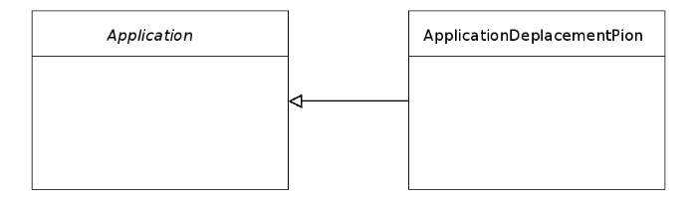
+Application(w:unsigned int, h:unsigned int, &title:std::wstring)
+run() : void
+module(const Position &v) : float
+distance(const p1:Position &, const p2 :Position &) : float
#m_window : sf::RenderWindow
#m_mouse :Position
#stop():void
#loop() : void <<abstract>>
#init() :void
#mouse_button_pressed() : void
#mouse_button_released() : void
#mouse_moved() : void
#key_pressed(const sf::Event::KeyEvent &) : void
-m_running:bool
-process_events ():event
-set_mouse_coord(x:int, y:int) : void
<<abstract>>
-m_position:Position
-m_modele_rond:sf::CircleShape
-m_police:sf::Text
-m_texte_fin:sf::Text
-m_rectangle:sf::RectangleShape
-m_etat:Etat
-loop():void
-dessiner_rond(const p:Position &):void
-dessiner_bouton_fin():void
-souris_dans_rond(const p:Position &):bool
-const souris_dans_rectangle(const coin:Position &,const dims:position &):bool
-mouse_button_pressed() : void
-mouse_button_released() : void
-mouse_moved() : void
-key_pressed(const sf::Event::KeyEvent &) : void
<<Interface>> Etat
INITIAL:enum
DEPLACEMENT:enum
FINAL:enum

