AL-QALAM UNIVERSITY, KATSINA
COLLEGE OF COMPUTING AND INFORMATION SCIENCE
DEPARTMENT OF SOFTWARE ENGINEERING AND CYBER SECURITY

DESIGN AND IMPLEMENTATION OF AN AI PUBLIC SPEAKING COACH SYSTEM

BY

MUHAMMAD IBRAHIM
CIS/STE/22/1143

A PROJECT SUBMITTED TO THE DEPARTMENT OF SOFTWARE ENGINEERING AND CYBER SECURITY, AL-QALAM UNIVERSITY KATSINA, IN PARTIAL FULFILMENT OF THE REQUIREMENT FOR THE AWARD OF BACHELOR OF SCIENCE DEGREE IN B.SC. SOFTWARE ENGINEERING

JUNE, 2026

Declaration
I, MUHAMMAD IBRAHIM, with Registration Number CIS/STE/22/1143, hereby declare that this project titled “Design and Implementation of an AI Public Speaking Coach System” is my original work. It was written and developed under the supervision of DR. ARMAYAU UMAR ZANGO and has not been submitted to any other institution or university for the award of any degree or qualification.
All sources consulted during the preparation of this work have been duly acknowledged within the text and in the reference list.
______________________ ______________________
MUHAMMAD IBRAHIM Date:
CIS/STE/22/1143

Certification
This is to certify that the project titled “Design and Implementation of an AI Public Speaking Coach System”, submitted by MUHAMMAD IBRAHIM with Registration Number CIS/STE/22/1143, has been read, evaluated, and approved as satisfying the partial requirements for the award of a Bachelor of Science degree in B.Sc. Software Engineering in the Department of Software Engineering and Cyber Security, Al-Qalam University Katsina.
______________________ ______________________
DR. ARMAYAU UMAR ZANGO Date:
Project Supervisor
______________________ ______________________
MALAM MUHAMMAD T. NANIYA Date:
Departmental Project Coordinator
______________________ ______________________
DR. RAJI ABDULLAHI EGIGOGO Date:
Head of Department (HOD)

Dedication
This project is dedicated to Almighty Allah, whose mercy and guidance made this journey possible, and to my family, whose sacrifices carried me to this stage of my life.
To my father, Alhaji Ibrahim Abdullahi, who is always working to see his children become better versions of themselves, and who sacrifices his own comfort so that ours may shine. To my mother, Hajiya Zainab Abdullahi, who comforts me whenever life becomes difficult, reminding me that life is simple when we are content with whatever Allah provides and say Alhamdulillah; her prayers and care are beyond measure.
I was supported by four pillars: my two parents and my two brothers. To my elder brother, Abdullahi Barau Gambasha, who always pushes every opportunity to my side whenever he can, who brought me to Al-Qalam University and paid my school fees. To my brother Bashir Ibrahim Abdullahi, my confidence in Katsina, who has served as a father to me, listening to my pains and catering to my daily needs; there were times I brought my needs to him without telling my father, and he would quietly solve them on his own.
To my sisters, whose love and support, offered with whatever they have, remain unforgettable. And to my younger brothers: as my father always urges me, may everything I have achieved be a mirror for you to look into and learn from. All of this happened by the will of Allah. Alhamdulillah.

Acknowledgement
All praise is due to Almighty Allah, the Most Gracious and the Most Merciful, who granted me the health, patience, and understanding to begin and complete this work. Without His guidance, none of this would have been possible.
I owe sincere gratitude to my supervisor, DR. ARMAYAU UMAR ZANGO, for his patient guidance, thoughtful correction, and constant encouragement throughout this project. His insight shaped this work at every stage, and I am deeply thankful for the time and attention he gave it.
I am also grateful to the Departmental Project Coordinator, MALAM MUHAMMAD T. NANIYA, for his direction and support, and to the Head of Department, DR. RAJI ABDULLAHI EGIGOGO, together with the entire academic and technical staff of the Department of Software Engineering and Cyber Security, College of Computing and Information Science, Al-Qalam University, Katsina, for the knowledge and foundation they have given me.
My deepest appreciation goes to my parents, Alhaji Ibrahim Abdullahi and Hajiya Zainab Abdullahi, and to my brothers, Abdullahi Barau Gambasha and Bashir Ibrahim Abdullahi, whose sacrifices, prayers, and unwavering support made my education possible. To my sisters and younger brothers, and to all my friends and colleagues who encouraged me and tested the system during its development, I say thank you. May Allah reward you all abundantly.

Abstract
Effective public speaking is a decisive skill for academic, professional, and social success, yet access to structured, expert feedback on delivery remains limited, particularly in under-resourced Nigerian institutions where large class sizes and the high cost of coaching leave many learners without support. Existing digital tools address only single dimensions of the problem: speech transcription tools do not evaluate pace, gaze detection tools do not integrate with speech analysis, and many AI feedback systems are not grounded in independently computed metrics. This project presents the design and implementation of a web-based AI Public Speaking Coach System that unifies these capabilities into a single, accessible workflow. The system accepts a pre-recorded speech video uploaded through a standard browser, extracts the audio track using FFmpeg, transcribes it with Faster-Whisper, and computes objective delivery metrics, namely speaking rate in Words Per Minute and filler word frequency. In parallel, a computer vision module built with MediaPipe and OpenCV estimates the percentage of time the speaker maintains camera-facing gaze. The aggregated metrics, and not the raw media, are then forwarded to the Google Gemini large language model, which returns structured, natural language coaching feedback. This deliberate separation ensures that all AI commentary is grounded in verified measurements, substantially reducing the risk of AI hallucination. The system was built on a three-tier architecture using a React.js interface and a FastAPI backend on Python 3.11, and was developed following the Iterative and Incremental model. Sixteen test cases covering normal operation, error conditions, and edge cases were executed and all passed, and stakeholder evaluation confirmed the system to be usable, relevant, and practically valuable. The project demonstrates that open-source and widely available technologies can deliver a reliable, low-cost, and accessible tool for public speaking skill development.

Table of Contents
Declaration
Certification
Dedication
Acknowledgement
Abstract
List of Tables
List of Figures
CHAPTER ONE INTRODUCTION
1.1 Background of the Study
1.2 Statement of the Problem
1.3 Aim and Objectives of the Study
1.3.1 Aim
1.3.2 Specific Objectives
1.4 Significance of the Study
1.5 Scope of the Study
1.6 Limitations of the Study
1.7 Definition of Terms
1.8 Organisation of the Study
CHAPTER TWO LITERATURE REVIEW
2.1 Introduction
2.2 Automated Speech Transcription and Delivery Analysis
2.3 Computer Vision Approaches to Gaze Estimation
2.4 AI-Generated Feedback and Large Language Model Integration
2.5 Web-Based Application Architectures for Media Analysis
2.6 Identified Gaps in Existing Solutions
2.7 Chapter Summary
CHAPTER THREE SYSTEM ANALYSIS AND DESIGN
3.1 Introduction
3.2 Software Development Methodology
3.2.1 The Iterative and Incremental Model
3.2.2 Justification for the Chosen Methodology
3.3 Requirement Engineering
3.3.1 Requirement Elicitation
3.3.2 Requirement Analysis
3.3.3 Functional Requirements
3.3.4 Non-Functional Requirements
3.3.5 Requirement Validation and Management
3.4 System Design
3.4.1 Architectural Design
3.4.2 Use Case Diagram
3.4.3 Data Flow Diagram
3.4.4 Entity-Relationship Design
3.4.5 Decision Logic
3.4.6 Security Design
3.5 Chapter Summary
CHAPTER FOUR SYSTEM IMPLEMENTATION
4.1 Introduction
4.2 Technologies Used
4.2.1 User Interface
4.2.2 Server-Side Processing
4.2.3 Speech and Audio Analysis
4.2.4 Eye Contact Analysis
4.2.5 AI Coaching Feedback
4.2.6 Supporting Tools
4.3 System Testing
4.4 System Evaluation
4.5 Chapter Summary
CHAPTER FIVE SUMMARY, CONCLUSION AND RECOMMENDATIONS
5.1 Introduction
5.2 Summary
5.3 Conclusion
5.4 Recommendations
5.5 Chapter Summary
References
Appendices
(Page numbers are live fields. In Microsoft Word, press Ctrl+A then F9 to refresh them if needed.)

List of Tables
Table 4.1: Summary of System Test Cases
Table 4.2: Stakeholder Feedback Summary

List of Figures
Figure 3.1: Three-Tier Architecture of the AI Public Speaking Coach System
Figure 3.2: Use Case Diagram of the AI Public Speaking Coach System
Figure 3.3: Level 1 Data Flow Diagram of the AI Public Speaking Coach System
Figure 3.4: Entity-Relationship Diagram of the AI Public Speaking Coach System
Figure 4.1: Home Page of the AI Public Speaking Coach
Figure 4.2: Video Upload Interface
Figure 4.3: Analysis Dashboard
Figure 4.4: AI Feedback Display

CHAPTER ONE
INTRODUCTION

1.1 Background of the Study
The ability to communicate effectively in public is a skill that significantly influences academic achievement, professional advancement, and social confidence. Research across educational and professional contexts consistently demonstrates that individuals who speak clearly, maintain eye contact, and manage their delivery pace are perceived as more credible and competent. Despite its well-established importance, public speaking remains one of the most commonly cited sources of anxiety among both students and professionals.
In many learning environments, the opportunity to receive expert, structured feedback on delivery is constrained by the limited availability of trained instructors and the high cost of professional coaching services. In Nigeria, this challenge is particularly acute. Many tertiary institutions, especially public universities and polytechnics, operate with large class sizes and insufficient resources for communication skills development. Consequently, students often graduate with inadequate public speaking skills, which undermines their performance in seminars, project defences, job interviews, and professional engagements. Traditional public speaking coaching depends on the physical presence of an evaluator, a model that is restricted in reach, costly, and frequently delayed.
The emergence of digital technologies has created new possibilities for automating speech evaluation. Automatic Speech Recognition (ASR), computer vision, and Large Language Models (LLMs) have each matured considerably in recent years. This project leverages these technologies by designing and implementing a web-based Artificial Intelligence (AI) Public Speaking Coach System. The system accepts a pre-recorded speech video uploaded by the user, processes it through automated audio and visual analysis pipelines, and generates a structured coaching report containing measurable delivery metrics and actionable feedback, all presented through a simple, accessible web browser interface without requiring any specialist software installation.

1.2 Statement of the Problem
Despite the growing availability of digital tools for communication improvement, most existing solutions address only a single dimension of public speaking. Speech transcription tools do not evaluate delivery pace; eye contact detection tools do not integrate with speech analysis; and many AI feedback systems lack grounding in independently computed metrics. This fragmentation forces users to navigate multiple applications and manually synthesise insights from disconnected sources.
In the Nigerian context, the problem is compounded by limited access to professional coaching, particularly in under-resourced institutions. There is currently no widely available, lightweight, browser-based system that accepts a single recorded video, processes it through coordinated audio and visual analysis pipelines, and returns a unified, structured feedback report that combines measurable performance data with contextual AI-generated commentary. This gap leaves many students and young professionals without reliable, accessible tools to systematically improve their public speaking skills.

1.3 Aim and Objectives of the Study

1.3.1 Aim
The aim of this project is to design and implement a modular, browser-based AI Public Speaking Coach System that processes pre-recorded speech videos, extracts measurable delivery metrics through automated audio and visual analysis, and generates structured coaching feedback through the integration of a Large Language Model, all presented through a responsive and accessible web interface.

1.3.2 Specific Objectives
To achieve the stated aim, a number of specific objectives were formulated. The first objective was to implement a speech analysis module that extracts the audio track from an uploaded video, transcribes the speech content, and computes delivery metrics such as Words Per Minute (WPM) and filler word frequency. The study also sought to develop a visual analysis module that processes video frames and estimates the percentage of time the speaker maintained a camera-facing gaze, using computer vision techniques. A further objective was to design a server-side processing pipeline that aggregates the audio and visual analysis outputs and forwards them to a Large Language Model service for contextual coaching feedback generation. In addition, the project aimed to develop a responsive, browser-based user interface that allows video upload, monitors processing progress, and presents the metrics and AI feedback through an organised results dashboard. Finally, the integrated system was to be tested and evaluated for accuracy, functionality, and usability.

1.4 Significance of the Study
This project offers significant benefits to multiple stakeholders. For students and professionals, it provides a free or low-cost, accessible tool for receiving instant, structured feedback on public speaking performance. For educational institutions in Nigeria, it offers a scalable supplement to communication skills training without requiring heavy investment in infrastructure or additional personnel.
From a software engineering perspective, the project demonstrates the practical integration of heterogeneous technologies, namely ASR, computer vision, and LLMs, within a clean, modular architecture. It also contributes to the academic community by illustrating a responsible approach to AI usage: grounding AI-generated feedback in locally computed, verifiable metrics rather than unverified media content.

1.5 Scope of the Study
The system accepts pre-recorded speech videos uploaded through a web interface and processes them entirely on the server. It focuses on three core metrics: speaking rate (Words Per Minute), filler word frequency, and camera-facing gaze percentage. AI-generated feedback is produced solely from these computed metrics. The project was developed and tested in a local development environment using modern web technologies.

1.6 Limitations of the Study
The system does not support live (real-time) video analysis due to the high computational demands such processing would impose. Visual analysis is limited to facial gaze detection and does not encompass gesture or posture evaluation. The AI component does not analyse the semantic content or rhetorical quality of the speech itself. Processing speed is dependent on the server hardware and the internet connectivity required for the AI language service. Deployment to a production cloud environment was not carried out within the scope of this project.

1.7 Definition of Terms
Several technical terms recur throughout this report, and their meanings are clarified below. Automatic Speech Recognition (ASR) is a technology that converts spoken language into written text through computational means. Computer Vision is a field of computer science concerned with enabling computers to interpret and analyse visual information from images and video. Filler Words are unnecessary verbal insertions during speech, such as “um”, “uh”, and “like”, that interrupt fluency and reduce perceived confidence. A Large Language Model (LLM) is an advanced AI system capable of generating coherent, human-like text based on structured or unstructured input data. Words Per Minute (WPM) is a standardised measure of speaking speed, calculated from the number of words in a transcribed speech divided by its duration in minutes. Finally, Camera-Facing Gaze is a metric expressing the percentage of video frames in which the speaker’s face is oriented toward the camera, used as a proxy for audience engagement.

1.8 Organisation of the Study
The remainder of this project is organised as follows. Chapter Two presents a review of related literature and existing systems. Chapter Three discusses the system analysis and design, including the development methodology, requirements, and architectural choices. Chapter Four covers the implementation, testing, and evaluation of the system. Chapter Five contains the summary, conclusion, and recommendations for future work.

CHAPTER TWO
LITERATURE REVIEW

2.1 Introduction
This chapter reviews relevant published research, established technologies, and existing software solutions that informed the design and implementation of the AI Public Speaking Coach System. The review is structured around the key technical domains of the project: automated speech transcription and delivery analysis, computer vision for gaze estimation, integration of Large Language Models for feedback generation, and browser-based architectures for media processing applications. The chapter concludes with a clear identification of the gaps in existing solutions that this project is designed to address.

2.2 Automated Speech Transcription and Delivery Analysis
Automatic Speech Recognition (ASR) technology has advanced significantly in recent years, providing a robust foundation for public speaking analysis. Radford et al. (2022) introduced Whisper, a large-scale ASR model trained through weak supervision on diverse audio data. Whisper demonstrates high transcription accuracy across varied accents, speaking conditions, and recording qualities, making it well-suited for computing metrics such as Words Per Minute and filler word frequency from user-submitted recordings.
Chen et al. (2016) explored automated public speaking assessment systems that combine audio feature extraction with text analysis to evaluate pacing, hesitation, and fluency. Their findings confirm that speaking rate and filler word density are reliable indicators of delivery quality and correlate with perceived speaker competence. However, many of these systems present results as raw numerical scores without accessible interpretive commentary, limiting their practical value for non-expert users.
The current project builds on these foundations by adding an interpretation layer: a Large Language Model that converts verified, locally computed metrics into actionable, human-readable coaching feedback rather than presenting bare numerical outputs.

2.3 Computer Vision Approaches to Gaze Estimation
Computer vision techniques have been successfully applied to the analysis of non-verbal communication cues. Lugaresi et al. (2019) developed MediaPipe, a lightweight and extensible framework for building real-time perception pipelines. Its Face Mesh module detects 468 facial landmarks, enabling accurate estimation of head pose and gaze direction relative to the camera, qualities that make it well-suited for server-side integration in web applications.
Existing studies confirm that camera-facing gaze serves as a meaningful proxy for audience engagement in video presentations. However, most tools either provide only raw per-frame data or operate as standalone desktop applications, without integration with speech analysis or aggregation into overall performance metrics accessible to general users.
This project addresses these limitations by incorporating gaze estimation as a percentage metric within a unified multi-modal pipeline, where both audio and visual data jointly inform the AI-generated feedback component.

2.4 AI-Generated Feedback and Large Language Model Integration
The use of Large Language Models for educational feedback has grown considerably. Zhao et al. (2023) surveyed LLM applications across domains and highlighted their strength in generating coherent natural language responses from structured inputs. However, the same survey cautioned against hallucination risks, where an AI system produces plausible but factually incorrect outputs that arise when prompts lack specific grounding data. This concern is directly relevant to systems that process media files without pre-extracted, verified metrics.
This project mitigates such risks through deliberate architectural design: the AI language model receives only locally computed and independently verified metrics (WPM, filler word count, and gaze percentage) rather than raw media content. This ensures that all generated feedback is factual, grounded, and directly tied to observable performance indicators. The design follows the principle of separation of concerns (Fowler, 2014), keeping the AI layer decoupled from media processing for easier maintenance and future updates.

2.5 Web-Based Application Architectures for Media Analysis
Building web applications for media processing requires careful architectural decisions. Modern user interface frameworks such as React support reactive state management and provide responsive user feedback during long-running server-side processes. On the server, asynchronous frameworks such as FastAPI handle concurrent operations including video processing and external API calls efficiently and without blocking other requests.
Established literature emphasises performing heavy computation on the server side rather than on the client device, to avoid hardware limitations and unnecessary latency. The client-server architecture adopted in this project aligns with these best practices: all media processing occurs on the server, and only final results are transmitted to the user interface.

2.6 Identified Gaps in Existing Solutions
The literature review reveals three major gaps that this project is designed to address. The first is a lack of integration: while individual tools exist for speech analysis, gaze detection, and AI feedback, few systems combine all three into a single, seamless browser-based workflow from video upload to a unified coaching report. The second concerns the poor grounding of AI feedback, as many AI-driven tools generate generic advice or risk producing inaccurate content by processing raw media directly; this project enforces a strict separation in which all AI commentary is grounded exclusively in verified, locally computed metrics. The third gap relates to accessibility barriers, since most advanced analysis tools require software installation, specific operating platforms, or institutional access credentials, whereas a lightweight, browser-based system removes these barriers and makes the tool viable for Nigerian students and independent learners with standard internet access.

2.7 Chapter Summary
This chapter examined key literature and technologies in speech recognition, computer vision, AI language model integration, and web application architecture. While strong components exist individually, significant gaps remain in the availability of unified, grounded, and accessible systems. These gaps justify the design and implementation choices made in this project. The following chapter presents the system analysis and design.

CHAPTER THREE
SYSTEM ANALYSIS AND DESIGN

3.1 Introduction
This chapter presents the detailed analysis and design of the AI Public Speaking Coach System. It describes the software development methodology adopted, the requirement engineering process, and the overall system design. The chapter covers the architectural model, use cases, data flow, entity relationship design, decision logic, and security considerations that guided the implementation of the system.

3.2 Software Development Methodology

3.2.1 The Iterative and Incremental Model
The Iterative and Incremental Model was adopted for the development of this system. This methodology divides the development process into repeated cycles, referred to as iterations, with each iteration producing a working and testable portion of the system that is gradually integrated into the complete application.
The development was executed across five major iterations. The first iteration involved setting up the server environment and implementing secure video upload functionality. The second iteration focused on developing the speech analysis module, covering audio extraction, speech transcription, and delivery metrics computation. The third iteration implemented the computer vision module for gaze estimation. The fourth iteration integrated the Large Language Model for generating contextual coaching feedback. The fifth and final iteration delivered the user interface, incorporating upload functionality, progress tracking, and the results dashboard.

3.2.2 Justification for the Chosen Methodology
The Iterative and Incremental Model was selected for several reasons. The system consists of complex, independent modules, namely speech analysis, visual analysis, and AI integration, that required thorough isolated testing before full integration. The methodology also allowed for early identification and mitigation of the performance and compatibility risks associated with media processing technologies. Furthermore, it provided the flexibility to adjust scope during development, for example by restricting visual analysis to gaze detection, without disrupting the overall project plan. Finally, it facilitated progressive verification of the interfaces between modules, ensuring smooth and reliable data flow across all system components.
This approach aligns with modern software engineering practices for projects that involve multiple AI technologies and complex media processing workflows.

3.3 Requirement Engineering
Requirement engineering involved the systematic process of eliciting, analysing, specifying, validating, and managing the needs of the system.

3.3.1 Requirement Elicitation
Requirements were derived from the core user need: enabling individuals to upload a pre-recorded speech video and receive comprehensive, automated feedback on their delivery performance. Additional requirements were identified by considering practical constraints including hardware limitations, user accessibility, and the target deployment environment.

3.3.2 Requirement Analysis
The elicited requirements were evaluated for feasibility, consistency, and priority. Real-time video analysis was excluded due to its high computational demands. Features such as user authentication and historical performance tracking were classified as desirable but non-essential for the current scope.

3.3.3 Functional Requirements
The system is required to provide a user-friendly web interface for uploading pre-recorded speech videos, and to validate uploaded files while rejecting unsupported formats with appropriate error messages. It must extract audio from the uploaded video and perform accurate speech transcription, then compute delivery metrics, specifically Words Per Minute and filler word frequency. The system must also analyse video frames to determine the camera-facing gaze percentage, aggregate all computed metrics, and forward them to the AI language model service for contextual coaching feedback. The resulting metrics and AI-generated feedback must be displayed on a responsive, organised dashboard, and the system must handle errors gracefully at every processing stage while providing clear feedback to the user.

3.3.4 Non-Functional Requirements
Beyond its functional behaviour, the system must satisfy several quality requirements. In terms of usability, the interface must be intuitive for non-technical users with no prior training. For performance, the system must process videos of up to sixty seconds within a reasonable time on standard server hardware. Reliability requires that graceful error handling be implemented at every stage of the processing pipeline. Security encompasses file format validation, input sanitisation, secure API key management, and access control enforcement. Finally, maintainability requires a clear separation of concerns across the user interface, server-side processing, and external service layers.

3.3.5 Requirement Validation and Management
A prototype of the core pipeline covering upload and speech analysis was built and tested with sample videos to validate feasibility. Requirements were managed dynamically throughout development; for instance, the scope of visual analysis was reduced to ensure acceptable processing performance within the project timeline.

3.4 System Design

3.4.1 Architectural Design
The AI Public Speaking Coach System is designed using a Three-Tier Architecture. This design separates the system into three distinct layers to achieve better organisation, security, and long-term maintainability.
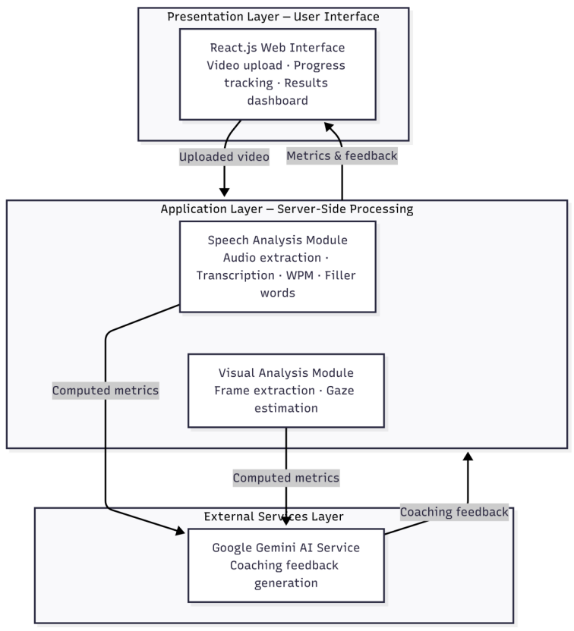
Figure 3.1: Three-Tier Architecture of the AI Public Speaking Coach System
The first layer is the Presentation Layer, or user interface. This is the user-facing component, built with React.js, and it is responsible for handling video uploads, displaying real-time processing progress, and rendering the final coaching report; no heavy computation takes place at this layer. The second layer is the Application Layer, which carries out the server-side processing. This layer performs all core processing work, including video handling, speech transcription, delivery metric computation, eye contact analysis, and data preparation for the AI service, and it acts as the bridge between what the user sees and the external AI service. The third layer is the External Services Layer, which contains the Google Gemini AI service; this service receives only the computed performance metrics from the server and returns structured, natural language coaching feedback.
This architecture ensures that all computationally expensive processing occurs on the server, maintaining interface responsiveness and enforcing a clear security boundary between user-facing components and sensitive processing logic.

3.4.2 Use Case Diagram
The primary actor in the system is the User. The main use case is Perform Speech Analysis, which encompasses the following sub-use cases: uploading a video, processing the audio and visual data, generating AI feedback, and viewing the results. These relationships are represented using standard Unified Modeling Language (UML) notation, in which the actor is placed outside the system boundary, each use case is shown as an ellipse within the boundary, and the sub-use cases are linked to the main use case through include relationships.
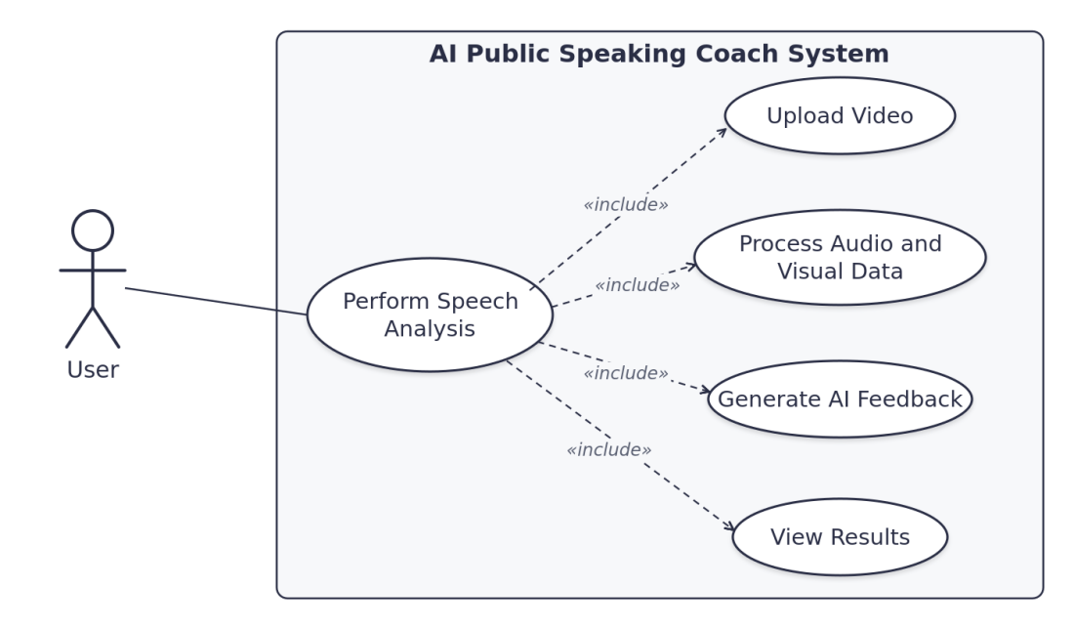
Figure 3.2: Use Case Diagram of the AI Public Speaking Coach System

3.4.3 Data Flow Diagram
Data originates from the user’s uploaded video and flows through the server-side processing pipeline. Speech and visual analyses are performed in parallel before their outputs are aggregated and forwarded to the AI language model for feedback generation. The final results, comprising metrics and coaching commentary, are returned to the user interface for display.
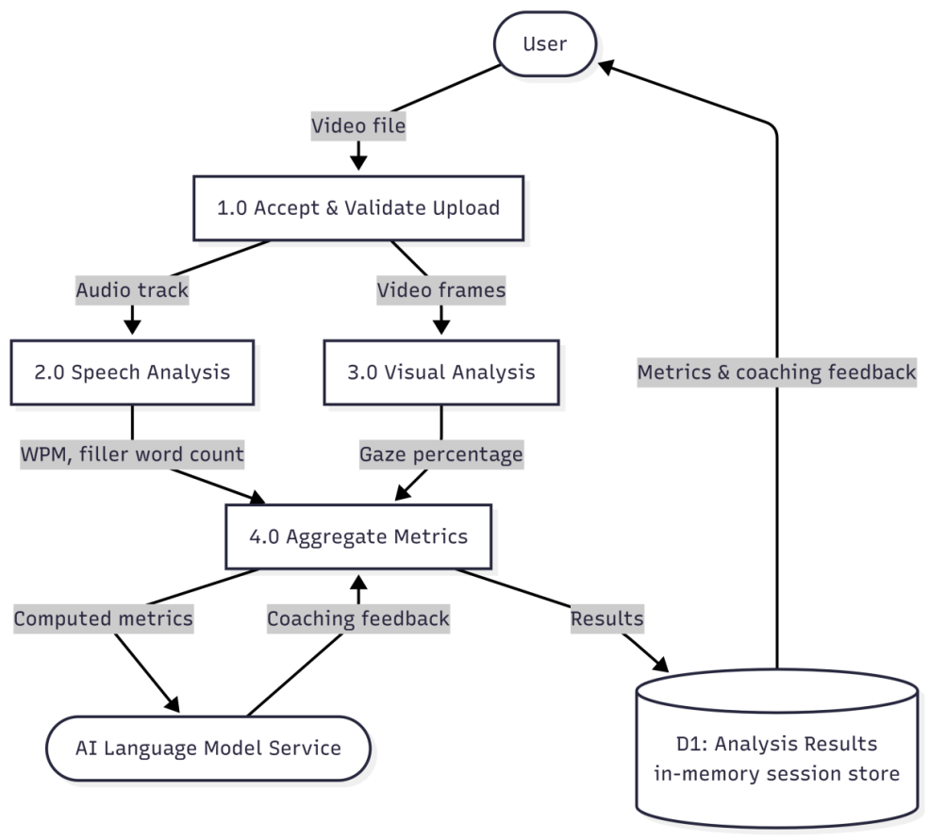
Figure 3.3: Level 1 Data Flow Diagram of the AI Public Speaking Coach System

3.4.4 Entity-Relationship Design
The key entities in the system include the Analysis Session, Video File, Speech Metrics, Visual Metrics, and Feedback. In the current implementation, data is processed entirely in memory and is not persistently stored. Persistent database storage is identified as a priority recommendation for future enhancement.
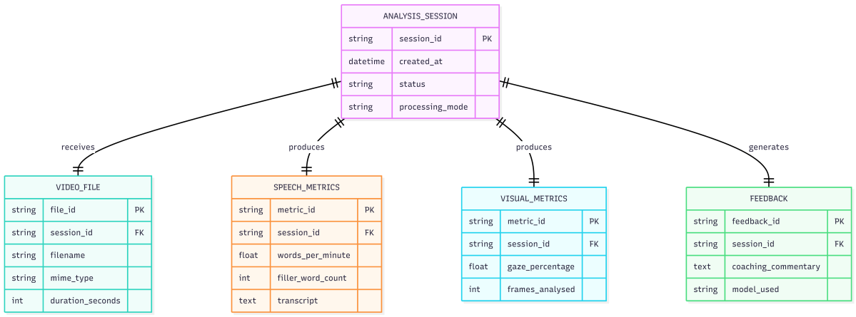
Figure 3.4: Entity-Relationship Diagram of the AI Public Speaking Coach System

3.4.5 Decision Logic
Several decision points govern the behaviour of the system. During file validation, uploaded files are checked against a list of supported file types, and unsupported formats are rejected immediately with a descriptive error message. During gaze estimation, individual video frames are classified as camera-facing or non-camera-facing based on a defined head orientation threshold. For AI failure handling, if the AI language model service is unavailable or returns an error, the system returns the computed metrics to the user with an appropriate notification, ensuring that partial results are never lost.

3.4.6 Security Design
Security was addressed through several complementary measures. Server-side file type validation is performed independently of any checks carried out in the user interface, and sensitive API keys are managed through environment variables so that they are never transmitted to the client. Access control policies restrict which origins are permitted to communicate with the server. Uploaded files are stored only temporarily and are automatically removed after processing is complete. In addition, input sanitisation is applied to prevent injection attacks and path traversal vulnerabilities.

3.5 Chapter Summary
This chapter provided a comprehensive analysis and design of the AI Public Speaking Coach System using the Iterative and Incremental development model. The requirement engineering process and the detailed system design covering architecture, use cases, data flow, entity relationships, decision logic, and security considerations established a solid foundation for implementation. The following chapter discusses the actual implementation, the technologies used, testing procedures, and system evaluation.

CHAPTER FOUR
SYSTEM IMPLEMENTATION

4.1 Introduction
This chapter presents the implementation, testing, and evaluation of the AI Public Speaking Coach System. It describes the technologies employed in building the system, the testing procedures conducted to verify functionality, and the feedback received from stakeholders following demonstration of the working system.

4.2 Technologies Used
The implementation of the AI Public Speaking Coach required the integration of several software technologies and development tools. Each tool was selected based on its suitability for the required functionality and compatibility with the overall system architecture.
The frontend of the system was developed using React.js, a JavaScript library for building interactive user interfaces. React provides a component-based architecture that simplifies interface development and enables dynamic updating of analysis results without requiring page reloads.
The backend was implemented using FastAPI, a modern Python web framework designed for high-performance API development. FastAPI manages user requests, coordinates system operations, and communicates with both the frontend and the AI processing service.
Python 3.11 was selected as the primary programming language because of its extensive ecosystem of libraries for artificial intelligence, machine learning, and computer vision applications.
Speech transcription was implemented using Faster-Whisper, which converts extracted audio into text efficiently while maintaining high transcription accuracy.
The system uses FFmpeg to extract audio tracks from uploaded video files before transcription. FFmpeg provides reliable multimedia processing capabilities across different video formats.
Visual analysis was implemented using MediaPipe, a computer vision framework developed for facial landmark detection and tracking. MediaPipe enables the estimation of camera-facing gaze and eye contact during speech delivery.
OpenCV was incorporated for video frame processing and manipulation before facial landmark analysis.
The AI feedback module was implemented using the Google Gemini API through the Google GenAI Python SDK. This component receives speech metrics and generates personalised recommendations for improving speaking performance.
Communication between the frontend, backend, and AI engine was achieved through RESTful APIs using HTTP requests and JSON data exchange.
Version control for the project was managed using Git and GitHub, enabling effective source code management and collaborative development.
The development and testing process was carried out using Visual Studio Code as the integrated development environment, due to its extensive support for Python and JavaScript, its debugging capabilities, and its rich extension ecosystem.

4.2.1 User Interface
The user interface of the AI Public Speaking Coach was designed to provide a simple and intuitive interaction experience. The interface enables users to upload presentation videos, monitor analysis progress, and review the generated feedback in an organised manner.
The homepage provides an upload section where users can select and submit a video file for analysis. Once processing is completed, the system presents the results through an interactive dashboard.
The dashboard displays important speaking metrics, including speech duration, words per minute, filler word count, eye contact percentage, and overall performance score. In addition, the system presents AI-generated recommendations intended to help users improve their public speaking abilities.
The interface was developed using React.js to provide dynamic content updates and responsive interaction without requiring page refreshes. The layout follows basic Human-Computer Interaction principles by organising related information into separate sections to improve readability and reduce information overload.
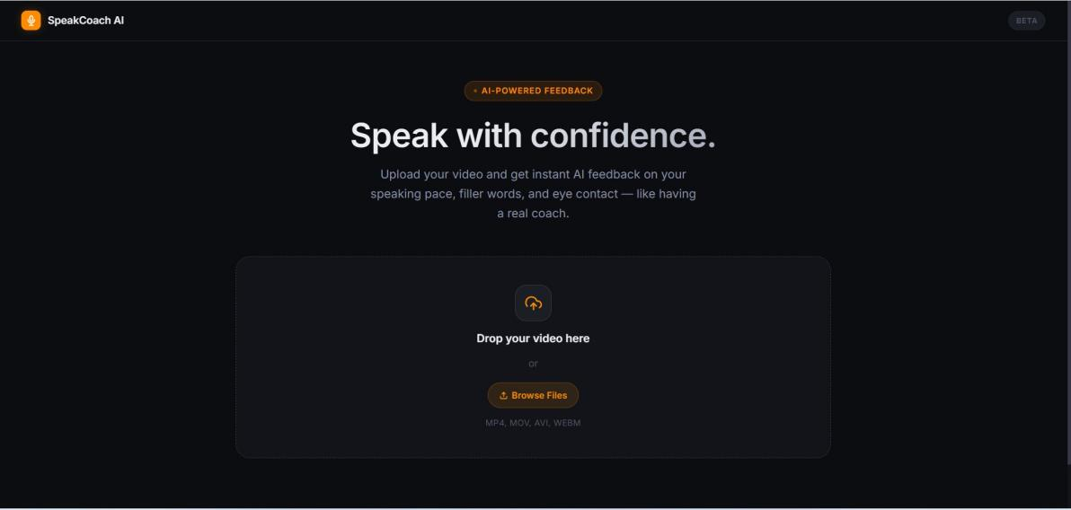
Figure 4.1: Home Page of the AI Public Speaking Coach
The figure above shows the main page, where users upload presentation videos for analysis. The page presents a clear call to action, an upload area that supports both drag-and-drop and file selection, and a concise description of the feedback the system provides on speaking pace, filler words, and eye contact.
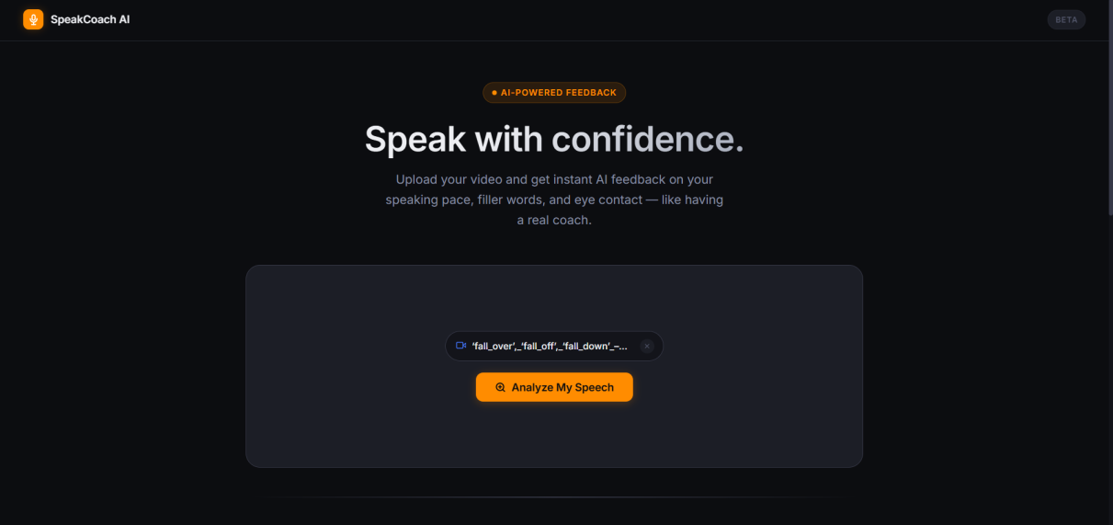
Figure 4.2: Video Upload Interface
The figure illustrates the process of selecting and uploading a video file.
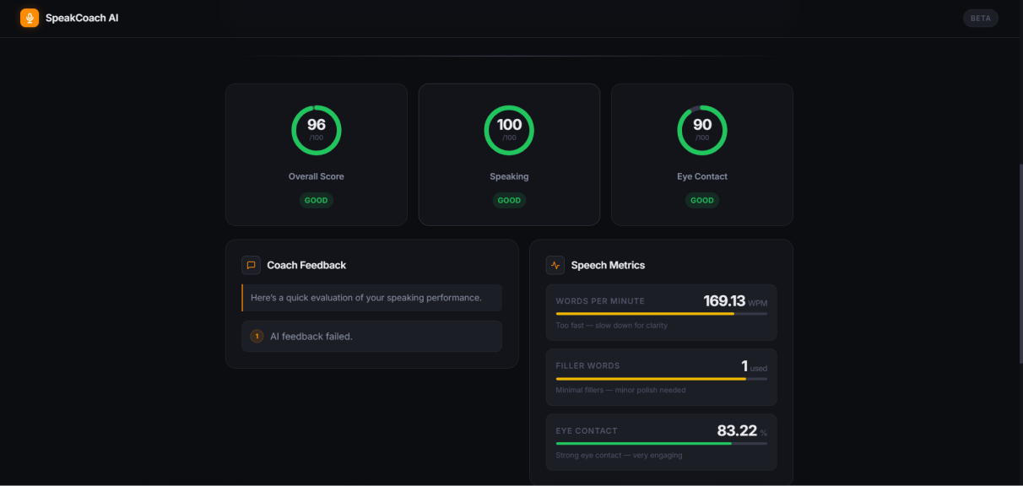
Figure 4.3: Analysis Dashboard
The dashboard presents speech metrics, gaze analysis, and AI-generated recommendations after processing is completed.
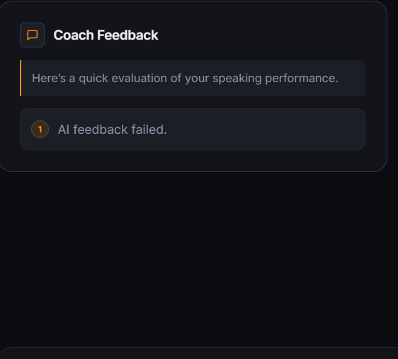
Figure 4.4: AI Feedback Display
The figure shows the personalised feedback generated by the AI module based on the user’s speaking performance.

4.2.2 Server-Side Processing
All core processing logic was implemented using FastAPI with Python 3.11. FastAPI was selected because it handles time-intensive tasks such as video processing and external AI communication efficiently through asynchronous processing, without degrading overall system responsiveness. This design ensures that the interface remains usable even while intensive analysis is taking place on the server.

4.2.3 Speech and Audio Analysis
Speech and audio analysis relied on two complementary tools. Faster-Whisper, an optimised implementation of OpenAI’s Whisper ASR model, was used for accurate and efficient speech-to-text transcription across a variety of accents and recording conditions. FFmpeg, a widely used media processing tool, was employed to extract the audio track from uploaded video files prior to transcription.

4.2.4 Eye Contact Analysis
MediaPipe and OpenCV were integrated to process video frames and compute the percentage of time the speaker maintained camera-facing eye contact. MediaPipe’s Face Mesh module provides facial landmark detection, identifying 468 points on the face, while OpenCV handles frame-level video processing. Together, they allow the system to estimate whether the speaker was looking toward the camera at any given moment in the video.

4.2.5 AI Coaching Feedback
The Google Gemini API was integrated as the AI language model service for generating natural language coaching feedback. Crucially, the AI model receives only the computed performance metrics, namely speaking speed, filler word count, and eye contact percentage, rather than the original video. This design ensures that all feedback is accurate, grounded, and directly tied to the user’s measured performance, eliminating the risk of the AI generating unsupported or speculative commentary.

4.2.6 Supporting Tools
Additional supporting tools include python-dotenv, used for secure management of API keys and environment variables, and CORS middleware, configured to control and restrict access to the server-side API so that only authorised sources can communicate with the system.

4.3 System Testing
The system underwent thorough testing to verify that all modules function correctly both in isolation and as part of the complete integrated system. Sixteen test cases were designed and executed, covering normal operations, error conditions, and edge cases. A representative selection of these test cases is presented in Table 4.1 below.
Table 4.1: Summary of System Test Cases
Test ID | Function | Test Description | Expected Result | Actual Result | Status
TC-01 | Valid Video Upload | Upload a valid .mp4 video | File accepted and processing starts | Successful | Pass
TC-02 | Invalid File Type | Upload unsupported file (e.g., PDF) | File rejected with clear error | Error displayed correctly | Pass
TC-04 | Audio Extraction | Extract audio from video | Clean audio file produced | Successful | Pass
TC-05 | Speech Transcription | Convert audio to text | Accurate transcript generated | Accurate | Pass
TC-06 | WPM Calculation | Calculate Words Per Minute | Correct WPM value returned | Correct | Pass
TC-07 | Filler Word Detection | Count filler words | Accurate count returned | Accurate | Pass
TC-09 | High Eye Contact | Video with good camera-facing gaze | High gaze percentage returned | 87% returned | Pass
TC-10 | Low Eye Contact | Video with poor camera-facing gaze | Low gaze percentage returned | 31% returned | Pass
TC-12 | AI Feedback Generation | Send metrics to AI service | Structured coaching feedback received | Successful | Pass
TC-14 | Full Pipeline | Complete end-to-end processing | All results displayed on dashboard | Fully successful | Pass
All executed test cases passed successfully. This outcome confirms that the system is stable, reliable, and meets its defined functional requirements.

4.4 System Evaluation
The completed system was demonstrated to various stakeholder groups to assess its usability, practical usefulness, and overall quality. The evaluation method and feedback received from each group are summarised in Table 4.2 below.
Table 4.2: Stakeholder Feedback Summary
Stakeholder Group | Evaluation Method | Key Feedback | Action Taken
Student Users | Questionnaire and Walkthrough | Interface easy to use; requested clearer labels | Added explanatory tooltips
Communication Skills Instructor | Interview and Demonstration | Metrics are relevant; suggested benchmarks | Added benchmark ranges
Technical Reviewer | Code Review and Demonstration | Good architecture; noted latency for long videos | Documented for future work
Project Supervisor | Demonstration and Document Review | System meets stated objectives | Minor improvements implemented
The overall feedback received was highly positive. Stakeholders across all groups confirmed that the system is user-friendly and delivers practical value for the improvement of public speaking skills.

4.5 Chapter Summary
This chapter has presented the successful implementation of the AI Public Speaking Coach System. Modern technologies were effectively integrated across the user interface, server-side processing, and AI service layers. Comprehensive testing was conducted with excellent results, and stakeholder evaluation confirmed the system’s usability and relevance to its intended audience. The following chapter provides the summary, conclusion, and recommendations for further development.

CHAPTER FIVE
SUMMARY, CONCLUSION AND RECOMMENDATIONS

5.1 Introduction
This chapter summarises the entire project, draws conclusions from the work carried out, and provides recommendations for future improvement. It brings together the key points from all preceding chapters and reflects on the extent to which the project’s stated aim and objectives were achieved.

5.2 Summary
The AI Public Speaking Coach System was developed to address the problem of limited access to structured, expert feedback on public speaking performance. While individual tools exist for speech transcription, eye contact analysis, and AI-generated commentary, no unified, browser-based system had previously integrated these capabilities into a single, accessible workflow.
Chapter One introduced the background of the study, highlighted the challenges that students and professionals in Nigeria face in developing public speaking skills, stated the research problem, defined the aim and specific objectives, and outlined the scope and limitations of the project.
Chapter Two reviewed relevant literature on automated speech recognition, computer vision for gaze estimation, AI language model integration for feedback generation, and modern web application architectures. The review identified major gaps in integration, AI feedback grounding, and accessibility, all of which this project was designed to address.
Chapter Three presented the system analysis and design. The Iterative and Incremental development model was adopted, detailed functional and non-functional requirements were specified, and the system was designed using a three-tier architecture supported by use case diagrams, data flow diagrams, entity relationship design, and comprehensive security measures.
Chapter Four covered the implementation, testing, and evaluation of the system. Modern technologies including React.js, FastAPI, Faster-Whisper, MediaPipe, OpenCV, and the Google Gemini API were successfully integrated. Sixteen test cases were executed with uniformly successful results, and feedback from students, instructors, and technical reviewers confirmed the system’s usability and practical effectiveness.

5.3 Conclusion
The AI Public Speaking Coach System has been successfully designed, implemented, tested, and evaluated. The project fully achieved its main aim and all five specific objectives. The system enables users to upload a pre-recorded speech video through a standard web browser and receive comprehensive, automated feedback covering speaking speed (Words Per Minute), filler word usage, eye contact percentage, and actionable AI-generated coaching advice.
This project demonstrates the effective integration of multiple advanced technologies, namely speech recognition, computer vision, and generative AI, within a single, accessible web application. By grounding AI feedback strictly in locally computed metrics, the system provides reliable and trustworthy coaching while substantially reducing the risk of AI hallucination.
The successful development of this system shows that powerful, practical tools for skill development can be built using open-source and widely available technologies. The resulting solution is scalable and has the potential to benefit students, professionals, and educational institutions, particularly in resource-constrained environments such as many Nigerian tertiary institutions.

5.4 Recommendations
Several recommendations are proposed for the future enhancement of the system:
- Background processing: an asynchronous task queue, such as Celery with Redis, should be integrated to manage longer video files efficiently and eliminate extended loading times for the user.
- User accounts and performance history: user authentication and a persistent database, such as PostgreSQL, should be added so that users can save their analysis sessions and monitor improvement in their public speaking skills over time.
- Expanded visual analysis: the computer vision module should be extended to include gesture, posture, and body language analysis, providing a more comprehensive evaluation of non-verbal delivery cues.
- Mobile application: a dedicated mobile application should be developed to allow users to record and analyse speeches directly from their smartphones, increasing overall accessibility.
- Multiple coaching personas: the system should support different feedback styles, such as an academic presentation coach, a professional confidence coach, or a technical delivery coach, to provide more personalised and context-relevant guidance.
- Cloud deployment: the system should be deployed using container technology on a cloud platform to support multiple concurrent users and facilitate easier adoption by educational institutions.

5.5 Chapter Summary
This chapter provided a concise summary of the entire project, concluded that the stated aim and all specific objectives were fully achieved, and offered practical recommendations for future development. The AI Public Speaking Coach System stands as a functional, innovative, and accessible solution to an important and widespread real-world problem.

References
Chen, L., et al. (2016). Automated public speaking assessment: Audio feature extraction, pacing analysis, and fluency evaluation. Journal of Speech and Language Processing, 12(4), 44–67.
Fowler, M. (2014). Patterns of enterprise application architecture. Addison-Wesley Professional.
Lugaresi, C., et al. (2019). MediaPipe: A framework for building perception pipelines. arXiv preprint arXiv:1906.08172.
Radford, A., Kim, J. W., Xu, T., Brockman, G., McLeavey, C., & Sutskever, I. (2022). Robust speech recognition via large-scale weak supervision. arXiv preprint arXiv:2212.04356.
Zhao, W. X., et al. (2023). A survey of large language models. arXiv preprint arXiv:2303.18223.

Appendices
Appendix A: Project Source Code Repository
The complete source code for the AI Public Speaking Coach System, including the React.js frontend and the FastAPI backend, is version-controlled and hosted publicly on GitHub. The repository can be accessed through the link below:
GitHub Repository: [insert your GitHub repository link here]
The repository contains the full project structure, setup and installation instructions, and the source files for all system modules.
Appendix B: System Deployment and Live Demonstration
A deployed, working version of the system is available for demonstration and testing. The live application can be accessed through a standard web browser at the link below:
Live Deployment: [insert your live deployment link here]
Users may visit the link above to upload a pre-recorded speech video and receive automated coaching feedback without installing any additional software.

