

**Project Subject:**

**PROJECT TRACKER**

**Group Members:**

1. **AMANY MOHAMMAD ALOMARY 134896**
2. **DU’A OMAR ABDO AL SAMARAH 127181**
3. **DINA MOHAMMAD ISMAIL ALOMARY 126861**
4. **ESLAM ZAID SULEIMAN ALSHQEIRAT 133034**
5. **SHATHA HOSSAM ISSA MUSTAFA 133844**
6. **REHAM ABEDALLAH MOHAMMAD AL KHATEEB 127138**

**7- WALA’A ABDULLAH MOHAMMAD ALYAQOUB 125638**

Dr. Ahmad AL-jarrah

*ROLES:

**Leader:** SHATHA HOSSAM ISSA MUSTAFA

**Analyzer**:REHAM ABEDALLAH, DINA MOHAMMAD, WALA’A ABDULLAH, AMANY MOHAMMAD

**Time Keeper:** ESLAM ZAID,DU’A OMAR

**PRESENTER:** REHAM ABEDALLAH, DINA MOHAMMAD, WALA’A ABDULLAH.

PHASE #1:

**Amany:** problem description

**Du'a:** problem description

**Dina:** project plan

**Eslam :** project plan

**Shatha:** Requirements

**Reham:** project plan

**Wala'a:** problem description

PHASE #2:

**Sub-Group 1**: Shatha, Eslam (Software Architecture, Class Diagram).

**Sub-Group2:** Amany, Dina (Sequence Diagram)

**Sub-Group3:** Wala’a, Doa`a (ER Diagram)

**Sub_Group4:** Reham (Use Case Diagram)

PHASE #3:

**Eslam, Shatha:** User Interface

**Amany, Dina:** Data base

**Wala'a, Du'a:** User Interface and Final Report

**Reham:** User Interface and Final Report

**Abstract of phase (1):**

Project Tracker is a web application that allows the instructor to track the work of a group of students on a specific project at the same time students can use the system to manage their work and with the instructor.

The goals of the web App:

1-Facilitates the process of communication between students and their teacher and between them as team members.

2-It helps in completing the task in a timely manner.

3-Saving time and effort and facilitating the educational process without the need for constant movement and the great effort expended.

4-Raising the level of productivity of students and providing them with the necessary competencies for time development, which leads to the development of personal and educational skills.

**Explain:**

Suppose we have a number of students that will be divided into groups, the teacher has the ability to assign each student to a specific team and give them a specific role and assign tasks, time and achievements. Students in the same team can communicate together by sending a message that appears to all team members and also communicate with the teacher.

Where both the student and the teacher will create their own account and enter the required information to finish building a special email for each of them to be able to log in to the site.

Where educational materials are broadcast of all kinds using available digital tools, such as computers, tablets and mobile phones via the Internet.

**In phase(2) it included:**

1. **Software Architecture**

We choose “3-Tier Layer “architecture style, this architecture suitable for programs that have a composite structure and divided to subtasks into layer and Each layer provides services to the next higher layer. Also, this architecture is the simplest one, and is the best way to learn about architecture.

*Why Layered Architecture?*

Layered Architecture allows you to think in concerns. It provides the tools, and makes us think more about creating cleaner and more decoupled code. When you work on a layer, you can forget about the layer above it. We only need to think about the current layer, and the ones under it. This frees up brain power.

You can also easily use a layer with multiple different higher-level layers. You could create an API Presentation or a Web Presentation completely separate from each other and using the same Application layer. This because you decoupled your application and domain code from the presentation.

The first layer is a presentation layer that show to us user interface that the user can interact with it, second layer is the application layer is what holds everything together. It coordinates the objects and services of your application. Application services represents how the application is driven.

Third level is data base layer is where the information proceeded by the application is stored and managed.

There is other architecture style that our software can be related to like

“microservices” because it is best for web applications and websites and it is also useful for corporate data centers that have well-defined boundaries. Also, it is easier to rewrite and update.

 We use “Edrawmax” to implement our project using the layered architecture:

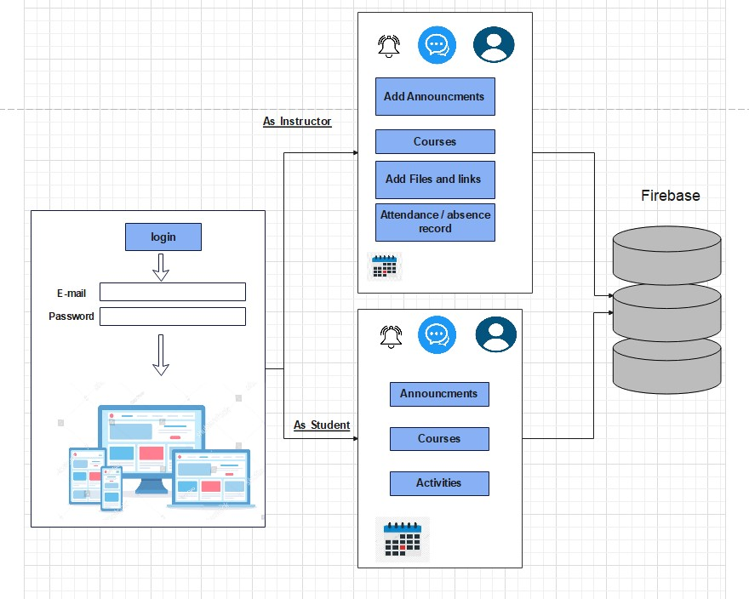

# Project Management System ER Diagram

**Step 1**: In the Project Tracker System we have the following entities

 App

 Project

 Project Category

 Project Member Assignment

* Project Member
* Project Manager
* Project Updates

**Step 2**: After we have specified our entities, it is time now to connect or establish a relationship among the entities.

app has 1 or more projects to be managed (1 to many relationship). the project belongs to a specific type or category (1 to 1 relationship).



the project can be managed by multiple project managers, it depends of the scope of the project, but to be more flexible the relationship will be set to (1 to many relationship).

 The project will be assigned to several members (1 to many relationship).

 The project member can be assigned to several tasks (1 to many relationship).

* The project member posts an update (1 to many relationship).
* The project will receive an update (1 to many relationship).

**Step 3**: The last part of the ERD process is to add attributes to our entities.

* **App Entity has the following attributes:**

 Name

 Logo

 Information

 Website

 Contact information

 Username

 Password

* **Project Entity has the following attributes:**

 Project ID – primary key represented with underline

 Category ID – foreign key

 Manager ID – foreign key

 Name

 Description

 Code

 Banner

 Start Date

* End Date
* Remarks

* **Project Category Entity has the following attributes:**

 Category ID – primary key represented with underline

* Name
* Description
* **Project Member Assignment Entity has the following attributes:**

Project Details ID – primary key represented with underline

Project ID – foreign key

Project Member ID – foreign key

* **Project Member Entity has the following attributes:**

 Project Member ID – primary key represented with underline

 Code

 Name

 Contact

 Email

 Username

* Password
* Status
* **Project Manager Entity has the following attributes:**

 Project Manager ID – primary key represented with underline

 Code

 Name

 Email

 Contact

 Username

* Password
* Status
* **Project Update Entity has the following attributes:**

 Update ID – primary key represented with underline

 Code

 Date of Update

 Description of Update

 Project ID

 Member ID

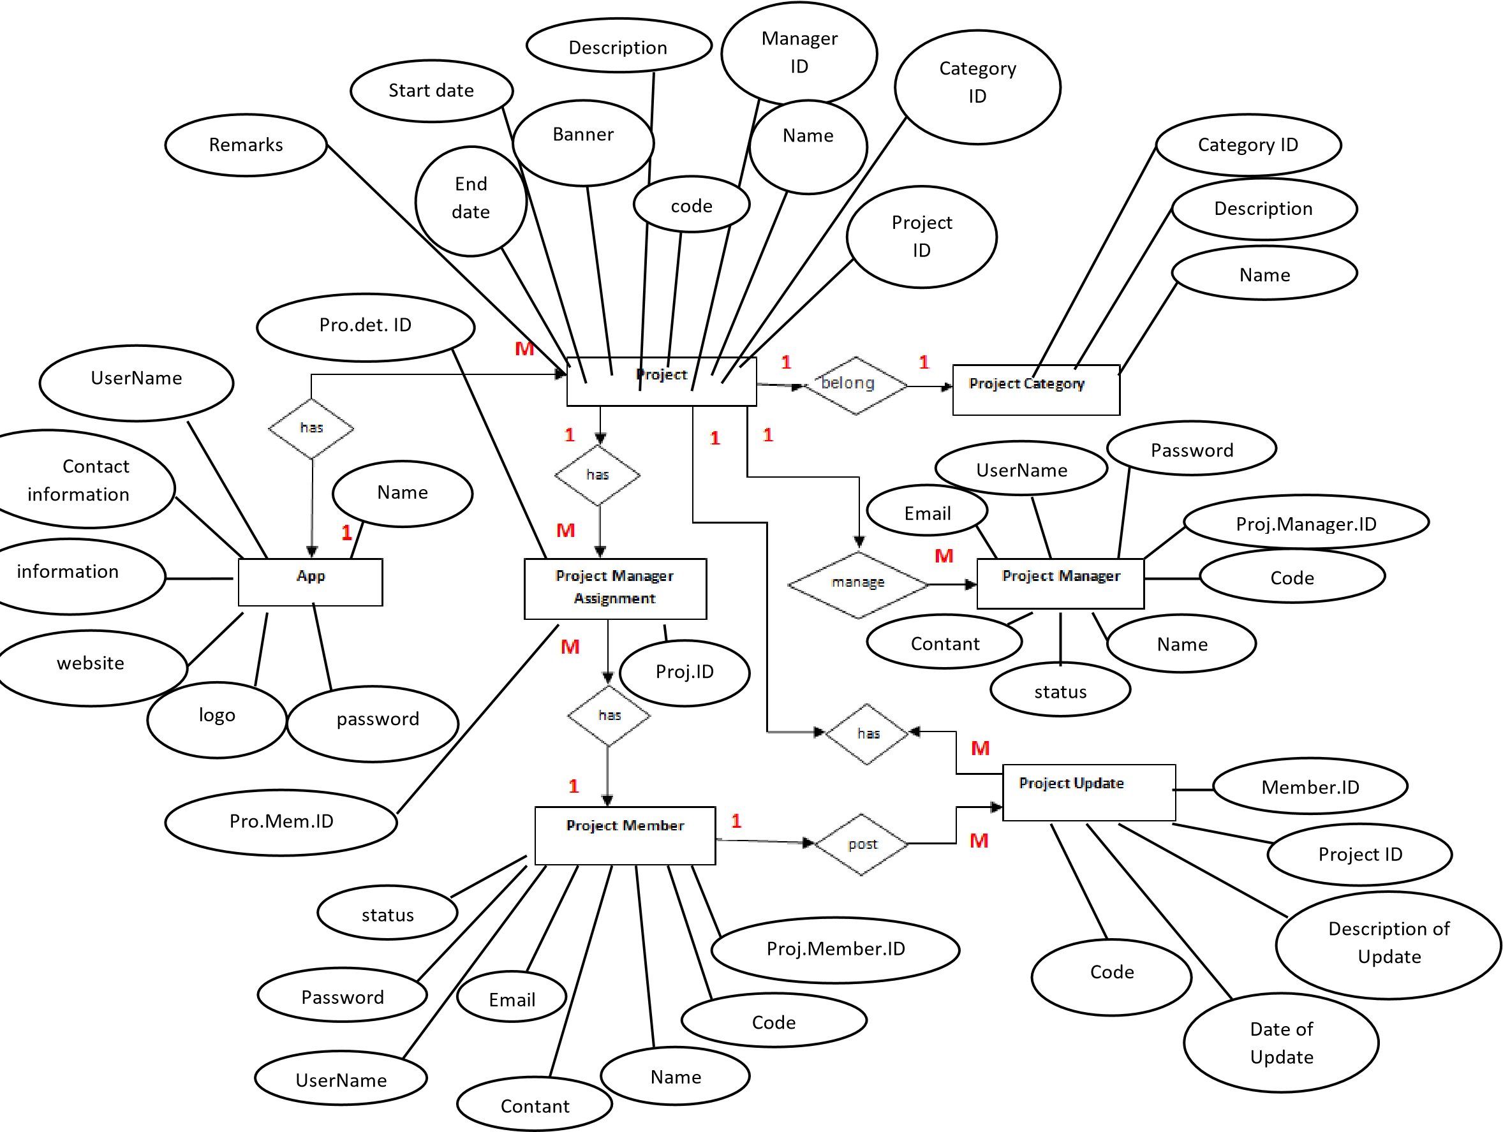

**Description**

project Tracker is a system that allows an instructor to keep track of a group of students' progress on a certain project. Students can utilize the system to organize their work and communicate with the instructor at the same time. Assume we have a class with enough pupils to be divided into two or more groups. As a result, the instructor can allocate each student to a certain team and assign each member a specific responsibility. Furthermore, the instructor can create a project that includes all of the necessary specifications and properties, such as tasks, time, and deliverables. Students in the same team can communicate by sending a message that appears on the screens of all team members. They have the ability to communicate with the instructor as well. Whenever you want Students can change the status of a task at any moment, such as starting later, working on, finishing on time, finishing with a delay, and so on, and the teacher can examine the task and provide comments to students. There is a title, description, estimated progress, start date, end due date, actual end date, or any other proposed properties for the work. One or more students can be assigned to the work. Members of the group or the instructor can leave a comment on the task, to which others can respond.

**5) The UML of system:**

* Use Case Diagram of our project:

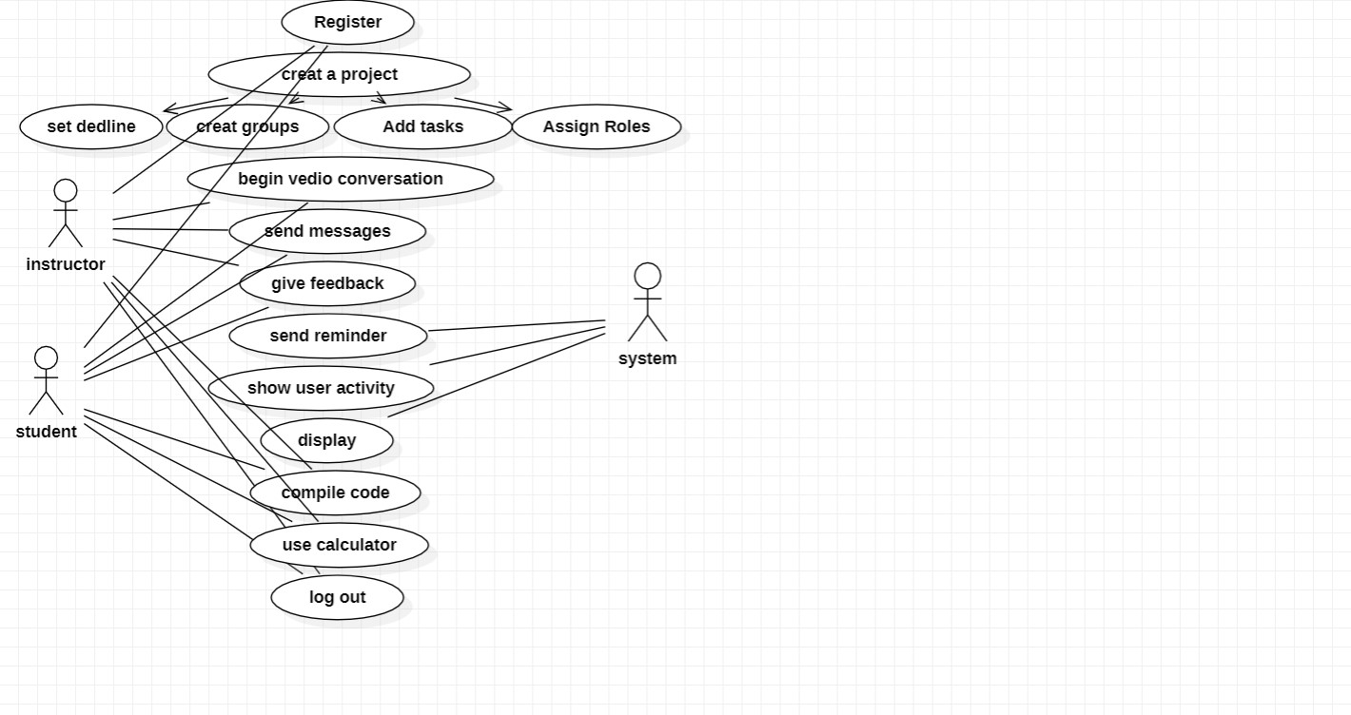

* Class Diagram of our project:

In class diagram we add all details about our project.

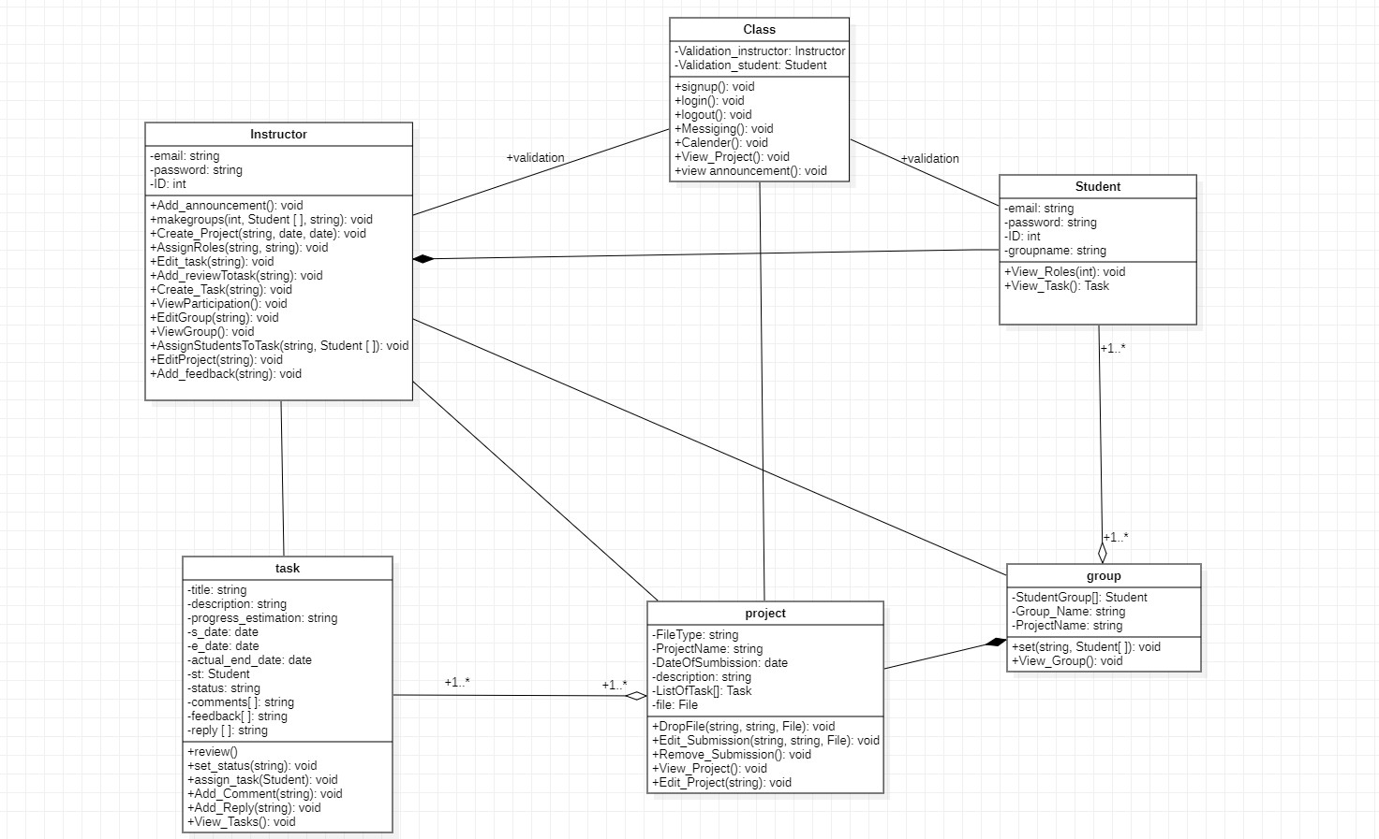

* Sequence Diagram of our project:

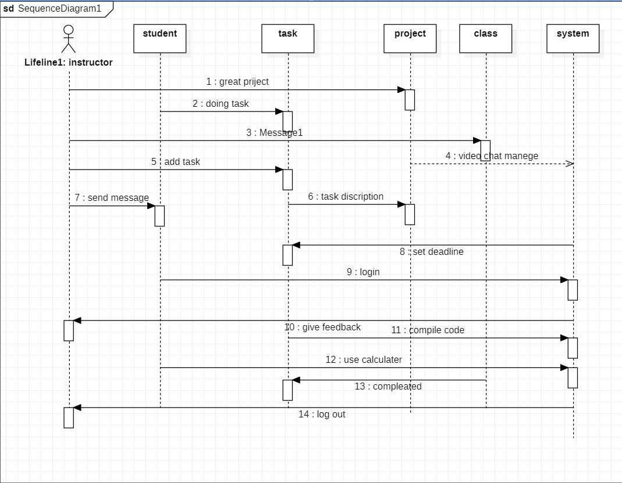

**In phase (3) it included:**

1. **User Interface:**

The user interface (UI): - is the point at which human users interact with a computer, website or application. The goal of effective UI is to make the user's experience easy and intuitive, requiring minimum effort on the user's part to receive maximum desired outcome.

* Why Is user interface important?

User interface is important to meet user expectations and support the effective functionality of your site

* Interface elements include:

* Input Controls: checkboxes, radio buttons, dropdown lists, list boxes, buttons, toggles, text fields, date field
* Navigational Components: breadcrumb, slider, search field, pagination, slider, tags, icons
* Informational Components: tooltips, icons, progress bar, notifications, message boxes, modal window
* Languages used:
* Html
* CSS
* Bootstrap
* JavaScript
* JQuery
* SQL for data base

**-Web pages included in the user interface:**

1. **Sign Up Page:**

#### It is the page through which the user can enter the site for the first time so that he enters the required information. (ex: Email, Password and Repeat Password).

1. **Login Page**

#### It is the page through which the user can login to his account that he created previously.

1. **Class**

#### It is a page through which the student can see the tasks that he must do and deliver, and the upcoming activities, activities and announcement, in addition to the fact that the instructor can add projects, activity and announcements.

#### This page contains the projects with start date ,end date and description.

1. **Grade**

#### It is a page through which the student can see his marks and the instructor can enter the marks of the students and modify them.

1. **Group**

#### It is a page in which the names of the groups divided by the instructor and information about them appear, in addition to the fact that he can add a new group .

**6) Feedback**

#### It is an interactive page in which the instructor places an assessment and comment regarding the work submitted by the students, and the student can view it.

**7) Dashboard**

**Main page that shows to students and instructors that have a time aline and the user can move to the class.**

1. **Team**

#### Instructor can see the work of each group and the progress, status in their work, and each group show in this page team member, Task and enter the status of their work

1. **Task**

#### These are the tasks that members perform to complete the project.

1. **status**

**Student can set the status of a task as to start later on, working on, finished on time, finished on delay.**

1. **Recourse**

## It helps students in their project and the student can see it and the instructor can add more than one resource.

**The Resources:**

* [**https://l.facebook.com/l.php?u=https%3A%2F%2Fwww.w3schools.com%2F%3Ffbclid%3DIwAR0PTl4dyjp-jMHudCJ83arQ2Cxl8wR1jj98q8tWCoWXLAns_ZjK58m2gUg&h=AT3O1vUWfla19RDGcDLsvWtwIIk-cZ_o9bWKdISvSIZ-aCEDsWEevXWE9qdvhDAz1Cmfjvz76ieNHj7egb4ITC1SLjf5IQTLy_Zfb1UwRTMkbsyuYSsjf7KosjY2XiC8PGQXV6dmCIe2PlI**](https://l.facebook.com/l.php?u=https%3A%2F%2Fwww.w3schools.com%2F%3Ffbclid%3DIwAR0PTl4dyjp-jMHudCJ83arQ2Cxl8wR1jj98q8tWCoWXLAns_ZjK58m2gUg&h=AT3O1vUWfla19RDGcDLsvWtwIIk-cZ_o9bWKdISvSIZ-aCEDsWEevXWE9qdvhDAz1Cmfjvz76ieNHj7egb4ITC1SLjf5IQTLy_Zfb1UwRTMkbsyuYSsjf7KosjY2XiC8PGQXV6dmCIe2PlI)
* [**https://l.facebook.com/l.php?u=https%3A%2F%2Fcolorhunt.co%2F%3Ffbclid%3DIwAR3UPTEtX8VZVdDPheXsy2so7YNJe6c-kZc8Muzq_1V1Xy3ZXtZE4TzthvM&h=AT3OVhH4AAuOnXs4e6h16P-LXFnhUCegYaM4mPgy7Lecti7j1LsO7BZYHVs-n4Fok71otD60S4lnc08JG1FicrGYBCVEguF9GDzsYyYDymQCTNip7esc9nb7EFfc4mcfg8EEfiCq8l9SqcM**](https://l.facebook.com/l.php?u=https%3A%2F%2Fcolorhunt.co%2F%3Ffbclid%3DIwAR3UPTEtX8VZVdDPheXsy2so7YNJe6c-kZc8Muzq_1V1Xy3ZXtZE4TzthvM&h=AT3OVhH4AAuOnXs4e6h16P-LXFnhUCegYaM4mPgy7Lecti7j1LsO7BZYHVs-n4Fok71otD60S4lnc08JG1FicrGYBCVEguF9GDzsYyYDymQCTNip7esc9nb7EFfc4mcfg8EEfiCq8l9SqcM)
* [**https://l.facebook.com/l.php?u=https%3A%2F%2Fcolorhunt.co%2F%3Ffbclid%3DIwAR3UPTEtX8VZVdDPheXsy2so7YNJe6c-kZc8Muzq_1V1Xy3ZXtZE4TzthvM&h=AT3OVhH4AAuOnXs4e6h16P-LXFnhUCegYaM4mPgy7Lecti7j1LsO7BZYHVs-n4Fok71otD60S4lnc08JG1FicrGYBCVEguF9GDzsYyYDymQCTNip7esc9nb7EFfc4mcfg8EEfiCq8l9SqcM**](https://l.facebook.com/l.php?u=https%3A%2F%2Fcolorhunt.co%2F%3Ffbclid%3DIwAR3UPTEtX8VZVdDPheXsy2so7YNJe6c-kZc8Muzq_1V1Xy3ZXtZE4TzthvM&h=AT3OVhH4AAuOnXs4e6h16P-LXFnhUCegYaM4mPgy7Lecti7j1LsO7BZYHVs-n4Fok71otD60S4lnc08JG1FicrGYBCVEguF9GDzsYyYDymQCTNip7esc9nb7EFfc4mcfg8EEfiCq8l9SqcM)
* [**https://l.facebook.com/l.php?u=https%3A%2F%2Fgetbootstrap.com%2F%3Ffbclid%3DIwAR2_9m-uTCTF_sz0KajukdkBRSZTe7CVcMtVKqalEOeJaphZGb1LxBUGw4k&h=AT1IfeMadB80GPGa0UPvAU9hYh_ynPJAbKflvOdP-0neqbqHRLAVphgvkrAAWTMGrSCNkU8EgVtnIg7ahgMjrDPKupzwwP5d1EFc4_9TB0Z3E7F592Ajlwn3WZrtV7QYeNjeIfVUGuq0v8k**](https://l.facebook.com/l.php?u=https%3A%2F%2Fgetbootstrap.com%2F%3Ffbclid%3DIwAR2_9m-uTCTF_sz0KajukdkBRSZTe7CVcMtVKqalEOeJaphZGb1LxBUGw4k&h=AT1IfeMadB80GPGa0UPvAU9hYh_ynPJAbKflvOdP-0neqbqHRLAVphgvkrAAWTMGrSCNkU8EgVtnIg7ahgMjrDPKupzwwP5d1EFc4_9TB0Z3E7F592Ajlwn3WZrtV7QYeNjeIfVUGuq0v8k)
* [**https://l.facebook.com/l.php?u=https%3A%2F%2Fwww.udemy.com%2Fcourse%2Fthe-complete-web-development-bootcamp%2Flearn%2Flecture%2F12385728%3Fstart%3D480%26fbclid%3DIwAR2sjHPhVn7K5HLuhYRyvH_ca8v2EXjNHu9Q6aWijrVY8zsb9HCNXAsvhTQ%23overview&h=AT1-_tmAq2vTWQZvzddQFmf2NsZOylV7RryPqF_MTs1gAsGMJYTnUYEpFS2G61B-iMgx9GB2BUkGkBjazOJnk21L8XFsoZtitD6kirGAtWmeGdiOpZ66ca_pCA4fOZVjRVp_9w**](https://l.facebook.com/l.php?u=https%3A%2F%2Fwww.udemy.com%2Fcourse%2Fthe-complete-web-development-bootcamp%2Flearn%2Flecture%2F12385728%3Fstart%3D480%26fbclid%3DIwAR2sjHPhVn7K5HLuhYRyvH_ca8v2EXjNHu9Q6aWijrVY8zsb9HCNXAsvhTQ%23overview&h=AT1-_tmAq2vTWQZvzddQFmf2NsZOylV7RryPqF_MTs1gAsGMJYTnUYEpFS2G61B-iMgx9GB2BUkGkBjazOJnk21L8XFsoZtitD6kirGAtWmeGdiOpZ66ca_pCA4fOZVjRVp_9w)
* [**https://l.facebook.com/l.php?u=https%3A%2F%2Fatom.io%2F%3Ffbclid%3DIwAR2_9m-uTCTF_sz0KajukdkBRSZTe7CVcMtVKqalEOeJaphZGb1LxBUGw4k&h=AT1Cq_eOpnpmEeZ8nHAkVx0sW5k1oeyK1XvYaDB6PAvwfInXLkgcgsDkTJ2Zk3e2Wntb3_XhkenuFVAJ9bt5j_8nBTsL-fAj-Fsc7RUdQZ5SCExE7PsVJG3f27gNZDkgyn9DU9VAPxyBGWM**](https://l.facebook.com/l.php?u=https%3A%2F%2Fatom.io%2F%3Ffbclid%3DIwAR2_9m-uTCTF_sz0KajukdkBRSZTe7CVcMtVKqalEOeJaphZGb1LxBUGw4k&h=AT1Cq_eOpnpmEeZ8nHAkVx0sW5k1oeyK1XvYaDB6PAvwfInXLkgcgsDkTJ2Zk3e2Wntb3_XhkenuFVAJ9bt5j_8nBTsL-fAj-Fsc7RUdQZ5SCExE7PsVJG3f27gNZDkgyn9DU9VAPxyBGWM)
* [**https://l.facebook.com/l.php?u=https%3A%2F%2Fwww.codeply.com%2F%3Ffbclid%3DIwAR2ld8iK7ao0VuD6DuV6MJ2SKWQ2uSY_cVrUdWWDGoTzRzw5qAWxDdSTOts&h=AT1-_tmAq2vTWQZvzddQFmf2NsZOylV7RryPqF_MTs1gAsGMJYTnUYEpFS2G61B-iMgx9GB2BUkGkBjazOJnk21L8XFsoZtitD6kirGAtWmeGdiOpZ66ca_pCA4fOZVjRVp_9w**](https://l.facebook.com/l.php?u=https%3A%2F%2Fwww.codeply.com%2F%3Ffbclid%3DIwAR2ld8iK7ao0VuD6DuV6MJ2SKWQ2uSY_cVrUdWWDGoTzRzw5qAWxDdSTOts&h=AT1-_tmAq2vTWQZvzddQFmf2NsZOylV7RryPqF_MTs1gAsGMJYTnUYEpFS2G61B-iMgx9GB2BUkGkBjazOJnk21L8XFsoZtitD6kirGAtWmeGdiOpZ66ca_pCA4fOZVjRVp_9w)

# “We could not connect the Database with the system. It was difficult for us, so we separated the instructor system from the student system”.

**Shatha:**

**ClassIns, Dashboard, ForgetPass, GroupIns, Team, login, JustLearn, messageIns, Class, Group, Login, message, sign_up**

**Eslam:**

**Dashboard, Grades, Participants, Status, Task, Team, class, JustLearn**

**Dua'a:**

**final report, Team, class, JustLearn, Dashboard**

**Wala'a:**

**final report, Team, class, Dashboard**

**Reham:**

**Final report, Resources, ResourcesIns, Feedback, FeedbackIns**

**Dina, Amany:**

**Data base**