Supervised learning is the one which uses real examples tagged with some features (input) and possible results (output) in order to classify new examples.

(Not like clustering nor fraud detection).

Tips: The features you choose are the most important key. The more examples you have, the better for your model.

If your model is nor working as good as you expected, you may have to use other features.

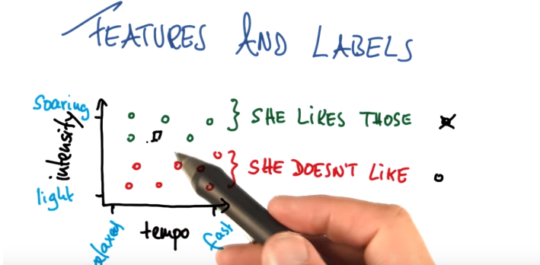

One thing you have to keep in mind is that when cases like cancer detection, a classifier with 90% accuracy, is way worst than just saying to every pacient he has no cancer (because only 0,01% of the cases are positive).

Example given some prior data, calculate the % of the tests which output is positive:

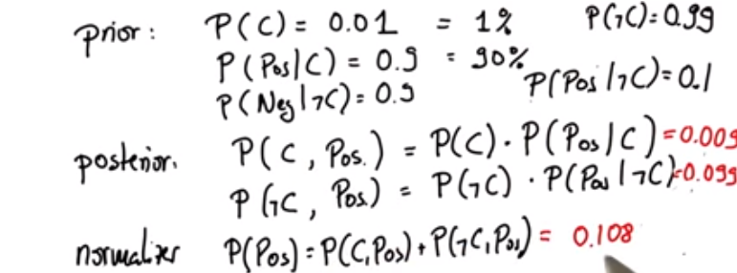

Only the 8% of the positives outcomes of having Cancer will be true (0,009)/(0,009+0,099)

P(C|pos)=0,0833.

This can be a goog method for detecting spam emails, os just for text learnin.

The idea is simple, the probability of being spam if it contains some words.

P(spam| 'hola','vender','casa').

