Application Documentation

# Overview

This application is a modern survey and questionnaire management platform. It allows users to create, edit, and distribute questionnaires, manage target populations, collect responses, and analyze results. The platform leverages AI for smart questionnaire generation and provides robust tools for segmentation, analytics, and secure data handling.

# Pages & Their Operations

## 1. Landing Page

* 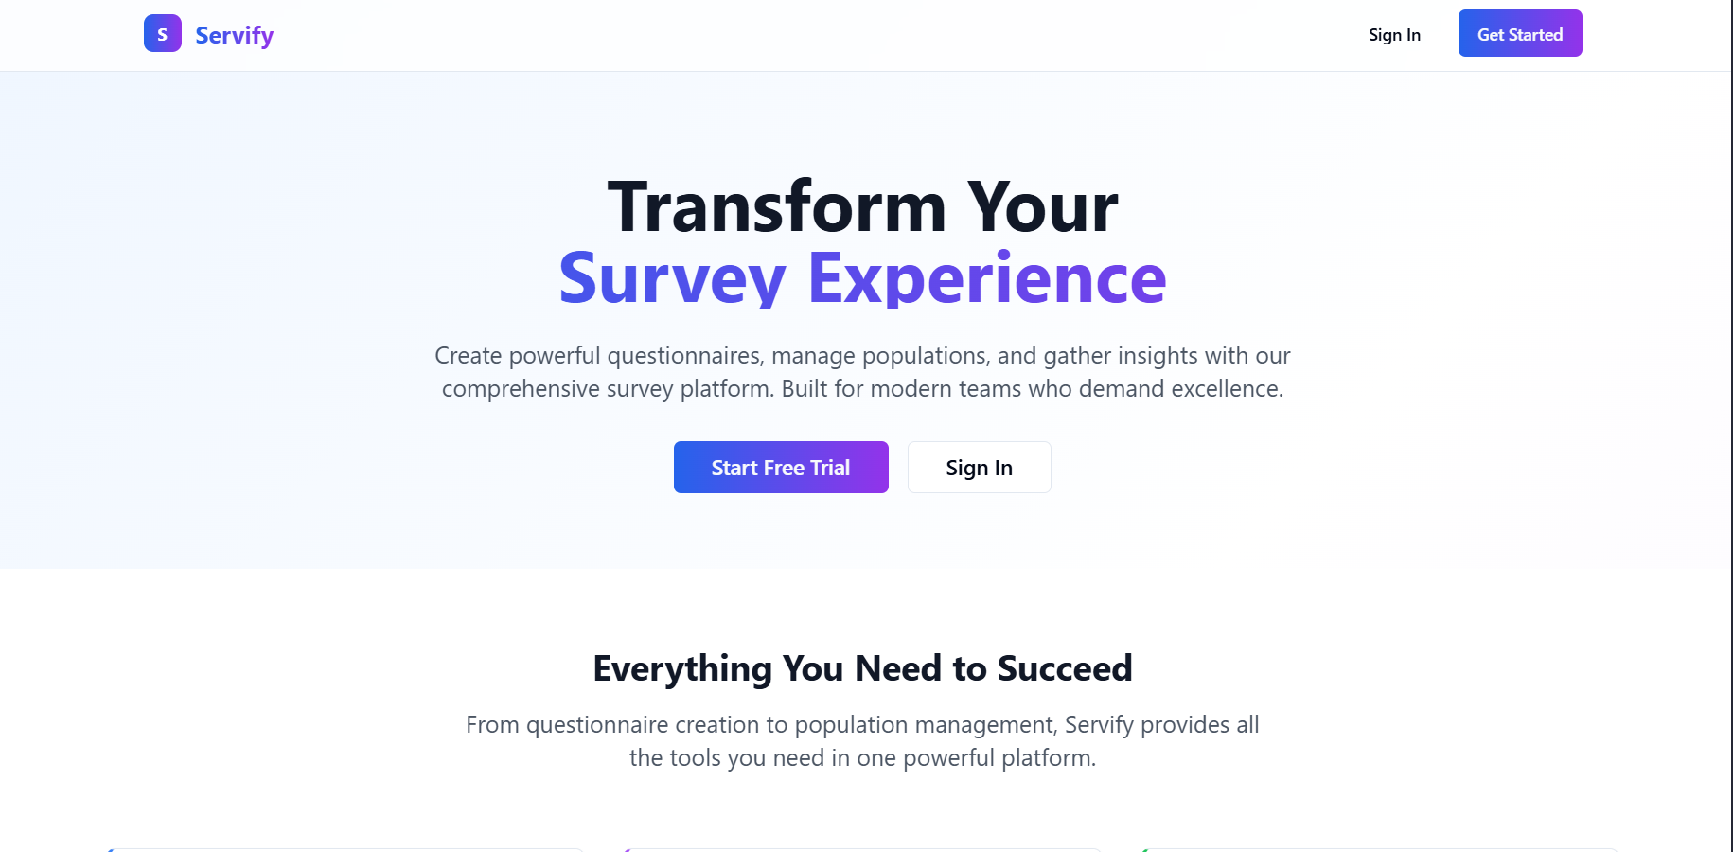
* Purpose: Introduction to the platform, value proposition, and quick access to authentication.
* Operations:
* Navigate to Login or Register.
* View platform features and call-to-action.

## 2. Authentication

* Login Page
* 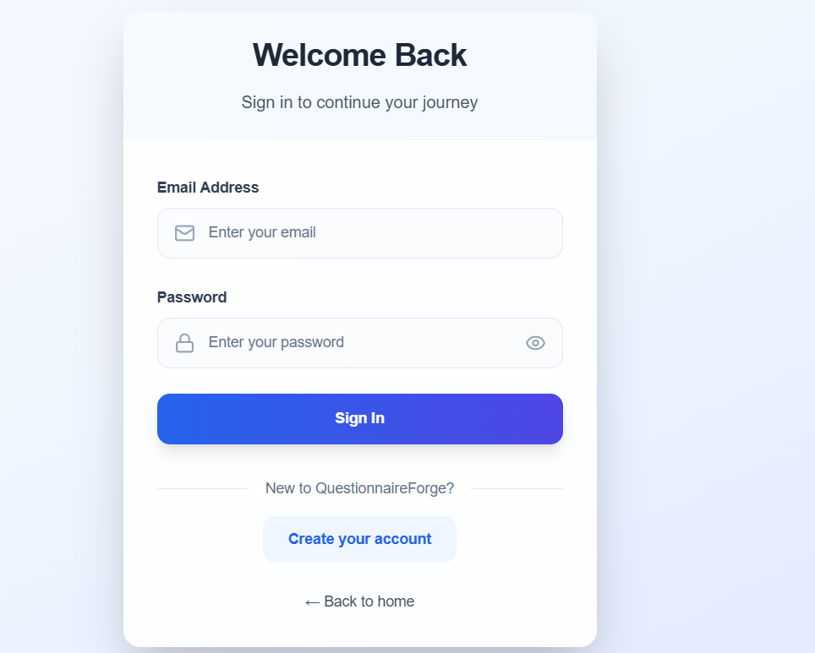
* Purpose: Secure user authentication.
* Operations: User login with email and password.
* Register Page
* Purpose: New user registration.
* Operations: Create a new account with email, password, and name.

## 3. Dashboard

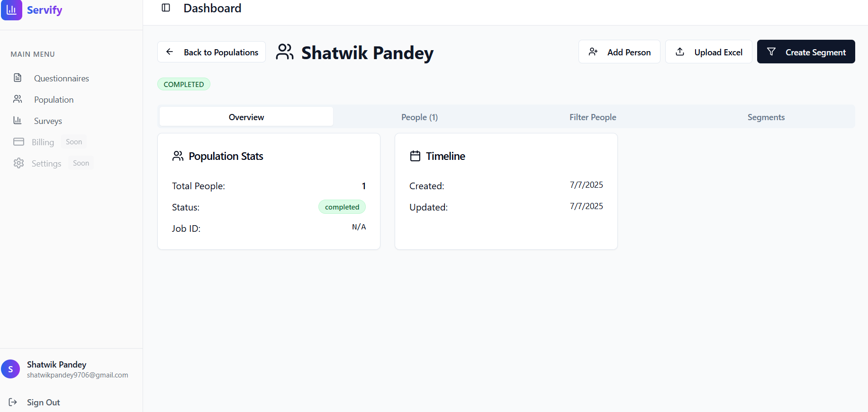

* Purpose: Central hub for all user operations after login.
* Operations:
* Sidebar navigation to all main sections (Questionnaires, Population, Surveys, etc.).
* View dashboard header and status.

## 4. Questionnaires

* Questionnaire List Page
* 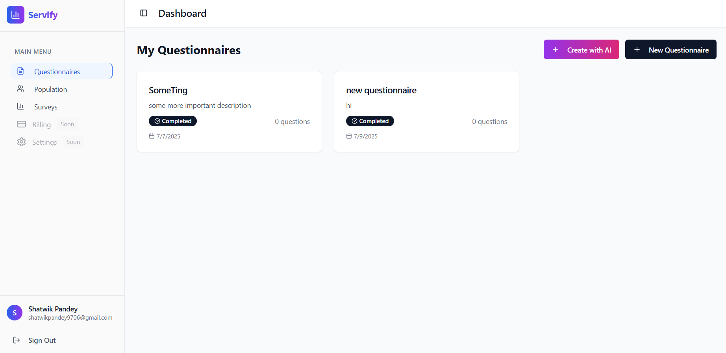
* Purpose: Manage all questionnaires.
* 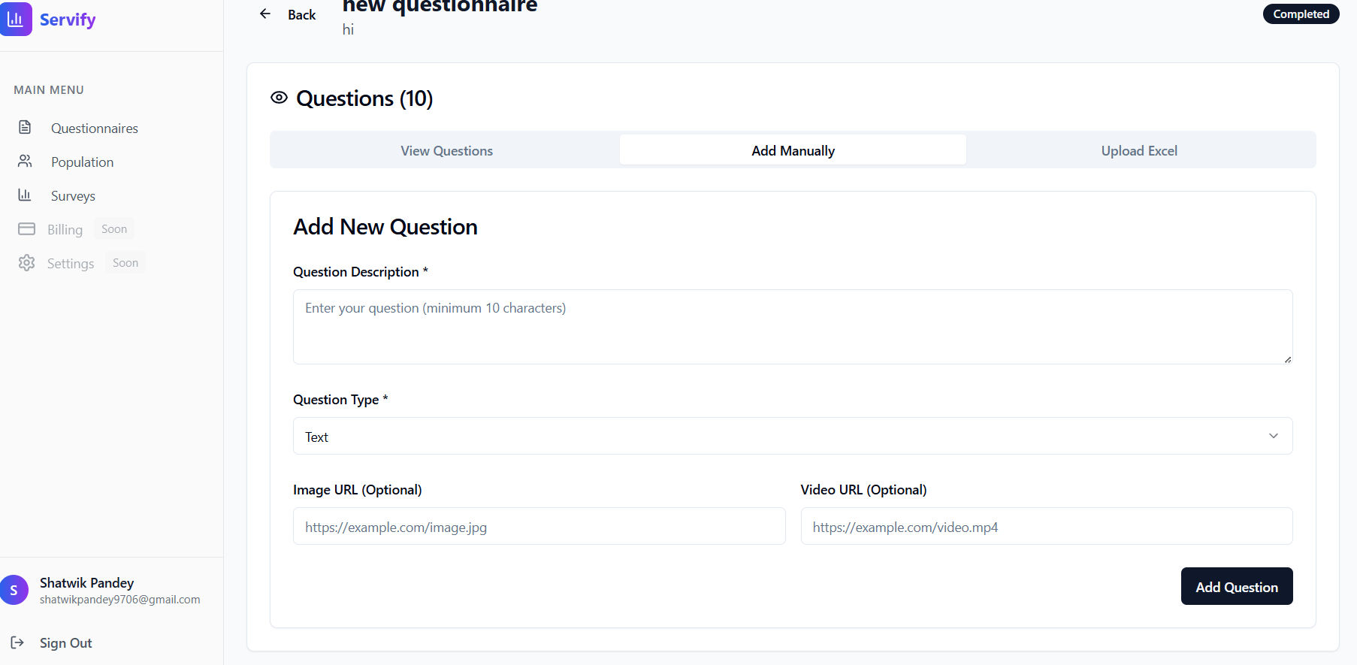
* Operations:
* View all questionnaires.
* Create a new questionnaire (manually or with AI).
* 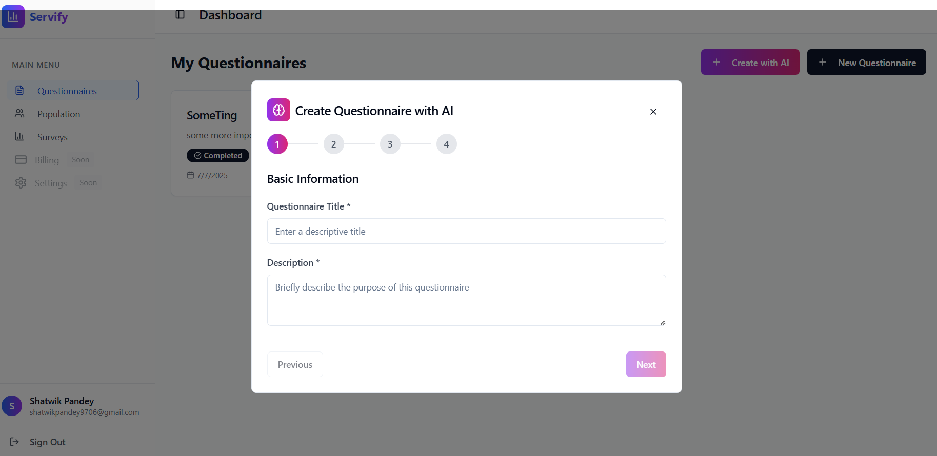
* Edit, duplicate, or delete questionnaires.
* Open a questionnaire to view or manage its questions.
* Questionnaire View Page
* Purpose: Manage questions within a specific questionnaire.
* Operations:
* View all questions in the questionnaire.
* Add a question manually (with support for all types and options).
* Upload questions via Excel.
* 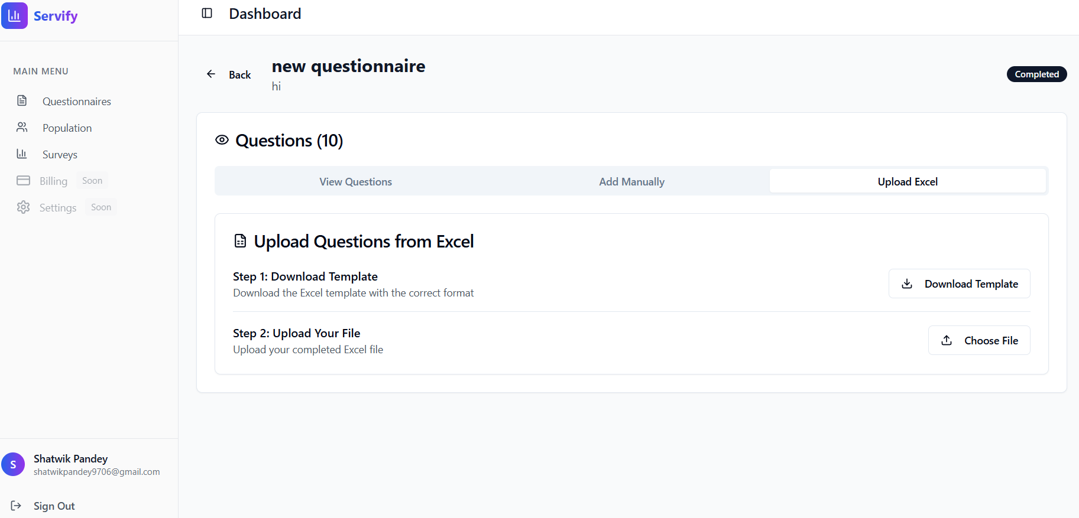
* Edit a question: Change description, type, options, image URL, and video URL.
* Delete a question: Remove a question from the questionnaire.
* 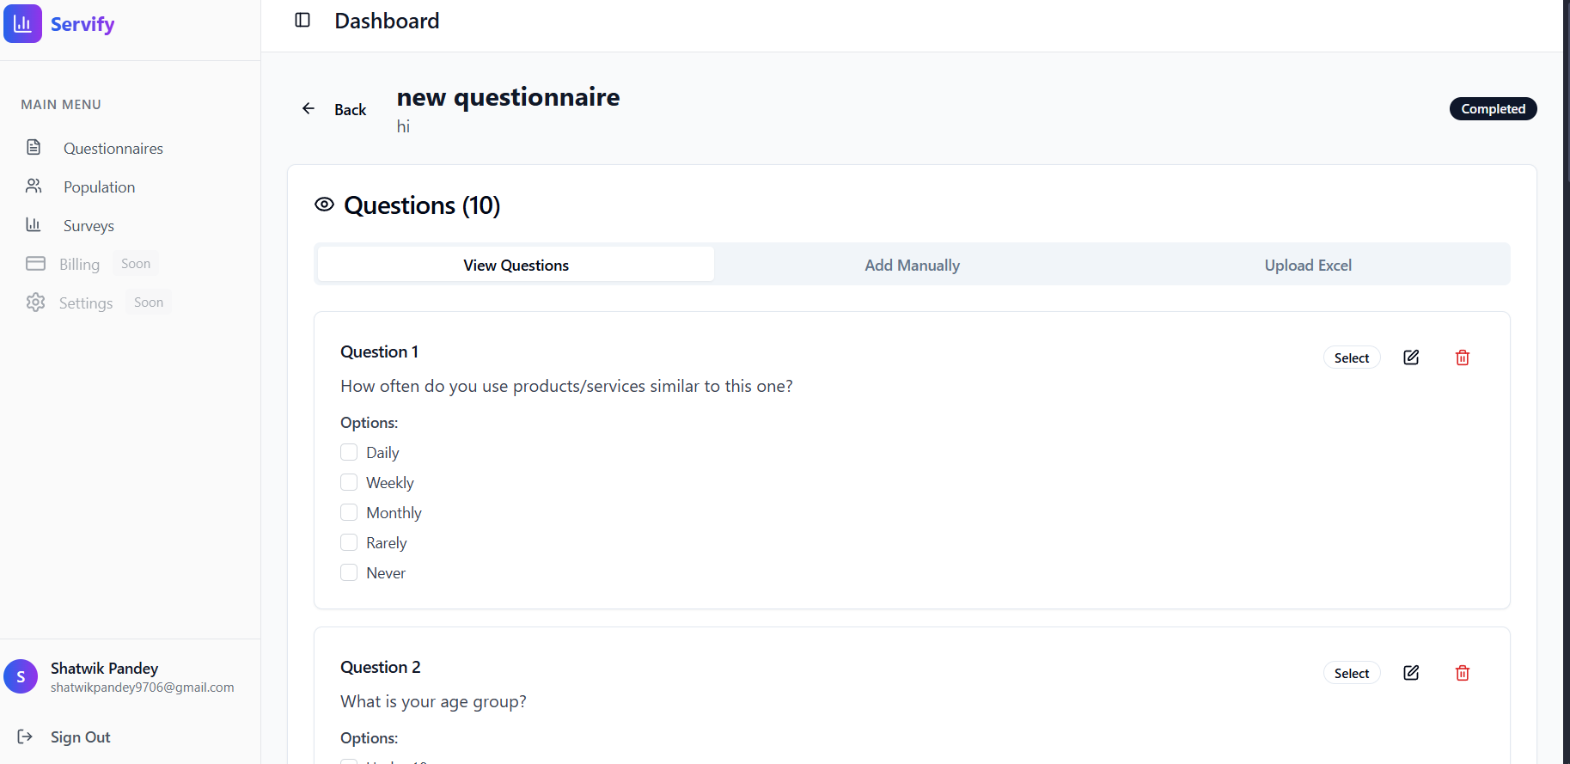

## 5. Population

* Population List Page
* 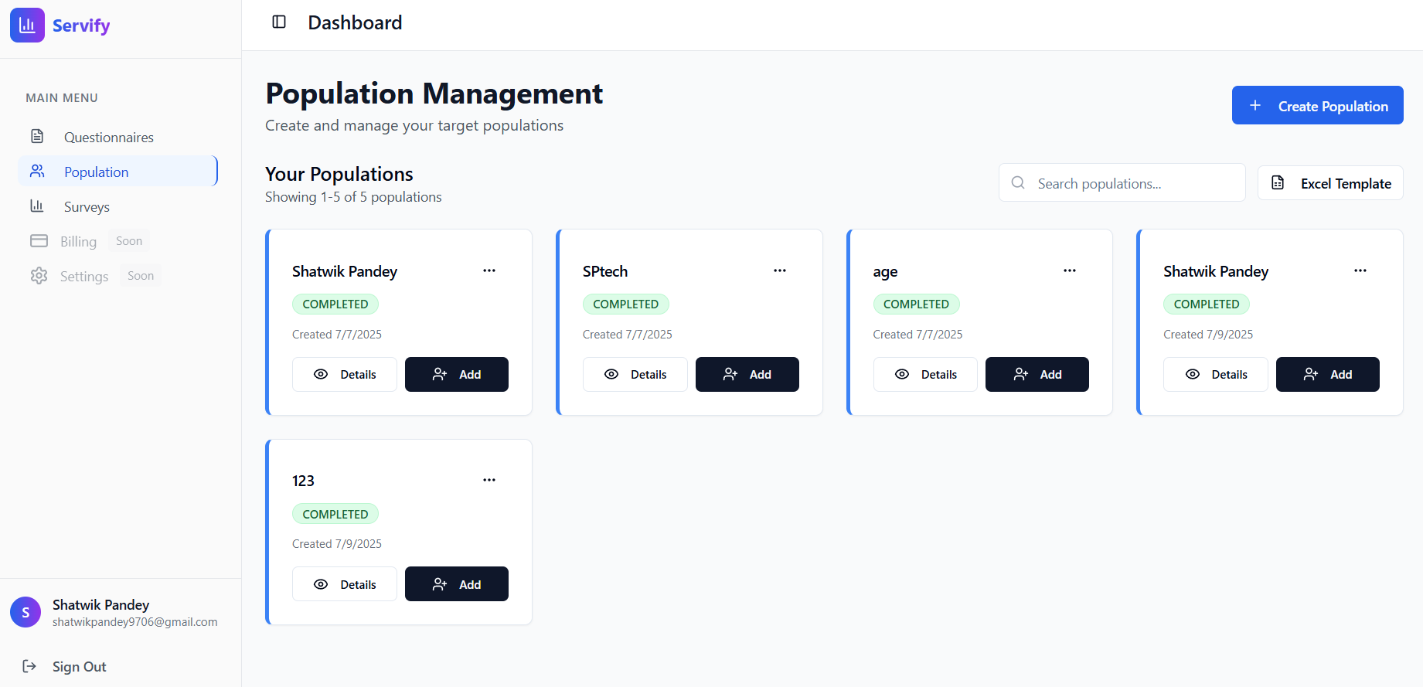
* Purpose: Manage target populations for surveys.
* Operations:
* View all populations.
* 
* Create a new population.
* Import people via Excel.
* Add individuals manually.
* Segment populations based on custom criteria.
* 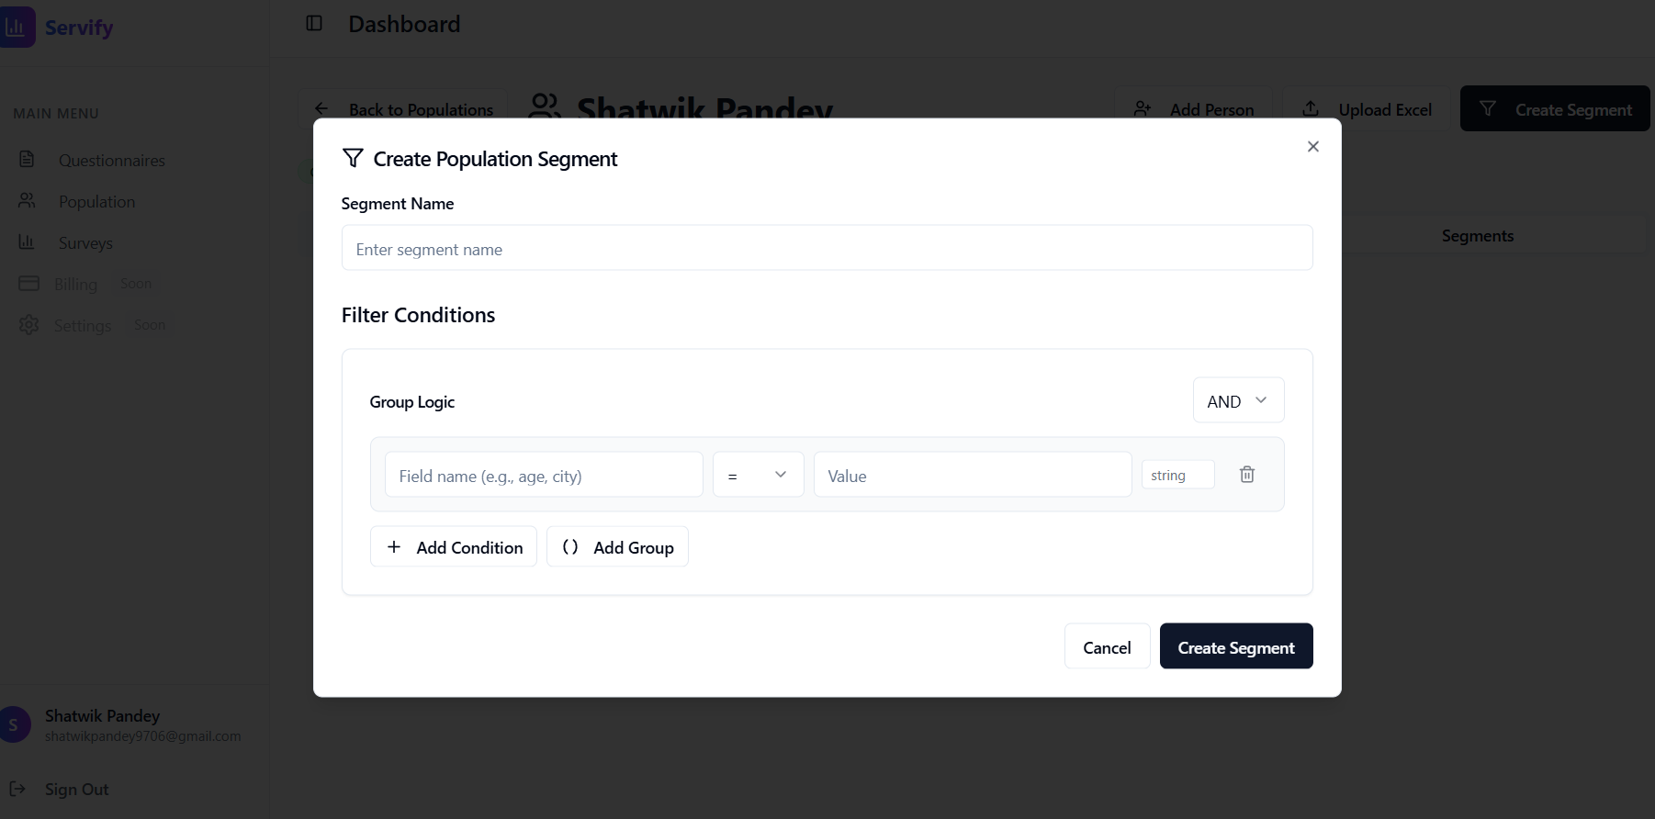
* View details of a specific population.
* Population Details Page
* Purpose: Detailed management of a single population.
* Operations:
* View all people in the population.
* Add, edit, or delete individuals.
* Upload people via Excel.
* Create and manage population segments.
* Filter and analyze population data.

## 6. Surveys

* Survey List Page
* 
* Purpose: Manage all surveys.
* Operations:
* View all surveys and their statuses.
* Create a new survey and assign it to a population.
* 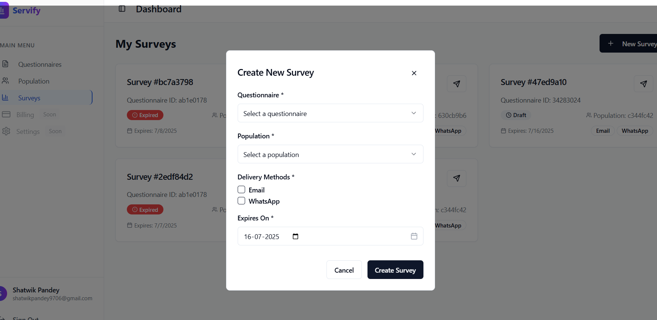
* View survey details and analytics.
* Survey Details Page
* 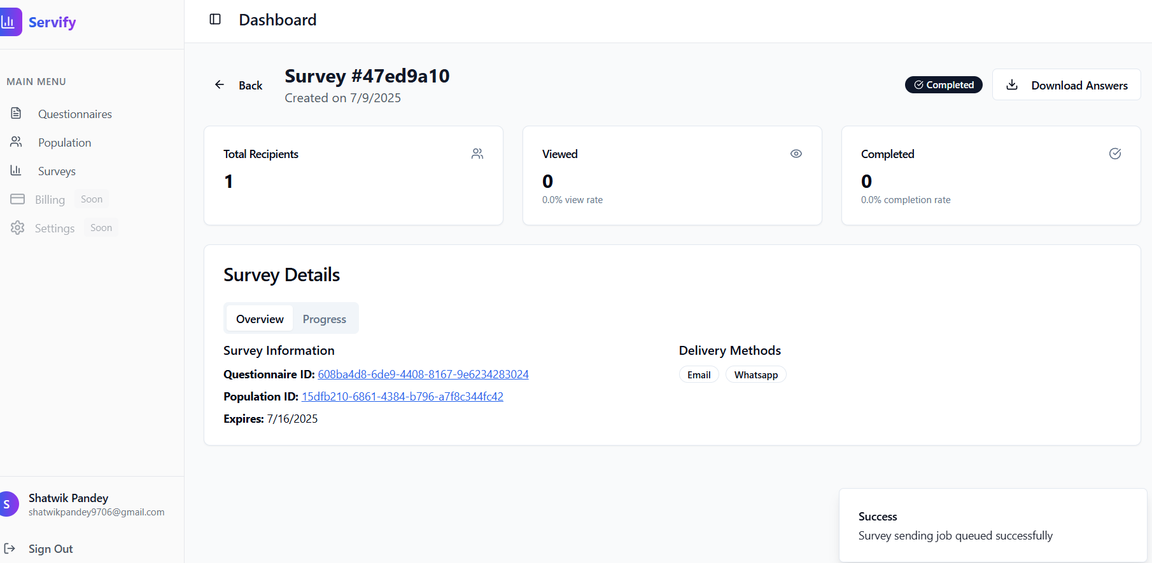
* Purpose: View and analyze a specific survey.
* Operations:
* View survey responses and analytics.
* Download or export survey results.
* Survey Response Page
* Purpose: Public or user-specific page for filling out assigned surveys.
* Operations:
* Respond to survey questions.
* Submit answers.

## 7. Other Pages

* Not Found (404) Page
* Purpose: Friendly error page for invalid routes.
* Operations: Link to return to the home or dashboard.

# Unique Functionalities

* AI-Powered Questionnaire Generation: Automatically generate questionnaires based on product/service and target audience.
* Advanced Segmentation: Create filtered segments of populations for targeted surveys.
* Excel Import/Export: Import people and questions via Excel templates.
* Real-time Analytics: Instantly visualize and filter survey results.
* Role-based Access & Security: Secure access to all features and data.