**What is Exploratory Data Analysis?**

Exploratory data analysis is one of the basic and essential steps of a data science project. A data scientist involves almost 70% of his work in doing the EDA of the dataset. In this article, we will discuss what is **Exploratory Data Analysis (EDA)** and the steps to perform EDA.

**What is Exploratory Data Analysis (EDA)?**

Exploratory Data Analysis (EDA) is a crucial initial step in data science projects. It involves analyzing and visualizing data to understand its key characteristics, uncover patterns, and identify relationships between variables refers to the method of studying and exploring record sets to apprehend their predominant traits, discover patterns, locate outliers, and identify relationships between variables. EDA is normally carried out as a preliminary step before undertaking extra formal statistical analyses or modeling.

**Key aspects of EDA include:**

* **Distribution of Data**: Examining the distribution of data points to understand their range, central tendencies (mean, median), and dispersion (variance, standard deviation).
* **Graphical Representations**: Utilizing charts such as histograms, box plots, scatter plots, and bar charts to visualize relationships within the data and distributions of variables.
* **Outlier Detection**: Identifying unusual values that deviate from other data points. Outliers can influence statistical analyses and might indicate data entry errors or unique cases.
* **Correlation Analysis**: Checking the relationships between variables to understand how they might affect each other. This includes computing correlation coefficients and creating correlation matrices.
* **Handling Missing Values**: Detecting and deciding how to address missing data points, whether by imputation or removal, depending on their impact and the amount of missing data.
* **Summary Statistics:** Calculating key statistics that provide insight into data trends and nuances.
* **Testing Assumptions**: Many statistical tests and models assume the data meet certain conditions (like normality or homoscedasticity). EDA helps verify these assumptions.

**Why Exploratory Data Analysis is Important?**

Exploratory Data Analysis (EDA) is important for several reasons, especially in the context of data science and statistical modeling. Here are some of the key reasons why EDA is a critical step in the data analysis process:

1. **Understanding Data Structures**: EDA helps in getting familiar with the dataset, understanding the number of features, the type of data in each feature, and the distribution of data points. This understanding is crucial for selecting appropriate analysis or prediction techniques.
2. **Identifying Patterns and Relationships**: Through visualizations and statistical summaries, EDA can reveal hidden patterns and intrinsic relationships between variables. These insights can guide further analysis and enable more effective feature engineering and model building.
3. **Detecting Anomalies and Outliers**: EDA is essential for identifying errors or unusual data points that may adversely affect the results of your analysis. Detecting these early can prevent costly mistakes in predictive modeling and analysis.
4. **Testing Assumptions**: Many statistical models assume that data follow a certain distribution or that variables are independent. EDA involves checking these assumptions. If the assumptions do not hold, the conclusions drawn from the model could be invalid.
5. **Informing Feature Selection and Engineering**: Insights gained from EDA can inform which features are most relevant to include in a model and how to transform them (scaling, encoding) to improve model performance.
6. **Optimizing Model Design**: By understanding the data’s characteristics, analysts can choose appropriate modeling techniques, decide on the complexity of the model, and better tune model parameters.
7. **Facilitating Data Cleaning**: EDA helps in spotting missing values and errors in the data, which are critical to address before further analysis to improve data quality and integrity.
8. **Enhancing Communication**: Visual and statistical summaries from EDA can make it easier to communicate findings and convince others of the validity of your conclusions, particularly when explaining data-driven insights to stakeholders without technical backgrounds.

**Types of Exploratory Data Analysis**

EDA, or Exploratory Data Analysis, refers back to the method of analyzing and analyzing information units to uncover styles, pick out relationships, and gain insights. There are various sorts of EDA strategies that can be hired relying on the nature of the records and the desires of the evaluation.

**Steps for Performing Exploratory Data Analysis**

Performing Exploratory Data Analysis (EDA) involves a series of steps designed to help you understand the data you’re working with, uncover underlying patterns, identify anomalies, test hypotheses, and ensure the data is clean and suitable for further analysis.

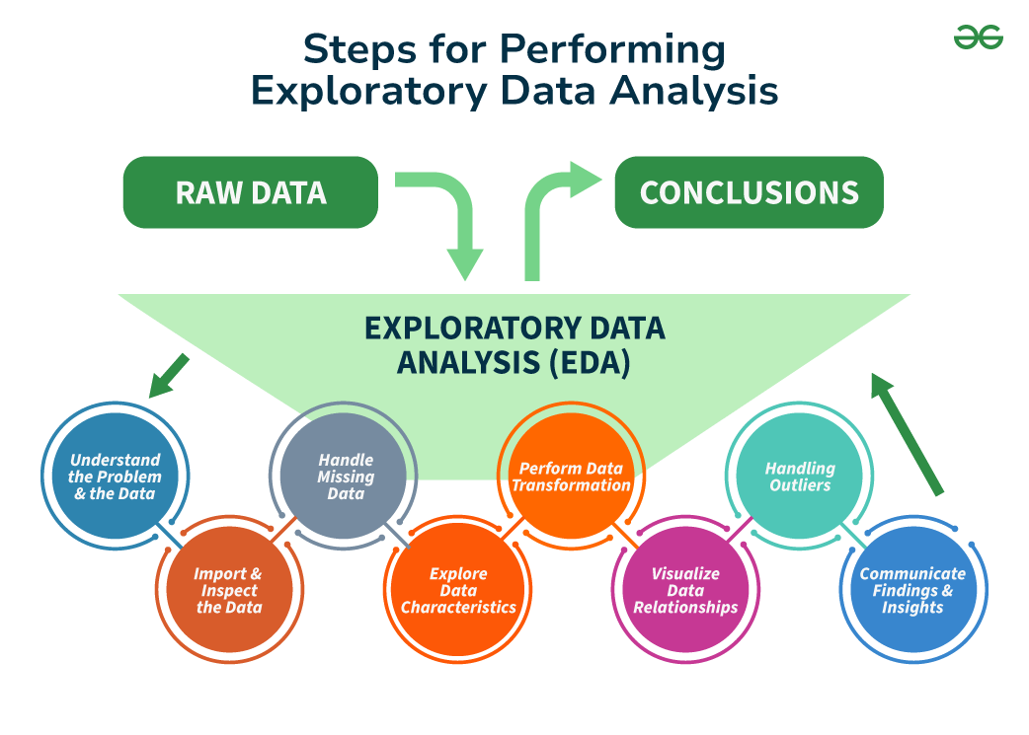

**Step 1: Understand the Problem and the Data**

The first step in any information evaluation project is to sincerely apprehend the trouble you are trying to resolve and the statistics you have at your disposal. This entails asking questions consisting of:

* What is the commercial enterprise goal or research question you are trying to address?
* What are the variables inside the information, and what do they mean?
* What are the data sorts (numerical, categorical, textual content, etc.) ?
* Is there any known information on first-class troubles or obstacles?
* Are there any relevant area-unique issues or constraints?

By thoroughly knowing the problem and the information, you can better formulate your evaluation technique and avoid making incorrect assumptions or drawing misguided conclusions. It is also vital to contain situations and remember specialists or stakeholders to this degree to ensure you have complete know-how of the context and requirements.

**Step 2: Import and Inspect the Data**

Once you have clean expertise of the problem and the information, the following step is to import the data into your evaluation environment (e.g., Python, R, or a spreadsheet program). During this step, looking into the statistics is critical to gain initial know-how of its structure, variable kinds, and capability issues.

Here are a few obligations you could carry out at this stage:

* Load the facts into your analysis environment, ensuring that the facts are imported efficiently and without errors or truncations.
* Examine the size of the facts (variety of rows and columns) to experience its length and complexity.
* Check for missing values and their distribution across variables, as missing information can notably affect the quality and reliability of your evaluation.
* Identify facts sorts and formats for each variable, as these records may be necessary for the following facts manipulation and evaluation steps.
* Look for any apparent errors or inconsistencies in the information, such as invalid values, mismatched units, or outliers, that can indicate exceptional issues with information.

**Step 3: Handle Missing Data**

Missing records is a joint project in many datasets, and it can significantly impact the quality and reliability of your evaluation. During the EDA method, it’s critical to pick out and deal with lacking information as it should be, as ignoring or mishandling lacking data can result in biased or misleading outcomes.

Here are some techniques you could use to handle missing statistics:

* **Understand the styles and capacity reasons for missing statistics**: Is the information lacking entirely at random (MCAR), lacking at random (MAR), or lacking not at random (MNAR)? Understanding the underlying mechanisms can inform the proper method for handling missing information.
* **Decide whether to eliminate observations with lacking values (listwise deletion) or attribute (fill in) missing values**: Removing observations with missing values can result in a loss of statistics and potentially biased outcomes, specifically if the lacking statistics are not MCAR. Imputing missing values can assist in preserving treasured facts. However, the imputation approach needs to be chosen cautiously.
* **Use suitable imputation strategies**, such as mean/median imputation, regression imputation, a couple of imputations, or device-getting-to-know-based imputation methods like k-nearest associates (KNN) or selection trees. The preference for the imputation technique has to be primarily based on the characteristics of the information and the assumptions underlying every method.
* **Consider the effect of lacking information**: Even after imputation, lacking facts can introduce uncertainty and bias. It is important to acknowledge those limitations and interpret your outcomes with warning.

Handling missing information nicely can improve the accuracy and reliability of your evaluation and save you biased or deceptive conclusions. It is likewise vital to record the techniques used to address missing facts and the motive in the back of your selections.

**Step 4: Explore Data Characteristics**

After addressing the facts that are lacking, the next step within the EDA technique is to explore the traits of your statistics. This entails examining your variables’ distribution, crucial tendency, and variability and identifying any ability outliers or anomalies. Understanding the characteristics of your information is critical in deciding on appropriate analytical techniques, figuring out capability information first-rate troubles, and gaining insights that may tell subsequent evaluation and modeling decisions.

**Calculate summary facts** (suggest, median, mode, preferred deviation, skewness, kurtosis, and many others.) for numerical variables: These facts provide a concise assessment of the distribution and critical tendency of each variable, aiding in the identification of ability issues or deviations from expected patterns.

**Step 5: Perform Data Transformation**

Data transformation is a critical step within the EDA process because it enables you to prepare your statistics for similar evaluation and modeling. Depending on the traits of your information and the necessities of your analysis, you may need to carry out various ameliorations to ensure that your records are in the most appropriate layout.

Here are a few common records transformation strategies:

* Scaling or normalizing numerical variables to a standard variety (e.g., [min-max scaling, standardization](https://www.geeksforgeeks.org/data-pre-processing-wit-sklearn-using-standard-and-minmax-scaler/))
* Encoding categorical variables to be used in machine mastering fashions (e.g., one-warm encoding, label encoding)
* Applying mathematical differences to numerical variables (e.g., logarithmic, square root) to correct for skewness or non-linearity
* Creating derived variables or capabilities primarily based on current variables (e.g., calculating ratios, combining variables)
* Aggregating or grouping records mainly based on unique variables or situations

By accurately transforming your information, you could ensure that your evaluation and modeling strategies are implemented successfully and that your results are reliable and meaningful.

**Step 6: Visualize Data Relationships**

Visualization is an effective tool in the EDA manner, as it allows to discover relationships between variables and become aware of styles or trends that may not immediately be apparent from summary statistics or numerical outputs. To visualize data relationships, explore univariate, bivariate, and multivariate analysis.

* Create frequency tables, bar plots, and pie charts for express variables: These visualizations can help you apprehend the distribution of classes and discover any ability imbalances or unusual patterns.
* Generate histograms, container plots, violin plots, and density plots to visualize the distribution of numerical variables. These visualizations can screen critical information about the form, unfold, and ability outliers within the statistics.
* Examine the correlation or association among variables using scatter plots, correlation matrices, or statistical assessments like Pearson’s correlation coefficient or Spearman’s rank correlation: Understanding the relationships between variables can tell characteristic choice, dimensionality discount, and modeling choices.

**Step 7: Handling Outliers**

An [Outlier](https://www.geeksforgeeks.org/machine-learning-outlier/) is a data item/object that deviates significantly from the rest of the (so-called normal)objects. They can be caused by measurement or execution errors. The analysis for outlier detection is referred to as outlier mining. There are many ways to detect outliers, and the removal process of these outliers from the dataframe is the same as removing a data item from the panda’s dataframe.

Identify and inspect capability outliers through the usage of strategies like the [interquartile range (IQR)](https://www.geeksforgeeks.org/interquartile-range-to-detect-outliers-in-data/),[Z-scores](https://www.geeksforgeeks.org/z-score-for-outlier-detection-python/), or area-specific regulations: Outliers can considerably impact the results of statistical analyses and gadget studying fashions, so it’s essential to perceive and take care of them as it should be.

**Step 8: Communicate Findings and Insights**

The final step in the EDA technique is effectively discussing your findings and insights. This includes summarizing your evaluation, highlighting fundamental discoveries, and imparting your outcomes cleanly and compellingly.

Here are a few hints for effective verbal exchange:

* Clearly state the targets and scope of your analysis
* Provide context and heritage data to assist others in apprehending your approach
* Use visualizations and photos to guide your findings and make them more reachable
* Highlight critical insights, patterns, or anomalies discovered for the duration of the EDA manner
* Discuss any barriers or caveats related to your analysis
* Suggest ability next steps or areas for additional investigation

Effective conversation is critical for ensuring that your EDA efforts have a meaningful impact and that your insights are understood and acted upon with the aid of stakeholders.

**Conclusion**

Exploratory Data Analysis forms the bedrock of data science endeavors, offering invaluable insights into dataset nuances and paving the path for informed decision-making. By delving into data distributions, relationships, and anomalies, EDA empowers data scientists to unravel hidden truths and steer projects toward success.