**ASSIGNMENT – 6**

**AIM:**

To solve and implement the given problems using Backtracking.

**Qn1:**



**Psuedo Code:**

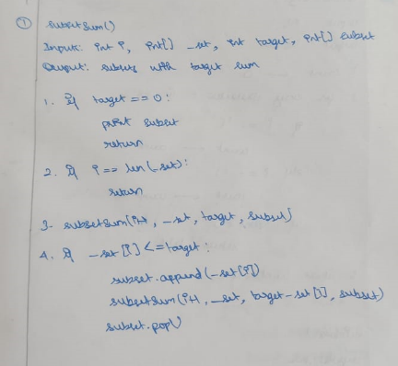

**Source Code:**

def subsetSum(i, _set, target_sum, subset):

    if target_sum == 0:

        print(subset, end=", ")

        return

    if i==len(_set):

        return

    subsetSum(i+1, _set, target_sum, subset)

    if _set[i] <= target_sum:

        subset.append(_set[i])

        subsetSum(i+1, _set, target_sum-_set[i], subset)

        subset.pop()

l = [2,3,5,6,8,10]

print("List: ", l)

sum = int(input("Enter sum: "))

subsetSum(0, l, 10, [])

**Output:**

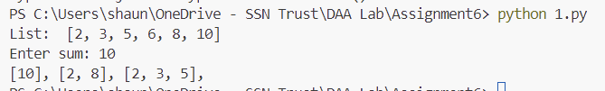

**Qn2:**

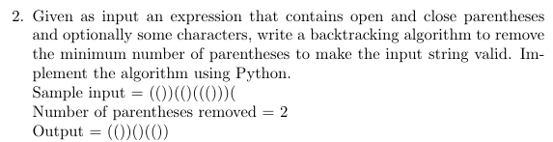

**Psuedo Code:**

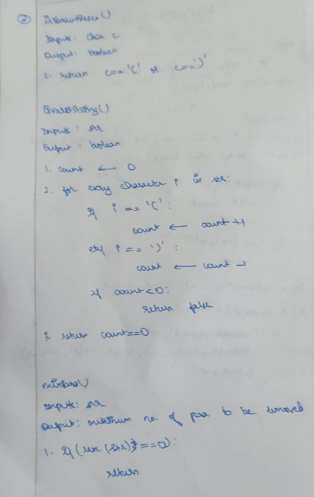

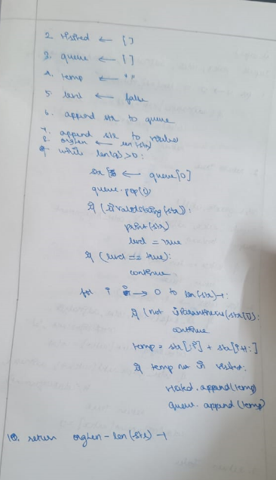

**Source Code:**

def isParanthesis(c):

    return c=="(" or c==")"

def isValidString(str):

    count = 0

    for i in str:

        if i == "(":

            count += 1

        elif i == ")":

            count -= 1

        if count<0:

            return False

    return count==0

def minPara(str):

    if len(str) == 0:

        return

    visited = []

    q = []

    temp = ""

    level = False

    orgLen = len(str)

    q.append(str)

    visited.append(str)

    while len(q) > 0:

        str = q[0]

        q.pop(0)

        if isValidString(str):

            print(str)

            level = True

        if level:

            continue

        for i in range(len(str)):

            if not isParanthesis(str[i]):

                continue

            temp = str[:i] + str[i+1:]

            if temp not in visited:

                visited.append(temp)

                q.append(temp)

    return orgLen - len(str) - 1

expression = "()()))())"

print("String: ", expression)

min_count = minPara(expression)

print(f"Min Para to be removed: {min_count}")

print()

expression = "()v)"

print("String: ", expression)

min_count = minPara(expression)

print(f"Min Para to be removed: {min_count}")

**Output:**

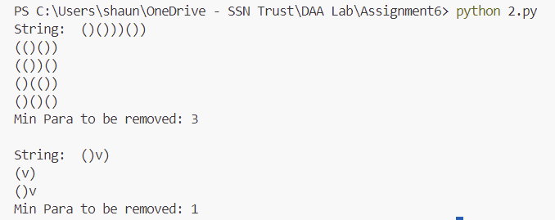

**Qn3:**

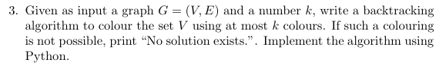

**Psuedo Code:**

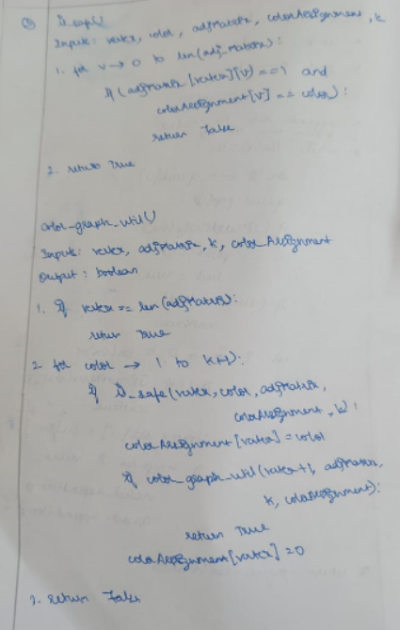

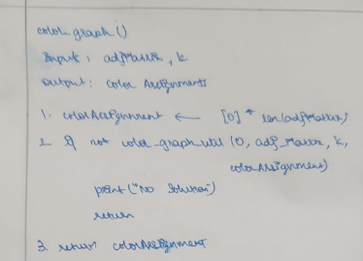

**Source Code:**

def is_safe(vertex, color, adj_matrix, color_assignment, k):

    for v in range(len(adj_matrix)):

        if adj_matrix[vertex][v] == 1 and color_assignment[v] == color:

            return False

    return True

def color_graph_util(vertex, adj_matrix, k, color_assignment):

    if vertex == len(adj_matrix):

        return True

    for color in range(1, k+1):

        if is_safe(vertex, color, adj_matrix, color_assignment, k):

            color_assignment[vertex] = color

            if color_graph_util(vertex+1, adj_matrix, k, color_assignment):

                return True

            color_assignment[vertex] = 0

    return False

def color_graph(adj_matrix, k):

    color_assignment = [0] * len(adj_matrix)

    if not color_graph_util(0, adj_matrix, k, color_assignment):

        print("No solution exists.")

        return

    print("Color assignments:")

    for vertex, color in enumerate(color_assignment):

        print(f"Vertex {vertex}: Color {color}")

# Sample Input

V = 4

E = [(0, 1), (0, 2), (1, 2), (1, 3), (2, 3)]

k = 3

# Initialize adjacency matrix

adj_matrix = [[0] * V for _ in range(V)]

for u, v in E:

    adj_matrix[u][v] = 1

    adj_matrix[v][u] = 1

print("Adjacency Matrix:")

print(*adj_matrix, sep="\n")

print("K: ", k)

print()

# Color the graph

color_graph(adj_matrix, k)

**Output:**

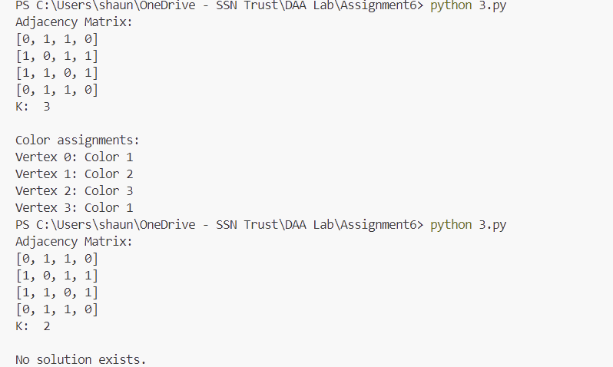

**Learning Outcomes:**

* I learnt to analyse and implement backtracking algorithms using Python.