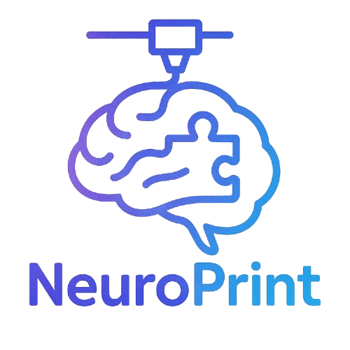 NeuroPrint Brain Quiz

Name: ____________________________  Date: ____________________________

Instructions: Answer each question to the best of your ability.

# Section 1: Frontal Lobe

1. What are two primary functions of the frontal lobe?

___________________________________________________________

___________________________________________________________

2. The frontal lobe plays a large role in:

a) Balance

b) Vision

c) Decision-making

d) Breathing

# Section 2: Occipital Lobe

3. Which lobe is primarily responsible for vision?

_______________________________________

4. True or False: The occipital lobe is located at the front of the brain.

_______

# Section 3: Cerebellum

5. What does the cerebellum help control?

a) Language

b) Emotions

c) Coordination

d) Smell

# Section 4: Label the Brain

6. Label the following regions on the diagram provided:

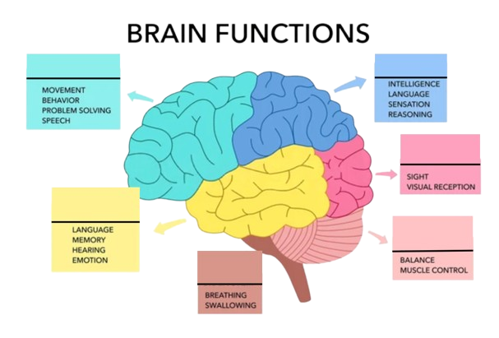

- Frontal Lobe

- Parietal Lobe

- Occipital Lobe

- Cerebellum

- Brainstem

# ⭐ Bonus Question

7. A patient has trouble forming new memories after a head injury. Which part of the brain might be damaged?

___________________________________________________________

For the answer key and additional quizzes, please email shaunhafez@gmail.com.