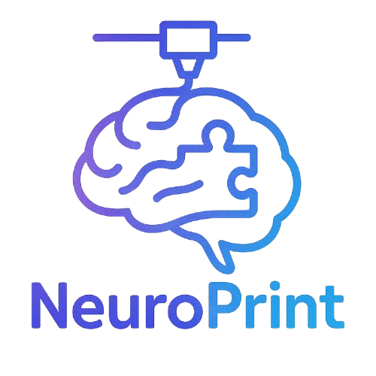 NeuroPrint Teacher Guide

Bringing the Brain to Life in the Classroom

# 📋 Table of Contents

1. Introduction

2. Learning Objectives

3. Materials Included

4. Suggested Pacing Guide

5. Classroom Activities

6. Assessment Ideas

7. Extensions & Enrichment

8. Standards Alignment

9. FAQs

10. Contact

# 1. Introduction

Welcome to the NeuroPrint Teacher Guide! This resource is designed to help you integrate neuroscience concepts into your classroom using 3D-printed brain models, interactive activities, and student-friendly worksheets. Whether you're teaching biology, psychology, or health science, NeuroPrint makes complex brain anatomy engaging and accessible.

# 2. Learning Objectives

- Identify major regions of the brain (e.g., frontal lobe, occipital lobe, cerebellum).

- Explain the basic function of each brain region.

- Understand how brain anatomy relates to behavior and cognitive function.

- Explore careers in neuroscience and healthcare.

- Engage with 3D models and digital tools for multimodal learning.

# 3. Materials Included

- 🧠 3D-printed Brain Model (available via request)

- 🖼 Printable Brain Diagram Worksheet

- 📝 Label-the-Brain Worksheet

- 📄 Editable Quiz Template

- 📲 Website with Interactive Brain Map and Explanations

- 🔗 QR Codes linked to model sections

# 4. Suggested Pacing Guide

| Week | Topic | Activities |
| --- | --- | --- |
| 1 | Introduction to the Brain | Brain diagram worksheet, intro video |
| 2 | Brain Regions & Functions | 3D model walkthrough, label worksheet |
| 3 | Sensory/Motor Systems | Class discussion + brain games |
| 4 | Quiz & Project | Student quiz + group presentations |

# 5. Classroom Activities

**Model Exploration**: Hand out the 3D model. Students scan QR codes linked to simple & advanced explanations of each brain region.

**Label-the-Brain Relay**: Teams race to label printed brain diagrams from memory. Bonus points for naming functions!

**Brain Function Charades**: Students act out behaviors related to specific lobes—others guess the region!

**Career Corner**: Assign each student a neuroscience-related career to research and present.

# 6. Assessment Ideas

**Formative**: Exit tickets, diagram labeling, Kahoot!

**Summative**: Brain quiz (editable), short answer explanations, group presentations

**Project Option**: “Design Your Own Brain Region” – Students invent a new brain lobe with a unique function

# 7. Extensions & Enrichment

- Guest speaker (e.g., local neurologist, med student)

- Field trip to a neuroscience lab or virtual tour

- Introduce brain-related case studies or real-world neurological conditions (e.g., stroke, epilepsy)

# 8. Standards Alignment

Add your local/state/national standards here.

Example (for NGSS):

- HS-LS1-2: Develop and use a model to illustrate the hierarchical organization of interacting systems within multicellular organisms.

# 9. FAQs

**Q: How do I get the 3D brain model?**

A: Visit “neuroprint.info” and fill out the 'Request a Model' form.

**Q: Can I modify the worksheets?**

A: Yes! All printable resources are editable and teacher-friendly.

**Q: Do students need devices?**

A: Only for QR code scanning or optional site activities. Everything can also be printed.

# 10. Contact

📧 Email: shaunhafez@gmail.com

🌐 Website: neuroprint.info

📦 Model Request Form: neuroprint.info/request_model