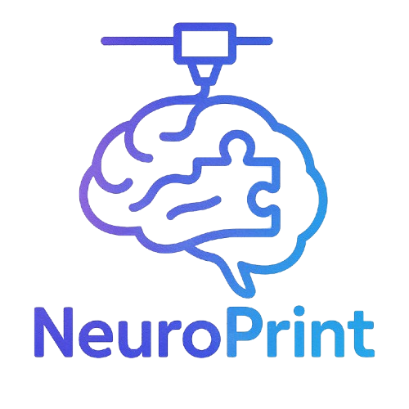 NeuroPrint Brain Quiz
Name: ____________________________ Date: ____________________________
Instructions: Answer each question to the best of your ability.

Section 1: Frontal Lobe
1. What are two primary functions of the frontal lobe?
___________________________________________________________
___________________________________________________________
2. The frontal lobe plays a large role in:
a) Balance
b) Vision
c) Decision-making
d) Breathing

Section 2: Occipital Lobe
3. Which lobe is primarily responsible for vision?
_______________________________________
4. True or False: The occipital lobe is located at the front of the brain.
_______

Section 3: Cerebellum
5. What does the cerebellum help control?
a) Language
b) Emotions
c) Coordination
d) Smell

Section 4: Label the Brain
6. Label the following regions on the diagram provided:
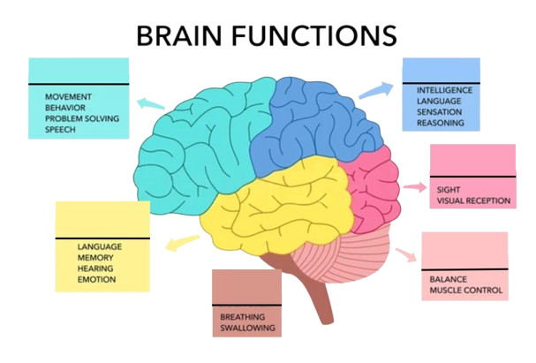

- Frontal Lobe
- Parietal Lobe
- Occipital Lobe
- Cerebellum
- Brainstem

⭐ Bonus Question
7. A patient has trouble forming new memories after a head injury. Which part of the brain might be damaged?
___________________________________________________________
For the answer key and additional quizzes, please email shaunhafez@gmail.com.

