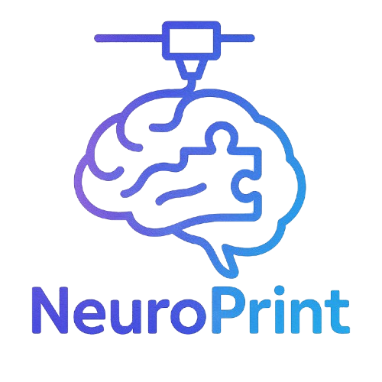 NeuroPrint Teacher Guide
Bringing the Brain to Life in the Classroom

📋 Table of Contents
1. Introduction
2. Learning Objectives
3. Materials Included
4. Suggested Pacing Guide
5. Classroom Activities
6. Assessment Ideas
7. Extensions & Enrichment
8. Standards Alignment
9. FAQs
10. Contact

1. Introduction
Welcome to the NeuroPrint Teacher Guide! This resource is designed to help you integrate neuroscience concepts into your classroom using 3D-printed brain models, interactive activities, and student-friendly worksheets. Whether you're teaching biology, psychology, or health science, NeuroPrint makes complex brain anatomy engaging and accessible.

2. Learning Objectives
- Identify major regions of the brain (e.g., frontal lobe, occipital lobe, cerebellum).
- Explain the basic function of each brain region.
- Understand how brain anatomy relates to behavior and cognitive function.
- Explore careers in neuroscience and healthcare.
- Engage with 3D models and digital tools for multimodal learning.

3. Materials Included
- 🧠 3D-printed Brain Model (available via request)
- 🖼 Printable Brain Diagram Worksheet
- 📝 Label-the-Brain Worksheet
- 📄 Editable Quiz Template
- 📲 Website with Interactive Brain Map and Explanations
- 🔗 QR Codes linked to model sections

4. Suggested Pacing Guide
Week | Topic | Activities
1 | Introduction to the Brain | Brain diagram worksheet, intro video
2 | Brain Regions & Functions | 3D model walkthrough, label worksheet
3 | Sensory/Motor Systems | Class discussion + brain games
4 | Quiz & Project | Student quiz + group presentations

5. Classroom Activities
**Model Exploration**: Hand out the 3D model. Students scan QR codes linked to simple & advanced explanations of each brain region.
**Label-the-Brain Relay**: Teams race to label printed brain diagrams from memory. Bonus points for naming functions!
**Brain Function Charades**: Students act out behaviors related to specific lobes—others guess the region!
**Career Corner**: Assign each student a neuroscience-related career to research and present.

6. Assessment Ideas
**Formative**: Exit tickets, diagram labeling, Kahoot!
**Summative**: Brain quiz (editable), short answer explanations, group presentations
**Project Option**: “Design Your Own Brain Region” – Students invent a new brain lobe with a unique function

7. Extensions & Enrichment
- Guest speaker (e.g., local neurologist, med student)
- Field trip to a neuroscience lab or virtual tour
- Introduce brain-related case studies or real-world neurological conditions (e.g., stroke, epilepsy)

8. Standards Alignment
Add your local/state/national standards here.
Example (for NGSS):
- HS-LS1-2: Develop and use a model to illustrate the hierarchical organization of interacting systems within multicellular organisms.

9. FAQs
**Q: How do I get the 3D brain model?**
A: Visit “neuroprint.info” and fill out the 'Request a Model' form.
**Q: Can I modify the worksheets?**
A: Yes! All printable resources are editable and teacher-friendly.
**Q: Do students need devices?**
A: Only for QR code scanning or optional site activities. Everything can also be printed.

10. Contact
📧 Email: shaunhafez@gmail.com
🌐 Website: neuroprint.info
📦 Model Request Form: neuroprint.info/request_model

