Shaun

Lobsinger

19826 W. Lincoln St.

Buckeye, AZ 85326

T: 480-433-6235

E: [shaun.lobsinger@gmail.com](mailto:shaun.lobsinger@gmail.com)

W: <https://shaunlobsinger.com>

# Objective

To innovate new web products with a focus on user experience within a inclusive and supportive team environment.

# Education

### **MS - Human Factors (Applied Psychology) / 2015**

Arizona State University: Ira A. Fulton Schools of Engineering, Mesa, AZ

### **BS - Psychology / 2011**

Arizona State University: College of Liberal Arts and Sciences, Tempe, AZ

# Skills Summary

**Coding**  
HTML, CSS, SASS, Node, NPM, MySQL, JavaScript, Bootstrap, React, Redux.

**Tooling**   
Jira, Git, Webpack, VS Code, Linux

# 

# Experience

### **GoDaddy**

### Software Developer 4 / 1/2017 – Present

At GoDaddy, I am focused on providing top tier experiences to our small business customers. I have helped drive streamlined solution for purchasing, setting up, and managing Microsoft 365 as well as our white label Open-Xchange email products. Users are seamlessly able to create their email account, access commonly used functions such as distribution groups and alias management right from a GoDaddy branded experience.  
  
As lead developer, I have worked hard to drive architectural and performance improvements to our application. For example, I am working diligently to bring our application over from a legacy PHP app to a fresh node.js API that is able to service as a touch point for any GoDaddy application to manage email.

### **Arizona Federal Credit Union**

### Senior Web Application Developer / 6/2013 – 12/2017

My role at the credit union focused on full stack development, Linux server management, and user experience design. Acting as the sole web developer for the organization, I was responsible for collecting project requirements, creating work flows, developing prototypes, coding, and presenting solutions to my stakeholders.

I took the initiative to introduce GIT to the organization as well as implement BitBucket Server and Bamboo Server to provide a complete CI/CD pipeline. I have worked on several business-critical applications including two major redesigns of arizonafederal.org, an online membership application, and an online quiz game to coincide with a promotional internet reality show.

# 

# 

# Projects

### **Productivity Email Management Panel (2017 - present)** [**https://productivity.godaddy.com**](https://productivity.godaddy.com)

### Productivity Panel is an email management application which abstracts the complexity of setting up and managing email from Microsoft 365 interface.

**Technologies:**

* PHP
* Node
* React
* Redux

### 

***Arizona Federal Redesign (2016)***

[**https://web.archive.org/web/20180224041255/https://arizonafederal.org/**](https://web.archive.org/web/20180224041255/https://arizonafederal.org/)

A complete overhaul of the Arizona Federal website to modernize the design and functionality. The site includes a responsive design, additional interactive elements implemented in vue.js, and has a striking visual appeal compared to the previous design.

**Technologies:**

* PHP (Laravel)
* Vue.js

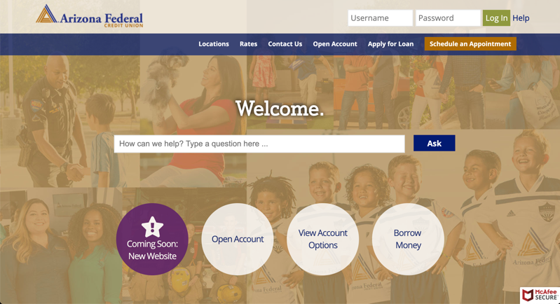

***Arizona Federal Online Membership Application (2015)***

***https://join.arizonafederal.org***

Online membership application allowing users to join the credit union. Implemented with   
**Technologies:**

* PHP (Laravel)
* Vue.js
* AWS (S3)



***My Comeback (2015)***

***https://mycomeback.arizonafederal.org***

Contest website for credit union members to learn about managing their finances.

**Technologies:**

* PHP (Laravel)
* Vue.js
* AWS (S3)



# References

### **Jonathan Jolly**

### Human System Analyst – General Dynamics P: 602-909-2869

### **Jesus Islas**

### Digital Banking Manager – Arizona Federal Credit Union P: 623-418-1864

### 

### **Johnathan Roig**

### Sr. Developer – GoDaddy P: 480-209-5896

Additional references available upon request.